  Burton Green Church of England Academy  Teaching Assistant x2 FTC |  |  | 
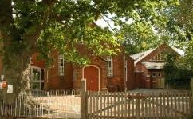    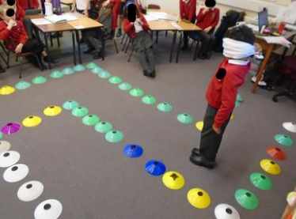 |  |  | 
Are you the right person for this key role within the academy and community? |  |  | Teaching Assistant – FTC  30 hours per week, 39 weeks per year  Mon – Fri, 8.30am to 3.30pm  Current grade and salary:  Spine point 7, Grade F pay scale FTE £22,369 per annum (£15,738.22 actual salary)  Start Date:  ASAP  Academy Visit:  Please see contact details below  Closing Date:  Sunday 12th November 2023  Interview Date:  W/C Monday 13th November 2023
The Diocese of Coventry Multi Academy Trust is looking to appoint a resourceful and highly effective Teaching Assistant to support children with educational targets across the school.  The successful candidate will support children with needs from Reception to Year 6.  They will follow safeguarding procedures and regulations & have previous experience of working with young children and/or supporting children with SEND. | Are you  *Able to work with individuals and groups and work as part of a team to provide care in a safe and happy environment?  Highly motivated with a positive attitude?  * Able to support and motivate children to flourish and develop?  * Able to work effectively with colleagues and parents? | Do you:  *Have high expectations of yourself, colleagues and children?  *Enjoy working as part of a team to improve outcomes for children?    If so, please apply!
For an appointment to visit the school please contact the school office on 02476 464130.
Applications to Clusterhr@covmat.org - For full information please see www.covmat.org/vacancies

