RECRUITMENT PACK

Art Coordinator

September 2025


The Archbishop Lanfranc Academy
Mitcham Road, Croydon, CR9 3AS
020 8689 1255
office@lanfranc.org.uk
www.lanfranc.org.uk


Contents

Welcome 1
Our Values 2
Job Title Here 3
Job Description 4
Person Specification 9
Department Description 11
How To Apply 12
How To Find Us 13


Welcome

Thank you so much for your interest in The Archbishop Lanfranc Academy, and for considering becoming part of ‘Team TALA’. There’s been a school on this site for nearly 100 years, and, despite being a new academy with a new building, we’re proud of our history and our place in the community.
The Archbishop Lanfranc Academy is a modern, vibrant community and yet one with a long and historic tradition of educating students from the three London boroughs on whose crossroads we sit – Croydon, Merton and Sutton. The Academy is proud of its history, and through its various incarnations, has educated children from its local community since 1931.
We are an 11–16 mixed, comprehensive secondary of about 850 students, situated on the north Croydon/Mitcham border. We benefit from a lovely site with brand new buildings; some great sports facilities (including a fully equipped gym available for staff); plenty of on-site parking; good public transport links and well resourced, purpose built, classrooms and learning spaces, rebuilt in September 2017. The Academy also benefits from an on-site nursery open to both staff and the general public which has a grading of “Good” from Ofsted.
We are committed to high-quality, collaborative and relevant CPD for all members of staff to enable and support them to make the best possible progress in their role and in their future career development. As a growing school there are many opportunities for ‘in-house’ progression.
But more than that, we are a school with a vision for outstanding education and care for all of our students, and are made up of passionate, hardworking staff, and energetic determined students. We invest in our staff, whatever stage of their career, and support and challenge all colleagues to deliver the very best possible experience for our students.
For more information about the school, see:
- Our student prospectus
- Performance tables
- Our Ofsted report
Or, better still, contact us for a discussion or to arrange a visit to come and see us: office@lanfranc.org.uk
Many thanks,
Simon Trehearn
Principal

Our Values

TALA Mission Statement
The Archbishop Lanfranc Academy exists to serve and empower its diverse community by providing an inclusive, safe and nurturing environment that values and celebrates cultural diﬀerences. TALA Vison and Values are promoted to all students so they can achieve their goals in a rapidly changing world.

TALA Vision
Students at The Archbishop Lanfranc Academy are successful learners who strive for excellence academically, creatively and socially. By focusing on personal growth, they become aspirational, resilient, conﬁdent and principled adults.

TALA Values

Teamwork – We all contribute to the betterment of the ‘teams’ we are in
Accountability – We are responsible for our own development and behaviour
Leadership – We have the power to exert inﬂuence and bring about change
Aspiration – We place no limits on what we can achieve

Coordinator of Art

We are seeking to appoint a talented colleague to join our Creative and Performing Arts Faculty and lead on our teaching of Art.
All students in Key Stage 3 enjoy Art as part of their core curriculum, and GCSE Art is offered as a subject in Key Stage 4.
Art benefits from some beautiful and well resourced classrooms, and is situated alongside Music and Drama in our Creative and Performing Arts Faculty.
Students have the opportunity to enjoy timetabled Art lessons, but we also complement and enrich their experiences throughout trips, workshops, collaborative experiences and displays.



Job Description

Job Title: Coordinator of Art
Accountable To: Principal & Governing Body
Responsible To: Team Leader
Salary Range: M1 to UP3 (+ TLR 2 Outer London Allowance)

Accountable For:
Ensuring that the areas of Academy life for which I am responsible contribute to outcomes above expectations for the Academy students, especially in the standards they attain and the progress and achievement they make.
Understanding, operating and developing the ethos of the Academy so that it becomes a centre of excellence where mutual respect, tolerance, care and support are evidenced in all of the Academy’s activities and that this in turn ensures that everybody takes pride in all aspects of the Academy’s work.

RESPONSIBILITIES

Teaching and Learning
- To be responsible for standards of teaching and learning within the curriculum areas.
- To develop and maintain a rigorous system of monitoring, evaluating and improving the quality of teaching and learning within the curriculum areas.

Curriculum
- To ensure that appropriate aims and objectives and schemes of work are fully developed and in place for all subjects within this area.
- To develop and maintain a programme of activities which contributes to the enrichment programmes of the Academy.

Leadership and Management
- To ensure that the professional understanding and practice of all staff within the area Team is promoted, particularly through the sharing of best practice within the Team.
- To ensure that there is a regular formal programme of area team meetings.
- To contribute personally to the improvement and development of the Academy beyond the area and work collaboratively with fellow teachers, Coordinators, Team Leaders and Senior Staff.

Students and Parents
- To ensure that the area team is fully aware of the progress students are making through an effective Assessment for Learning system and is able to support students in maintaining and/or accelerating the rate of progress.
- To ensure that the area team provides appropriate academic care and guidance to students.
- To develop within the area team a positive approach to behaviour management, ensuring that staff consistently apply the behaviour policy, including the use of rewards and sanctions.
- To ensure that students’ work is displayed attractively throughout the Academy.
- To ensure that Parents are kept fully informed regarding their child’s attainment and progress in line with the Academy’s policies and procedures for reporting to Parents.
- To promote, wherever feasibly, systems and actions that will assist Parents in contributing to their child’s learning.

Partnership Working
- To promote a culture of working with other area teams and external agencies to enrich the quality of the curriculum and learning experienced by the students.

Other Requirements
- To carry out any other duties as may be reasonably required by the Principal.
- To be aware of and adhere to all Academy policies and procedures.
- To maintain confidentiality at all times.
- To promote and safeguard the welfare of children and young people at the Academy.
- To work in support of the Academy Improvement Plan.
- To take time to read notices, keep to deadlines and carry out duties to the best of your ability.

The responsibilities defined in this job description are undertaken within the context of:
- Your responsibilities as a Teacher as defined in the Teacher Standards (England and Wales)
- The core and post-threshold standards as defined by the Secretary of State.



Person Specification

Qualifications
- A relevant university degree
- Qualified Teacher Status
- Evidence of further professional development where appropriate
Experience
- Experience working with young people of a range of abilities
- Evidence of making an effective contribution to a team
- Regular engagement with up-to-date pedagogy
Skills and Attributes
- Ability to deliver high quality teaching and learning over time to all students in the subject area
- Ability to be an effective Tutor
- Capacity to work alongside colleagues, contributing effectively to overarching aims and priorities
- Ability to quickly establish and maintain positive relationships with students, staff and parents
- Ability to demonstrate and promote good practice in line with the ethos of the Archbishop Lanfranc Academy
- Understanding of safeguarding issues and promoting the welfare of children and young people
- Well-developed communication skills, including high level of written and oral literacy and competent ICT use
- Suitability to work with children
- Potential for professional progression

The Archbishop Lanfranc Academy is committed to safeguarding and promoting the welfare of children and expects all staff and volunteers to share this commitment.
Applicants must be willing to undergo child protection screening appropriate to the post, including checks with past employers and the Disclosure and Barring Service.
Candidates should be aware that a check of social media accounts may take place during screening.
Appointment will be dependent upon further health, medical and attendance checks.

Please see the Safeguarding Statement on our website
https://lanfranc.org.uk/wp-content/uploads/2024/09/Safeguarding-statement-2024.pdf

Department Description

The Archbishop Lanfranc Academy has a Creative and Performing Arts Department consisting of 3 full time specialist members of staff; the Team Leader who's a Drama specialist; an Art Coordinator and a Music Coordinator. All staff are keen to share good practice and are supportive of one another, and benefit from beautiful classroom, practice and performance spaces.
KS3
All students study Art in Key Stage 3 and the national curriculum is used as the starting point for our engaging and culturally rich curriculum.
KS4
Art is offered at Key Stage 4, with flexibility given to the Coordinator for Art for delivering the most appropriate course for our students. Currently students are following the Pearson Edexcel GCSE Art and Design (2016) course.
For more information see our website: https://lanfranc.org.uk/welcome-secondary/curriculum/cpa/



How To Apply

To apply for this position, please complete the Academy's application form available both on the TES and on the academy website, under the vacancies section, at www.lanfranc.org.uk.
Completed application forms can be returned by mail/ email to:
The Principal
The Archbishop Lanfranc Academy
Mitcham Road
Croydon
CR9 3AS
Email: recruitment@lanfranc.org.uk

How To Find Us

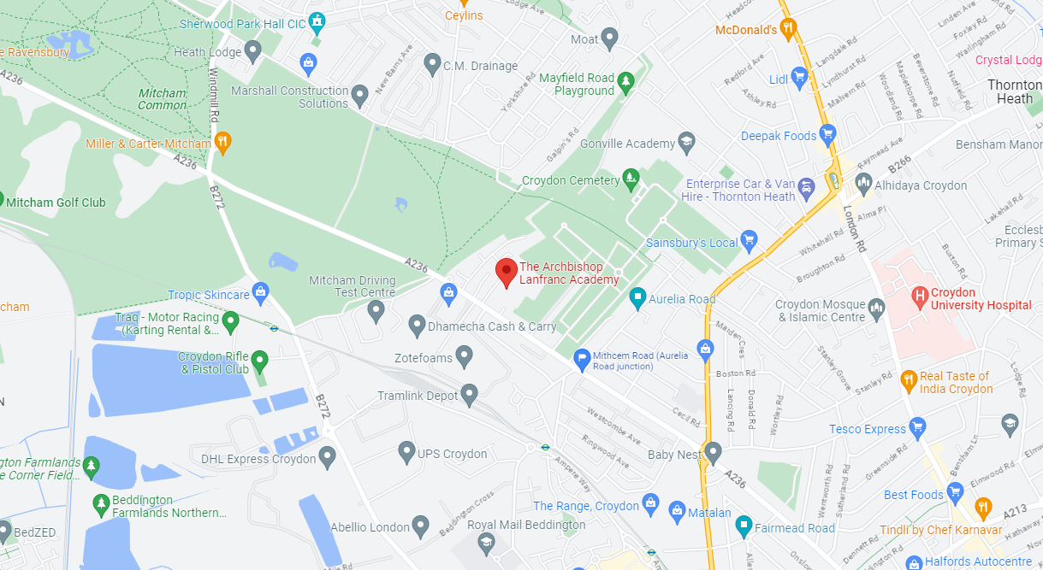

Bus Routes:
152, 255, 264, 455 and 463

Tramlink:
Therapia Lane and West Croydon
The Archbishop Lanfranc Academy
Mitcham Road, Croydon, CR9 3AS
020 8689 1255
office@lanfranc.org.uk
www.lanfranc.org.uk

