Therfield School
Excellence Leadership Opportunity

Teacher of Science Candidate Pack
www.therfield.surrey.sch.uk

Dear Candidate,

Thank you for showing an interest in our vacancy for a teacher of Science. We are seeking a teacher who is passionate about their subject area to join a highly successful department.

The Department takes a collaborative approach and values each individual’s skills, interests and strategies for teaching and learning. We welcome new ideas and look forward to the involvement of the person appointed in our on-going drive to raise standards even further.
The Department is well-resourced and we try to continually evaluate and develop the resources which we use in order to motivate and best meet the needs of all our students and staff. We believe that excellent teaching, using a variety of appropriate strategies, supports both behaviour and interest.

We value the professional development of the teachers within the department and encourage colleagues to widen their areas of interest and expertise. All staff are supported through the line-management system and the school has a well-respected induction programme for new staff.
If you have any further questions regarding the role or would like to arrange a school visit prior to applying please contact the school.
If you feel that you are someone who can join our fantastic group of staff and make a contribution to our thriving school community, then I encourage you to complete an application form.

James Malley
Headteacher

Information about the school

Therfield School is an 11-18 mixed comprehensive school situated in Leatherhead. The school currently has just over 950 students on roll and has been growing quickly in the last few years. We expect this to continue and to have over 1000 students in September 2021. The sixth form is also growing and our students have a strong track record of securing places at Oxbridge and Russell Group Universities.
We are ambitious for our students. That includes securing excellent academic outcomes, but also involves delivering on the commitment of our motto, “Excellence, Leadership, Opportunity”. To us, that means we have a duty to ensure that students leave us fully equipped to make a significant contribution to society and the wider world around them. That means our extracurricular opportunities are vital to our students’ development. 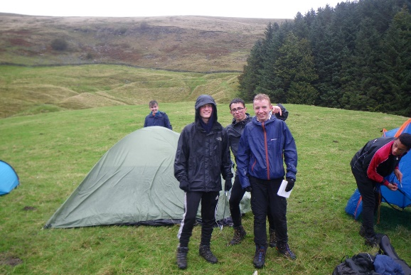
As well as running a variety of academic, sports, music and drama clubs, we are a lead participator in the Duke of Edinburgh Award Scheme. We also believe passionately in offering excellent residential trips with recent visits to Washington DC and New York, Iceland and a ski trip to Austria just some of the opportunities available to our students and staff.

There is a strong sense of collegiality amongst staff and a team ethos that new colleagues really appreciate and, we believe, is unrivalled in most schools. The continuing professional development programme is strong and this is showcased through a hugely successful “TeachMeet” every January, where colleagues across Surrey come together to share the very best pedagogical ideas and techniques. The welfare of our staff, and the demands of their workload, are very important to us and there is a strong staff association who provide a range of events for all colleagues.
We are part of a small multi academy trust (The South East Surrey Schools Education Trust) with two other Surrey secondary schools. This gives us strong opportunities for partnership work building on our inclusive values. We also benefit from close links with our feeder schools and other partner schools locally.

Our most recent Ofsted inspection took place in 2019 and we were very proud to receive the feedback below:-
- There are strong relationships between staff and pupils that underpin a positive atmosphere in which pupils want to learn.
- Pupils enjoy coming to school and told inspectors that teachers care about them and lessons are fun.
- In lessons, they work well together and are confident to express their ideas.
- Classes are orderly and pupils respond well to teachers’ requests. They set to work quickly and work very well together.
- Therfield is a friendly and welcoming school where inclusion really matters.
- The inclusive nature of the school means that staff go to great lengths to help pupils manage their behaviour and support their learning and development.
- The school is characterised by a nurturing and caring ethos.
- Parents appreciate the caring ethos and the efforts of staff to help their children succeed.
- Students behave well around the school and are friendly and polite to visitors.
- In class, inspectors saw pupils keen to learn and eager to be rewarded for their efforts.
- Staff know their pupils well and provide high-quality support to develop pupils’ learning.
- Leaders have ensured that there is a strong culture of safeguarding within the school.
- Pupils who responded to the online questionnaire, and those interviewed by inspectors, said that they felt safe in school.
- The rising number of pupils on roll is evidence that the school is gaining the confidence of the local community.
- Staff feel valued and empowered. One wrote, ‘There is an emphasis on staff happiness here that goes a long way.’

Job Profile – Teacher of Science

Purpose
To serve the aims of Therfield School by ensuring the highest quality of teaching and learning of Science by appropriate co-ordination, planning, monitoring, evaluation, and staff development.

Responsible to

Subject Leader – Science
Salary
TMS or Upper Pay Scale as appropriate
Key Accountabilities
- To teach Science within the age range 11 –18.
- To develop programmes of study, materials and schemes of work and participate in professional development programmes
- To follow school policies and procedures in respect of the duties of a classroom teacher and form tutor.
- To ensure the quality of provision for teaching and learning in Science
- To support the department with behavioural issues at all levels
- To critically evaluate the progress made by students at all levels
- To perform the duties of a Form Tutor as required
- To contribute to the cultural and community life of the school

Key Tasks
Teaching
- To form effective relationships with students, teaching staff, non-teaching staff, parents and other professionals
- To teach the National Curriculum and other programmes of study effectively, mindful of the needs and responses of the young and the school’s SEN policy
- To provide a stimulating classroom environment
- To foster good working and learning habits in students
- To regularly assess and record students’ work, progress and attainment
Curriculum
- To contribute to the planning of programmes of study and schemes of work appropriate to the needs of all students
- To keep abreast of professional and subject developments
- To participate in professional meetings and training programmes and to share the benefits with colleagues
- To participate in arrangements for CPD and Performance Management

Pastoral Care and Discipline
- To support the ethos of the school
- To perform the duties of a Form Tutor as a member of a Year Team
- To contribute to the life of the community according to your talents and skills
- To help exercise responsibility for the conduct and behaviour of students within the department and the school as a whole
- To participate in arrangements made for the supervision and safety of students between lessons and at the start and end of the school day
- To attend scheduled meetings with parents
- To record students’ progress
- To maintain an up to date teaching record/diary
- To assist as required with arrangements for public examinations
- To contribute to the evaluation and effectiveness of administrative routines

Meetings in which you will be involved
- Department meetings
- Year team meetings as relevant
- Whole staff meetings and staff briefings

Therfield School is committed to safeguarding and promoting the welfare of children and young people and expects all staff and volunteers to share this commitment
Personal Specification: Teacher of Science

 | Essential | Desirable
Education and Training | Fully Qualified Teacher or NQT | Additional qualifications or academic experience.
Curriculum Experience | Good knowledge of the current curriculum and related developments | Successful teaching across age and ability range (KS3 to KS5)
Pastoral Experience |  | Successful experience working with young people in a pastoral capacity (e.g. as form tutor, youth worker, voluntary work)
Personal Qualities | Reliable and trustworthy  Committed to teaching  Sense of humour  Calm under pressure  Able to work well in a team  Quick learner

Our Benefits
Continued Professional Development
A comprehensive programme of CPD is available to all staff staring with a broad induction program for all new staff.
NQTs and SCITTs take part in a yearlong planned programme of training
Annual TeachMeet developing and sharing practice from across Surrey
Career progression
We are committed to support the career development of all colleagues with programmes in place for aspiring middle and senior leaders.
Long standing record of career progression for colleagues
Financial
We offer competitive salaries at all levels, and fall within the London Fringe category. All staff have access to the Teacher’s Pension or Local Government pension Scheme.
Community
We also have a well-supported Staff Room Association which organises regular social events providing colleagues with the opportunity to mix outside of school.
Supportive and friendly staff group who will always go the extra mile for each other.
Good practice staff draw which encourages staff to recognise each other and build positive relationships.
As a member of the RFU we are allocated tickets for the 6 Nations and other major competitions, which are available for staff to purchase via a ballot.
We run a two week timetable with school finishing at 2.30pm every other Friday.
Family First
We are a supportive family centred school and adopt a policy where ‘no one misses their child’s nativity’
We have a comprehensive special leave policy which gives staff the opportunity to enjoy a successful work life balance
Location
Easy access to the M25 and bus and rail links. Leatherhead station, which is a 10 minute walk, is on the main lines from London Waterloo, Victoria, Guildford and Dorking.
Staff Welfare
We purchase a confidential Employee Assistance programme which is available to all staff 365 days a year, the service provides a team of trained wellbeing and counselling practitioners.
New staff have buddies assigned to be able to help them transition into the school and feel comfortable in the new surroundings.
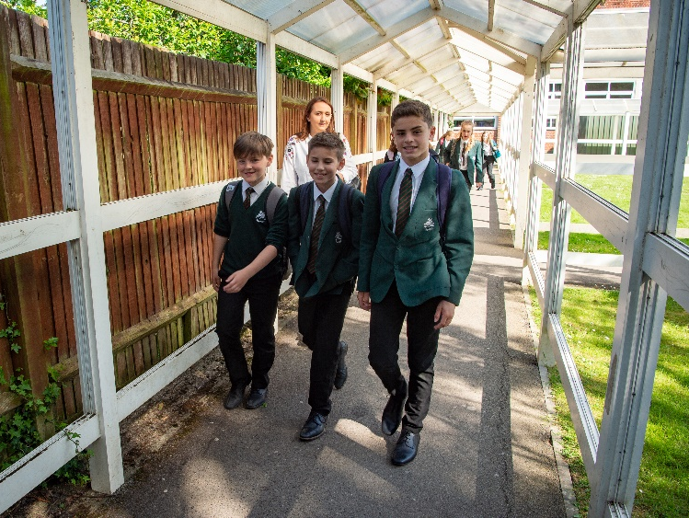

Therfield School - Dilston Road - Leatherhead - Surrey - KT22 7NZ
01372 818123
enquiries@therfield.surrey.sch.uk
www.therfield.surrey.sch.uk
@TherfieldSchool

