BISHOP HEBER HAS ANOTHER FABULOUS A-LEVEL YEAR in 2017!
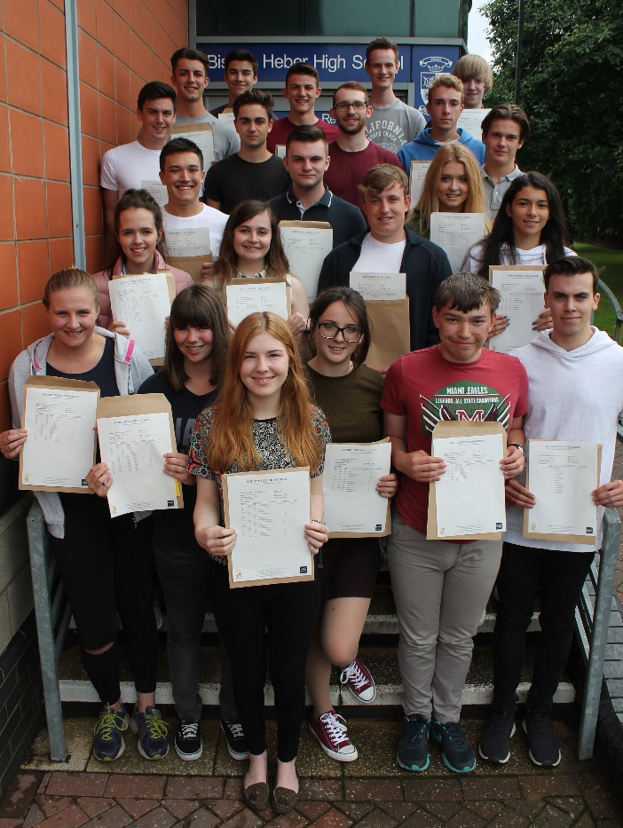
The publication of A-level results at Bishop Heber High School is once again a cause for celebration amongst students, staff and parents, with 60% of all grades awarded being A*-B and 12% A* grades. Furthermore, almost 80% of grades achieved were A*-C demonstrating once again that Bishop Heber is one of the leading comprehensive Sixth Forms in Cheshire. Many students will now be taking up their places at Universities across the country or in apprenticeship schemes, whilst others will be entering employment or taking gap years abroad. Performance across all subjects was impressive, but of particular note are Art, French, Geography, Maths, Further Maths, Government and Politics, Religious Studies and Sociology where over 75% of all grades achieved were A*-B.
The performance of the following students is particularly noteworthy. Jacob Sims (Whitchurch) achieved an impressive result of three A* grades and two A grades securing his place to study Engineering at Cambridge. Millie Thompson (Farndon) achieved three A* grades and one A grade and will be studying Architecture at Bath. Will Wright (Churton) gained three A* grades and will be studying Economics and Mathematics at Bristol. Alexander McCarthy (Whitchurch) will be studying Mathematics at Warwick having achieved two A* and two A grades. Kia Owen (Bersham) gained one A* and three A grades alongside an A grade in her Extended Project Qualification and is going on to study Philosophy, Politics and Economics at Oxford. William Farr (Malpas) successfully gained one A* grade and four A grades and will study law at Durham, while Rhian Barton (Farndon) with one A* Grade and three A grades and will be studying Chemical Engineering at Leeds.
Head Boy, Alex Burrage (Wrexham) who achieved two A* grades and one A grade will be going on to study Psychology at Bath, while Head Girl, Tilly Smith (Clutton) is going on to study Law at Bristol.
Other impressive results were achieved by George Morris (Gresford) gaining A*AA to study Sport and Exercise at Surrey, while Charlie Colville (Tattenhall) achieved three A* grades and will be going on to study History of Art at Warwick. Alice Odunaiya (Pandy) achieved three A grades and will study Business Management at Birmingham while Tabitha Payton-Edwards (Cross Lanes) achieved A*AA and will be studying Architecture at Newcastle.
Kieran Rose (Farndon) also gained A*AA securing a place to study Chemical Engineering at Loughborough and Charlotte Platt (Whitchurch), who achieved three A grades will be going on to study Fine Art at Chester. Eleanor Walley (Whitchurch) gained one A* grade and two A grades enabling her to take up her place studying Geography at Bristol. Ethan Wormley (Whitchurch) achieved three A grades and two B grades and will be going on to study Computer Science at Newcastle.
A conservable number of students also achieved impressive results gaining A*AB. Lillie Ford (Malpas) will study Architecture at Bath, Luke Perry (Farndon) will be studying Civil and Architectural Engineering at Bath, Benjamin Ross (Farndon) will be studying Chemical Engineering at Newcastle, Daniel Smith (Tarporley) will be studying Economics and Finance at Exeter and Tom Weaver (Malpas) will be studying English Language and Linguistics at Sheffield. Furthermore, a large number of students gained AAB grades. Ellie Cliff (Tattenhall) will study Biology at Nottingham, Nicholas Duffy (Tilston) studying Civil and Structural Engineering at Sheffield, Luke Harrod (Wrexham) will study Computer Science at Durham and Matthew Morgan (Malpas) will be studying Biomedicine at Lancaster.
The Headteacher, David Curry was delighted and commented “With all the recent changes in A-levels we are especially thrilled with the outstanding success of our students today. We are extremely pleased that so many of our students achieved their expected places at a wide range of Universities. Students have once again secured places at top/prestigious Universities such as Cambridge, Oxford, Bath, Bristol, Durham, Manchester, Newcastle, Sheffield, Leeds and Warwick, amongst others.
These achievements demonstrate yet again that the School continues to provide high quality education to students across Cheshire and the wider area, and more importantly, that students feel challenged and supported to achieve their very best. Bishop Heber High School is an established centre of excellence for A-level and these results again demonstrate the outstanding efforts of both the students and staff. Finally, I am sure that the students would also wish me to acknowledge the hard work and commitment of the teaching and support staff at Heber who work tirelessly to help students achieve the best results they can.”
“I would like to take this opportunity on behalf of all my colleagues and Governors at Heber to wish all ‘Leavers’ our best wishes for the future – please keep in touch.”
The Director of Sixth Form, Simon Woodward said that he was extremely proud of the effort our students have made during their time in the Sixth Form. “The success of our students is testament to their hard work and dedication. It is undoubtedly a product of the excellent working relationships between staff and students, alongside the tenacity and resilience our students have shown in the pursuit of their chosen next steps. We wish all our students continued success with every endeavour in the future.”

