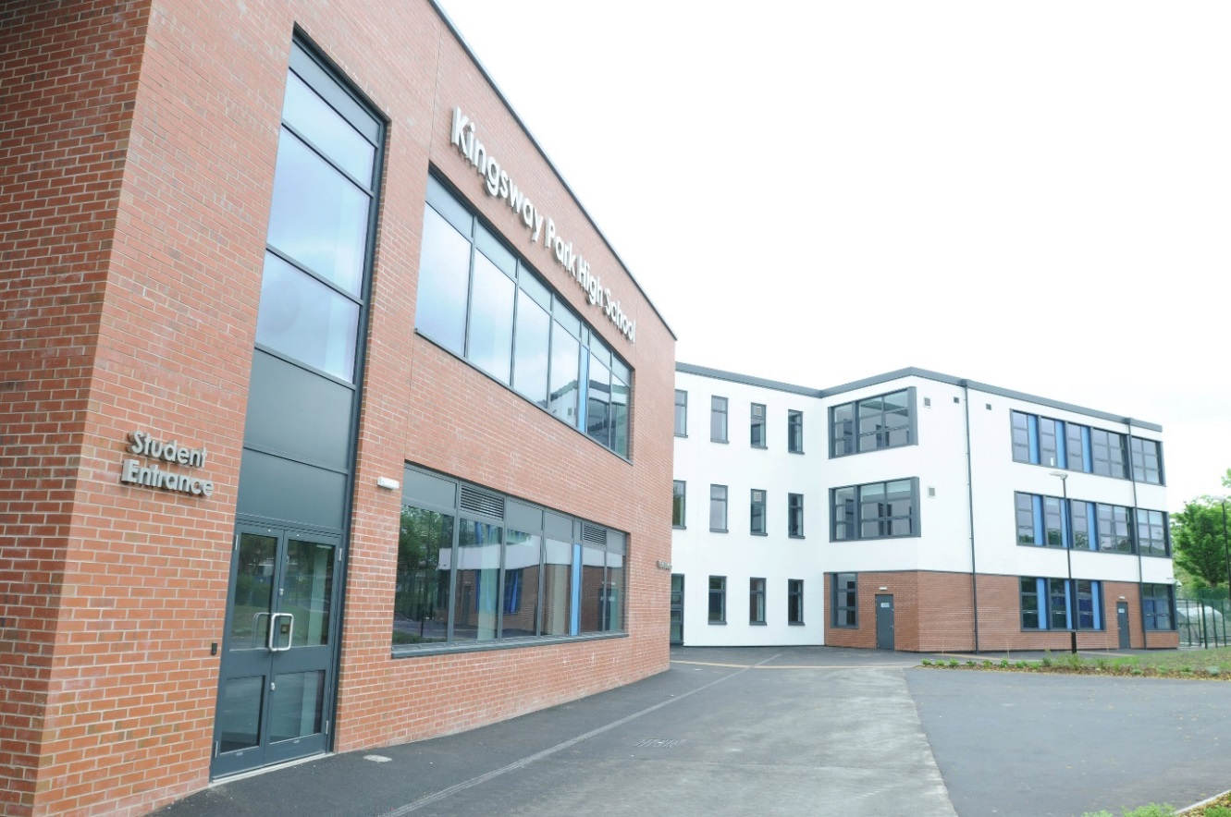

Teacher of Maths

Candidate Information Pack

Contents

Welcome and Introduction ………………………………………. 3
Background Information ………………………………………. 4
Kingsway Park High School Vision ……………………………………… 4
Making your Application ………………………………………. 5
Job Description & Overview ………………………………………. 6

June 2017

Dear Colleague

I am delighted to provide an application pack for the role of Teacher of Maths at Kingsway Park High School. This is a very important role at Kingsway Park High School and securing a high quality candidate is crucial. The appropriate training and support will be put in place for the successful candidate.
Our school motto is Aspire, learn, achieve which encapsulates the whole vision for Kingsway Park High School. We want to create learners that want to and have a desire to do well, know where they are going and what they have to do to get there.
We expect at all times a “Can do” attitude and we want all staff and students to be PROUD and have PRIDE in everything they do, day in and day out. We are a forward thinking, reflective learning community. We want all our staff to inspire, motivate and encourage our students to excel in their learning, behaviour and achievements.
I am very proud to be the Headteacher at Kingsway Park High School.
The appointment and retention of the right staff is crucial and we have a strong commitment and belief in developing staff at all levels. There is a high quality induction, appraisal and staff development programme for all.
Finally, if after reading all of the contents of this pack you wish to apply for the post advertised then I would like to take this opportunity to thank you for your application, investment of time and whatever the outcome, I wish you well in the future.
Yours faithfully

Deborah Ball Headteacher

Background information

Kingsway Park High School opened as a new school in September 2010 due to the closure of two neighbouring schools (Springhill High School and Balderstone Technology College).
There are presently around 1000 students (Yr7 – 11) and 160 staff who attend or work at the school. In September 2013 the school moved permanently into the new facilities on the Turf Hill Road site. The facilities, resources, learning and working environment are outstanding.
In September 2013, the school had a full OFSTED inspection and was awarded GOOD in all categories (Achievement, Leadership & Management, Student Behaviour, Teaching & Learning). The report is available to view on
http://www.ofsted.gov.uk/inspection-reports/find-inspection-report/provider/ELS/135795
The school is also part of the Rochdale Pioneer Trust. This is a consortium of all of the secondary schools, colleges and special schools in Rochdale. The purpose of the Trust is to raise and monitor standards of achievement and educational provision across ALL of the schools in Rochdale and it is supported by the use of external HMI’s to “inspect schools” and identify key priorities for strengths and areas of development. Each educational establishment has 2 Pioneer Trust visits per year and a detailed report with action points is created for each school. This then allows schools across the Borough to share good practice/expertise and broker external support if needed. It also drives up school improvement and self-evaluation across the local authority.

Our Vision

At Kingsway Park High School we believe it is important to foster in all of our students characteristics, values and habits that will last them for a lifetime and prepare them for their future. All students need to have determination, optimism and be emotionally intelligent. They all need to have the desire and determination to achieve success.
All staff/students at Kingsway Park High School need to be PROUD and have PRIDE in everything that they do within school. We constantly strive to improve our performance in everything that we do. Attention to detail is paramount and we strongly believe, it’s the little things that really matter.

Making Your Application and the Assessment Process

I hope that having read this pack you are inspired to apply for the post. If you are, then this is what you need to do:-

Application
Complete the application form and send it either by email to ksmith@kingswaypark.org or post to:-

Karen Smith – PA to Headteacher
Kingsway Park High School
Turf Hill Road
Rochdale
OL16 4XA

Salary Scale: £22, 467 - £38,250

The deadline for this post is 9.00 AM on 20th June 2017.

If you wish to discuss any details regarding the post or you wish to make an appointment to visit the school please contact Karen Smith on 01706 716761.

Job Description & Overview

The Maths Department is a large, highly successful and well-respected department within school. Staff within the department are hardworking, committed and forward thinking. There are fantastic opportunities within the department for professional development, collaborative working practices and developing high quality teaching. The department is well resourced.
The successful candidate will have a significant role in being part of a successful and passionate Maths department.
We are seeking someone who has a real passion for Maths. It needs to be someone who has high expectations of themselves and others. It needs to be someone who will “go the extra mile”
The successful candidate will have a high quality induction programme in order to support their professional development needs.
This post is suitable for a newly qualified teacher or an experienced teacher who wishes to have a new challenge in a new school.
To start in September 2017 or January 2018 and a recruitment and retention point will be available for a suitable candidate.

