January 2018

Dear Applicant

Role: Early Years Practitioner – Full time
Start: ASAP

Thank you for your interest in the above post. Please find enclosed information about our school, the personnel specification and job description.

The deadline for applications is Friday, 25 January 2018 at noon. We will be inviting candidates for interview week beginning 28 January 2018.

You are very welcome to look around the school prior to making your application. Please contact the school office to arrange a visit.

We look forward to receiving your application.

Yours sincerely
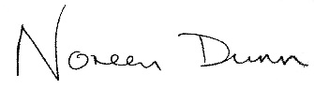

Noreen Dunn
Executive Headteacher

