Bury Grammar SchoolS

MFL TEACHER

SEPTEMBER 2018

APPLICATION PACK



Bury Grammar Schools
The Bury Grammar Schools are a family of independent, selective, day schools for girls and boys aged 3 to 18, which combines a strong tradition of academic excellence with the best of modern educational practice. The Schools are situated in the heart of Bury and are widely recognised as one of the top independent schools in the North West of England. In all, there are five Schools in the Bury Grammar Schools Foundation; a Senior Girls’ School, a Senior Boys’ School, a Junior Girls’ School, a Junior Boys’ School and a co-educational Infant School and Nursery. Currently there are over 1,300 girls and boys on roll, most living in the town of Bury, its suburbs and the surrounding area of North Manchester, including towns such as Bolton and Rochdale.

Exam results are very strong. In 2017 a truly impressive 65% of Bury Grammar School Girls GCSE grades were at the coveted A*/A level, and an astonishing 90% of grades were at A*-B. They also say a 100% pass at A Level examinations; 28% of grades were at the elite A/A* level, 64% of grades were at A* to B. In the Boys School they are also celebrating another successful year of GCSE results with a phenomenal 44% of grades at the coveted A/A* level. In A-levels they also excelled with a stunning 45% of grades at A*/A (set against a national average of 26%) and 71% of grades at A* - B

Both schools have been rated as Excellent by the Independent Schools Inspectorate and are proud of the outstanding standard of education provided.

As an employer we are focused on creating an outstanding place for all our staff to work so that we can attract, retain and engage talented individuals, who have a desire to transform the lives of others.
More information regarding the Schools and their history can be found on our website at http://burygrammar.com.

Our Facilities
The Bury Grammar Schools date back to 1570 but the current campus was established in 1903. The Schools later expanded in the 1950s and 1960s when a new Boys’ School was constructed and since then several fantastic new buildings have been added across the campus, the most recent being a brand new joint Sixth Form centre which was opened in November 2014 and Boys Sports Complex which opened in September 2016. We continually strive to improve our facilities and give our staff and pupils the best possible environment to work and learn in.

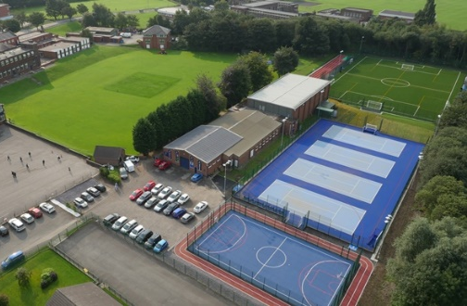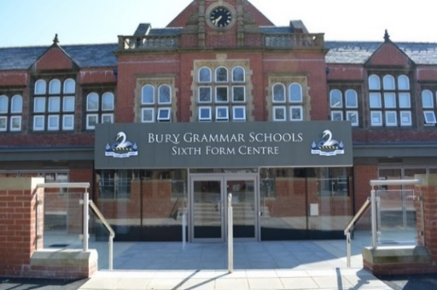
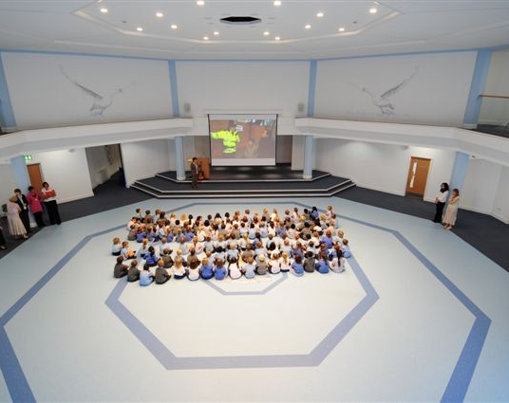

The Post

We are seeking to appoint, from September 2018, an inspiring and enthusiastic MFL Teacher to join a friendly and successful department. The successful candidate will be an outstanding teacher, passionate about their subject, and willing to contribute to the wider life of a busy day school.

Please note that although this post is currently based in the Girls’ School at Bury Grammar Schools, you may be required to teach and work in either the boys or the girls school.

The Department

The Modern Foreign Languages Department at Bury Grammar School Girls is a highly achieving department who encourages pupils to explore different cultures and instills a love of language learning. We offer French, German and Spanish to GCSE and A level. In Year 7 pupils study French and choose either German or Spanish in Y8. Our department is staffed with language specialists and native speakers. We are well resourced with modern equipment and an excellent range of teaching resources and authentic material. Girls are encouraged to speak in the target language and also have contact with Foreign Language Assistants to further nurture their linguistic abilities.
Our varied extra-curricular programme includes MFL Film Club, Lingua Karaoké and le Café français for AGT students. For the first time in 2016 we introduced "Linguastars", a course run on two Saturday mornings which aims to introduce Year 6 pupils to different languages. Whilst having a lot of fun, the participants learn phrases to impress on holiday and improve their understanding of different cultures.
The MFL department prides itself on its organisation of many school trips. We organise one of the longest running exchanges in the country with Köln Deutzer Gymnasium in Germany. We run exchanges to Dijon, France and Daimiel, Spain and also run annual trips to Berlin, Madrid and Geneva.

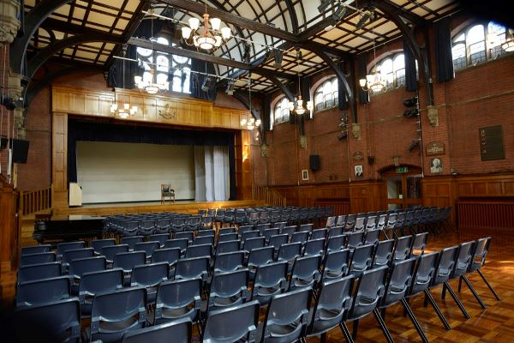


Salary and Benefits
The starting salary will be dependent on experience.

- All individuals who join Bury Grammar Schools will automatically become members of the Teachers’ Pension Scheme unless they decide to opt out of the Scheme.
- Fee remission will be offered for children to attend Bury Grammar Schools from reception onwards; children of staff must meet the academic requirements of the School
- Childcare voucher scheme
- Free use of after school club for children who are pupils at the Schools between set times.
- Daily lunch allowance at the School canteen.
- Free parking on-site
- Training and Development Opportunities will be offered.

Guidance Notes for Applicants
We advise you to read carefully all available information for this job before you start completing the application form. This pack includes a job description and a person specification which details the skills, qualifications and experience which are required for the job.

All shortlisting decisions will be based initially on essential criteria. We interview those candidates who are the closest match to the identified criteria.

Rehabilitation of Offenders/ Disclosure and Barring Service
A criminal conviction will not necessarily be a bar to employment. The Bury Grammar Schools (BGS) comply with the Disclosure and Barring Service’s Code of Practice and will consider the suitability of all applicants on merit and ability.

The Rehabilitation of Offenders Act 1974 entitles people who have been convicted of a criminal offence carrying a sentence of up to 30 months' imprisonment and who have completed the appropriate period of rehabilitation to regard their conviction as 'spent'. 'Spent convictions' can then be regarded as never having occurred.

The Rehabilitation of Offenders Act 1974 (Exceptions) Order 1975, however, exempts certain types of employment such as working in a school from the provisions of the Act. In addition, the Police Act 1997 requires Police checks for all posts that come into contact with under 18s and vulnerable adults on a regular basis. Appointment to this post will require the post holder to undergo checks by the Disclosure and Barring Service before commencing any duties which could bring them into contact with children.

Any information disclosed will be kept in strict confidence and used only in consideration of your suitability for the job for which you are applying. If you fail to disclose relevant information requested at any stage of the recruitment process, then your employment could be subject to withdrawal of contract, dismissal or disciplinary action in accordance with Bury Grammar Schools policies.

Application Form
Please complete all sections of the application form. If a section does not apply to you, please just write 'not applicable' in the box.

Incomplete forms and CVs sent without an accompanying completed form will not be accepted.

Applications for the role will only be accepted from those who complete application forms. CVs will not be accepted in substitution for completed application forms.

If you need to attach a continuation sheet to any section, please ensure that your full name is included at the top of the page. NB: If you are planning to submit your application electronically, all documents, including any attachments, must be sent in Microsoft Word format.

Evidence of permission to work in UK
Prior to being permitted to commence employment with BGS, you will be required to produce documentary evidence of permission to work in the United Kingdom. You could provide, for example, either a British passport or a passport or National Identity Card from an EEA Country or Switzerland; alternatively, a document showing your permanent UK National Insurance Number and your full UK Birth Certificate.

A full list of acceptable documentary evidence is available on request. Original documents must be seen before you start working for BGS.

For further information, please refer to the Home Office website www.bia.homeoffice.gov.uk.

Useful information on living and working in the UK can be found at www.britishcouncil.org/eumobilitv

Employment
Please give us details of your complete work history since leaving school/tertiary education. This should include information on your current and past employers, job title, dates employed and salary. Please explain any breaks in employment when detailing your full work history.

In your accompanying letter, you need to demonstrate clearly how your experience, knowledge, skills and abilities match those required in the job, as detailed in the Person Specification. Where possible you should give examples of when you have used specific skills and abilities or needed to develop competencies in the relevant areas. You can draw on elements from any aspect of your life, such as education, work, home or community life, as long as you focus on its relevance in comparison to the needs of this job.

References
Please give details of 2 referees who can comment on your suitability to do this job. At least one reference must be from your current or latest employer and your references must cover your last three years of employment. It is BGS policy to request references prior to interview. If you do not wish for your current or latest employer to be contacted before the interview, then please make this clear on the application form. BGS reserves the right to contact your current or latest employer following the interview and prior to offering a contract of employment.

In providing the names of referees, you are agreeing that the Bury Grammar Schools may ask their opinions on your character in relation to this application. These opinions, given in trust, will remain confidential.

General
If you do not receive an invitation to interview within four weeks of the closing date, then you may assume that your application has been unsuccessful.

By signing and returning our application form you consent to Bury Grammar Schools using and keeping information about you provided by you, or by third parties such as referees, relating to your application or future employment. In the case of unsuccessful candidates this information will be retained for six months from the closing date. Information provided by successful candidates will be transferred to their personnel file.

How will we keep your information secure?
Personal and Monitoring information is treated as strictly confidential and will be dealt with in accordance with the Data Protection Act (1998) and our Data Protection Policy.

Whom can I contact if I need help in completing the form?

Please contact us via email at vacancies@burygrammar.com

Please send your completed application to: vacancies@burygrammar.com

Closing date for applications: 12 Noon on Monday 5th February

Safer Recruitment

The Bury Grammar Schools operate an equal opportunities policy, and are committed to safer recruitment and safeguarding pupils. Any appointment will be subject to successful DBS clearance, satisfactory references and confirmation of medical fitness for the post.

Thank you for your interest in a role at Bury Grammar Schools.



Job Description: Modern Foreign Languages Teacher
Reporting to: Headmistress

The following duties shall be deemed to be included in the professional responsibilities which you may be required to perform:
1. Teaching
- planning and preparing courses and lessons;
- teaching, according to the pupils’ educational needs, the pupils assigned, the setting and marking of work (including examinations) to be carried out by the pupils in School and elsewhere;
- assessing, recording and reporting on the development, progress and attainment of pupils.
- providing additional support as may be needed to best meet the educational needs of pupils.
2. Supporting learning
- promoting the general progress and well-being of individual pupils and of any class or group or pupils assigned;
- providing guidance and advice to pupils on educational and social matters; making relevant records and reports;
- being a Form Tutor, if required, and carrying out the duties expected to fully meet the requirements of such a role;
- making records and reports on the personal and social needs of pupils;
- communicating and consulting with the parents of pupils;
- communicating and co-operating with persons or bodies outside the School;
- participating in meetings arranged for any of the purposes described above;
- accompanying pupils on trips away from the School;
- contributing to the extra-curricular life of the School;
- attending School functions;
- participating in assemblies;
- contributing to the maintenance of a stimulating working environment in School;
- upholding the ethos and high standards of the School and abiding by the rules laid down by the School from time to time.
3. Assessments and Reports
Providing or contributing to oral and written assessments, reports and references relating to individual pupils and groups of pupils.
4. Appraisal
Participating in any arrangements that may be made for teacher appraisal.
5. Review: further training and development
- reviewing from time to time methods of teaching and programmes of work;
- participating in arrangements for professional development.

6. Contributing to academic provision
Advising and co-operating with the Headmaster/mistress, Head of Department and other teachers on the preparation and development of courses of study, schemes of work, teaching materials, teaching programmes, methods of teaching and assessment or pastoral arrangements.

7. Syllabus
Teachers are responsible for ensuring that they teach the correct public examination syllabus offered at BGS in their subject in accordance with School policy. Teachers should be aware of any subject area developments outside the School and where appropriate bring them to the attention of colleagues.
8. Discipline, health and safety
Maintaining good order and discipline among the pupils and safeguarding their health and safety both when they are on the School premises and when they are engaged in authorised school activities elsewhere.
9. Staff Meetings
Participating in meetings at the School which relate to the curriculum for the school or the administration or organisation of the School, including pastoral arrangements.
10. Public Examinations
Participating in arrangements for preparing pupils for public examinations and in assessing pupils for the purposes of such examinations, recording and reporting such assessments; and participating in arrangements for pupils’ presentation for and supervision during such examinations.
11. Administration
- participating in administrative and organisational tasks related to such duties as are described above, including the management or supervision of persons providing support for the teachers in the School and the ordering and allocation of equipment and materials;
- registering the attendance of pupils and supervising pupils, whether these duties are to be performed before, during or after school session or lunch times, evenings, weekends or cover for absent colleagues.
12. Duties
Undertaking supervisory duties as assigned according to the custom of the School.
13. Time table
The School may alter the weekly time table from time to time depending on amongst other things the School roll.
Other Duties

Other duties as may be assigned from time to time by the Headmaster/mistress

General Duties
• Work flexibly to meet the Schools requirements including on occasion working in other departments as directed by your line manager. This requirement is likely to be particularly relevant during holiday periods as well at key events in the School calendar where you may be expected to work evenings or weekends.
• Comply with all School policies and procedures. Within these boundaries, staff are expected to use initiative to resolve problems and address issues.
• Be committed to safeguarding and promoting the welfare of children at all times
• Ensure the quality standards and performance measures applying to your area of work are met and facilitate continuous improvements in all aspects of the post.
• Maintain a safe environment by working within Health & Safety guidelines and being aware of your responsibilities for health and safety.
• Value diversity and promote equal opportunities
• Comply with GDPR and data protection legislation and relevant policies and procedures where applicable.
• Participate in appraisal activities as required. Undertake further training as needed to ensure up to date knowledge and implementation of best practice.
• All Bury Grammar Schools’ employees are expected to act as ambassadors for the Schools and promote the organisation and its services positively as well as behave in a manner consistent with the Schools’ Values at all times.
• Undertake any other duties and tasks appropriate to the grade and character of work as may reasonably be required.
The details contained in this job description reflect the content of the job at the date the job description was prepared. However, over time, the nature of individual jobs inevitably change; existing duties may be lost and other duties gained without changing the general character of the duties or the level of responsibility entailed. Consequently, the Schools will expect to revise this job description from time to time and will consult with the job holder in so doing.
Person Specification: MFL Teacher

 | Essential | Desirable
Good honours degree | Y
Teaching qualification | Y
A real academic interest in their subject | Y
An understanding of assessment for learning | Y
An understanding of the impact of quality feedback | Y
An interest and understanding of pastoral care | Y
A willingness to undergo appraisal and continual professional development | Y
Willingness to contribute to extracurricular activities | Y
Ability to coach a sport |  | Y
A willingness to work as part of a team | Y
A sense of humour | Y
Understanding of child-safeguarding issues and successful measures that promote and ensure the safe-guarding of children | Y
Knowledge of current legislation, guidance and developments relating to the subject area. | Y
Successful practice in accordance with the specified teaching standards 2012 (as identified below) | Y

