

JOB DESCRIPTION

JOB TITLE: Lecturer – Construction – Brickwork

REPORTS TO: Head of School – Construction

AREA: Construction

GRADE/SALARY: Lecturers Scale, points 6 to 14 £28,986 to £39,562 per annum
Level 5 Teaching Qualified up to £43,572 per annum

POST NO: LB032

CLOSING DATE: Sunday 30th June 2024

DBS: Enhanced DBS check with children’s barred list check _______________________________________________________________________

PURPOSE:

To promote the efficient running of a successful provision at the Woodlands Campus by providing teaching, training and assessment to learners working in the Centre across a range of construction and related qualifications. This post will also support teaching at the Stratford-upon-Avon Campus if required.

PRINCIPAL DUTIES:

    - To deliver the curriculum by using a variety of teaching methods in order to ensure
effective learning.

    - To act as course tutor.

    - To ensure that employability and employer engagement activities are embedded
into the programmes.

    - To support community/personal enrichment activities (including trips related to
learning).

    - To prepare schemes of learning, lesson plans, assignment schedules, learning
materials and student assignments.

    - To mark students’ work with developmental feedback.

    - To participate in curriculum development activities.

    - To participate in the recruitment of students and the student admissions process.

    - To represent the College at internal and external events and meetings.

    - To be proactive in maintaining and developing quality standards, including internal
verification, on all programmes and demonstrate a commitment to quality improvement.

    - To continually maintain, undertake and meet any relevant CPD requirements.

    - To liaise with parents/guardians.

    - To undertake general administration relevant to the role.

    - To embed sustainability within the curriculum.

    - To adhere to policies, procedures and values of Solihull College & University
Centre.

    - To undertake all mandatory training in a timely manner as required
e.g.Safeguarding, Prevent.

    - To actively promote equality, diversity & inclusion and to champion anti-racist
practice.

    - To support the college to become a Sustainable Net Zero organisation by 2030
and support the delivery of its Sustainability Strategy.

    - To undertake necessary Health and Safety responsibilities, duties and training as
required by this post.

    - To undertake any necessary Data Protection responsibilities, duties and training
as required by the post.

    - Such other duties as required which are broadly consistent with the general
functions and grading of this position.

EQUAL OPPORTUNITIES:

Solihull College & University Centre is committed to a comprehensive policy of Equal Opportunities. All employees are required to abide by this policy and ensure its compliance throughout the College.

SAFEGUARDING:

Solihull College & University Centre is committed to ensuring a safe environment for all students and expects all staff to engage fully to this commitment.

CORE VALUES:
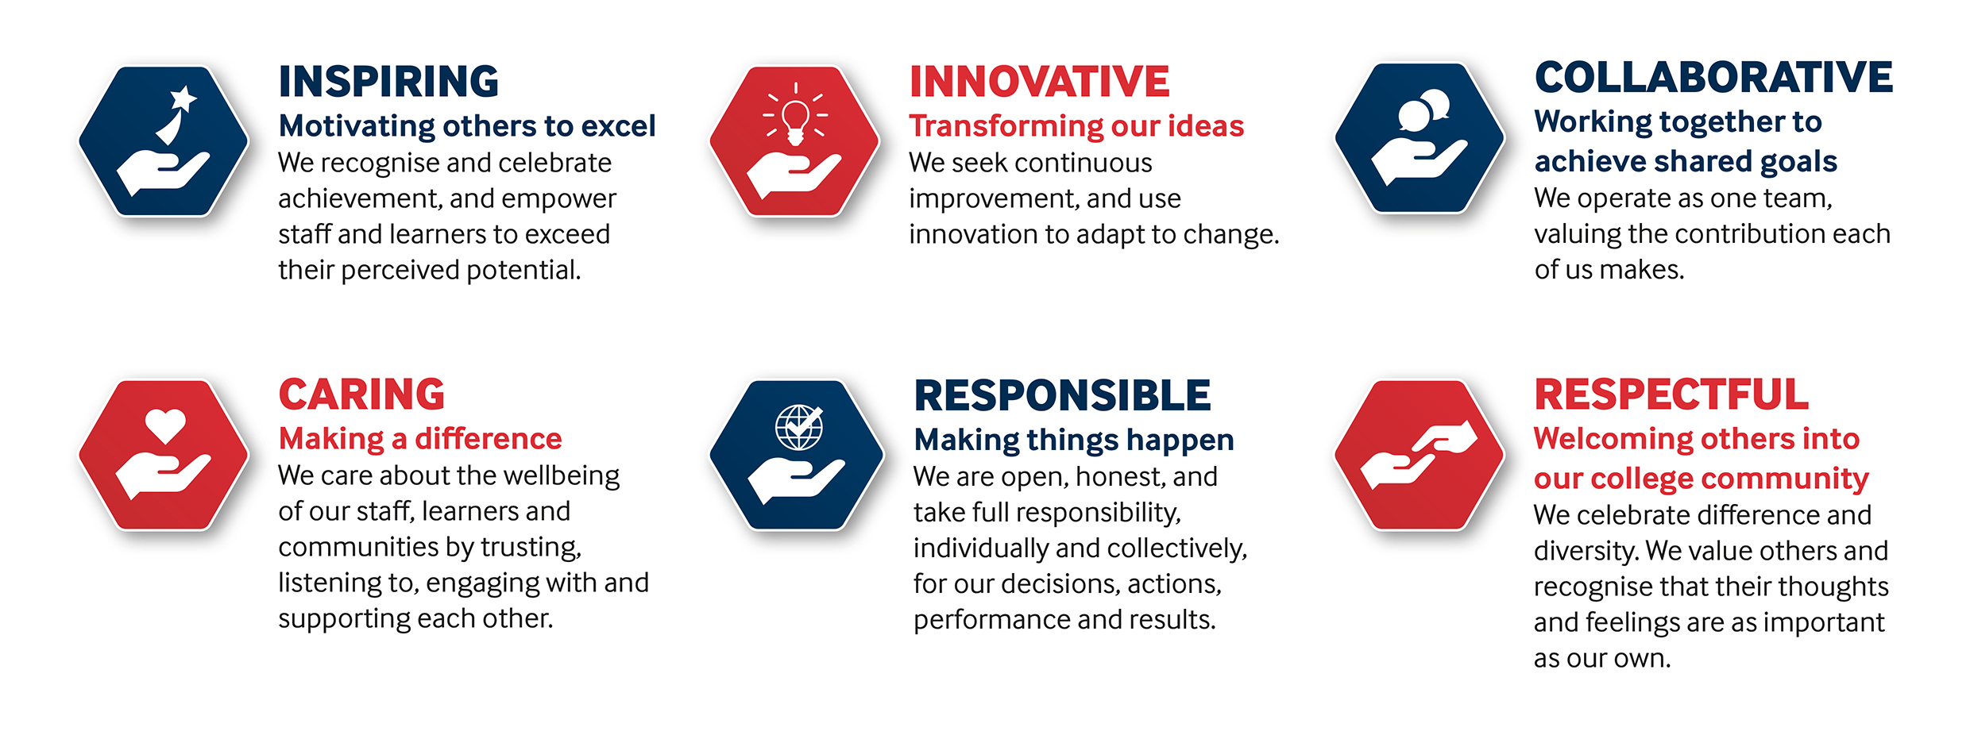

SOLIHULL COLLEGE & UNIVERSITY CENTRE

PERSON SPECIFICATION

JOB TITLE: Lecturer – Construction – Brickwork

SALARY: Lecturers Scale, points 6 to 14 £28,986 to £39,562 per annum
Level 5 Teaching Qualified up to £43,572 per annum

POST NO: LB032

SPECIFICATION | ESSENTIAL | DESIRABLE
EDUCATION /  TRAINING | Level 5 teaching qualification (or willingness to work towards)  Level 2 qualification in Bricklaying  Level 2 qualification in English and Maths (or willingness to work towards) | Level 3 Assessor Award (or equivalent)  Level 4 Verifier Award (or equivalent)  Qualification or experience in other construction trades
RELEVANT  EXPERIENCE | Proven experience of working within the Construction Industry covering appropriate skills | Proven experience of teaching and/or training  Experience of teaching in Further Education  Experience of working with 14 – 19 year olds  Experience in teaching BTEC Level programmes in Construction
SKILLS /  APTITUDES | Dynamic and innovative approach  Works well within a team  Strong commitment to The College values and to learners  Able to demonstrate pro-activeness  Flexible, adaptable and reliable  Ability to cope positively with change  Resilient  An awareness of sustainability and climate change and how it applies to FE and can be embedded into the curriculum
OTHER  REQUIREMENTS | Willingness to contribute to curriculum development and co-ordination  An appreciation of teaching and learning best practice  Willing and able to travel between sites  Committed to personal and professional development  Strong commitment to Equal Opportunities  An understanding of the needs and challenges of teaching a range of students  A commitment to the Safeguarding of Young People and Vulnerable Adults and an awareness of the Government ‘Prevent’ strategy | General awareness of cultural diversity

