Rokesly Avenue
London
N8 8NH
Bola Soneye-Thomas
Head Teacher
Tel: 020 8348 0290
Fax: 020 8342 8410
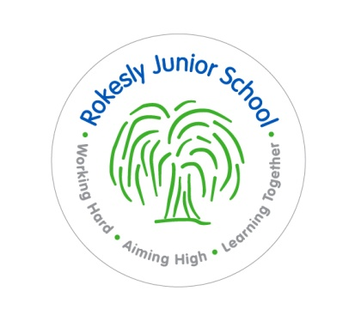
www.rokeslyschools.org.uk

Teaching Assistant Required

Rokesly Junior School is a very good school with enthusiastic, highly motivated and happy children who are keen and eager to learn.

We are seeking to appoint a teaching assistant to help teachers in a range of duties and to support the educational needs of identified pupils in the classroom, with a particular emphasis on literacy and mathematics. Experience of working with pupils with SEND and experience of personal care would be desirable.

We are looking for someone who:

- has good literacy and numeracy skills;
- has high levels of enthusiasm and a commitment to helping pupils to succeed;
- has good organisational and communication skills;
- is a good team player;
- will be committed to the school and will contribute to all aspects of school life.

We can offer:

- a friendly and supportive staff within a welcoming school environment;
- strong governor and parental support;
- ongoing professional development.

Please contact the school office on 020 8348 0290 for further details and an application pack.

Closing date: Noon Tuesday 19th March 2019
Interviews: Thursday 21st March 2019

Please note that there will be a written test as part of the interview process.

Rokesly Junior School is committed to safeguarding and promoting the welfare of children and young people and expects all staff and volunteers to share this commitment.

