Sanders Draper
Resilience
Achievement
Family
Maths Teacher
Recruitment pack

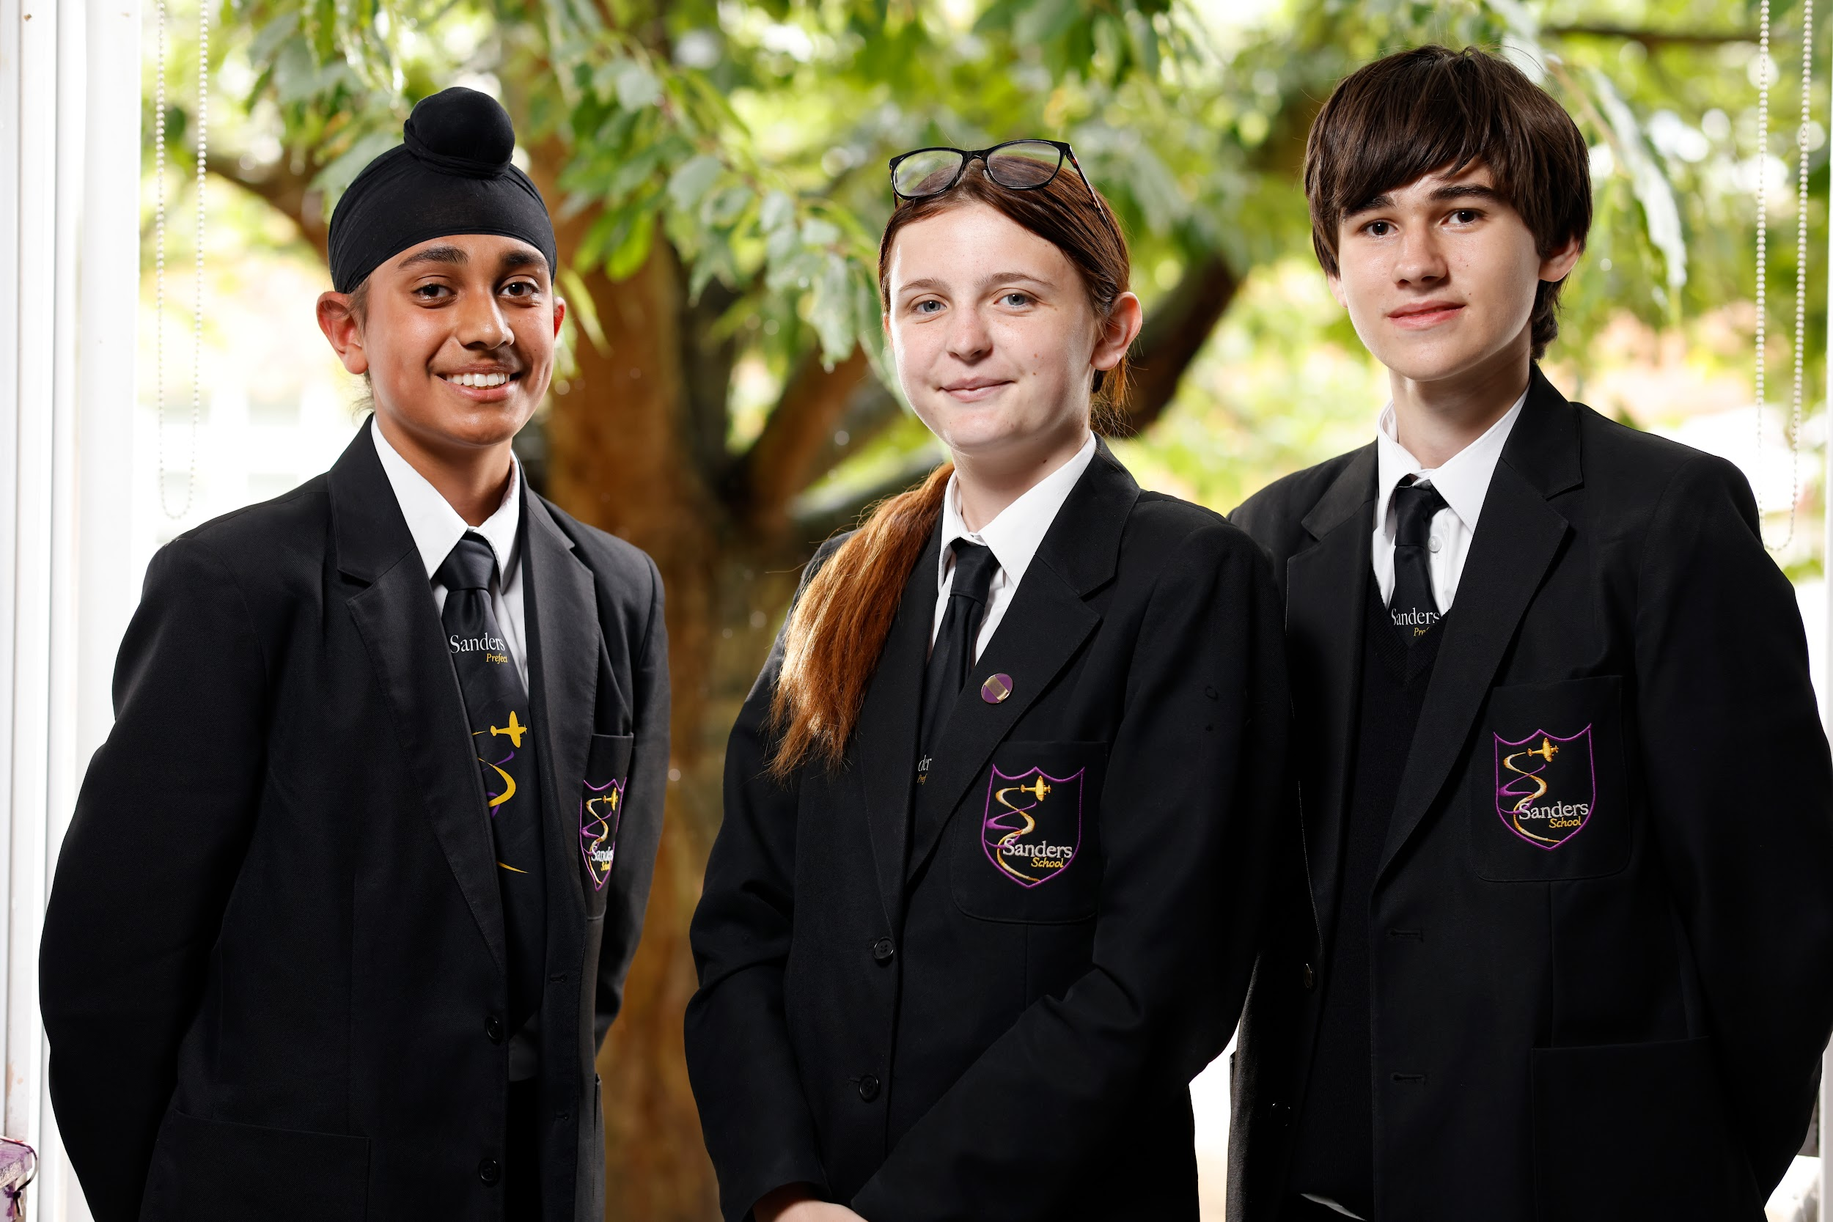

“Pupils are happy and safe, Pupils valued their small school community where they are well known by staff and their peers. Staff have high expectations of pupils’ work and conduct. Older pupils are positive role models for younger ones... The school is a calm and orderly environment… There is a zero-tolerance approach to bullying or discriminatory language in the school… Leaders have planned an ambitious curriculum for all pupils.”
Ofsted Jan 2023




‘To be the best I can be’

Welcome From the Headteacher

We are delighted that you have expressed an interest in our school and we offer you a very warm welcome to Sanders Draper. Thank you for taking the time to consider joining our passionate team of staff at Sanders Draper part of the Success for All Educational Trust (SFAET). We share the Trust vision of ‘Commitment to Success for All’ and work hard as a team to ensure our students develop the skills that will enable them to achieve the very best at every stage of their life.

Sanders Draper has a very unique history and you’ll read more about this further in this pack. We believe strongly in being the best I can be, by being true to our values of Resilience, Achievement and Family. If you were to ask a parent why they chose Sanders for their child, they would tell you how the focus here is on the development of the whole child. Sanders strives for academic success as well as offer a range of opportunities beyond the classroom and throughout providing excellent pastoral care. We understand the importance and role that a school plays within the local community. Our students play an increasing role looking to give back positively to Hornchurch and Havering.

Our students are amazing and have a real thirst to grow, develop and be challenged. We provide many opportunities for them to use their voice and also represent Sanders; for example, classroom ambassadors, House Captains, Student Prefects, Student President, Sports Captains/Leaders, on the sports field, the stage in the school play or in the many opportunities to play music.

We are committed to improving outcomes for all students and focus on high quality teaching and learning to ensure the best possible progress for every student. Our Partnership with The Redden Court School (Outstanding), The Royal Liberty School (Good) and Rise Park (Good) affords us fantastic opportunities to collaborate and share best practice at secondary and through the transition to secondary school. Together we are passionate about raising educational standards across Havering.

Sanders Draper has been and continues to be a journey to becoming an outstanding educational establishment, we are relentless in our pursuit of this and it has been noted and commented on by Ofsted, external audits and is very noticeable with how oversubscribed we have become; in Year 7 we have more students listing us as their first choice school alone than places we have available.

We are driven by our belief that every student is capable of achieving great things and that through our belief in them. We also understand the importance of working with home in partnership illustrating. We have a balanced CPD programme which offers a mixture of department time, staff designed training-matix covering a range of aspects of note for staff/departments and whole school CPD program. Additionally we offer support to staff at all levels to develop and experience opportunities to progress their careers within Sanders and the Trust. You can read further about our recent ‘Good’ Ofsted inspection on our website.

Staff well-being is vitally important and we offer a range of services for all staff in the school to access. Visitors to our school are always impressed by the atmosphere at Sanders and the real passion and pride students have for the school. I would welcome you to visit us to see this for yourself, meet some of our amazing students and staff and get a true taste of Sanders. Thank you again for expressing an interest in joining Sanders Draper.
Mr Brooks, Headteacher

ADVERT

Maths Teacher
Equivalent - MPS (Outer London)
Required for September 2025
Permanent position, full time

We seek to appoint an outstanding teacher to join our Maths Faculty . The successful applicant will be instrumental in contributing towards the continued development of our faculty as we strive for excellence. The successful applicant will be part of a team that ensures high quality first teaching and targeted student intervention programmes which lead to excellent student progress. This post would be ideal for either a strong ambitious and aspiring teacher or a qualified and experienced teacher. The faculty is a strength of the school and there is real expertise and passion within the area. The faculty work well as a team and can offer a supportive and happy environment that both staff and students enjoy.

About Us: Sanders Draper is a thriving and highly ambitious secondary school which is oversubscribed and has students in years 7-11. With a proud rich history and traditions, our school sits at the heart of the community. We are an Ofsted-rated Good school with a passionate and caring staff body. As part of a local Trust, we prioritise creating a safe and nurturing environment where students feel valued and supported.

Overview: We seek a dedicated Teacher to join our Maths team As a teacher of Maths you will be accountable for the standards attained by all students within your lessons and set high standards of expectations in class. Plan and apply strategies/interventions for rapid progress and run extra-curricular opportunities for students. Be able to motivate students and achieve excellent results, showing excellent organisational and ICT skills. Have an awareness of effective assessment and use of data to track student progress. Have the capacity to work collaboratively as part of a team and of course have a passion for the subject and an ability to share this.

Benefits of Joining Sanders Draper: Opportunity to work in a school with a strong community ethos and supportive staff body. Be part of a school with a rich history and traditions, rooted in the local community. Work in a nurturing environment where staff have high expectations for student success. Contribute to an ambitious curriculum that focuses on building a deep body of knowledge in all subjects

Join Us: If you are a teacher with a passion for student well-being and academic success, we invite you to join Sanders Draper Secondary School. Together, we can continue to provide a safe and enriching environment where students thrive and succeed.

The Role: A full time teacher of Maths

Closing Date: 6th May 11am Interviews to be held from: 9th May

For an application pack, informal discussion or to arrange a visit to the school please contact the school on 01708 443068, email vmurphy@sandersschool.org.uk or visit our website www.sfaet.co.uk We welcome visits. If you are interested in the role, please submit your application as early as possible. We reserve the right to close this vacancy early if we receive sufficient suitable applications for the role.

The school is committed to safeguarding and promoting the welfare of children and young people and expects all staff and volunteers to share this commitment. This post is subject to an enhanced disclosure from the Disclosure and Barring Service. The Sanders School is an equal opportunities employer. We welcome enquiries from everyone and value diversity in our workforce. Applications are welcome from all sections of the community regardless of gender, gender identity, ethnic origin, disability, age or sexual orientation.

You will be able to find a wealth of further information about the school on our website www.sandersschool.org.uk
Job Profile

___________________________________________________________________

Job Title: Maths Teacher
Pay Scale: Main Scale
School: Sanders Draper part of the SFAET
Responsible to: Head of Faculty

Job Purpose

A teacher is responsible for ensuring that the students he/she teaches are able to learn effectively and to make progress.

Key Accountabilities

- The preparation of lessons in accordance with the school’s agreed policies and procedures within the Humanities faculty.

- Planning of lessons and teaching resources that enable students to learn and make progress.

- The Assessment of students' learning recognises its place in developing students' learning.

- Using assessment to inform teaching and learning. Following the school policies on assessment and marking.

- Setting and marking of homework, extended learning tasks and class work. Working in accordance with the homework policy.

- The provision of an effective learning environment through proper use of resources and effective management of student behaviour.

- Being a reflective practitioner, keeping up to date, through reading and INSET, with educational thinking.

- Contributing to the development of a subject area through attending meetings and being involved in Faculty review and planning.

- Being a positive role model for students, encouraging them to behave in accordance with the school code of conduct. Using the Behaviour Management Policy and Working Together Code of Conduct.

- Developing positive relationships with parents through the formal reporting system, parents’ evenings and when in communication with parents.

- Promoting positive attitudes in students when undertaking the role of form tutor, using the tudor period effectively.

- Ensuring that school equipment is used safely and taking measures to ensure the security of equipment after use.

- To take an active role in the School Performance Management system to review own progress and set targets for future development.

- To undertake the responsibilities of a form tutor.

Other Professional Responsibilities

- To take appropriate action to identify and minimise any risks to health, safety and security in the immediate working environment.

- To work in accordance with the values of the school particularly with regard to promoting positive attitudes towards tolerance and respect for other people.

- To work in accordance with school policies and procedures as identified in the staff handbook and school policy folder.

Signed: .......................................................................... Date: ...................................

Signed: .......................................................................... Date: ...................................
(Head Teacher)

The school is committed to safeguarding and promoting the welfare of children and young people and expects all staff and volunteers to share this commitment.

This post is subject to an enhanced disclosure from the Disclosure and Barring Service. Sanders Draper is an equal opportunities employer.

“We welcome enquiries from everyone and value diversity in our workforce. Applications are welcome from all sections of the community regardless of gender, gender identity, ethnic origin, disability, age or sexual orientation.

To be the best I can be


Vision and values

Vision
-To be the best I can be…
Build and demonstrate Resilience
Demand outstanding Achievement
Always working as a Family
At Sanders Draper, the focus is for all of our students “to be the best they can be.” -For students to excel in their learning by being on top FORM and to achieve and improve on an academic and personal level and be better than they were yesterday. -Fostering a culture where children come first and everyone is an engaged learner.
Values
Our purpose is excellence at Sanders Draper and we live our values in our actions.
Value | Artefact – what actions you will see from students and staff at Sanders Draper. | Evidence
RESILIENCE | We never give up on our learning because when we work hard we achieve amazing results.  Distractions and excuses are not acceptable.  We are fully committed to our studies and the school.  Mistakes are learning opportunities and we accept and embrace these. | -Challenge in class  -Engagement stamps  -Rewards/postcards  -Curriculum
ACHIEVEMENT | Success is a journey not a destination, we will celebrate the steps along the way.  We focus on controlling the controllables and being the best versions of ourselves.  We always follow instructions: first time, every time to support achievement.  We come to school to learn and value our education and nothing gets in the way. | -GCSE results  -Awards evening  -Rewards/postcards  -Club and Wider curriculum  -Curriculum design
FAMILY | We do the right thing because it is the right thing to do (even when no one is watching).  We are kind to everyone and treat others as we wish to be treated, everyone feels safe.  We support and look out for each other and know mistakes are learning opportunities.  We are proud of our diversity and everyone is part of our family.  WELLBEING | -House system  -Diversity ambassadors  -E&V  -Rewards/postcards  -Collaboration of staff  -Behaviour policy
Value | Artefact – what actions you will see from students and staff at Sanders Draper. | Evidence
FEEDBACK | Teacher systematically and effectively checks students’ understanding throughout the lesson via a range of strategies. Assessment for learning, exam readiness and metacognition are an embedded part of lessons. Questioning is challenging, it creates thinking and student engagement.  Results of assessments and feedback are used to make informed decisions about what students have learnt and what they need to consolidate/relearn. | -marking stickers  -AFL toolkit  -DPR  -Coaching bubbles  -Learning walks  -Rewards/postcards
ORACY & LITERACY | We value the spoken word and so afford opportunities for this (cold calling)  Students are secure in the academic language of the subject, misconceptions or errors are challenged and addressed.  Pupils are able to discuss their learning journey, they understand the essence of the spiral curriculum and can articulate this clearly.  Students are encouraged to challenge/question their learning, being able to debate topics. | -Class ambassadors  -Talk school  -School council  -Rewards/postcards
RECALL & RETRIEVAL | Retrieval practice is effectively embedded into all lessons.  Questioning encourages students to consider prior learning in relation to present topics.  Students are able to link new ideas to existing knowledge having notable impact on the quality of learning and progress. | -lesson starters  -revision  -spiral curriculum  -Rewards/postcards
MODELLING | It is make explicitly clear what success looks like  Students are able to confidently engage with exemplar material. Students take an active role, when appropriate, with live models completed in class. Students are able to identify key areas of success and areas for improvements when engaging with exemplar materials.  Live modelling should demonstrate the teacher's expert subject knowledge. | -Assemblies  -Learning/topic delivery  -Rewards/postcards

“Staff enjoy working at the school. Teachers at the early stages of their careers feel particularly well supported. Staff appreciated that leaders are caring and approachable. Leaders are considerate of their workload. The trust provides many opportunities for professional development for staff at all levels.” Ofsted Jan 2023

“ All classes visited were calm and purposeful. Students demonstrated excellent behaviour and all students were engaged and working well. Students enjoy their learning and teachers choose tasks and ways of learning that interest them. Expectations are high.” Havering School Improvement Review
“I would just like to say a massive thank you to all of the staff at Sanders, both the senior leaders and the teachers. The communication from the school is outstanding and we always feel like we know what is going on in the school. We are so happy that we picked Sanders Draper and would recommend the school to family and friends. Thank you for all that you do” - Parent

Introduction
This is a fantastic opportunity to join the forward looking and ambitious leadership team. We are seeking to appoint a dynamic individual with real commitment and drive to join the Senior Leadership Team (SLT) in their tireless pursuit of continual school improvement. Teamwork and communication are critical to this role; working closely with SLT members, leading middle leaders, teaching and support staff on areas of focus, working with parents and outside agencies etc.

Candidates should have a proven track record of raising standards through their leadership. They should be able to demonstrate the impact of their current leadership role on school improvement. Our aim is to move beyond ‘Good’ provision for our students and this role of Assistant Head Teacher will play a significant part in this.

The ideal candidate will have the opportunity to significantly contribute to developing the strategic direction of the school as part of the senior leadership team. We are looking for somebody who has a genuine commitment to raising the aspirations of our students and who fully understands the difference that care, guidance and support can make to the lives and future of young people and their families.

The successful candidate will work with the Head, Deputy and SLT team and will be responsible for the leadership of safeguarding attendance and behaviour of students at our school. They will lead the pastoral team effectively to ensure the school vision and standards within these areas become embedded in everyday school life. This Assistant Head Teacher will work effectively with the Headteacher/Deputy Headtecher to ensure that all students are supported in order to achieve the highest possible outcomes.

This job description covers core elements of the post. Specific responsibilities, in addition to those outlined below, will be decided based on the strengths and experiences of the successful candidate and the requirements of the school. These will be incorporated into the final job description for the post.

As Assistant Head Teacher, you will be required to meet the general requirements of this post, and those of a class teacher, as specified in the School Teachers’ Pay and Conditions Document and Teachers’ Standards. In addition, you will be required to fulfil any reasonable expectations from the Headteacher. The post will require you to work in partnership with the Head Teacher, governors, staff and students to ensure the continuous improvement and effective operation of the school.


What people say about us

“ You can feel their commitment to teaching whilst talking to them. I really just wanted to let you know how I felt as I could see that so much passion and hard work had gone into creating a well organised and informative open evening. What a great atmosphere. Happy students and staff and ” (A visiting parent Open Evening)

Staff enjoy working at the school. Teachers at the early stages of their careers feel particularly well supported. Staff appreciated that leaders are caring and approachable. Leaders are considerate of their workload. The trust provides many opportunities for professional development for staff at all levels. Ofsted Jan 2023

“I am proud to be a member of Sanders and understand we are all working together as one team to be successful” (Year 9 student)

“There are sports and subject based clubs as well as go-karting and origami. Pupils who attended the writing club have had their work published. ” Ofsted Jan 2023

“I am excited at the journey Sanders is on and the drive and passion by the leaders to improve the outcomes for the students” (Staff member)

“Sanders is better than primary school because there’s more after school clubs, I go to rugby on a Monday. The Atmosphere is great, the teachers help us and are really nice” (Year 9 student)

“Sanders offers incredible support to its students #Proud2BTeamSanders” (Parent)

“At school I feel safe and know that the staff really care about me. They are always there. ” (Yr8 student)

“The Parental Communication Group allows parents to provide constructive feedback directly to the school. The group looked at the processes and systems in place and how it could be improved from a parental view and not just that of the school. It is about being part of the school community, being involved and helping to make a difference.” (A parent who is a member of the Parental Forum Group)

They provide pastoral and practical support for children who are worried about anxiety, depression and other concerns. The team are aware of the social and cultural pressures on the children, they recognise the lack of parental understanding and confusing role models for some children. The clear aim is de-escalation, keeping children focused on day to day life and the positives they experience. (External 175 Audit - Havering Borough)

“I am so proud to be a staff member at Sanders and know that I am making a real difference to the future lives of our students” (Staff member)

“My daughter has had lots of opportunity to develop as a leader which is so important” (Parent)



Curriculum Provision

Sanders Draper is proud to offer a broad and balanced curriculum through which our students are exposed to a range of creative and practical subjects from Year 7.

In line with national expectations, students are encouraged to follow the English Baccalaureate (The EBACC subjects are English, maths, science, history or geography, and a foreign language). All students will complete the Combined Science GCSE (some students are offered the chance to take the three single sciences). At the end of Year 9, students select from history or geography for their humanities subject.

At Key Stage 3 (Years 7, 8 and 9), all students study the following subjects: art, drama, design technology, English, ethics and values, French, food, geography, history, ICT, maths, music, physical education, and science.

To support students in making informed decisions as to their GCSE choices, a range of aspects run in KS3 and in Year 9, so that students and families are aware of the expectations of subjects and can make a fully informed choice.

Additional support is provided for students who struggle to complete their homework in the form of Homework Club which takes place in the library each day from 8.00am to 8.30am and from 3.15pm to 4.00pm.

You can find further information regarding our curriculum provision within the curriculum section on the school website.

GCSE subjects on offer at Sanders Draper

Compulsory | Optional (2 subjects selected from the list below)
English (Language and Literature)  Maths  Science (Combined or Triple)  History or Geography  Ethics and Values  Physical Education (Core no-exam)  French* (compulsory for some students) | Art  Business Studies  Childcare  Citizenship  Food  Design and Technology  Performing Arts  Physical Education - GCSE  Textiles  (those not studying French study 3 subjects)

“I was supported in making good choices for my GCSEs and was able to have a good mixture of the core and optional expressive subjects. It means I have lots of choices open to me in the future.” – Year 9 student

“Leaders have planned an ambitious curriculum for all pupils.. The curriculum has been well thought through, teachers lay strong foundations of knowledge and build these up over time… They build upon these important concepts each year. This careful sequencing helps pupils to build a deep body of knowledge in most subjects. Teachers give regular opportunities for pupils to revise prior learning so that it is embedded.” Ofsted Jan 2023

“The new curriculum model has moved to a traditional broad and balanced curriculum for all” Havering School Improvement Review

Wider Curriculum

At Sanders Draper, we encourage pupils to take advantage of the many opportunities offered to them. Pupils can benefit significantly from taking part in extracurricular activities, not only to support their academic progress but also to encourage their all-round development. We strongly believe that pupils taking part in extracurricular activities benefit in many ways, including lower stress levels, increased confidence and improved attendance.

There is an extensive offer of PE clubs (including football, basketball, rugby, fitness, trampolining and netball) and Sanders Draper are active participants in borough wide sport competitions. The creative arts faculty offers clubs in music, drama and art, and many students perform at events throughout the year. All teaching staff run clubs as we know the importance of educating the child beyond the classroom and adopt the approach that there is something for every child to take part in to develop their skills further and improve their teamwork, communication and confidence. Some of the clubs offered are GoKarting, writing, puzzle club and robotics club.

We previously secured funding from the European Union to take part in a multi-cultural project with 4 schools across Europe. Our project “Hand in Hand - To Promote Social Responsibility” aims to develop our students into more responsible, tolerant and culturally aware citizens. It involves students travelling across Europe, experiencing different cultures. and understanding how young people live in different societies: an amazing opportunity!!

The enrichment opportunities that we offer at Sanders Draper encourage students to think about their subject area outside of the classroom and to develop cultural capital. Trips to universities allow students to envisage where they could be in terms of their education if they work hard in their studies. Students are encouraged to take part in whole school events, to represent the school, and to carry out roles in the community. The careers programme at Sanders Draper also allows for enrichment outside of the classroom, with opportunities to experience careers related talks, workshops and visits, to help students understand the world of work and have hands-on experience in their chosen career. This year students have been able to have interactions with employers via online webinars, introducing them to the world of work and informing them of the broad range of new careers that are available to them.
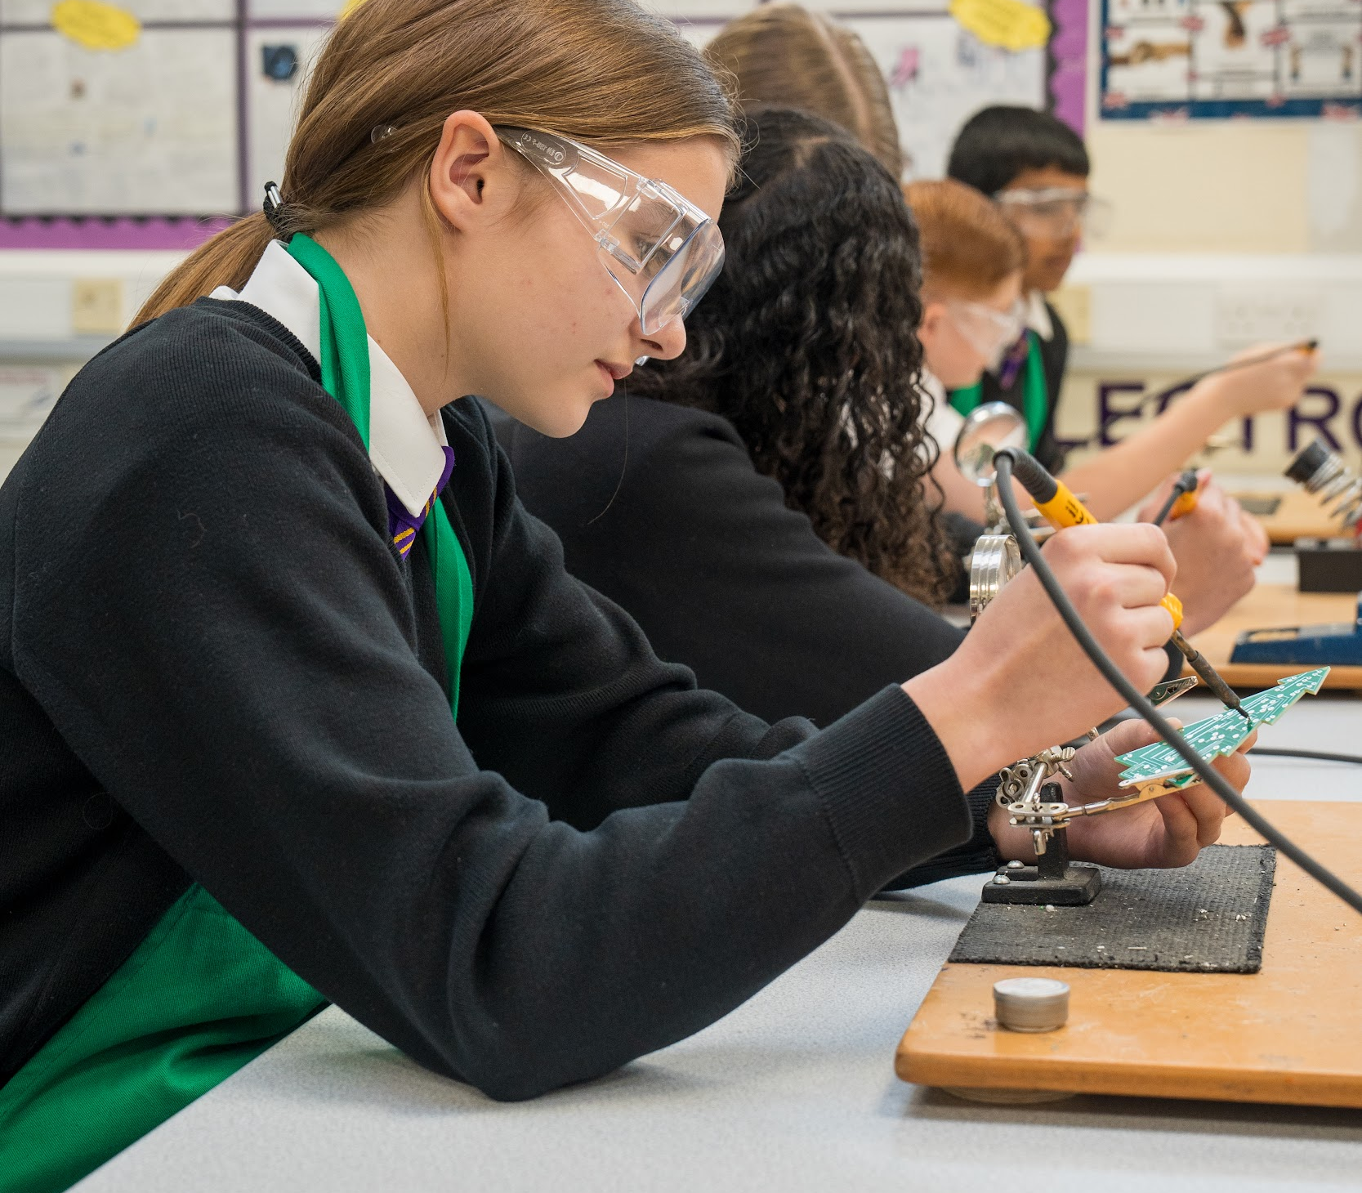
To support students of all ages to find out about career options and the various pathways available to them, we have introduced Unifrog, a careers platform with a wealth of careers information, videos, and information on college and university, including Oxbridge. Students can personalise their Unifrog page with their own searches and match their personality and likes to the perfect career for them!! We also have a new fully funded project - employability skills through the Skills Builder company - that we carry out with Year 7 during form-time. The students love working on key employability skills as well as drop down careers days.

We actively encourage students to take part in enrichment and strongly believe in the impact of such experiences and how they develop students’ well-being, confidence, teamwork and leadership skills. We also believe in ensuring that our young students are safe, so we have regular workshops on areas that are important to make young people more aware, such as internet safety and staying safe when in the community.

“There are sports and subject based clubs as well as go-karting and origami. Pupils who attended the writing club have had their work published” Ofsted Jan 2023

Raising Standards
At Sanders Draper, we work hard to implement change in order to raise standards for all our pupils. Working as a body of staff and led by the Raising Standards Team, we look to continually improve the level of education and care your child receives at our school.
The theory behind our work is taken from national educational research from organisations such as The Sutton Trust, PIXL Schools, Fischer Family Trust, TES, and the Department for Education. All of these help us to improve your child’s educational experience and outcomes.

Our aims include:
- To improve the quality of education for all of our students
- To improve outcomes for all of our students
- To ensure the well-being of our students
- To communicate effectively with all stakeholders
- To bring our community together
- To celebrate our community successes

It is important for us to ensure that all students have the chance to achieve their full potential. We can only achieve this if we understand how to help, support and stretch our students. In order to do this, we have introduced new initiatives and systems that allow us to be transparent with all stakeholders.

These include:
- Using robust data
- Tracking and monitoring students and staff
- Improving our SEND provision for all students
- Offering support (academic and pastoral)
- Ensuring staff have access to continual professional development
- Improving teaching and learning
- Maintaining our highly successful pastoral care system

Whilst intervention is key with students in Year 11 for GCSE success, our aim is to have early intervention strategies for pupils throughout their school career. This will help to remove the barriers they have to learning and allow them to achieve. This includes ‘behaviour for learning’ taking place inside all classrooms and a team approach so that all students feel that they can actively participate in class.

We look to close the gaps for students in all subject areas and work to achieve this by testing students, implementing appropriate intervention strategies, and then testing our impact. Students and families support us and we work together to raise outcomes for the students.

“My child was supported in a range of ways to ensure that they made progress and attained the results needed to go on to study for their A Levels.” Parent of a Sanders student

“Teachers use assessment well. They check pupils’ understanding throughout lessons. Pupils value the feedback that teachers provide. It helps them to improve their work. Pupils are not afraid to speak up if they do not understand. Teachers clarify any misconceptions should they arise.”. Ofsted Jan 2023

“Leaders are ambitious to improve the outcomes for the students” Havering School Improvement Review
Pastoral Care

At Sanders Draper, we pride ourselves on our outstanding pastoral care. Student well-being is at the heart of everything we do. We work tirelessly to ensure that students feel supported and that whilst they are part of the Sanders Draper community, students are happy, healthy and safe. We believe that this is fundamental in enabling all students to progress.

At Sanders Draper, we are a community, a family built on teamwork to ensure that we continue to grow and thrive together. We believe each member of our team plays an important part and that each has a key role in our success.

We are a proud school with a proud history. Our close links with the local community, RAF and World War 2 are reflected in our house system. This house system has been launched at Sanders Draper in order to further develop our students and ensure that they have appropriate and deserving role models. Each student belongs to a ‘house’ and each ‘house’ has a ‘house hero’. Several ‘house heroes’ either lived or worked in Havering during World War 2 and contributed to our local communities' war efforts. They epitomise our school values and we celebrate this with our students and through the work we do within the house system.

Form tutors are the first point of contact for students. Each morning students attend form-time. This provides an opportunity for staff to develop relationships with students based on trust and mutual respect. It allows for the reinforcement of expectations and the monitoring of standards. Form tutors deliver a form-time curriculum which is developed to meet the needs of students at different stages of their school career. It also provides an opportunity for reflection: we encourage our students to learn from their mistakes and we encourage discussion and debate. Students take responsibility for their own progress. They monitor and record their attendance, and track their achievement points and set targets for themselves related to their progress and attitude to learning.

Once a week students receive key messages through assemblies. Assemblies are led by staff from across the school. They are an opportunity for us to share experiences and key messages, and to celebrate the achievements of those within our community. Year groups are led by a dedicated Head of Year. They oversee the pastoral provision and care of young people within their year group. Our pastoral team extends to our safeguarding officers. These key members of staff provide exceptional care for our young people.

We have robust clear systems for managing conduct and behaviour and have high expectations of every student in terms of their attitude and approach to school life. Each lesson is an opportunity for learning and we do not tolerate poor conduct or low-level disruption in lessons. We believe that all students can achieve, and we ensure that they understand the need for respect and attention to their learning.

We get to know young people as individuals. We excel in providing quality care and guidance. We aspire for our students to be well-informed, well-rounded individuals. We are committed to every member of our team.

“Pupils are happy and safe… -Pupils valued their small school community where they are well known by staff and their peers… Older pupils are positive role models for younger ones…-The school is a calm and orderly environment” Ofsted Jan 2023

“At school I feel safe and know that the staff really care and are always there. ” - Yr9 Sanders student

“The safeguarding lead and team have a great understanding of children’s mental health concerns.” Havering School Improvement Review

“They provide pastoral and practical support for children who are worried about anxiety, depression and other concerns. The team are well aware of the social and cultural pressures on the children, they recognise the lack of parental understanding and confusing role models for some children. The clear aim is de-escalation, keeping children focused on day to day life and the positives they experience.” Havering Borough 175 Safeguarding Audit.
Teaching and Learning


At Sanders Draper, we aim to provide a challenging and engaging experience in every lesson and inspire our students to become the best, well-rounded individuals that they can be. Our Teaching and Learning Policy ensures that we:
- provide opportunities for all learners to make outstanding progress in their learning
- engender a positive approach to learning
- train, develop and support teachers to unlock skills, knowledge and potential
- promote the use of resources which encourage and motivate learners
- develop a love of life-long learning
- monitor the quality of teaching within the school
- maintain consistently high standards of teaching

Our philosophy of teaching and learning begins with ensuring all our students are exposed to a consistent, broad, balanced and challenging curriculum which helps develop every student as a successful learner, deeply embedding our core values of resilience, achievement and family ‘to be the best I can be.’ At Sanders Draper, you will expect every lesson to include individual, group and peer work; a focus on literacy and reading; a deep-rooted understanding of why we learn what we do, and a myriad of opportunities to develop personal, oral and subject-specific skills.

Because of our commitment and belief in developing the whole child, we ensure that all teachers are provided with regular, structured and bespoke training to guarantee that they can share and use the best possible practice with our students in the classroom. We place a strong emphasis on collaboration and our heads of faculties, classroom specialists, pastoral team and senior leadership team all work closely together to place all the students at our school at the centre of everything we do.

In every subject, we monitor and track our students' progress every half term through assessments; provide bespoke intervention when needed; and track and monitor teaching and learning through regular learning walks, work scrutiny, lesson observations, and analysis of key data. Students can expect to find the highest quality of teaching with a thoroughly planned curriculum, all directly linked to GCSE outcomes so that every child in every subject is able to develop the core skills needed in Year 11 and beyond.

We are exceptionally proud of our diverse and focused curriculum which allows all of our students to learn, be challenged and excel academically, morally and socially, equipping them with the key skills for success beyond Sanders.

“Since starting at Sanders, all of the older students have made me feel really welcomed” Sanders student

“I think the fact that as a school you go to the lengths you go to get the kids the best results and grades I can’t praise you and thank you enough” Year 11 parent

“A raft of CPD has been put in place to rapidly up-skill staff and ensure Trust expectations are met and to ensure teachers can deliver the new curriculum. Leaders have set clear non-negotiables around lesson organisational and class classroom protocol” Havering School Improvement Review

Staff Stories

Mr M Yeates, Head of Faculty - Performing Arts / Pupil Premium Lead
I joined Sanders as a newly qualified teacher; it was the perfect school to develop my practice and knowledge of teaching, planning and assessment. With support I was given the freedom to develop music within the school, raising its profile, and I became a part of the Sanders community. Professionally the school has supported and developed my skills so that I could make an impact in more whole school responsibilities. I am Head of Performing Arts and part of the Raising Standards Team, helping to improve outcomes for all our students. The school has given me the time and resources to be able to start a two-year NPQML course in Middle Leadership which will benefit both my own practice and the whole school. The Sanders Draper community is a special community, made up of unique and curious young minds. I not only love teaching the pupils but also running the various extracurricular clubs.

“Staff enjoy working at the school. Teachers at the early stages of their careers feel particularly well supported. Staff appreciated that leaders are caring and approachable. Leaders are considerate of their workload. The trust provides many opportunities for professional development for staff at all levels…”

Mrs Allen, Second in Science
Sanders Draper has supported me from when I was training 5 years ago, through my NQT, and then I progressed into the KS3 Lead in Science role 3 years ago. I have been encouraged to challenge stereotypes within the science industry to help more girls think about a career in science by a number of interesting projects I have been working on. The staff and students are a pleasure to work with and I enjoy coming to work every day. I can see that the multi-academy-trust is a good support network and I look forward to the progress that we are planning on making as a school to become the best that we can be.

“Staff are well trained to recognise the signs that a child might be at risk of harm… Leaders are rigorous in following up safeguarding issues…”

Mrs S King, Deputy Head (Curriculum, Outcome & Raising Standards Lead)
Sanders Draper recognises the need to raise standards across the school for all students. My appointment was based upon this, coming from a school that made significant progress, and I am keen to add to and drive forward changes at Sanders Draper. I have had the privilege of working in Dagenham, Dubai and Basildon and feel my experiences can help drive Sanders Draper to be the best school it can be, whilst remaining a community school with a great history. The staff and students are a pleasure to work with and our team ethic is impacting positively on our results and pupil achievement. Our drive and inclusion in the trust can help us to meet our goals for all of our students.

“Leaders ensure that the school’s approach to behaviour is commonly understood and applied…”Ofsted Jan 2023

Mrs M Shread, Assistant Head (Wider curriculum and Personal Development)
I began my teaching career as a trainee teacher at Sanders Draper in September 2003...and I have never left!! The school has been a part of my life now for 18 years and my career has progressed massively during that time. I began as a science teacher, moved into a Head of Year role, became Head of the Science Department and then Head of the Science and PE faculty, and finally became an Assistant Head. I have never wanted to leave Sanders as both the staff and students are amazing and it is like having an extended family. The opportunities that we provide, and the support, encouragement and development of the whole child at Sanders Draper is something I am particularly proud to be a part of and we really work hard here to grow students into being the best people that they can be!!

Student Stories

Kyla - From the very first moment I stepped into Sanders, I already felt as though I was part of a whole new family. The sense of community overwhelmed me in the most positive way possible. There were greetings and smiles everywhere I turned, which gave me the reassurance and confidence to know that I was going to love the school - everyone was extremely welcoming. Every member of Sanders will do their best to ensure you are in a happy and calm environment. I am proud that I was the school's first president. The school provides many opportunities for you to expand your learning and settle in comfortably. There are a wide range of clubs varying from sports to art to reading - these enable you to make more friends and build a good relationship with your teachers. All of the staff members are exceptionally friendly: the bonds that will be built run in and out of lesson time. The staff make you believe that you are capable of anything. I was given amazing encouragement and support throughout my whole time at Sanders. Whenever you may be in need, someone will always be there to listen and help you in any way that they can. There are many exciting things to look forward to at Sanders Draper.

Ella - Being at Sanders has given me so many opportunities over the years. Our values are Resilience, Achievement and Family, which are definitely shown throughout Sanders. New students can always expect a warm welcome from their classmates in their own year, or the older years above. When I first joined Sanders, it was a big change from primary, but I soon found out that this was nothing to worry about. At Sanders Draper, we have a great support system from teachers and students, and this has always really helped me. There was always someone to help me find my way around the school or answer any questions I had. Settling into the school was made really easy - everyone greeted me and made sure that it was a happy environment for us. I was able to make new friends and good relationships with teachers in class, and also by taking part in the wide range of clubs that Sanders has to offer such as sports, arts, science, and more which allow the bonds between students, their peers, and their teachers to become even stronger and create amazing opportunities for us as students. Along with this, our Student Voice and prefect system let us use our voices to help make positive changes in our school. At Sanders Draper, you are confident that you can achieve anything, which is supported by the constant encouragement from teachers. From just needing someone to listen, to needing a question answered - there is always someone that you can go to at Sanders Draper.

Jake - As soon as I left primary school I was apprehensive about joining secondary school. This was going to be a whole new world, right? The sense of being part of this school was nerve-racking but in the best way possible. I felt nervous, if not a little scared on the first day of school because of all the new things: new teachers, new friends and even a new school. Luckily these 'new' worries didn't stick around for long. I made a lot of friends, the teachers were very nice and this new experience was great. Sanders provides many opportunities varying from sports to art to technology, and these enable you to make more friends and build a good relationship with teachers. Every member of Sanders Draper will do their best to ensure that you are in a happy and welcoming environment. Whenever you are struggling and may be in need of support, there are always people to support or listen to you in any way that they can. There are many exciting things to be looking forward to at Sanders and you will have an amazing time.

Elena - As I started my very first day here at Sanders, I felt as if I knew everyone, and the friendly smile and the greeting by every staff member made me feel as if I was part of the family. Every single classroom comes with new ideas as the teacher plans what we are going to learn about, with such creative and driven teachers, always ready to help when needed. I always feel they show how much they really care about you. There are a wide range of extracurricular activities for everyone to enjoy. Our staff here make you dream, believe and achieve, as they all believe that every single young person has an opportunity to be something big in life. I am extremely proud of being part of this team as there are a lot of things to look forward to here at Sanders Draper.

Daniel - The transition from primary to secondary is quite drastic: new people, new buildings and new lessons. Luckily, Sanders makes this process easy. The staff here are very welcoming and you will quickly make new friends. With sports, science, journalism, chess, music and art clubs to choose from, the opportunities are countless! The community here at Sanders is great and I am sure you will love your experience. Why wouldn't you join?

Staff wellbeing and benefits
We offer the following staff benefits:
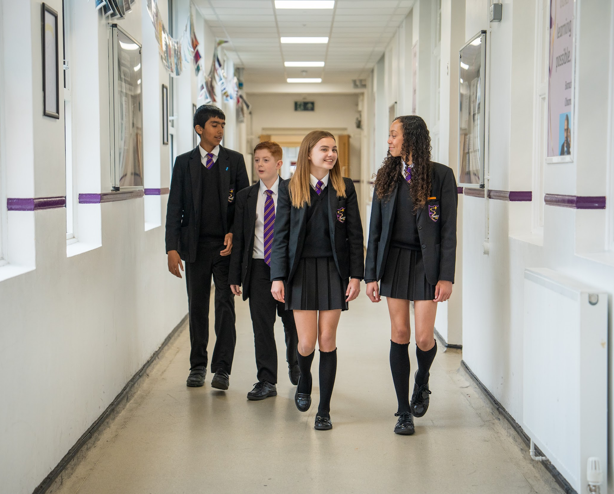
-Career Development (apprenticeships, support towards achieving further qualifications, leadership programmes, progression opportunities, teacher training, shadow opportunities and a vast CPD programme of relevant courses through both internal and external training providers)
-Pension
-All teaching staff are allocated a laptop,
-Staff supervision sessions with a trained professional,
-Promotion of a Cycle-to-work scheme
-Fortnightly line management meetings to support staff development and performance
-The Sanders Draper local committee has a link member who is responsible for overseeing wellbeing, further highlighting the importance we place on this aspect. This is also further emphasised by the Trust approach and relentless focus on the wellbeing of all staff members.
-Regular staff social and get-together events as a school and across the trust
-Staff surveys where staff views are gathered and actions are taken based on the results.

Further staff benefits:
Access to a Healthcare Cash Plan that pays cash benefits to cover a range of healthcare expenses such as dental check ups and treatments, a virtual GP and prescription service, optical care and physiotherapy.

Employee Assistance Programme (EAP) providing staff with up to 6 sessions or face-to-face, structured telephone, video or online counselling per year along with other services.

A Health Cash Plan - This is a policy that pays cash benefits to cover a range of healthcare expenses such as dental check ups and treatments, a virtual GP and prescription service, optical care and physiotherapy. The plan from Medicash has a list of treatments and conditions that are covered and as a policyholder you can claim back the cost of these items up to the annual limit within each category. Many of the benefits are available for up to 4 dependent children and it is possible for you to add to the level of your cover to increase your entitlements.

Counselling - The Trust has purchased a separate Employee Assistance Programme to provide staff with up to 6 sessions or face-to-face, structured telephone, video or online counselling per year along with other services. Details will be provided on these services within the next 7-10 days.

Sanders Draper House System and the schools rich history
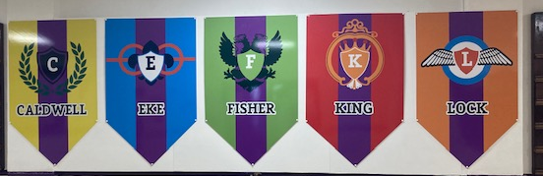
We are keen to ensure that our students are aware of the rich history of the school and the local area. As a school, we honour Raimund Sanders Draper by the changing of the school name to Sanders Draper in September 2021.
We have introduced a new house system which celebrates the rich history of the local area and the unique heritage of the school. We have 5 'Houses’: each student at Sanders Draper will be a member of a 'house'; a team and community within Sanders Draper. We would like to thank all that have been involved in the work on this project and the students, staff, parents and community who have been casting their votes for the house heroes. All of the heroes have shown our values of ‘Resilience, Achievement and Family’ in their lives and will be great role models for our students, staff and families at Sanders Draper.
Caldwell | Fisher | Lock | King | Eke
 |  |  |  | 
The Ops room support worker at RAF Hornchurch during WW2. The Ops room was the nerve centre for RAF Hornchurch. It provided strategic guidance and was key to both the protection of Dunkirk and the Battle of Britain.  Operating the printer, teleprinter and contributing to plotting, she worked in terrifying times but was known to have shown unfaltering bravery and courage. | The true professional and former Sanders student who epitomises the values of Resilience, Achievement and Family who died in action in Helmand Province, Afghanistan, on 5th November 2013.  He had extensive experience in overseas ops and tours. During his second tour of Afghanistan, he sadly died.  Regarded as a true professional by his peers and those whom he led. | The flying ace of WW2. A pilot whose courage and determination helped win the Battle of Britain  A distinguished pilot, he had extraordinary skill in chasing down the enemy and was known for his utter determination in protecting London’s airspace and the citizens who lived there. He was described as a ‘cool’ character, always calm, even in the face of adversity. | Volunteering for the RAF in WW2 having migrated from Jamaica, he helped to organise the first Caribbean-style carnival in London, later becoming the first Notting Hill Carnival. Elected Mayor for the London Borough of Southwark in 1983.  Known for his work with the Windrush Foundation, to preserve the memories of the West Indian pioneers who left their homes to migrate and help rebuild a post-war Britain | A young boy, a hero, who made a selfless choice  Ronald Eke was a 13-year-old when his family home was hit by 2 bombs in mid-November 1940. Despite horrendous injuries (both of his legs being severely crushed) he pretended that his injuries were mild in order to allow for his family members to be found first. He gave invaluable information so his family and others were saved.

You can find out more about the Havering Heroes and our House system through our website
https://www.sandersschool.org.uk/about-sanders/sanders-house-heroes
https://www.sandersschool.org.uk/about-sanders/sanders-house-heroes/overview-of-our-house-system

Sanders Draper History
When Suttons School was officially opened by Lady Simon on 2nd June 1938, it was unique in being situated only 530 yards from the perimeter of Hornchurch Aerodrome, soon to gain fame as a vital Sector Station in R.A.F. Fighter Command's elite No. 11 Group.
Built to accommodate 960 boys and girls in two entirely separate establishments, locating the Boys' School at the southern end of the building was a major error since it overlooked the aerodrome, and teachers whose windows had panoramic views across the airfield swiftly discovered that ensuring the average schoolboy's mind was upon his work instead of watching aircraft taking off and landing was no easy task!
On Wednesday 24th March 1943 at 10.40am, a Spitfire of No. 64 Squadron piloted by an American volunteer serving with the R.A.F., Flying Officer Raimund Sanders Draper, developed engine trouble shortly after take-off. What actually happened will never be known for sure but those present believe that he intended to pass to the left of the school in an attempt to land on the open ground beyond.
Realising that with reduced power he could possibly hit the school, he deliberately put the nose of the Spitfire down in the playing field, whereupon it bounced up onto the gravel drive and came to rest against the wall and windows of the two end classrooms. The noise was tremendous but mercifully the high octane fuel did not ignite and only one boy, Dick Barton aged 13, was injured.
​An R.A.F. crash tender smashed its way clean through the wooden boundary fence but Sanders Draper was dead in his cockpit. The boys were assembled in the School Hall by Mr Ward, the Deputy Headmaster, where he told them the sad news. After the dinner break, schooling resumed as normal.

We are forever grateful to Raimund Sanders Draper for the ultimate sacrifice he made, which allows our students to study today. The Sanders community celebrates annually on the 24th March, coming together as we pay our respects to Sanders Draper.

To be the best I can be

Headteacher: Mr Stuart Brooks BSc (Hons)
Sanders Draper, Suttons Lane, Hornchurch, RM12 6RT
Tel: 01708 443068 Email: enquiries@sandersschool.org.uk
Website: sandersschool.org.uk Twitter: @Sanders_Draper

