

400 Boys (Prep School)

**IAPS Boarding and Day**

700 Boys (Upper School)

**HMC Boarding and Day**

Prep School Deputy Head



Bedford Prep School

Bedford School is one of the region’s leading boarding and day schools, educating boys from the ages of 7 to 18. Part of The Harpur Trust, Bedford’s leading educational and social welfare charity, we’re a vibrant school with a very strong sense of community, set in a beautiful 50-acre estate in the heart of the town. The Prep School, educating boys from 7 to 13, is situation in its own part of the Bedford School estate.

We believe that boys learn best when they’re happy, confident and their curiosity is stimulated, so we feel it’s very important that learning is fun, creative, inspirational and active.  We also recognise boys learn differently to girls, and this informs our teaching.

Whether it’s music and the arts, science and technology, language and literature, or sports and games, boys are encouraged to learn new skills and embrace new experiences.

Visit our classes and you’ll find boys thoroughly engaged in their learning, inspired by challenge, competition, high expectations and risk within a safe environment.  Our expectations are high but achievable, and our curriculum encompasses and transcends the National Curriculum, uniting traditional practice with innovative teaching, and the best of the creative and academic.

Our extensive campus offers boys outstanding academic, sporting, music, drama and art facilities.  The Prep School shares superb facilities, such as the swimming pool, recreation centre, playing fields, astro and tennis courts with the Upper School and make use of the school’s fantastic theatre and other specialist facilities.

The School was inspected in October 2023, and we are particularly proud of the fact that ISI (Independent Schools Inspectorate) gave us a glowing report. Full details, including a copy of the inspection report can be found here:

<https://www.bedfordschool.org.uk/about-us/inspections-reviews/inspection-report/>

Working with each boy, we help them develop their sporting talents. We provide expert coaching in a wide variety of sports, including rugby, hockey, cricket, golf, skiing, cross country, swimming, badminton and rowing.

Creative arts are a big part of school life, with boys taking part in concerts, exhibitions and performances throughout the year.  In our dedicated music building with a state-of-the-art music technology suite and well-equipped practice rooms, many of our boys learn to play one or more instruments.

Boys can also get involved in a wide range of co-curricular activities, from cookery to steel band, chess to canoe building, there is something for every boy.

The school’s ongoing development programme has included the construction of a new Library (2003), Observatory & Planetarium (2003), a new Music School (2006) and a wonderful new theatre in St Luke’s Church, on the edge of the estate (2015). Other developments have included renovation of the school dining halls and kitchens (2023), fitness suite (2010), staff common room (2011), sports pavilion (2012) and science department (2015), the Prep School Year 3 and Year 4 building (2023) and the Outdoor Classroom (2024).

The Prep School

The Prep School classrooms are well appointed and resourced in terms of technology and learning resources. Boys obtain an excellent grounding in the subject whilst in the Prep School and go on to perform very well as they progress into the Upper School.

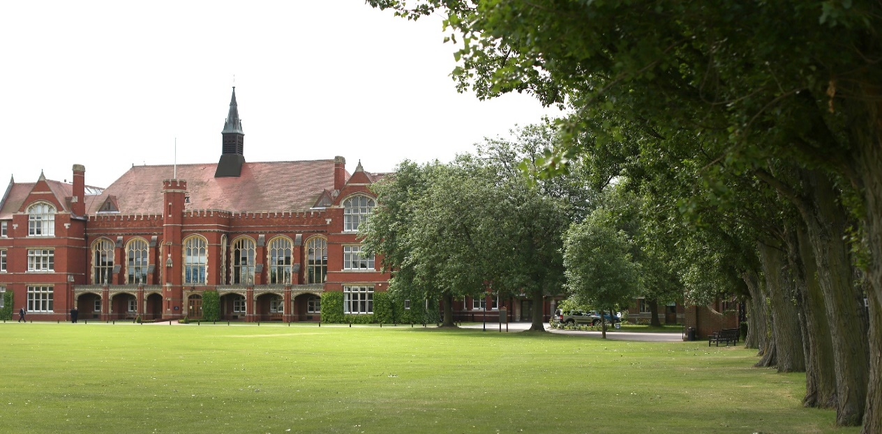

The Role

We wish to appoint an inspirational and energetic Deputy Head to work alongside the Headmaster to lead and manage the Prep School. Bedford Prep educates boys from 7-13 and is a thriving and dynamic independent school with first class facilities, small class sizes and enthusiastic pupils.

The post will suit applicants with experience of working in senior leadership roles from either the state or independent sectors. The successful applicant with have an excellent ability to lead and manage a range of teaching and support staff across every aspect of school life. They will be a talented and passionate leader, with the experience and drive to contribute fully to the future development and continuous improvement of the Prep School. The Deputy Head will sit on the school’s Senior Leadership Team and the whole school Core Management Team.

Benefits of Service

Bedford School has high expectations of its staff and therefore looks to reward them with generous salary scale increments and beneficial conditions of service. All teachers are offered membership of a pension scheme and have longer holidays than the maintained sector. Class sizes are small and most teachers have their own classroom. A wide range of opportunities for professional development exist and staff are encouraged to develop their skills and consider career options at all levels. There is ample opportunity to take on additional responsibilities for which there are allowances.

Fee concessions are available across the Harpur Trust schools and a health care scheme is also available for teaching staff.

All staff enjoy free on-site parking. Lunch and free refreshments are available throughout the day; other meals are available according to staff commitments.

Bedford is a dynamic and incredibly rewarding place to work with a strong sense of community.



General Information

Full-time teachers at Bedford are expected to:

• Play a full part in the extensive games and activities programme

• Be a Form tutor

Bedford School is committed to safeguarding and promoting the welfare of children and young people and expects all staff to share this commitment. Offers of appointment are subject to satisfactory references and DBS clearance.

Staff are normally expected to find their own accommodation, although there may be some school accommodation available in certain circumstances.

Application Process

Applicants are asked to complete the School Application Form; CVs in place of an Application Form cannot be accepted.

Short-listed candidates will be invited to the School for interview on the advertised date. The selection process will involve a lesson observation, a presentation, in-tray exercises and interviews. Candidates will also have an opportunity to tour the school.

The Prep School Headmaster, Ian Silk, would be happy to talk to prospective applicants and can be contacted by email on [isilk@bedfordschool.org.uk](mailto:isilk@bedfordschool.org.uk)

*Bedford School is part of The Harpur Trust*