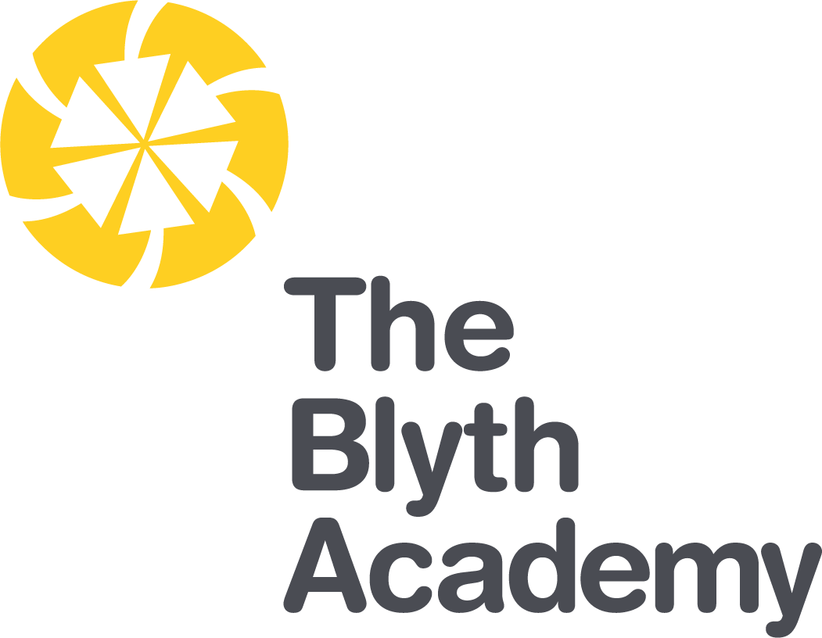

Outcomes Focused, Child Centred

English Teacher Recruitment Pack
Contents

Welcome from the Chief Executive | 03
Welcome from the Principal | 04
Introduction to The Blyth Academy | 05
Northern Education Trust | 06
Enrichment | 07
The Application Process | 09
Where to Find Us | 10
Job Advert | 11
Job Description | 12
Person Specification | 15

Welcome from the Chief Executive

On behalf of the Northern Education Trust Board, welcome to the Northern Education Trust.

We are unswerving in our commitment to ensure that the outcomes our young people secure prepare them fully for life beyond school. Our Academies are happy and thriving communities where children both achieve and feel safe and cared for. As an inclusive Trust we strive to help young people overcome any barrier to learning.

We are a caring employer and invest heavily in professional development, allowing our staff opportunities to take the next steps in their career. We hope you find our website holds all the information you need to believe that whether you are a parent or prospective employee, your next steps should be taken with us.
Welcome from the Principal

I am delighted to offer you a warm welcome to Northern Education Trust, The Blyth Academy.
As one of the most improved schools in Northumberland 2019, I am thrilled to say that this is only the start of the regeneration of our Academy; it is a fantastic time to be part of our community. At The Blyth Academy, we place students at the centre of everything we do, we are unashamedly focused on the educational outcomes of our students and deem that our students deserve to achieve the very best grades that they are capable of.

“We constantly focus on standards as we understand outcomes are paramount. Our decision making is driven entirely by what is best for children. By doing this we enhance the life chances of the children and young people in our care.” Northern Education Vision.

English & Mathematics are the cornerstones of our curriculum model as we believe attaining a strong pass in these subjects will open up our students’ life chances, giving them the opportunity to access a variety of post-16 opportunities. However, our curriculum does not stop there, our students will be taught more than just course content; we will ensure students develop the skills needed to become an independent, lifelong learners. We will give them every opportunity to succeed in a huge variety of activities in and out of the classroom, including cultural events, sporting activities and community projects.

It is important to us that our students are happy, confident learners. Our Academy is justly known for the high quality pastoral care that sits at the heart of our pursuit of excellence and guides every aspect of Academy life. This is the result of a stable, dedicated and highly effective team of staff ensuring that pupils have the support they need throughout their school life.

As an outward facing Academy we welcome visitors, please get in touch if you would like to see the Academy in action. I look forward to showing our achievements so far and the future we hold.

Donna Park
Principal

Introduction to The Blyth Academy

The Blyth Academy is a small sized secondary school. It is an 11-16 academy with 769 students currently on roll. The majority of pupils live in areas containing significant pockets of deprivation characterized (10% most deprived areas in the country) by high unemployment, an inadequate employment base, low average income levels, poor physical and mental health and a degraded urban environment.

The proportion of disadvantaged pupils is significantly above the national average (58% v 28%) and is the number currently in receipt of free school meals (44.5% v 14.1%). The Blyth Valley has some of the lowest rates of people in employment in the United Kingdom at 69.6% in comparison to the national average of 75.8%. This coupled with the high numbers of claimants for out of work benefits (7.2% in Blyth compared to 5.1% nationally), suggests that there are low levels of aspiration amongst the families whom send their students the Academy.

Pupils within our Academy are mainly white British, with only 3% of pupils having EAL, compared to 16.9% nationally. SEN support students are lower than national at 9.5%. Those requiring an EHC plan are slightly above the national at 1.1%.

Historically, outcomes at The Blyth Academy have been inadequate; students were failed. At Northern Education Trust we make decisions based upon what is best for the children in our Academies. We have unashamedly focused upon outcomes in English and Maths. By doing this we enhanced the life chances of the children in Blyth and have given them the skills, knowledge and qualifications to access a wide range of opportunities in the future.

As a result, outcomes over the past two years in English and Maths have rapidly increased and are now above that of the national average. 65% of students have now achieved grade 4+ in both English and Maths was 42% achieving grade 5+ in both. The increase in progress 8 to 0.18 demonstrates the evolution of the curriculum, which is ambitious, inclusive broad and balanced and meets the highest of expectations for all of our learners.

We are proud that Ofsted commented on our outcomes focused, child centred approach, ‘Pupils enjoy coming to school and they feel safe. They say staff look after them and want the best for them. Pupils know that they can be themselves and so they accept others for what they are.’ Ofsted October 2019.

Northern Education Trust

Our Vision

We constantly focus on standards as we understand outcomes are paramount. Our decision making is driven entirely by what is best for children. By doing this we enhance the life chances of the children and young people in our care.

The 10 values which underpin our vision:

- We care passionately about the education and welfare of young people

- We believe that all young people, irrespective of background or ability will be successful in our Trust

- We are not and will never be selective. We believe that local schools are for all children

- We are always inclusive. Our mechanisms to support the most vulnerable child to succeed and overcome barriers to learning are a key aspect of our work

- Our approach to education recognises that outcomes are paramount and also allows children to gain experiences and values which prepare them fully for life in modern Britain. This includes workplace skills and appropriate advice for future progression

- We have high expectations of behaviour

- We adopt the local authority admissions protocol and work closely with them

- We would always wish to act in such a way that has a positive effect on a neighbouring school or community. We care passionately about children in all schools, not just our own

- That all employees act with integrity and embrace the value that ‘we are the Trust’

- We work regionally and nationally to develop approaches to MAT improvement that influence the wider school-led system

Enrichment

Below are examples of Enrichment sessions running weekly within our academy
OLC Study Club | A great place to complete homework, research, work collaboratively and use the ICT facilities. This club runs every night with free hot chocolate and biscuits)
School of Rock | There is a space in the school band for anyone and everyone who is interested in learning to play an instrument, performing or learning about the production side of show business.
Mr Taylor’s Flying Circus | If we can make it fly then it is part of our club. Launching rockets, modelling aircraft and flying model planes. This club will start in January.
Basketball | Open to all students. Coached in partnership with the Newcastle Eagles.
Ceramics Club | An art club looking at designing and sculpting ceramics.
The Duke of Edinburgh Award | Open to students in years 9 – 13, following the Bronze, Silver and Gold awards. Be part of an internationally recognised award.
Boys Football | Open to all year groups. Open all year round on the 4G Pitch
Girls Football | Coached in partnership with the NUFC foundation
Dance | Dance club runs on 2 nights. Examination Dance and Core Dance. See the timetable for details
Cooking club | One of our most popular clubs. Come and learn how to cook a range of dishes from around the world.
Creative writing | An opportunity to develop and explore through creative writing.
F24 Car club | We have a F24 electric car! Students have built this car and been involved in a competitive race at croft racing circuit. This year we plan to make the car faster, lighter and more aerodynamic.
Rugby | Coached in partnership with the RFU. Open to boys and girls. See the enrichment timetable for more details.
Trampolining | A very popular club which is open to all students. Come along for bounce of 1 of our 4 trampolines.
Cycling | The Blyth Academy cycle club. Come along to learn how to ride, fix and maintain all bikes. This club offers regular cycle rides and trips.
Zoo Keeper Club | Learn through experience with a range or animals, reptiles and insects. This club offers a trip to Kirkley Hall Zoo at the end of the year.
STEM Club | Bringing all aspects of science, technology, engineering and maths together. Based in a science Lab.
Student Ambassadors | Have your say. Be part of the student Ambassadors. Help to raise money, act as the student voice and work to contribute to the sustainability of our Academy.
Netball | Open to all years. At peak times this club will run on 2 nights per week. Check the enrichment timetable for more details.
Heggerty Maths Club
Computer Coding Club | Learn to code. Using a range of languages code and develop software and games on a number of different hardware platforms.
Rounders club | This club runs through the summer term
Cricket Club | This club runs through the summer term
Athletics club | This club is run by an external athletics coach
Badminton | Open to all year groups. This club is run by Active Northumberland.
Student attendance at Enrichment is tracked to all clubs and work towards prizes (Bronze, Silver, Gold and Platinum)

The Application Process

Thank you for your interest in this role within The Blyth Academy.

The information, job description and person specification have been provided to help you decide whether you wish to apply and, if so make an effective, good quality application.

Please take the time to match your skills, experience and aspirations against these when reaching your decision.

The Application Form

It is important that you complete all sections of the form and you provide full accurate information in each section. CV’s will not be accepted.
After the closing date all applications will be examined and shortlisting will take place. You will be notified at this point if your application has been unsuccessful by email or you will be invited for interview.
Details of interviews and any required tasks that you may need to prepare for will be sent to you. At this point references will be sought if permission has been given
On the day of interview, you will also be asked to bring various forms of identification and original certification as declared on your application.
Post interview
You will be contacted to advise if you have been successful or unsuccessful. If you are the successful candidate you will be made a verbal offer of employment which will be followed up with a conditional job offer. The pre employment checks include:
References
Health check
Proof of the right to work in UK
DBS clearance
Proof of Identity
Qualifications verification

Once all clearances are in place a start date will be a confirmed and followed up with a final offer letter

Where to Find Us
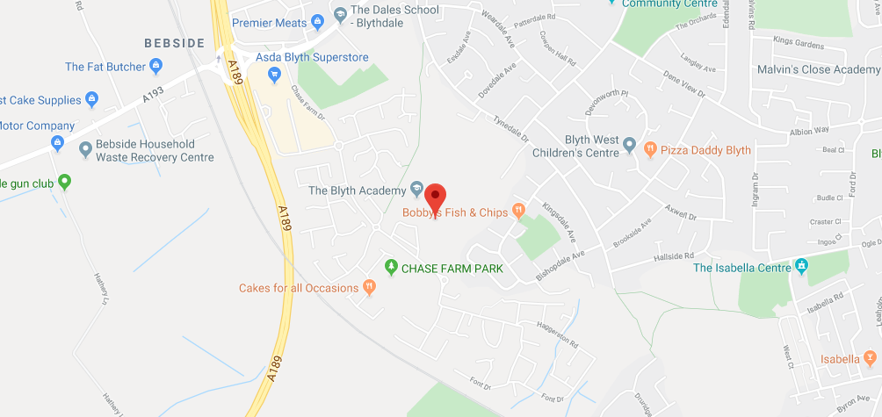

Directions to The Blyth Academy

From the A1 South:
From the A1 join the A19 for 2.3 miles
At the roundabout on the A189 take the second exit onto (A189) for 4.4 miles
Take the exit toward Blyth Riverside and take the third exit on the roundabout onto Cowpen Road 0.1miles
Take third exit onto Chase Farm drive going through two roundabouts and turn left in to the Academy car park

From A19
From Silverlink travel 4.8 miles to the roundabout and take 5th exit onto A189 for 4.4 miles
Take the exit toward Blyth Riverside and take the third exit on the roundabout onto Cowpen Road 0.1miles
Take third exit onto Chase Farm drive going through two roundabouts and turn left in to the Academy car park

From North
From A189 North Seaton Roundabout travel on A189 for 3.0 miles.
Take A193 exit toward Blyth/Blyth Riverside Business Park and the 1st exit at the roundabout 500ft
At the roundabout take third exit onto Chase Farm drive going through two roundabouts and turn left in to the Academy car park

Contact Details

The Blyth Academy
Chase Farm Drive
Blyth
NE24 4JP
Phone: 01670 798100
Email: blyth.enquiries@northerneducationtrust.org
Web: https://tba.northerneducationtrust.org
Job Advert

TEACHER – ENGLISH

Scale: MPS - UPS
Salary: £25,714 - £41,604
Closing Date: Tuesday 2nd March 2021
Interview Date: to be confirmed
Start Date: As soon as possible
Contract Term: Permanent

The Blyth Academy is seeking to appoint a teacher of English. The successful candidate will work as part of the English department carrying out the professional duties of a teacher in accordance with Academy policies under the direction of the Principal.

The Blyth Academy is part of Northern Education Trust, a nationally recognised and trusted academy sponsor with vast experience of school improvement, and specialised experience in all aspects of education. Trustees are committed to working with local authorities, other agencies and industry to improve the lives and life chances of young people. We want to give our students the opportunity to be economically self-reliant and have the ability to choose their own pathways to success.

We can offer you an excellent opportunity for career progression both within the Academy and the Trust as well as a supportive professional environment with an ambitious leadership team and a clear vision for the Academy.

For further information, contact the Business Manager, Jill Jackson j.jackson@northerneducationtrust.org

The Blyth Academy is committed to Safer Recruitment. Pre-Employment Checks will be undertaken prior to appointments being confirmed. Positions are subject to Enhanced DBS Checks. We expect all adults who work in our academy to share our commitment to Safeguarding and the Health and Well-Being of our Students.

Please return completed application forms to Jill Jackson - Business Manager
Email: j.jackson@northerneducationtrust.org
Telephone: 01670 798100

Please complete our application and monitoring form and note your letter of application/supporting statement should be no longer than 3 sides of A4.

Job Description

Northern Education Trust – Job Description

Job Title: | Teacher
Base: | Academy
Reports to: | Principal | Grade: | MPS - UPS
Service responsibility: |  | Salary: | £25,714 - £41,604  (FTE, Salary to be pro rata)
Additional: | Some travel may be required across NET sites. | Term:

The generic teachers’ job description applies to all teachers regardless the stage of their career. As a teachers’ career progresses they are expected to extend the depth and breadth of knowledge, skill and understanding as is judged to be appropriate to the role they are fulfilling and the context within which they are working.

NET expects all teachers to demonstrate that their practice is consistent with the Teaching Standards.

Responsibilities
The duties outlined in this job description may be modified by the Principal or Governors, with your agreement, to reflect or anticipate changes in the job commensurate with the salary and will be reviewed annually as part of the Appraisal process

The appointment of a Teacher is subject to the current conditions of employment for teachers contained in:

- The School Teachers’ Pay and Conditions Document (STCPD);
- the required Standards for Qualified Teacher status;
- other current and relevant legislation.

Teachers Role

- Set High Expectations Which Inspire, Motivate and Challenge Pupils
- establish a safe and stimulating environment for pupils, rooted in mutual respect
- set goals that stretch and challenge pupils of all backgrounds, abilities and dispositions
- demonstrate consistently the positive attitudes, values and behaviour which are expected of pupils

2 Promote Good Progress and Outcomes by Pupils
- be accountable for pupils’ attainment, progress and outcomes
- be aware of pupils’ capabilities and their prior knowledge, and plan teaching to build on these
- guide pupils to reflect on the progress they have made and their emerging needs
- demonstrate knowledge and understanding of how pupils learn and how this impacts on teaching
- encourage pupils to take a responsible and conscientious attitude to their own work and study

3 Demonstrate Good Subject and Curriculum Knowledge
- have a secure knowledge of the relevant subject(s) and curriculum areas, foster and maintain pupils’ interest in the subject, and address misunderstandings
- demonstrate a critical understanding of developments in the subject and curriculum areas, and promote the value of scholarship
- demonstrate an understanding of and take responsibility for promoting high standards of literacy, articulacy and the correct use of standard English, whatever the teacher’s specialist subject
- if teaching early reading, demonstrate a clear understanding of systematic synthetic phonics
- if teaching early mathematics, demonstrate a clear understanding of appropriate teaching strategies

4 Plan and Teach Well-Structured Lessons
- impart knowledge and develop understanding through effective use of lesson time
- promote a love of learning and children’s intellectual curiosity
- set homework and plan other out-of-class activities to consolidate and extend the knowledge and understanding pupils have acquired
- reflect systematically on the effectiveness of lessons and approaches to teaching
- contribute to the design and provision of an engaging curriculum within the relevant subject area/s

5 Adapt Teaching to Respond to the Strengths and Needs of all Pupils
- know when and how to differentiate appropriately, using approaches which enable pupils to be taught effectively
- have a secure understanding of how a range of factors can inhibit pupils’ ability to learn, and how best to overcome these
- demonstrate an awareness of the physical, social and intellectual development of children, and know how to adapt teaching to support pupils’ education at different stages of development
- have a clear understanding of the needs of all pupils, including those with special educational needs; those of high ability; those with English as an additional language; those with disabilities; and be able to use and evaluate distinctive teaching approaches to engage and support them

6 Make Accurate and Productive use of Assessment
- know and understand how to assess the relevant subject and curriculum areas, including statutory assessment requirements
- make use of formative and summative assessment to secure pupils’ progress
- use relevant data to monitor progress, set targets, and plan subsequent lessons
- give pupils regular feedback, both orally and through accurate marking, and encourage pupils to respond to the feedback

7 Manage Behaviour Effectively to Ensure a Good and Safe Learning Environment
- have clear rules and routines for behaviour in classrooms, and take responsibility for promoting good and courteous behaviour both in classrooms and around the Academy, in accordance with the Academy’s behaviour policy
- have high expectations of behaviour, and establish a framework for discipline with a range of strategies, using praise, sanctions and rewards consistently and fairly
- manage classes effectively, using approaches which are appropriate to pupils’ needs in order to involve and motivate them
- maintain good relationships with pupils, exercise appropriate authority, and act decisively when necessary

8 Fulfil Wider Professional Responsibilities
- make a positive contribution to the wider life and ethos of the Academy
- develop effective professional relationships with colleagues, knowing how and when to draw on advice and specialist support
- deploy support staff effectively
- take responsibility for improving teaching through appropriate professional development, responding to advice and feedback from colleagues
- communicate effectively with parents/carers in regard to pupils’ achievements and well-being

Personal & Professional Conduct
A teacher is expected to demonstrate consistently high standards of personal and professional conduct. The following statements define the behaviour and attitudes which set the required standard for conduct throughout a teacher’s career. Teachers uphold public trust in the profession and maintain high standards of ethics and behaviour, within and outside the Academy, by:

- treating pupils with dignity, building relationships rooted in mutual respect, and at all times observing boundaries appropriate to a teacher’s professional position
- having regard for the need to safeguard pupils’ well-being, in accordance with statutory provisions
- showing tolerance of and respect for the rights of others
- not undermining fundamental British values, including democracy, the rule of law, individual liberty and mutual respect, and tolerance of those with different faiths and beliefs
- ensuring that personal beliefs are not expressed in ways which exploit pupils’ vulnerability or might lead them to break the law

Teachers must have appropriate and professional regard for the ethos, policies and practices of the Academy, maintain high standards in their own attendance and punctuality

Teachers must have an understanding of, and always act within, the statutory frameworks which set out their professional duties and responsibilities

NET expects that all teachers are role models to students and promote the professional image of the Academy at all times in their behaviour, conduct and dress code

GDPR
- To adhere to GDPR and Data Protection Regulations, whilst maintaining
confidentiality

GENERAL
- To participate in wider Academy meetings and working groups as required
- Following Academy policies and procedures especially those relating to Child Protection and health; safety, security, confidentiality and data protection, reporting all concerns to an appropriate person

Whilst every effort has been made to explain the main duties and responsibilities of the post, each individual task undertaken may not be identified and the post holder may reasonably be expected to undertake other duties commensurate with the level of responsibility that may be allocated from time to time.

NET is committed to safeguarding and promoting the welfare of children and young people. We expect all staff to share this commitment and to undergo appropriate checks, including an enhanced DBS check.

Person Specification

Job Title

Application Stage

The following criteria will be used to short-list at the application stage:

Essential

 |  |  | Assessed by:
No | Categories | Essential / Desirable | App Form | Interview / Task
QUALIFICATIONS
1 | A honours degree | E
2 | A teaching qualification together with Qualified Teacher Status (QTS) | E
EXPERIENCE
3 | Experience of teaching, learning and assessment to at least KS3/4, preferably KS5 | E
4 | A good understanding of curriculum developments in English | E
ABILITIES, SKILLS AND KNOWLEDGE
5 | Able to use a range of teaching and learning strategies | E
6 | Commitment to high standards in all aspects of the academy’s work | E
7 | An understanding of how Assessment for Learning can improve student performance and how to embed this within your department | E
8 | Confidence in the use of standard computer packages and how these can be used to enhance student learning | E
9 | Able to use student level data to raise standards | E
10 | Enthusiasm for your subject | E
11 | Creative problem solving together with willingness to take on and develop and try new approaches and ideas | E
12 | Ability to relate to students in a pleasant and sympathetic manner and to recognise potential safeguarding issues | E
13 | Able to communicate both orally and in writing to students and their parents | E
PERSONAL QUALITIES
14 | Pleasant and friendly manner | E
15 | Polite and punctual | E
16 | Reliable | E
17 | A commitment to working as part of the whole Academy team and supporting the vision and aims of the Academy. | E

NET is committed to safeguarding and promoting the welfare of children and young people. We expect all staff to share this commitment and to undergo appropriate checks, including an enhanced DBS check.

The following methods of assessment will be used:

- Technical Assessment of application against criteria
- Activities designed to provide evidence to assess against Person Specification
- Presentation
- Interview

Additional Requirements

The following criteria must be judged as satisfactory when pre-employment checks are completed:

1 | Enhanced DBS Certificate
2 | Additional criminal record checks if applicant has lived outside the UK
3 | Medical clearance
4 | Qualifications essential to the post
5 | Two references from current and previous employers (or education establishment if applicant not in employment)

Chief Executive: Mr R Tarn
Northern Education Trust
c/o Thorp Academy
Main Road
Ryton
NE40 3AH

Phone: 0191 406 6383
Email: public.enquiries@northerneducationtrust.org
Web: www.northerneducationtrust.org

