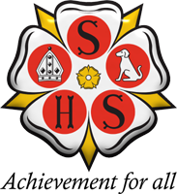 | 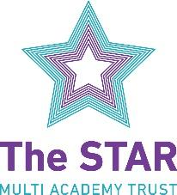  Sherburn High School  Headteacher: Ms Miriam Oakley  Garden Lane, Sherburn In Elmet, Leeds, LS25 6AS  Tel: 01977 682442  Web: www.sherburnhigh.co.uk Email: admin@sherburnhigh.co.uk

Teacher of Art and Photography
Maternity Cover MPS/UPS

Closing Date: 9.00am Monday12th April 2021
Interviews will be held: Thursday 15th April 2021
Contract Type: Maternity Cover
Start Date: Sept 2021

Are you an inspirational and enthusiastic Art and Photography teacher who is looking for a new / first challenge?
This is an exciting opportunity for an exceptional and well-qualified, inspirational teacher to join and make significant contributions to a small, supportive, high performing and forward thinking team.
As an enthusiastic and highly effective teacher, you must be able to teach Art and Photography at all key stages and be passionate about teaching and learning.
The school offers all employees training and support, peer mentoring, personal development (middle leadership / lead practitioner training where appropriate) a laptop and the chance to further develop skills by supporting extra-curricular activities.
Employees also benefit from NYCC’s Everybody Benefits Scheme, including access to tax free childcare vouchers, bike scheme.
This post is suitable for either an existing teacher or NQT; the school is supportive of flexible part-time working arrangements

Job descriptions, person specifications and application packs can be downloaded from our website at www.sherburnhigh.co.uk and emailed to recruitment@shs.starmat.uk

Potential applicants are encouraged to contact the school if further information is required. Please contact Leah Jamieson on 01977 682442 or email leah.jamieson@shs.starmat.uk

Enhanced DBS clearances and references will be obtained prior to appointment.

Sherburn High School is committed to safeguarding and promoting the welfare of children. We welcome applications from all sections of the community; we appoint on merit.

Sherburn High school is part of The STAR Multi Academy Trust which is an exciting new venture strengthening our existing partnership with other local schools.

Age range 11-18 mixed comprehensive with Sixth Form Current NOR 825

.

The STAR MAT is committed to equality, and to making fair and equitable treatment an integral part of everything we do.

The Trust is committed to safeguarding and promoting the welfare of children and expects all staff to share this commitment. The post is subject to a successful DBS check and pre-employment checks will be undertaken before an appointment is confirmed.

If you require assistance in applying for this position please contact us on 01977 687969.

