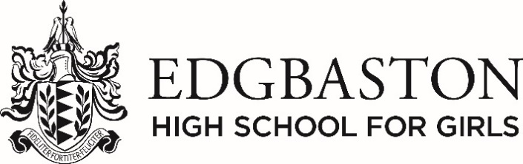

Teacher of Mandarin
FURTHER INFORMATION

THE SCHOOL

Founded in 1876 Edgbaston High School for Girls is the oldest independent day school for girls in Birmingham. The School is very pleasantly situated next to the Botanical Gardens, 1½ miles from the city centre. There are over 920 girls aged 2½ to 18 divided into 3 departments working together on one site. Continuity of education is a feature of EHS, but girls can join at all stages.

The School attracts girls both from the immediate neighbourhood and all over the West Midlands. They come for the high academic standards, the lively programme of extra-curricular activities and for the individual attention and flexibility of approach.

Pupils enjoy a broadly based programme which substantially fulfils the requirements of the National Curriculum and much more. Examination results are very good with high grades distributed across both Science and Arts subjects. Staff and parents work closely together so that each girl can develop her individual gifts to the full.

The Council which is the School’s governing body actively supports and encourages the work of the School. In the last 7 years major development and refurbishment programmes. including a new Sixth Form Centre, Library, Reception area and Fitness Suite in March 2011, a Preparatory School extension in 2017, a multi-purpose extension to the Senior School Hall and new Pavilion in 2018.

The Headmistress is a member of the Girls’ Schools Association and HMC and the School is a member of the Independent Schools Council.

POST OF TEACHER OF Mandarin

Mandarin is taught from Year 5 to Year 13 in ability based groups after school. Calligraphy Club takes place in the lunch hour.

Year 7 have an introduction to French/German/Spanish and Mandarin and chose 2 out of 3 to continue with Year 8. Mandarin is a third option after school. All pupils take an MFL to GCSE level.

