**THE STREETLY ACADEMY**

**SPECIAL EDUCATIONAL NEEDS & DISABILITIES DEPARTMENT (SEND)**

At the Streetly Academy we are a fully inclusive mainstream school with our emphasis always being on universal ‘Quality First Teaching’ for all. All teachers are accountable for the progress of every student they teach regardless of need.

***‘The true measure of any society can be found in how it treats its most vulnerable members”*** - Ghandi

This regularly used quote by our head teacher, Mr Downie to parents at open evenings, encompasses all that we believe here at The Streetly Academy.

At The Streetly Academy, our moral compass is steered by our very clear values. Our emphasis on some traditional expectations of respect, good old-fashioned uniform standards, and effort are fully encapsulated with our PRIDE system, drawn from the Olympics and Paralympic Values of:

* Personal Excellence
* Respect and Friendship
* Inspiration
* Determination and Courage
* Equality.

At The Streetly Academy we feel morally obliged to consistently improve in every area, from teaching to support work, behaviour management to leadership, working to ensure that every student, no matter what their ability, can grow, flourish, and achieve in a safe and stimulating environment. Values and Achievement sit at the centre of our vision, and we expect that every person connected to the school, parent or governor, student or staff member, maintains the same focus.

Every student, including those with Special Educational Needs and/or Disability (SEND), is encouraged to aspire to achieve the very best that they can, within an ethos of high expectations, with outstanding provision. Every teacher is a teacher of young people, including those with SEND. Special educational provision is available to those who need it and is underpinned by high quality and adaptive teaching; we place a heavy emphasis on quality first teaching for all.We cater for a range of disabilities, enabling students to access mainstream education, supporting both academic and emotional wellbeing needs.

**SEND Provision**

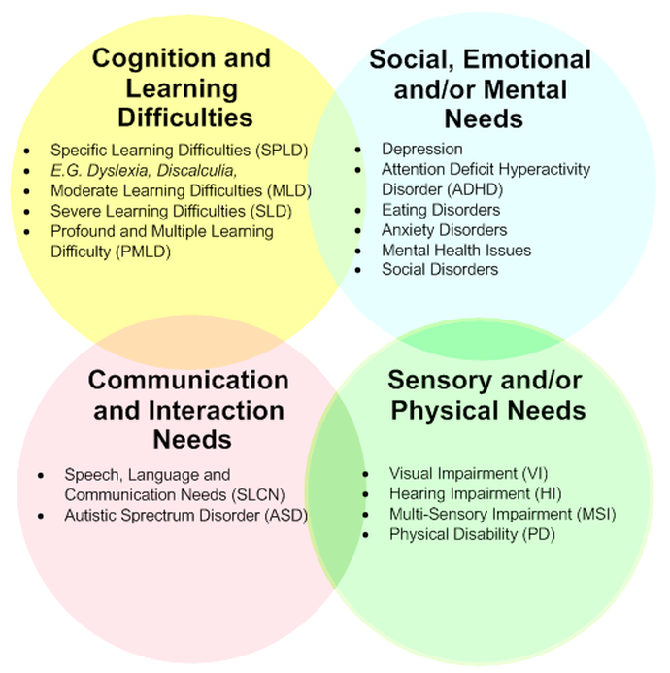

At The Streetly Academy we currently provide ***‘additional and/or different’*** provision for a range of needs, covering the four broad areas of need:

* **Communication and interaction**, for example, autistic spectrum disorder, Asperger’s Syndrome, speech and language difficulties
* **Cognition and learning**, for example, dyslexia, dyspraxia, moderate learning difficulties (MLD)
* **Social, emotional and mental health** difficulties, for example, attachment disorder, attention deficit hyperactivity disorder (ADHD),
* **Sensory and/or physical needs**, for example, visual impairments, hearing impairments, processing difficulties, epilepsy

**The four broad areas of need.**

Our SEND team consists of the SENDCo, Assistant to the SENDCo, full time Administration, a lead coordinator for each area of need and a large team of Teaching assistants/ HLTAs. The department is streamlined within the four categories of need and into teams of staff who have developed their expertise in one or more of the following areas:

1. Autism Spectrum Disorder (ASD)
2. Specific Learning Difficulties (SpLD)- Dyslexia, Dyscalculia, Dyspraxia, Dysgraphia
3. Attention Deficit Hyperactivity (ADHD)
4. Physical Disability (PD)
5. Speech Language and Communication Needs (SLCN)
6. Social Emotional & Mental Health (SEMH)
7. Examination access team
8. Transition and post 16 employability and next step pathways

The SEND department is based within the Student Support Centre (SSC) with well-resourced classrooms, We also have physio and therapy/sensory suite, and SpLD support space for phonics and literacy needs, a learning pod, as well as office facilities.

All students at the Streetly Academy have a Chromebook, we use the Lexia reading programme & Read & Write software for accessibility and basic skill development.  Our students take part in every aspect of school life – we run Boccia, FAB Club and PD Gym as well as TA-led lunchtime activities..

Our TAs have a high and respected profile across our school, and our SEND department is recognised for its highly inclusive work with our young people.

Interested candidates would be very welcome to make an informal visit prior to application.

Ms Paula Wiley

SENDCo

June 2025

deps/sen