CATHOLIC DIOCESE OF NOTTINGHAM

ST FRANCIS CATHOLIC PRIMARY SCHOOL
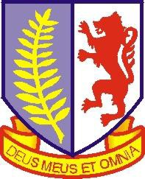
Full time KS1 or KS2 Class Teacher required 27th August 2019
Pay Scale: MPS Contract Type: Temporary

Now part of the St Thomas Aquinas Catholic Multi-Academy Trust, St Francis Catholic Primary school is seeking to appoint a full time class teacher to teach in either KS1 or KS2 from 27th August 2019. This appointment is temporary for one academic year due to fluctuating pupil numbers.

The successful candidate will:

- be an enthusiastic, passionate and committed teacher
- have high aspirations and work collaboratively within a team
- develop a strong and effective partnership with parents and the wider community
- be supportive of the Catholic Ethos of the school

We warmly welcome applicants to visit our school.

Closing Date: Wednesday 22nd May 2019

Interviews will be at a mutually convenient time asap thereafter.
A completed CES form, Rehabilitation of Offenders form and Recruitment Monitoring form, should be returned to the Head Teacher at St Francis Catholic Primary School, Dalby Road, Melton Mowbray, LE13 0BP or by email to adminteam@st-francis.leics.sch.uk

St Francis is committed to safeguarding and promoting the welfare of children and young people and expects all staff and volunteers to share this commitment. This post is subject to satisfactory references which will be requested prior to interview, an enhanced Disclosure and Barring Service (DBS) check, medical evidence, evidence of qualifications plus verification of the right to work in the UK.

