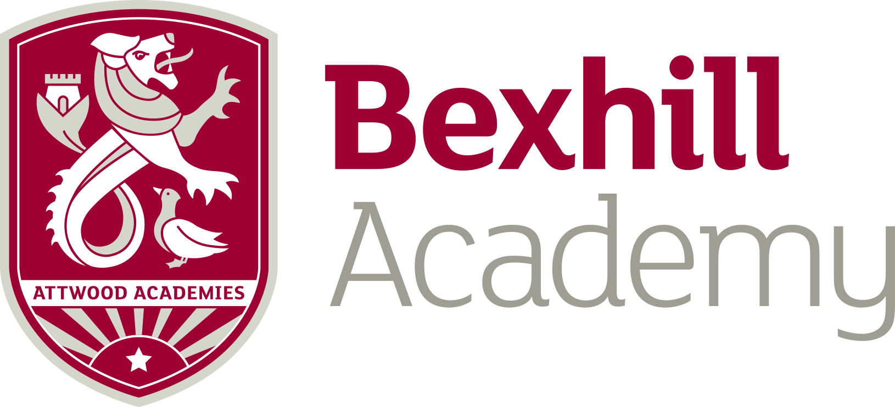

Introduction from the Vice Principal
Re: Head of House: January 2020 start
Welcome!
Thank you for expressing an interest in the role of Head of House at our school.
We are an ever improving and expanding school and the Heads of House provide stability and direction on all pastoral matters (coupled with academic monitoring and intervention). We are Ofsted ‘Good’ in all areas (May 2017) and the Houses played a huge part in this.
There are 5 houses, all of which are vertical, taking an element of each year group. Even the tutor groups are vertical, enhancing cohesion amongst the year groups.
Each house has in the region of 250+ students, 10+ tutors and a non-teaching Pastoral Manager.
The houses are named after inspirational and internationally recognised Universities:
- Cambridge
- Harvard
- Imperial
- Oxford
- Yale
Each House delivers a common theme and message, but there are obviously those individual differences in approaches and style that make a House unique. There are 5 tutor time slots per week, 4 usually in tutor bases, with a 5th in an assembly.
The person we require needs to have a passion for pastoral work, be a real leader (and have presence) and someone who can uphold our values of being Focussed, Aspirational, Independent and Resilient. You will need to have bags of energy and the ability to have time management skills that are second to none!
Particulars:
- There are normally 17 /25 teaching hours attached to this post.
- You may be asked to spend a session supervising students in the Internal Exclusion Room/Learning Recovery Room
- This post is paid on the teachers MPS or UPS scale with a TLR allowance of £6741 per annum. You will be tracking, monitoring and intervening with all groups in your house, including Pupil Premium.
- Heads of House also take on a whole school responsibility such as a responsibility for transition, charities or College/UCAS applications.
- This position is rewarded with a retention bonus of £1250 payable in the September of the 3rd year of service.
- Staff rewards scheme

Applicants:
We look forward to receiving applications from all suitably qualified and experienced staff.
We do however especially look forward to suitably experienced staff who are English Teacher trained and experienced.

If you wish to arrange an informal visit or chat, please contact paul.mendela@bexhillacademy.org in the first instance who will arrange for one of the team to contact you.

The closing date is Tuesday 1st October 2019 at 9am

We look forward to hearing from you
P Mendela
Vice Principal

