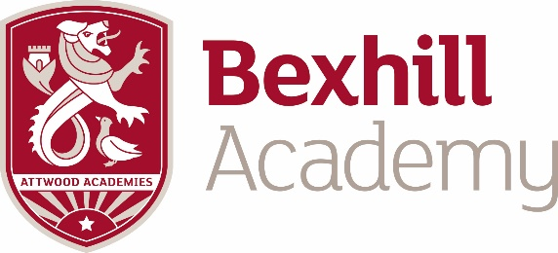

Post: Head of House
Accountable to: Assistant Principal
Salary: Teachers Main scale/UPS plus TLR of £6741.00per annum
Retention bonus payable after 2 years (paid in year 3 of £1250) + Staff attendance rewards scheme, use of gym and after-school classes
Person Specification
- Qualified Teacher, with appropriate Degree
- Experience of Pastoral Head of House/Head of Year work.
- Committed to comprehensive secondary education
- Is innovative and identifies and solves challenges with creativity.
- Has a productive and definable paranoia about the successful work of their teams.
- Has fanatical discipline about seeing things through.
- Has the courage and conviction to take risks and take difficult decisions wisely.
- Has a predisposition to immediate action, letting nothing slip.
- Is insistent on consistency of approach, individually and across the team.
- Has drive and steely determination but a deep sense of personal humility.
- Has belief in people.
Job Specification – To create succesful and resilient learners, who have good attendance, behaviour and achieve their academic potential through (not exhaustive!):
- Looking at all data (Behaviour, attendance and academic) throughly and basing actions and intervention accordingly. To track and monitor vulnerable groups accordingly.
- Knowing the students as individuals, promoting individual success
- Being accutely aware of strengths and weaknesses of the ‘House’ and planning action for all weaknesses, whilst prioritising those that will maximise outcomes.
- Liasing robustly with Parents, Heads of Department and outsuide agencies to ensure the ethos of the school is upheld and the student body is as successful as possible
- Upholding the Academy values by offering a strong and robust presence around the school.
- Adhering to all Safeguarding procedures
- Holding informative and interesting assemblies that send important messages
- Ensuring tutor time is effective
- Ensuring timetabling issues for students or new admissions are executed in a timely fashion
- Being a key ‘face’ of the Academy!

Impact
- Students in the House gain further momentum in meeting their expected grades; attainment and progress are increasingly better
- The gap between the progress of pupil premium students and non pupil premium in the House is diminishing over time.
- Students behaviour and attitude to learning is improving significantly
- Exclusions and attendance is improving year on year
- Behaviour and attitude around the school becomes more cohesive and pleasant

