
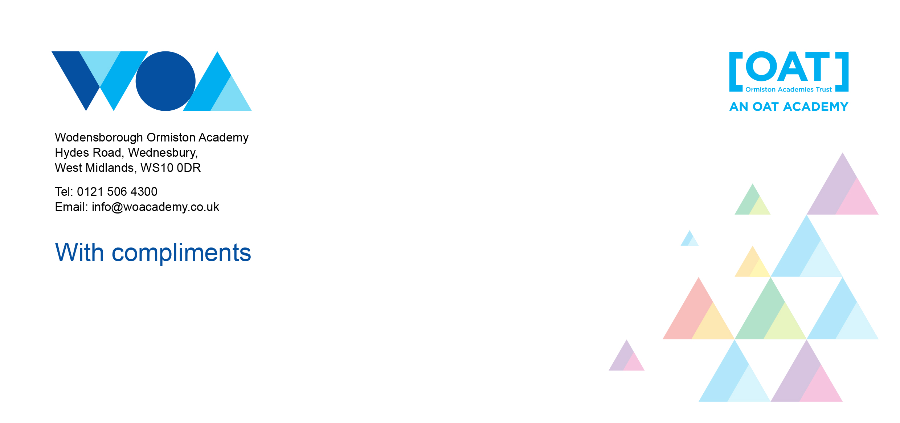
Lead Practitioner – Geography
Start date: | September 2025 or Sooner
Salary: | Leadership Pay Scale
Contract: | Permanent and full time. Teachers’ Pay and Conditions.







We are looking to recruit an outstanding teacher to support the work of our Quality of Education Team.

We are a popular and oversubscribed 11–16 mainstream school with the additional expertise and facilities to include two focused SEND provisions, for young people on the autistic spectrum, and for those who are deaf and hearing impaired (ARC and Deaf Academy). Our small and bespoke sixth form (WOA6) caters for students in Years 12 and 13 who have EHCPs. I believe education is the key to opportunity. As Principal, I have the very highest expectations of, and for, all and I am uncompromising in my view that the students must be at the very heart of all we do.
My vision – Believe, Achieve, Succeed – is more than just a phrase. It is a systematic approach to raising aspirations and standards which is underpinned by my unwavering commitment to improving the life chances of young people in Sandwell. I thank our local community for their steadfast support since I took up my post and sincerely look forward to further engaging with parents, local schools, employers and community groups to continue to provide our students with the support, skills and experience they need in order to have a successful future.
At WOA, we believe that every child has the potential to achieve and we expect nothing but the best for each and every one of our students. Through our curriculum, we aim to provide an excellent education for all our students; an inclusive education which raises aspirations and brings out the best in all of them and prepares them for success in education and later life. Our curriculum is progressive and designed to provide children with the core knowledge they need for success along their learning journey.
We have a team of dedicated, specialist curriculum and student welfare staff who work together to ensure that the needs of each individual child can be met. We work closely with our local community – families, schools, businesses and community groups – with whom we share a common priority, that our students are front, back and centre of every decision we make at WOA.
Finally, we have an open-door policy within the school, with a calendar of events which will provide you with an opportunity to see for yourselves what makes WOA so special. We actively encourage our families and our local community to come in to school and to meet with me and the team.
We believe that we all have an important part to play in raising standards. Come in, meet the team and join us on our journey!
Leigh Moore
Principal

For an informal discussion about the role, or if you have any additional queries, please contact Stephanie Thomson, PA to the principal stephanie.thomson@woacademy.co.uk.
WOA is committed to safeguarding children; successful candidates will be subject to an enhanced Disclosure and Barring Service check.

Job Description: Lead Practitioner – Geography
Reports to: | Vice Principal: Quality of Education
Responsible for: | Identified Staff Members
Salary: | L4 – L8
Contract: | Permanent
Hours | Full Time

The Role
- To inspire imaginative and effective approaches to teaching and learning to secure outstanding outcomes for learners in Geography
- To coach and develop staff in relation to curriculum, assessment, teaching & learning and intervention.
- To support other teachers to improve their effectiveness, modelling excellent practice and providing professional mentoring and to consistently teach high quality lessons which bring about excellent outcomes for students in Geography.
- To play a leading role in terms of developing improvements in teaching and learning within the school and with other staff – develop and implement CPD within Geography and whole school (as appropriate).
- To lead on a strand from the Quality of Education Plan to improve the quality of teaching across the academy.
- The post holder is expected to carry out the professional duties of a member of staff on the extended leadership team.

Key responsibilities
Teaching
- Plan and teach well-structured lessons to assigned classes, following the school’s plans, curriculum and schemes of work
- Assess, monitor, record and report on the learning needs, progress and achievements of assigned pupils, making accurate and productive use of assessment Adapt teaching to respond to the strengths and needs of pupils
- Set high expectations that inspire, motivate and challenge pupils
- Promote good progress and outcomes by pupils
- Demonstrate good subject and curriculum knowledge
- Participate in arrangements for preparing pupils for external tests
- Demonstrate best practice in Humanities, using engaging strategies to boost classroom engagement
- Show knowledge of the Humanities curriculum, including latest requirement and developments
- Lead by example, with highest professional and personal standards, and classroom management
- Offer statistic and practical support to classroom teachers and staff within the subject

Lead Practitioner responsibility
- To facilitate and deliver training / CPD for staff members across the Academy.
- To work as a lead practitioner to develop teaching and learning strategies that are effective and enable students to achieve challenging targets in Geography.
- To support the Head of Faculty and other Post Holders to ensure the curriculum has a clear purpose, delivery and impact across all key stages
- To support Academy improvement through professional mentoring and coaching of colleagues;
- To model excellent practice and lead others in the development of new pedagogies;
- To support other teachers to develop their expertise in planning, preparation and assessment;
- To work with the curriculum team to develop appropriate content for each level of learning which is challenging, engaging and differentiated to meet the needs of all students;
- To create and share resources that support the development of assessment for learning strategies;
- To contribute to the quality assurance of the academy by working with the leadership team to ensure rigorous monitoring and evaluation of progress towards Team and Academy Improvement Plans;
- To quality assure provision as part of an ongoing cycle. Creating a culture where feedback is seen as a gift and welcomed through an open door policy;

Whole-school organisation, strategy and development
- Contribute to the development, implementation and evaluation of the school’s policies, practices and procedures, so as to support the school’s values and vision
- Make a positive contribution to the wider life and ethos of the school
- Work with others on curriculum and pupil development to secure co-ordinated outcomes
- Provide cover, in the unforeseen circumstance that another teacher is unable to teach
- Ensure teaching and learning within Humanities is aligned with school ethos, identifying any procedural issues and providing workable solutions
- Lead by example, with the highest professional and personal standards and classroom management
- Provide leadership within your department and ensure whole school values are represented and understood

Health, safety and Wellbeing
- Promote the safety and wellbeing of pupils
- Maintain good order and discipline among pupils, managing behaviour effectively to ensure a good and safe learning environment

Professional development
- Take part in the school’s appraisal procedures
- Take part in further training and development in order to improve own teaching
- Where appropriate, take part in the appraisal and professional development of others
- Take part in professional development within your subject, sharing ways to improve subject teaching with others Lead other teachers in maintaining subject knowledge and latest pedagogical developments
- Take part in the appraisal and professional development of department heads and teachers within your department
- To work with the Head of Humanities and leadership team to lead the professional development of colleagues.
- To actively participate in the Academy’s appraisal processes for colleagues;
- Reflect on and address own professional development needs;
- Help to identify the professional development needs of colleagues;
- Facilitate the professional development of colleagues and contribute to the Academy’s bespoke CPD programme;
- To undertake NPQSL, NPQLTD or NPQLT.

Communication
- Communicate effectively with pupils, parents and carers
- Working with colleagues and other relevant professionals
- Collaborate and work with colleagues and other relevant professionals within and beyond the school
- Work and Liaise with Peers and Regional Lead Practitioners within the Ormiston Academies Trust.
- Develop effective professional relationships with colleagues with the focus of Humanities to ensure a continuous and progressive learning journey.

Personal and professional conduct
- Uphold public trust in the profession and maintain high standards of ethics and behaviour, within and outside school
- Have proper and professional regard for the ethos, policies and practices of the school, and maintain high standards of attendance and punctuality
- Understand and act within the statutory frameworks setting out their professional duties and responsibilities
- Management of staff and resources
- Direct and supervise support staff assigned to them, and where appropriate, other teachers
- Contribute to the recruitment and professional development of other teachers and support staff
- Deploy resources delegated to them

Safeguarding Responsibilities
Wodensborough is committed to the safeguarding of children and all staff are expected to ensure that the Academy is a safe and secure environment for our students.
The teacher will be required to safeguard and promote the welfare of children and young people, and follow school policies and the staff code of conduct.
It is the responsibility of all staff to recognise, respond and reflect in relation to all safeguarding disclosures/concerns in collaboration with the DSL/safeguarding team by operating within the guidelines of KCSIE and associated policies/guidance documents.
All academy staff will ensure that they facilitate a whole school approach to safeguarding which means ensuring safeguarding and child protection are at the forefront and underpin all aspects of academy life.
The Postholder will have contact with children.
The Postholder will be in regulated activity.
Please note, this is illustrative of the general nature and level of responsibility of the work to be undertaken, commensurate with the grade. It is not a comprehensive list of all tasks that the postholder will carry out.

Teaching Commitment
- The post holder will be expected to teach in line with the Academy’s generic teacher’s job specification. Designated non-contact time for management responsibilities will be made available as required.

Other
- Undertake other various responsibilities as directed by the line manager.

Wodensborough Ormiston Academy is committed to the safeguarding of children and all staff are expected to ensure that the Academy is a safe and secure environment for our students.

Wodensborough Ormiston Academy is signed up to the DfE Wellbeing Charter.


PERSON SPECIFICATION – Lead Practitioner for Humanities
 | ESSENTIAL | DESIRABLE | METHOD OF ASSESSMENT
EXPERIENCE | - 5 years teaching experience in the relevant subject area  - Using data to inform target setting and planning.  - Experience in successfully raising standards in the quality of teaching & learning.  - Experience in producing/contributing to department/faculty improvement plans.  - Experience in producing reports and data returns for SLT, LGB and external bodies.  - Experience in designing and implementing schemes of learning and assessments.  - A proven track record in raising standards of achievement in Humanities: successful GCSE results.  - Experience in supporting colleagues to improve their classroom practice.  - Experience in implementing systems for QA/monitoring.  - Experience in leading on raising achievement strategies including QA and moderation of data.  - Experience in line management/appraisal for teaching and/or support staff.  - Able to evidence measurable impact in relation to raising standards i.e. improvements in outcomes for Disadvantaged or SEND pupils.  - Experience in implementing interventions and monitoring impact.  - Understanding of external school data sets i.e. IDSR  - Working knowledge of SIMS.net (Schools Information Systems). | - Successfully supporting other colleagues i.e. NQT mentor  - Reporting to stakeholders including SLT and Governors.  - Working with children with SEND, or Disadvantaged students to rapidly improve outcomes. | Application and references  Interview process
SKILLS AND ABILITIES | - Ability to lead, inspire and motivate staff.  - Ability to lead, inspire and motivate pupils.  - Ability to identify barriers to learning and engagement and thus implement appropriate interventions.  - Ability to work well under pressure and to be able to juggle multiple responsibilities.  - Excellent written and oral communication skills  - Excellent organisational skills.  - Ability to hold other staff to account.  - Ability to use own initiative when applying school policies and procedures.  - Ability to work with high degree of accuracy.  - Consistently good or outstanding teaching record.  - To be able to evidence own personal contribution to examination results. | - Experience of coaching and mentoring others  - Experience of writing and delivery professional development programmes for teachers and non-teachers. | Application and references  Interview process
TRAINING | - Relevant subject specific training.  - Recent and relevant safeguarding training. | - Professional qualification linked to leadership i.e. NPQLT, NPQLTD, NPQLBC  - Exam Board training / exam marker  - NQT Mentor training | Application and references  Interview process
EDUCATION/  QUALIFICATIONS | - QTS  - Relevant Postgraduate teaching qualification. |  | Certificates and documentary evidence
ADDITIONAL | - A clear and Enhanced DBS |  | Application and clearance procedures

