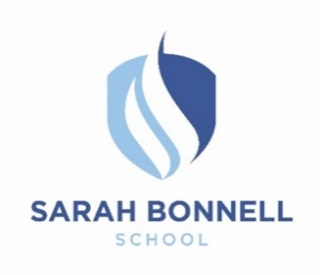 | Person Specification  Assistant Headteacher - SENDCo

Criteria

Education/Qualifications:
- Qualified Teacher Status.
- SENDCo qualification
- Honours degree.
- Evidence of continuing professional development.
- Evidence of further professional/educational study.

Professional knowledge, skills and competences:
- Be a successful classroom practitioner who is able to model outstanding teaching
- Ability to observe and evaluate mainstream and lessons for SEND, identify strategies for improvement and monitor them.
- Can demonstrate strategic thinking and planning that builds, communicates and carries forward a coherent and shared inclusive vision.
- A creative and analytical thinker who is able to engage in debate with middle and senior leaders in the school and who is able to gain the respect of students, staff and parents/carers.
- Current and relevant knowledge of best practice in school leadership and management, including specific focus on SEND.
- An ability to interpret data, including Raiseonline/FFt etc and translate this into priorities for school improvement.
- The ability to lead, coach and motivate staff within a staff appraisal framework understanding the importance of CPD for all staff and its role in school improvement.
- Excellent communication skills both oral and written, in a range of situations, both formal and informal, and with a range of audiences.
- Strong organisational and time-management skills and the ability to delegate appropriately.
- Ability to use ICT competently and effectively and a willingness to develop this further both at an individual and at whole school level.

Experience:
- Evidence of successful leadership at middle/senior level and of having led, planned, implemented and evaluated change.
- Evidence of successful leadership of SEND and inclusion which has improved outcomes for those with additional needs
- Evidence of successful impact of using data effectively to improve student progress.
- Experience of implementing strategies for improving the quality of teaching, learning and assessment.
- In-depth and up to date experience of school data systems e.g SIMs & 4Matrix
- Experience of working successfully with parents/carers, the wider school community and multi agency working.
- Experience of carrying out annual reviews alongside a range of professionals across setting
- Experience of holding individuals and teams to account for student outcomes.

Philosophy and commitment:
- A commitment to the Sarah Bonnell Values – Be Proud, Aim High, Work Hard, Be Kind, No Excuses
- A commitment to the responsibility to safeguard and promote the welfare of all students.

Personal qualities:
- A resolute commitment to the achievement of all young women.
- Ability to build and sustain effective relationships with parents/carers, staff, external partners, students and the broader community.
- An awareness of the importance of emotional intelligence in managing oneself and others.
- The ability to take personal responsibility, a readiness to reflect and self-evaluate and the ability to change, improve and develop.
- Resilience and optimism to lead through day-to-day challenges while maintaining a clear strategic vision and direction.
- Commitment to inclusion and equal opportunities.
- Willingness to participate actively in the wider school community.
- A desire to make Sarah Bonnell an outstanding school.

