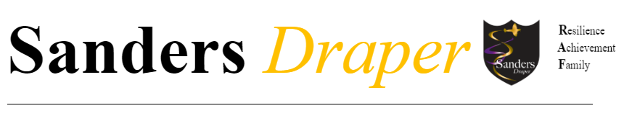

LEARNING SUPPORT ASSISTANT - SECONDARY

Job title: Learning Support Assistant

Scale: Scale 2, Point 3-4 - Actual Salary £19,642 - £21,934(33.5 hours)

Positions available: 3, possibly more

Responsible to: SENCO

Liaises with: Class teachers, HOFs and SENCO

Hours: 33.5 hours per week (timings of the day will be discussed at interview)

Starting: September 2025 (possibly the option of starting sooner)

Advert closes: Monday 2nd June 2025

Interviews from: Week beginning Monday 9th June 2025

The following provides the overall strategy and remit of the post holder. It should be read in conjunction with the Appraisal documentation to provide the key impact and outcomes expected for the academic year ahead. It is not intended as an exhaustive ‘job list’, but rather identifies key role descriptors that the post holder is accountable for.

The school expects staff to work flexibly and with initiative to improve student outcomes and welfare, and therefore a post holder may be required to carry out tasks as requested by the Headteacher.

Key role descriptors:
The Learning Support Assistant (LSA) is a member of a team of practitioners responsible for the education and care of the children in school.

The LSA is expected to have gained a NVQ level 2 qualification or be willing to complete one. The LSA supports students to make expected and above expected levels of progress. To do this the LSA will need to differentiate materials ensuring the students can experience success in their learning as well as being challenged. The teacher and the LSA work as a team – being ‘partners’ in supporting the students’ access to learning and the whole curriculum and their independence as learners

The LSA works under the direction and control of the Head Teacher and the SENCO. They may be required to work with groups or individuals from a class without the presence of the class teacher and supervise activities and tasks.

The main duties and responsibilities for this role are:

1. Support for students:
- provide appropriate levels of individual attention, reassurance and help for student(s) needs as identified in Individual Education Plans.
- support the specific needs of specified students; physical, emotional and/or behavioural
- where directed, act as an escort on and off school premises under the direction and where appropriate, in the presence of the teacher for the purpose of visits or off site educational provision
- support student(s) access to the curriculum, their learning in particular lessons and their progress towards specific individual targets
- ensure that teachers are aware of the specific learning needs of identified students
- support students in working independently around others through hover support
- to deliver as directed by the SENCO, one-to-one student programmes for interventions such as Literacy and Numeracy, handwriting, speech and language
- provide information, advice and direction to students about their behaviour within the agreed framework of school policies on discipline and behaviour i) take appropriate action to identify, analyse and minimise any risks to health, safety and security in the immediate working environment
- any staff appointed after September 2013 will be expected to provide Intimate Care for students as part of their role and therefore not receive additional payment.
- support the students with their use of the toilet

2. Support for the teacher(s):
- assist student(s) access to the curriculum by differentiating instructions and resources
- prepare materials of the quality and quantity specified by the teacher
- help student(s) to select equipment and materials relevant to their learning tasks and to use these safely and correctly
- support the maintenance of student records by providing information to the teacher/ SENDCo and recording, in accordance with school and faculties policy, the work of student(s)
- provide praise and encouragement to students to recognise and promote positive student behaviour in accordance with school rewards system and behaviour policies
- where necessary, correct student behaviour, supporting the teacher in maintaining order and discipline both in the classroom and in the school environment
- report uncharacteristic student behaviour patterns and Child Protection concerns about an individual student and incidents of inappropriate behaviour to the class teacher / named Child Protection Officer within the school.

3. Support for the school/faculty:
- attend internal meetings, including meetings of the faculty/student support faculty, all of which are recognised as directed time in the school calendar
- act as a reader or amanuensis as necessary at school and national tests and examinations where directed by SENCO / Exams officer
- assist in the administration of any appropriate assessments as directed by the SENCO
- share information and expertise, which could benefit other team members in their work in conjunction with the SENCO and/or Assistant Head in charge of CPD
- provide information to support student progress including information for student records, reports, Individual Education Plans and annual reviews
- actively encourage the development of positive relationships and promote confidence about the care and education of children during contact/communications with parents and external agencies, passing on any information by parents to the appropriate staff member
- promptly report any difficulties in communicating with parents and carers to the class teacher/ SENCO

4. Support for the curriculum
- support the curriculum plans and learning programmes designed by the teacher and obtain and use designated equipment and materials appropriate to the learning objectives and students’ development needs
- help students with the use of ICT and appropriate curriculum software
- obtain accurate and up-to-date information on students’ literacy, current reading ability, their writing skills and oracy and language development
- monitor students’ responses to learning activities and promptly inform the teacher when a student is experiencing difficulties that cannot be resolved
- respond to students’ use of home language and local accents and dialects in a manner which values cultural diversity and reinforces positive self images
- provide an appropriate level of assistance to enable students to experience a sense of achievement, maintain self-esteem and self-confidence and encourage self-help skills
- use appropriate strategies for challenging and motivating students to learn
- to supervise targeted students for break or lunch time as needed as directed by the SENCO

5. Arrangements for appraisal of performance:
- Participate in the school’s annual appraisal process and the regular reviewing of personal targets

ADDITIONAL REQUIREMENTS
- Sanders Draper School has a strong commitment to achieving equality of opportunity to the community and the employment of people and expects all employees to understand, comply with and promote its policies in their work and to undertake any appropriate training
- The postholder is expected to undertake any appropriate training, including recognised professional qualifications, considered necessary to fulfill the role
- The postholder is expected to demonstrate a flexible approach in the delivery of work. Consequently the postholder may be required to perform work not specifically identified in the job description, but which is in line with the general level of responsibility of the post.
- This job profile will be subject to review with the post holder after one year and may then be reviewed from time to time to met the needs of the students

We welcome visits. If you are interested in the role, and would like an informal and confidential discussion regarding the post, please email the school SENCO at bwigington@sandersschool.org.uk

We ask and advise that you submit your application as early as possible. We reserve the right to hold interviews earlier if appropriate.

Signed: ..........................................................................

Date: ..........................................................................

Print name ..........................................................................

Sanders Draper is committed to safeguarding and promoting the welfare of children and young people. All adults who work at the school must share this commitment to young people.

Learning Support Assistants
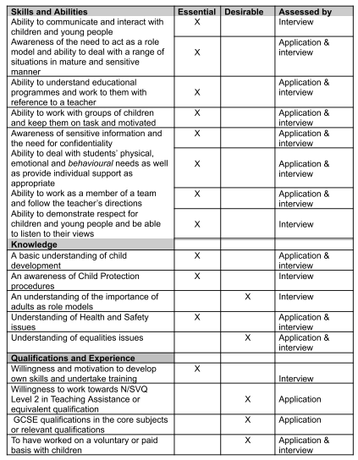

‘To be the best I can be’


Headteacher: Mr Stuart Brooks BSc (Hons)
Sanders Draper, Suttons Lane, Hornchurch, RM12 6RT
Tel: 01708 443068 Email: enquiries@sandersschool.org.uk
Website: sandersschool.org.uk Twitter: @Sanders_Draper

