Teacher of PE

Salary Range: Main Pay Scale

We are looking for an ambitious individual who is knowledgeable in their subject and is committed to supporting and developing the vision for St Aidan’s on our journey to outstanding.

The ideal candidate will:

- Be an outstanding classroom practitioner and role model, demonstrating high personal and professional standards
- Demonstrate good pedagogy practice, sharing it within the department.
- Support colleagues so that outstanding standards of behaviour are established and maintained.
- Fully support the extra-curricular activities of the Academy.

Further details and an application form are available from Alex Simpson, Tel: 01325 373778 or Email: a.simpson@staidansacademy.org.uk or alternatively downloaded from our website: www.staidansacademy.co.uk

Applications must be returned to Alex Simpson via the above email or by post to the below address.

The Academy is committed to safeguarding and promoting the welfare of children and expects all staff to share this commitment. The post is subject to a successful DBS clearance and pre-employment checks will be undertaken before an appointment is confirmed.

Closing Date: Tuesday 16 July, 12noon

Interview Date: Thursday 18 July

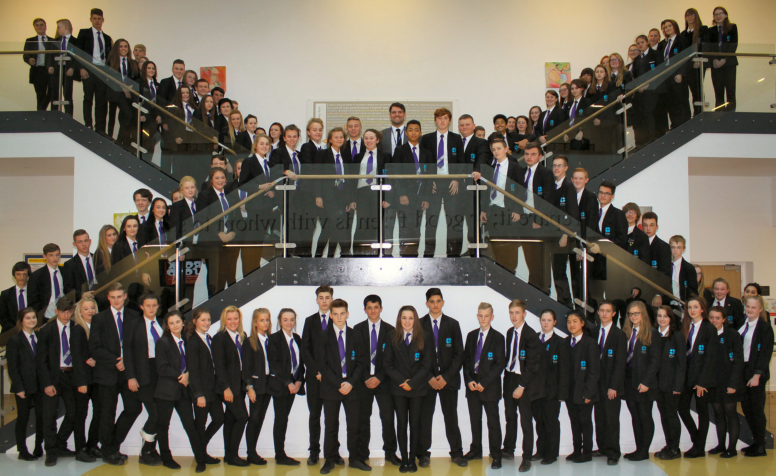

St Aidan’s Church of England Academy
Hunden’s Lane, Darlington
DL1 1LL

Phone: (01325) 373770

Principal: Nicole Gibbon

