8th November 2019

Dear Applicant

Thank you for taking the time to read the information on our position for an Exams Officer. I hope that through reading the attached information you gain a sense of the atmosphere, vision and ethos of our school.

Whitworth Park’s core vision is built on values of respect – for ourselves, for others and for members of the wider school community. We believe that perseverance, imagination, creativity and effective teamwork can be combined to enable all students to access exciting and fulfilling careers in the long term. Whitworth Park is a warm, welcoming and hardworking community striving for excellence.

This is a wonderful opportunity to join a welcoming and caring school. I would encourage you to contact my PA, Mrs E Rigby on e.rigby@whitworthpark.org.uk to arrange to visit the school and have a look around. You will find that staff and students in our school are exceptional people to work with. Behaviour and relationships are excellent and the environment is very pleasant.

On our website www.whitworthpark.org.uk you will find further information about the school, the department and the post itself. The closing date for applications is noon on Friday 22nd November 2019. If you do not hear from us within four weeks, please assume that you have been unsuccessful on this occasion.

We look forward to reading your application and to meeting you in person at interview.

Yours sincerely
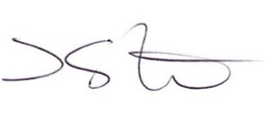

Mr D Stone
Headteacher

