TEACHING TEAM RECRUITMENT
2017

The purpose of this pack is to introduce the UTC and provide information that will help you apply to join us. If you’re inspired by the thought of working with us then please apply, even if you feel your expertise doesn’t quite fit. We are aiming to build a great team and it will take people with a range of skills and experience to make a success of it.
If you want to find out some more about me then a good place to start is my LinkedIn profile (https://www.linkedin.com/in/stevewarburton) but I’d also be really happy to meet you if you want to discuss our vision for the future of the UTC.
Steve Warburton MA (Oxon), MBA, NPQH
Principal

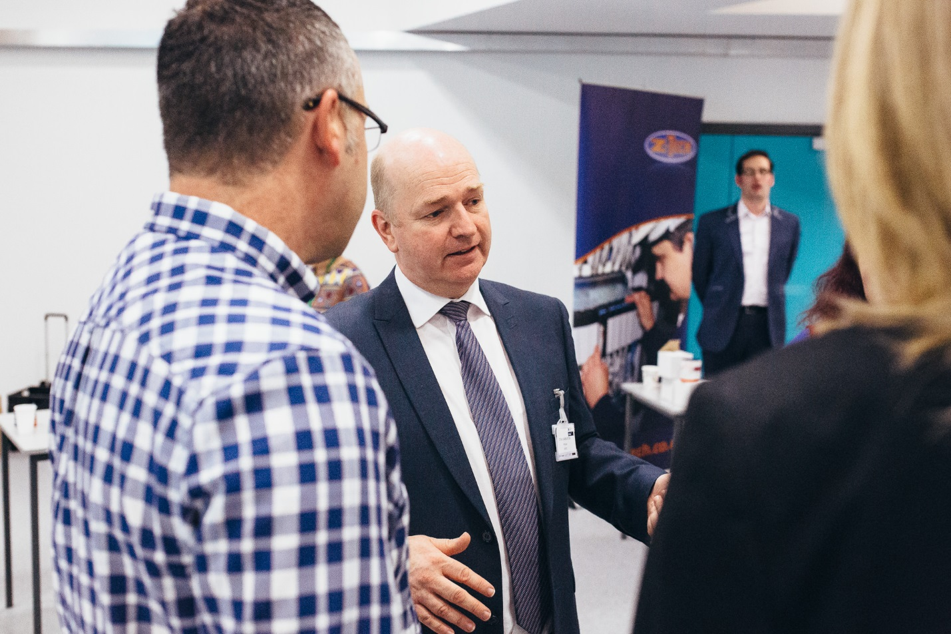
Steve Warburton talking with parents at a recent Open Evening

Greater Peterborough UTC
Teaching Team Opportunities December 2017

Lead Teacher of Computer Science

Greater Peterborough UTC opened in September 2016 with 140 students aged 14-18. Doubling in size this year, we are seeking to increase our teaching team so we can continue to provide high-quality academic and technical education.
GPUTC specialises in Engineering and the Built Environment and is programmed to continue growing to 400 students by 2019.
We are inviting applications from passionate and experienced individuals who are great in the classroom/workshop and keen to make a significant contribution to the development of the school. Enthusiastic for the UTC concept, fully supportive of our vision, you'll be inspirational, able to tackle problems head on and have the communication skills and emotional intelligence to engage with all the issues involved in developing a new school.
Our sponsors recognise that these are demanding roles in a pioneering organisation and we are committed to supporting staff as effectively as possible.
Further details and an up-to-date listing of roles that are still available plus how to apply are available from our website - www.gputc.com/jobs

Introducing Greater Peterborough UTC
What we say about ourselves to the world…
The Greater Peterborough University Technical College (GPUTC) is the choice for engineers, builders, designers and architects of the future. Our mission is simple; to enable students to develop a great future for themselves by providing them with the highest possible level of education: technical and academic.
We will equip students with the technical skills and practical work experience they will need to get a head start in the career they want. We can promise this because we are unique in having real businesses sponsoring us and our students. Our sponsors, and many other organisations, need high calibre people with the right skills to become valuable employees.
Our ambition is to ensure that every student graduates from us to a job, apprenticeship or further study at a college or university. We are so confident in what we have to offer that we guarantee all our graduates job interviews with our employer sponsors.

My perspective
It was interviewing students who were applying to join Greater Peterborough UTC that convinced me that I wanted to be its opening Principal and lead it into the success that this city needs it to be. It was the enthusiasm of these students – bright, gifted young people – for a new way of learning, for a way that integrated practical and academic learning together and did it within the context of real-world problems associated with engineering and the built environment that stoked my passion for education that can make a difference.
We’re now in the position where we need to continue building the team that can lead the school forward. It would be great if you have more than one area of expertise to offer to the organisation because for at least the first three years we will be stretched very thinly… however if you’re ‘just’ a brilliant teacher of your subject we’ll want to employ you. We’ll all be taking on multiple roles in and out of the classroom and that’s why we need some special people with great attitudes that shout ‘can-do’! The sense of mission and purpose will be tangible and the opportunity to work in a ground-breaking way could be career-defining moments wherever you are at on your career journey.
I’m under no illusions about the challenge it will be to guide our first cohorts to success. Virtually everything will need to be created by us – that’s hard work but also fulfilling. Time is limited and you will need to be innovative thinkers and pragmatic implementers who know how to get things done with restricted resources.

The UTC
Development
This UTC has been a long time in development and the Trust Board have shown considerable resilience to bring it to fruition. We failed to recruit enough pupils to open in September 2015 and, although a very disappointing setback, this proved to be a blessing in disguise for the project.
Student recruitment into Year 10 and Year 12 for our September start was strong. We surpassed the initial opening targets set by the DfE, starting with 140 students (60 KS4, 80 post-16). Applications for next year are again very positive and should mean the student cohort is 280 – 300 in September 2017.
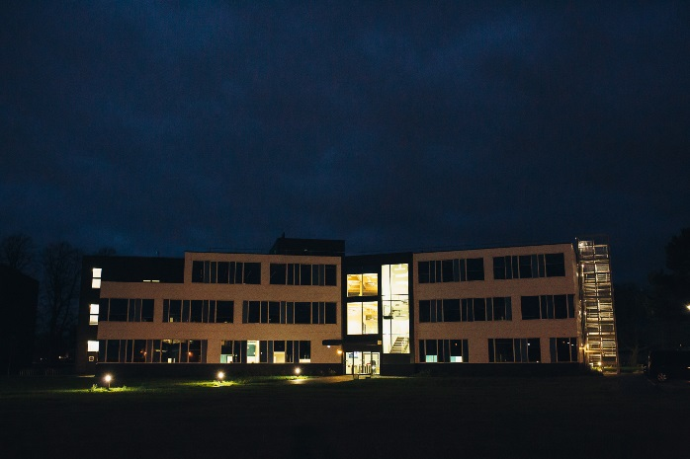
The UTC is a distinct institution situated on the campus of Peterborough Regional College in Park Crescent, Peterborough. Both PRC and Anglia Ruskin University – our Education partners - have contributed significantly to the UTC’s development and both these organisations will continue to work closely with us. Our industry sponsors and partners have been focused on providing board-level leadership, practical support, HR back-up, considerable marketing assistance and developing inspiring challenge projects. Our partners include Anglian Water, the Larkfleet group, Marshall Aerospace and Perkins Engines. That base of partners is helping our students see all the different avenues that are open to them when they graduate from us.
The UTC is a Free School, set up under the Academies Act with its own Trust Board and Funding Agreement. Funded directly by the EFA, our budget is little different to other schools but we do benefit from being able to focus our resources on a restricted range of subjects.

Curriculum
Students in KS4 study core GCSEs: Maths/English/Sciences and Geography, coupled with options to study GCSEs Computer Science, Art & Design, Product Design , Modern Foreign Languages and Business Studies, all alongside Level 2 qualifications in either Engineering or the Built Environment.
These qualifications are supplemented by the statutory requirement to teach Religious Education and provide opportunities for PSHE and Sport, as well as extensive Qualifications+ opportunities.
At post-16 the focus is much more on the Technical courses with students’ programmes being built around 12-module Level 3 Technical Diplomas in Engineering (OCR Cambridge Technicals) or the Built Environment (City & Guilds) and supplemented with one or two A levels in Maths, the Sciences, Computer Science, Business Studies, Geography, Art & Design, Product Design or the Extended Project Qualification.
These dense pre- and post-16 programmes are supplemented with additional opportunities to take part in activities that broaden out the curriculum and allow for development of the rounded young people who will be ready, willing and able to either make a direct contribution to any company that employs them or which places them in the ideal place to succeed at University.
For the students we are aiming to establish as ‘adult’ an environment as possible. There will be no ‘bells’ as students and staff take responsibility for their own timekeeping , whilst mentor support will replace tutor groups as the primary approach to pastoral care and development support.

Working at the UTC
The operational day is a long one for staff – students are with us from 0900hrs to 1645hrs – and there is the expectation that the UTCs offer more than what students would normally experience in a mainstream school. Preparation time and non-contact time will be built into the staffing time allocation (no member of staff teaches more than 80% of the week) and it is intended that one day a week will feature an earlier finish for teaching staff to support the provision of staff CPD.
We operate very similar term dates to schools in the Peterborough area, with some limitations imposed by our transport partnership with Peterborough Regional College which enables students from across the region to access the UTC.
All the leadership team will be contributing to the teaching at KS4 and KS5 – this will increase the visibility and engagement of the team with staff and students. There will be no tutor groups but each of us will be mentoring several students, meeting them on a one-to-one basis once a fortnight.
Full-time teachers have between 22 and 25hrs hrs of classroom contact time, which includes mentoring and enrichment activities within the UTC day. It would be easy to ‘hide’ this information, but the reality is that everyone needs to know the size of the task they are committing themselves to.

Well-Being & Development
Staff are supported in their development by having access to management and skill development activities offered by our sponsors such as Anglian Water’s ‘Building High Performing Teams’ programme. An element of your development could also be a sponsored placement on the STEM Insight Programme to enable you to develop your own awareness of, and integration with, the industries linked to our GPUTC specialisms.
It is also intended to offer colleagues an opportunity every six months to take a ‘well-being’ day’s leave in term-time, as a recognition of the commitment made by colleagues daily to provide the very best for our students.

Resources
Significant investment in ICT resources and specialist equipment has already been made but all staff will have the opportunity to contribute to decision-making about the remaining key elements.
Every classroom has the same ICT provision for staff and all teachers are provided with a high-specification i7-driven ultra-portable which connects wirelessly to classroom displays. The level of ICT provision for students means that there is 1 device for every 2 students either in open areas for study and independent working or in our four design studios for Year 2 and the wireless network is fully configured to support students bring in their own devices.

Finding out more:
From our social media channels: @GPUTC
https://www.facebook.com/GreaterPeterboroughUTC

Via our newsletters: https://www.smore.com/u/gputc

About UTCs: http://www.utcolleges.org/

About teaching in Peterborough http://www.teachpeterborough.co.uk/

About our sponsors & partners : http://www.anglianwater.co.uk/
http://www.larkfleethomes.co.uk/
https://www.perkins.com/en_GB.html
http://marshalladg.com/
http://www.peterborough.ac.uk/
http://www.anglia.ac.uk

Expectations of Staff

- Be believers – that all young people can achieve beyond national expectations, and that all, without exception, will progress to university, employment and/or training.

- Be enablers – building a climate that engenders personal growth and success for all staff and students

- Be standard-setters - modelling the highest of standards that serve to uphold the vision and values of the UTC and maintaining high professional standards of attendance, punctuality, appearance, conduct and positive, courteous relations with students, parents and colleagues.

- Be collaborative – developing strong educational relationships with partners to provide inspiration and motivation and embody for the students, staff, governors, parents, and the wider community the vision and purpose of the UTC.

- Be inspiring - teach high-quality lessons that stimulate young peoples’ love for learning and development

- Be committed – to supporting the UTC in its mission and carry out the duties of a teacher in accordance with the current Teachers’ Standards Document and GPUTC policy.

- Be protective - ensuring equal opportunities for all free from harassment, bullying or discrimination.

- Be self-leaders - continually active in your own professional development

Newly-Qualified/FE-qualified/Industry-experienced or Academic staff
UTCs have flexibility in the types of staff they can employ. Greater Peterborough UTC intends to take full advantage of those freedoms to employ staff who:
- Are entirely new to the teaching profession and want to train with us
- Have qualified to teach in sectors outside the 11-18 focus of secondary schools
- Have significant experience in Industry or the Armed Forces, are experts in their specialist fields and whose natural habitat is the workshop… but they may have only an enthusiasm for teaching/training/instructing but no formal teaching qualification
- Are engaged in Degree and Higher Degree studies and have some time available to devote to teaching

More Information about the posts
Not all our students have made their option choices yet, but the details below identify the likely teaching loads of the posts. For all the posts that are not full-time, there is the possibility of teaching another subject to make up a ‘full’ timetable commitment. The Application Form gives an opportunity to identify such expertise in any of the subjects where we’re seeking staff.

Lead Teacher: Role Description
Responsible to – Vice Principal or Director of Learning
Job purpose:
1) Quality of Teaching and Learning
- To provide excellent teaching.
- To support colleagues within the faculty, and the UTC, so that they may become excellent teachers.
- To support other classroom staff in achieving excellence in their work.
- To deliver outstanding student outcomes and to support colleagues in achieving the same.
- To keep up to date with national developments in relevant subject and teaching practice and methodology.
- To advise senior colleagues on teaching and learning and to contribute to policy and practice across the UTC.
- To raise the quality of teaching and learning at the UTC.

2) Curriculum Development
- To work with colleagues to produce schemes of work and teaching and learning resources to promote high standards.
- To develop resources for learning outside the classroom.
- To assist colleagues in finding appropriate high quality resources.

3) Subject Management
- To ensure the appropriate resources are available for students to be successful
- To ensure that students are studying for and entered for the correct exam courses
- To design and develop professional development activities.
- To support colleague experiencing difficulties.
- To work with colleagues in other institutions as appropriate.

4) General UTC-wide Responsibilities
- Update the Principal, other senior Leaders and the Governing Body on the effectiveness of the provision in your subject area
- Lead by example as a teacher achieving high standards of student attainment and progress, behaviour and motivation through effective teaching
- Challenge underperformance and ensure corrective action and follow up
- Contribute to the Enrichment programme for students
- Support the development and maintenance of whole UTC policies and practices to ensure consistent application of whole UTC policy and procedure
- Have a teaching commitment in line with Subject Leader level
- Serve as a mentor for a group of students
- Sustain effective, positive relationships with all staff, students, parents/carers, governors and the local community
- Maintain clear expectations and high standards of professionalism
- Attend UTC events and activities such as Open Days and Parent Consultation Evenings as directed by the Principal
- Keep the UTC Leadership Team up to date with national developments specific to your area of responsibility

Teacher: Role Description
Salary in range: MPS/UPS
Teaching and learning
- Deliver outstanding learning experiences which engage and excite our students.
- Plan and teach well-structured lessons which engage students to learn for themselves.
- Bring the curriculum to life through practical application relevant to the world of work.
- Adapt teaching to meet the needs of groups and individual students.
- Have clear and high expectations of student attitudes; use the Workplace Skills to
ensure that students are clear about how they should behave.
- Give students regular feedback and clear targets in order to help them improve.
- Encourage them to reflect on their progress and support them to become successful
independent learners.
- Reflect on student learning and own teaching practice to improve future effectiveness.
- Work with colleagues to evaluate teaching, giving and receiving feedback to help
improvement.
- Gather feedback from students and respond positively to suggestions for improvement.
- Develop an inclusive and supportive approach so that all young people feel welcome and supported in their learning.
- Set work for classes for planned absence and, where possible, for unplanned absence.
Raising aspiration, achievement and attainment
- Be accountable for students’ progress and attainment in all classes taught.
- Have high expectations of students in achieving their academic targets, irrespective of background.
- Work with the Faculty Director to use assessment data to set challenging targets for
students and to accurately track their progress, with a focus on groups and gaps.
- Use accurate assessment methods to understand and track the progress of every
student and design appropriate strategies to support their learning.
- Address the needs and aspirations of each student through personalised learning.

Curriculum expertise
- Maintain subject expertise across relevant Key Stages and qualifications.
- Develop subject expertise, especially in areas with lack of experience or with new
qualifications.
- Design and implement a curriculum in specified subject areas which meets the needs of all students, is consistent with the UTC’s Vision and Values and fulfils statutory
requirements.
- Ensure that opportunities are taken to develop the curriculum to reflect the specialist
ethos of the UTC and which prepares young people for their range of future possibilities.
- Ensure that students understand how the curriculum is relevant to the world of work and develops their Workplace Skills.
- Support student development of literacy and numeracy skills throughout their experience.
- Have an attitude of flexibility to teach other subjects with appropriate support and CPD.
- Contribute to a flourishing enrichment programme which provides a broad and
stimulating experience for all students.
Developing the organisation
- Promote the UTC’s values across staff and students and with business partners.
- Contribute significantly to student recruitment, through attending events in the UTC and elsewhere and promoting the UTC.
- Treat students as young adults, show them respect and earn theirs.
- Promote the Workplace Skills through discussion with students and by demonstrating
them in professional approach.
- Work with the leadership team to critically evaluate the UTC’s performance and influence change.
- Contribute to the CPD of other staff using own expertise and seek opportunities to
develop personal knowledge and skills.
- Be efficient with resources and mindful of waste to ensure value for money.
- Ensure effective use of all technological and pedagogical resources.
- Work in partnership with parents/carers ensuring that they have full information about the progress of their children and contribute to their learning.

Additional duties
- Act with integrity and ensure a high standard of care and safeguarding for all our
students.
- Comply with health and safety rules and legislation, ensuring the safety of students and staff at all times.
- Provide a highly visible presence to students and colleagues through the day.
- Attend open evenings, parental events, progress review meetings and other dedicated activities, as required.
- Act in compliance with data protection legislation in respecting the privacy of personal information.
- Comply with the principles of the Freedom of Information Act 2000 in relation to the
management of UTC records and information.
- Undertake additional duties as may be reasonably directed by the Principal or line
manager where they meet the priorities of the UTC
All posts
The expectations will be assessed as part of the selection process, using the Application Form, Reference, Presentation and Interviews to provide evidential support. Whilst every attempt has been made to cover the main duties and responsibilities of these posts, this list is not exhaustive and each individual task involved in the roles may not be identified.
The role description is open to discussion at interview to meet a particular individual’s strengths or personal development goals.
Furthermore, the exact nature of the post will be finally determined once the appointment has been made and reviewed annually. This will be in full collaboration with the successful candidate taking into account the individual skills and experiences they bring with them.
This post is subject to a criminal records check from the Disclosure & Barring Service (formerly CRB) as part of the UTC’s responsibility for promoting the welfare and safeguarding of children.

The Appointment Process
Application is by our Application Form which can be downloaded from our website.
Please complete all sections in as much detail as possible and use section 6 for your covering letter which should clearly address the appropriate sections identified in the Role Description & Person Specification. If you want to apply for more than one role, please submit a separate section 6 for each position.
Please complete the Equal Opportunities Monitoring Form in addition and then submit your full application (this form plus your letter of application) to:
E-mail: s.warburton@gputc.com
Post: Mr S Warburton, Greater Peterborough UTC, Park Campus, Park Crescent,
PETERBOROUGH, PE1 4DZ

Short-listing will take place when approrpiate and if successful at that stage you will be invited to a selection event here at the UTC. That event will be a short intensive one and feature an interview exploring your responses to an online psychometric profile we will have asked you to complete, a tour of the UTC, a presentation and a panel interview. If invited to the selection event, please bring with the relevant documents referred to in your application (eg. Degree certificate).

