Ebor Gardens Primary Academy

Head of School
Information Pack

Contents
Welcome from Executive Principal…………………………………………….……………………3
About Ebor Gardens Primary Academy 4
About Wellspring Academy Trust 5
Job Description 6-9
Person Specification……………………………………………………………………..……..10-12
How to Apply / Timeline 13

Dear Applicant,

Re: Head of School, Ebor Gardens Primary Academy

Thank you for your interest in the Head of School position at Ebor Gardens Academy, Leeds.

We are looking for an exceptional professional to lead our academy and become a key member of our leadership team within our growing – and thriving - Multi-Academy Trust.

You will be able to demonstrate a track record of bringing out the best in people to create a fantastic learning culture for staff and pupils alike. Demonstrating high expectations and being able to share a compelling vision, you will invigorate a large staff team towards the next phase of the school’s journey. Ebor Gardens was judged to be ‘Good’ during its Ofsted inspection in March 2019 and we are now looking for the right person to lead the team forwards towards an even brighter future.

Ebor Gardens works in close partnership with our sister school Victoria Primary Academy that is less than a mile away. Exceptional leadership development is a feature of Wellspring Academy Trust, with opportunities for personal development via close working relationships with fellow Heads of School across the Trust. We are a community of leaders passionate about making a difference in the lives of our young people and we work closely together to unleash our own potential, in the certain knowledge that leaders who are thriving lead thriving schools.

Ebor Gardens is a large, inner city school which is full of possibility. It has a large staff team and over 400 wonderful children who are looking for a Head who will support, champion and encourage them to be the best they can be. If you think that could be you, I strongly encourage you to come and visit us.

Please contact Jeni McCormack, Senior Office Manager at Ebor Gardens Primary Academy, on 0113 2482750 or E-mail jeni.mccormack@eborgardensacademy.co.uk

I very much look forward to meeting you.

Sam Bailey

Executive Principal
Wellspring Academy Trust

About Ebor Garden Primary Academy

Ebor Gardens Primary Academy is a larger than average Primary school with 2-forms of entry and 460 pupils on roll. The recent Ofsted inspection recognised the improvements which have already been made and there is an appetite for building on the foundations to make that ‘good’ school great. The potential here is huge, and there is a real opportunity for the new Head of School to create a legacy in this area of high deprivation on the outskirts of Leeds town centre.

We aim to provide the best education we can for all our pupils in a magical school environment. We strongly believe that school should be a place of wonder for our children and are determined to make primary school days full of fun and memories to last a lifetime. Success is achieved in close partnership with pupils, parents, carers, governors and other members of our multicultural community. We believe that, together, we can achieve the extraordinary and this is our mission in the next few years.

As a school we are keen to develop innovative approaches to education, not always doing things the same way they have always been done.

This is an exciting time to lead the Academy with incredible opportunities to make a significant difference and to forge a reputation for excellence. The time is right for a leader with charisma, expertise and passion to drive the school forward to an exceptional future.

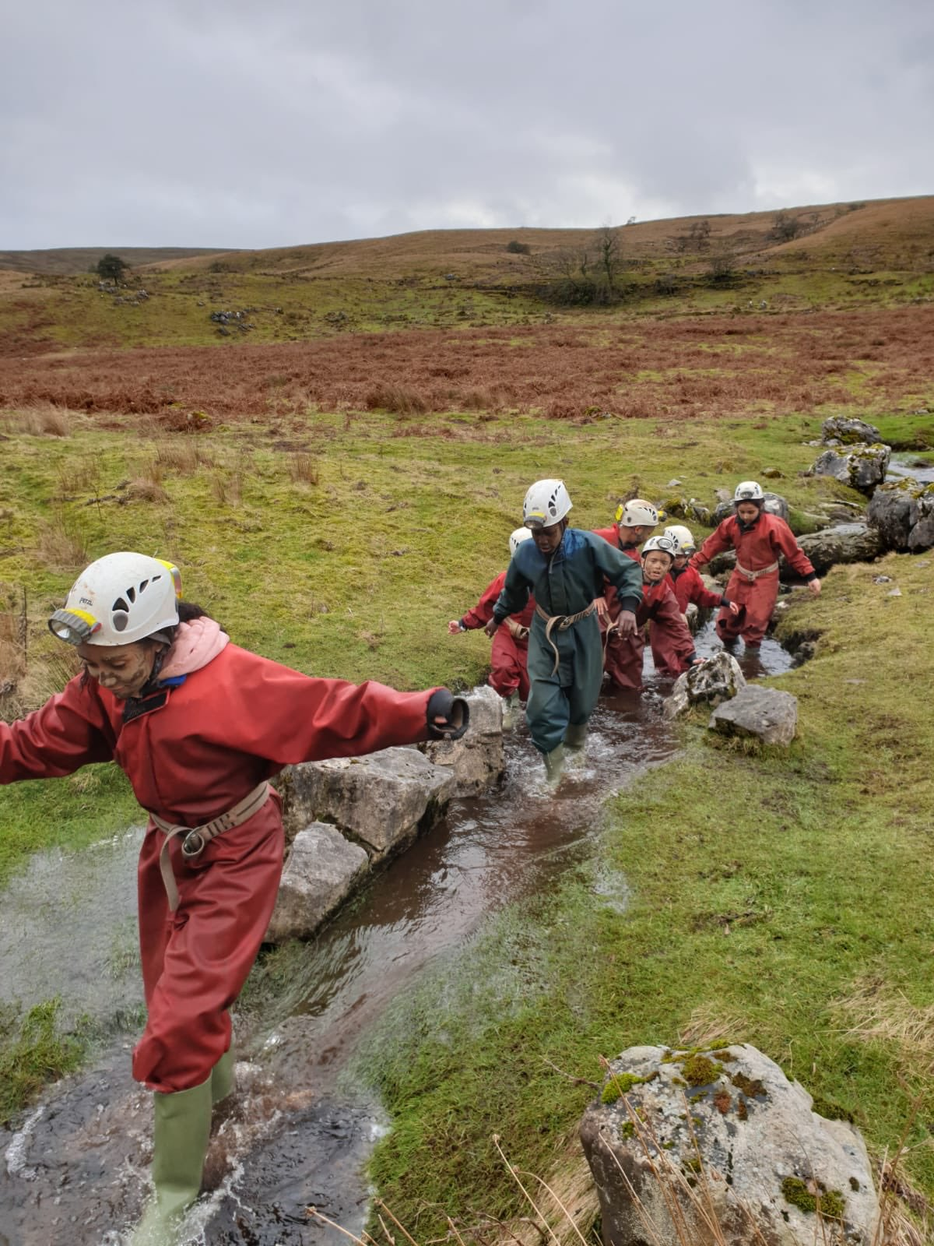

About Wellspring Academy Trust

We describe Wellspring as a community, rather than as a Trust. Wellspring is a community of Academies clustered in our West, Central and East regions. We have a community of Primary, Special and Alternative Academies. We have some small federated communities in localities.
We have communities of practice that have come together of their own accord to pursue matters common to them. We have communities of governors, and more. All of these communities co-exist happily within an overall Wellspring community.

Wellspring provides the infrastructure, resilience and assurance that enables each of these communities to thrive.

We are a flexible, dynamic and growing Trust.

We have the ambition to be a significant force for the good of our communities.

We have the vision to provide children and families with exceptional educational opportunities.

Our Core Principles are:
- Excellence in teaching and learning.
- Knowledge and skills growth that is celebrated by the community.
- Collaboration with all partners in education and the community.
- Succession planning within the institution and beyond.
- Providing an exceptional school experience for our children.

Our commitment to you

Professional Development
We believe that outstanding professional development underpins outstanding schools. The more members of staff who are enabled and empowered with expert skills and knowledge, the more effective their impact upon learning. We believe in the power of Professional Development. We believe that it can and should be happening every minute of every day. Wellspring Academy Trust has access to a rich seam of Professional Development for all staff through our network of leaders, colleagues and Academies, and through our Teaching School, Positive Regard.

Leaders Professional Development
Inside every successful school, you will find successful leaders. Almost every study of school effectiveness has shown both Primary and Secondary leadership to be the key defining factor. At Wellspring, we emphasise the importance of ongoing professional development for school leaders. We work together as leaders. We share our experiences and expertise. We recognise that we are stronger together.

Our recognition of the pivotal importance of effective leadership means that the pathway into other leadership opportunities will be open to you across the Trust.

More details are at www.wellspringacademytrust.co.uk

Wellspring Academy Trust

Job Description

Post Title: Head of School
Location: Ebor Gardens Primary Academy
Reporting to: Executive Principal, Governing Body
Grade: L16-L22
_________________________________________________________________________

Principle Responsibility
The appointment is subject to the current conditions of service for Headteachers contained in the School Teachers’ Pay and Conditions document and other current education and employment legislation.

Specific Responsibilities

Shaping the future
To work with the Executive Principal, Trust and Governing Body to develop a strategic vision for the Academy within its community; work with Executive Principal to analyse and plan for the future needs and further development of the Academy within the local, national and international context, by:

- Implementing the educational vision, direction and ethos that secures effective teaching and successful learning and achievement by pupils, preparing them for the opportunities, responsibilities and experiences of adult life;
- ​Ensuring that the vision for the Academy is clearly articulated, shared, understood and acted upon effectively by all;
- ​Working with the Executive Principal, Governing Body and the Academy community to translate the vision into agreed objectives and operational plans which promote and sustain Academy improvement;
- Demonstrate the vision and values in everyday work and practice;
- Ensuring that all those involved in the Academy are committed to its aims, motivated to achieve them and involved in meeting long, medium and short-term objectives and targets that secure the success of the Academy;
- ​Implementing a strategic plan that takes account of the diversity, values, experience and aspirations of the Academy and the wider community;
- Working to ensure that the strategic plan set in partnership with the Executive Principal and the Local Governing Body for Ebor Gardens Academy is underpinned by sound financial planning, which identifies priorities and targets for ensuring that pupils achieve high standards, make progress and increases teachers’ effectiveness and secures Academy improvement;
- ​Leading curriculum development and innovation, ensuring creativity and the use of appropriate technologies to achieve excellence;
- ​Ensuring that policies and practices take account of national, local and Academy data and inspection research findings; and
- Working in partnership with the Executive Principal to monitor, evaluate and review the effects of policies, priorities and targets of the Academy in practice and taking necessary action.

Securing Accountability
To be accountable to the Executive Principal for the efficiency and effectiveness of the Academy and to engage in the systematic and rigorous self-evaluation of the work of the Academy, collecting and using a rich set of data to understand the strengths and weaknesses of the Academy and combining the outcomes of regular Academy self-review with external evaluations in order to develop the Academy by:

- Providing information, objective advice and support that enables the Academy to meet its responsibilities for securing effective teaching and learning and improved standards of achievement and for achieving efficiency and value for money;
- Maintaining the Academy ethos, which enables everyone to work collaboratively, share knowledge and understanding, celebrate success and accept responsibility and accountability for outcomes;
- Reporting to the Executive Principal and Trust on the discharge of the functions and the affairs of the Academy;
- Ensuring individual staff accountabilities are clearly defined, understood and agreed and are subject to rigorous review and evaluation in keeping with performance management review timelines;
- Using a range of evidence, including national data and the Academy’s own performance data, to support, monitor, evaluate and improve aspects of Academy life, including challenging poor performance;
- Maintaining quality assurance systems, including Academy review, self-evaluation and performance management and presenting a coherent and accurate account of the Academy’s performance to a range of audiences to enable them to play their part effectively;
- Ensuring that parents and pupils are well informed about the curriculum, attainment and progress and about the contribution that they can make to achieving the Academy’s targets for improvement;
- ​Supporting the Executive Principal on reporting to the Governors annually on the performance management of Teachers at the Academy in relation to the School Teachers’ Pay and Conditions Document;
- Providing information about the work and performance of staff where it is relevant to their future employment; and
- Reflecting on personal contribution to Academy achievements and taking account of feedback from others.

Strengthening Community
To recognise and take account of the richness and diversity of the Academy’s communities. To contribute to a dialogue that builds partnerships and community consensus on values, beliefs and shared responsibilities. Listen to, reflect and act on, community feedback. Build and maintain effective relationships with parents, carers, partners and the community. Enhance the education of all pupils by:

- Contributing to an Academy culture and curriculum that takes account of the richness and diversity of the Academy and the wider community;
- Promoting positive strategies for challenging racial and other prejudice and dealing with racial harassment;
- Ensuring learning experiences for pupils are linked into and integrated with the wider community;
- Ensuring a range of community-based learning experiences;
- Working in partnership to provide academic, spiritual, moral, social, emotional and cultural well-being of pupils and their families;
- Contributing to the communication flow with the wider community to build upon all stakeholders’ confidence and understanding of the Academy;
- Identifying and using opportunities to invite parents and carers, community figures, businesses or other organisations into the Academy to enhance and enrich the Academy and its value to the wider community;
- Ensuring that the Academy promotes effective links with the local community and continues the development of close liaison with other local primary and secondary schools;
- Sharing effective practice, working in partnership with other schools and promoting innovative initiatives;
- Co-operating and working with relevant agencies to protect and safeguard children;
- Ensuring that the Academy offers appropriate extended services;
- Co-operating and working with relevant agencies to secure the outcomes of Every Child Matters;
- Maintaining an inclusive environment whereby all children, including those with physical or learning difficulties, can be welcomed and supported appropriately; and
- Maintaining an effective partnership with parents and carers to support and improve pupils’ achievement and personal development.

Managing the Organisation
To take day to day operational control of the Academy under the direction of the Executive Principal. Contribute to the Academy’s strategic plan and financial context, making informed judgments. Make a significant contribution to the development of appropriate structures and systems, delegating management tasks and monitoring their implementation. Prioritising, planning and organising self and others. Think creatively to anticipate and solve problems, by:

- Having day to day operational control of the organisational structure that reflects the Academy’s values and enables the management systems, structures and processes to work effectively in line with legal requirements and Trust policies;
- Working in partnership with the Executive Principal in managing and organising the Academy environment efficiently and effectively to ensure that it meets the needs of the curriculum and Health and Safety regulations;
- Producing and implementing clear, evidence-based improvement plans and policies for the development of the Academy and its facilities;
- Working with the Executive Principal to recruit, retain and deploy staff to achieve the vision and goals of the Academy;
- Dealing with the competence and capacity of staff;
- Identifying priorities for expenditure, allocating funds and ensuring effective administration and control;
- Holding staff to account for performance and disposition
- Managing, monitoring and reviewing the range, quality, quantity and use of all available resources in order to improve the quality of education, improve pupils’ achievements, ensure efficiency and secure value for money;
- Responsibility for promoting and safeguarding the welfare of children and young persons; and
- Deploying a range of technologies effectively and efficiently to manage the Academy.

Developing Self and Working with Others
Lead, motivate, support, challenge and develop individuals and teams. Foster an open, fair, equitable culture, treating people with dignity and respect. Maintain a positive Academy culture, by:

- Maximising the contribution of staff to improve the quality of education provided and standards achieved and ensuring that constructive working relationships are formed between staff and pupils;
- Planning, allocating, supporting and evaluating work undertaken by groups, teams and individuals, ensuring clear delegation of tasks and devolution of responsibilities in a manner consistent with their conditions of service;
- Maintaining a collaborative learning culture within the Academy;
- Sustaining effective systems for staff induction, professional developments and the management of staff performance, incorporating appraisal and targets for teachers, including targets relating to pupils’ achievement;
- Ensuring that trainees and newly qualified teachers are appropriately trained, monitored, supported and assessed in relation to the standards for Qualified teacher Status, the Career Entry Profile and standards for induction;
- Regularly reviewing own practice, setting personal targets and taking responsibility for own personal development;
- Challenging, influencing and motivating others to attain high goals, maintaining a culture of high expectations for self and for others, acknowledging and celebrating the achievements of individuals and teams and taking appropriate action when performance is unsatisfactory; and
- Collaborating and networking with others between and beyond the academies.

Leading Learning and Teaching
To work with the Executive Principal to secure and sustain effective teaching and learning throughout the Academy. To monitor and evaluate the quality of teaching and standards of pupils’ achievement, using benchmarks and setting targets for improvement, by:

- Ensuring that all pupils receive a high quality education in a happy, stimulating, safe and healthy environment;
- Ensuring a consistent and continuous Academy-wide focus on pupils’ achievement, using data and benchmarks to monitor progress in every child’s learning;
- Ensuring that learning is at the centre of strategic planning and resource management;
- ​Maintaining creative, responsive and effective approaches to learning and teaching;
- Ensuring a culture and ethos of challenge and support where all pupils can achieve success and become engaged in their own learning;
- ​Demonstrating and articulating high expectations and setting aspirational targets for the whole Academy community;
- Implementing strategies that secure high standards of behaviour and attendance;
- Determining, organising and implementing a diverse, flexible and purposeful curriculum that is relevant to pupils’ needs and is supported by an effective assessment framework;
- ​Implementing approaches that develop pupils’ understanding of themselves as learners and motivate and support them to improve their learning;
- Organising and implementing new and emerging technologies to enhance and extend the learning experience of pupils;
- ​Monitoring, evaluating and reviewing classroom practice and promoting improvement strategies to ensure that the highest standards of teaching and learning are maintained and that underperformance is challenged at all levels; and
- Giving and receiving effective feedback and acting to improve personal performance.

This job description may be amended at any time in accordance with the needs of the Academy after discussion and appropriate consultation with the post holder.

HEAD OF SCHOOL: PERSON SPECIFICATION | Essential / Desirable | How Identified
Leadership and management
Ability to build effective relationships with staff, parents, governors and other agencies | E | APP / SP
Ability to line manage staff | E | APP / SP
Ability to make and implement difficult decisions | E | APP / SP
Clearly communicates the vision of the Academy | E | APP / SP
Shaping the future
Implements an improvement plan across a whole school setting identifying the priorities and evaluating the impact | E | APP / SP
Works with and motivates teams and individuals to implement changes across the school | E | APP / SP
Leading Teaching and learning
Knowledge of leading and designing curriculum | E | APP / SP
Being an outstanding teacher – by national standards | E | APP / SP
Knowledge of using data to monitor pupil progress | E | APP / SP
Knowledge of assessment tools to monitor teaching and learning | E | APP / SP
Ability to identify effective interventions to ensure pupils maintain good progress | E | APP / SP
Ability to identify excellent classroom practice to enable teachers to improve, through effective feedback | E | APP / SP
Developing self and working with others
Has experience and understanding of effective CPD programmes | E | APP / SP
Regularly reviews own practice and continually participates in quality CPD | E | APP / SP
Uses CPD to motivate, enthuse and develop staff | E | APP / SP
Ability to plan and allocate work effectively | E | APP / SP
Ability to coach and mentor staff | E | APP / SP

Managing the organisation
Contributes to the vision of the Academy | E | APP / SP
Recruits, trains and manages a range of Academy staff | E | APP / SP
Provides operational guidance to senior leaders | E | APP / SP
Securing accountability
Contributes to whole school self evaluation | E | APP / SP
Holds people to account for what they have agreed to deliver | E | APP / SP
Works effectively with the governing body to fulfil statutory duties | E | APP / SP
Provides performance data to parents and governors | E | APP / SP
Strengthening the community
Builds relationships with community groups, outside agencies and other schools which create innovative learning experiences | E | APP / SP
Promotes the school | E | APP / SP
Works with parents and carers to improve pupil achievement | E | APP / SP
Child protection
Can manage and implement effective CP policies and procedures | E | APP / SP
Ability to deal with sensitive issues in a supportive and effective manner | E | APP / SP
Qualifications and training
Qualified Teacher Status or other educational qualification | E | APP / SP
A degree or management qualification | D | APP / SP
Commitment to undertake or qualification in leadership training programme | E | APP / SP

Experience
Of leading or managing a school or similar setting | D | APP / SP
Of developing effective teaching and learning | D | APP / SP
Of successful team leadership at a range of levels | E | APP / SP
Of leading and managing initiatives at whole school level | E | APP / SP
Of working effectively with a range of colleagues, external agencies, LA and schools | D | APP / SP
Personal qualities and attributes
Moral purpose (Equality, children and adults treated with respect) | E | APP / SP
Excellent communicator (Listening, putting a message across) | E | APP / SP
Child centred | E | APP / SP
Resilient | E | APP / SP
Integrity | E | APP / SP
Self motivated and able to motivate others | E | APP / SP
Enjoys challenge | E | APP / SP
Works to deadlines | E | APP / SP
Enthusiastic and optimistic | E | APP / SP
Excellent problem solving/analytical skills | E | APP / SP
Self awareness, knowledge of strengths and limitations | E | APP / SP
Have vision, commitment, enthusiasm and energy | E | APP / SP
Be committed to equal opportunities and the inclusion of all | E | APP / SP
Be hardworking and willing to be involved in the whole sphere of the Academies | E | APP / SP
Be flexible and work effectively under pressure | E | APP / SP
Be innovative and creative | E | APP / SP
Have high standards and expectations of self and others | E | APP / SP

How to Apply

Please complete the Wellspring application form sent as a separate attachment to this pack.

Completed applications should be sent to Jeni McCormack at Ebor Gardens Primary Academy.

Email: jeni.mccormack@eborgardensacademy.co.uk

To make an appointment to visit the school and meet with Executive Principal Sam Bailey, please contact Jeni McCormack on: 0113 2482449.

Timeline
Closing date: Friday 18th October 2019
Interview date: Wednesday 23rd October 2019
Start date: January 2020

