Appointment of

Teacher of English (Maternity Cover)

For January 2018

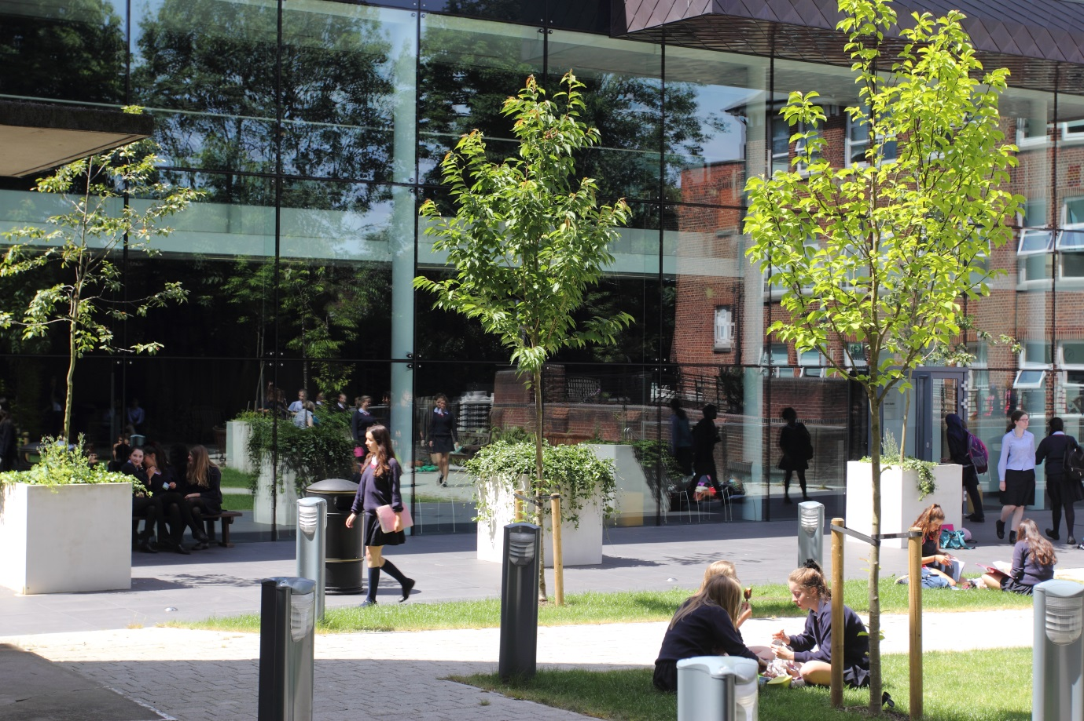

About the School
Notting Hill & Ealing High School is one of London’s leading independent girls’ day schools. Founded in 1873 it is the oldest of the 25 schools which make up the Girls’ Day School Trust (GDST) having begun life in Notting Hill and moved to Ealing in 1930. We are an all through school (ages 4-18). Around 300 girls in the Junior School and 600 in the Senior School, including 150 in the Sixth Form, make up a friendly and welcoming community. The Junior and Senior Schools occupy their own parts of the site and in day-to-day terms operate independently. We occupy a site in suburban, leafy, west Ealing with excellent transport links. (We are an easy walk or bus ride from Ealing Broadway or West Ealing stations: District and Central underground lines, mainline trains and Crossrail from 2018.) The school is oversubscribed and a very popular choice at all ages with girls joining us from most parts of West London as well as areas further afield.
NHEHS is an academically selective school. Our girls are ambitious, bright, enthusiastic and eager to learn. In our latest ISI inspection we achieved the highest possible grades across the board and the inspectors noted that ‘the quality of the pupils’ achievements and learning is exceptional.’ Public examination results are consistently outstanding and girls go on to study a wide range of subjects at prestigious universities including Oxbridge. (Latest results and the university destinations of Leavers can be found on our web site.) The school is highly regarded for the way it achieves its outstanding results within a particularly warm and supportive environment, and pastoral care and achieving the best for every girl is at the heart of everything we do.
“Teaching here is all about being able to have in-depth conversations with students about your subject and helping to enthuse them with the same passion as you have. Teaching at NHEHS is exactly what I imagined teaching would be like when I got my first teaching job; it’s what teaching should be!”
Liberty: joined NHEHS in September 2017 as a Head of Department
About the GDST
GDST schools share an ethos and heritage of girls-only education and are members of a unique network which adds value to each school, student and member of staff. Networking opportunities with other teachers across the Trust enable staff to share best practice and develop initiatives that benefit all our schools and students. In addition to supporting the work of individual schools in supplying excellent induction and development opportunities for staff, the GDST network provides access to an extensive training programme. This includes development opportunities (including a Middle Leaders Development Programme and Aspiring Leaders Programme) and to grants for individual courses of study.
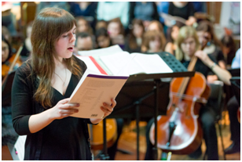
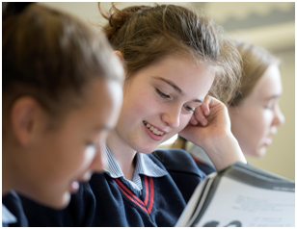
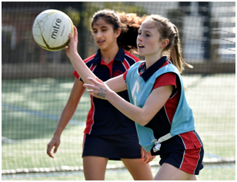
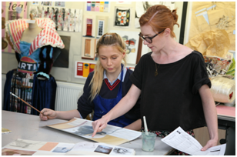
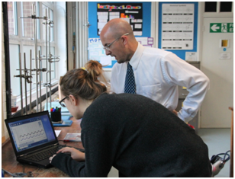

“We are delighted that you are considering NHEHS and hope that you will want to apply for this post once you have found out a little more about us. Our website, www.nhehs.gdst.net will tell you more about the school and give you a taste of the atmosphere here.”
Matthew Shoults, Headmaster
Teacher of English

The Post
The full-time post is available from January 2018.
The vacancy provides the opportunity for a well-qualified, inspirational teacher of English to teach up to A level, and to contribute further to a flourishing department in both its curricular and extra-curricular activities for a minimum of two terms and possibly more.

Person Specification
We are looking for a well-qualified graduate of English with a passion for the subject and excellent subject knowledge. The successful candidate is likely to be efficient and organised, with a sound understanding of the curriculum. She/he will be a good communicator who can enthuse and inspire both pupils and colleagues and will have exciting ideas about the teaching of English and the ways in which it can be further developed and encouraged within the school. The right candidate will be fully committed to the vibrant extra-curricular life of the school.

The Department
The English Department consists of eight teachers and includes the Senior Deputy Head (Pastoral). English is a popular and successful subject throughout the different stages of the school, and our results at GCSE and A Level are consistently outstanding. We achieve this level of success through challenging and thought-provoking lessons as well as our range of extra-curricular activities. We run multiple whole school events throughout the year, including World Book Day and National Poetry Day, and visiting speakers enthuse and inspire pupils. We have a responsibility to the whole school curriculum to ensure that the literacy skills of our students are of an excellent standard. However, we aim to achieve more than this; we aim to instil in our students a love of both English Language and English Literature.

Extra-curricular provision

Theatre trips are taken throughout the school year to support the texts our students are studying. Across the last few years, girls have had the opportunity to see a variety of productions including ‘The White Devil’ and a live screening of ‘Hamlet’ starring Benedict Cumberbatch and “Rosencrantz and Guildenstern are Dead” with Daniel Radcliffe at the Old Vic. We take all our Sixth Form students to conferences to enhance and extend their knowledge of the texts they are studying. Additionally, we run an English club for the Lower School, reading seminars for Year 12 and a student-led seminar programme for university applicants in Year 13. Participation in competitions within and outside school is also encouraged, such as the prestigious Poetry By Heart scheme.

The English Curriculum

Years 7, 8 and 9 (Key Stage 3)

Years 7, 8 and 9 all study a Shakespeare play, pre 19th Century poetry, a prose text and a variety of non-literary materials. The literacy skills of our students are developed through the delivery of language lessons. We help our students to develop their independent reading through discrete independent reading lessons and through creative projects, such as the Year 7 Reading Passport scheme. Tasks to develop the speaking and listening skills of our students are undertaken throughout the year.

Years 10 and 11 (Key Stage 4)
All students are entered for the Edexcel International GCSE examinations in Language and in Literature. Students are prepared for the 9-1 IGCSEs along with a separate spoken language endorsement.

A Level

We offer English Language and English Literature as A Level courses. We follow the AQA specification (7702) for English Language and the OCR course (H472) for English Literature. We will also be launching a combined AS English Language and Literature course in September 2018. Our results at GCE Level are consistently excellent. We run a programme of seminars for our Year 12 students and provide a structured and challenging set of sessions for students who are applying to study English at university, including preparation for Oxbridge interviews.

ICT

We aim to develop the ICT skills of our students within their English lessons. Staff and students use and create dedicated departmental pages on Firefly (our VLE) to create and provide resources, forums and blogs.

Facilities and Equipment

The English department has its own dedicated area within the West Wing building and a specific seminar room in the Sixth Form Centre. The department is well equipped and well resourced. There are laptops available for student use and the department library is well used by students and staff.

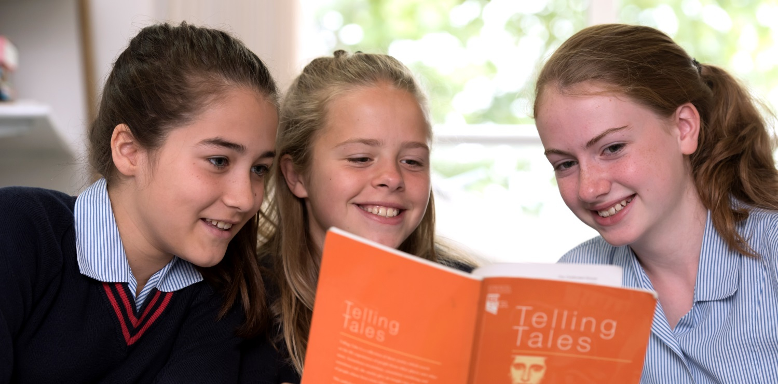

Terms and Conditions of the Post
The GDST offers attractive salaries and pay progression, when compared with the education sector generally, and has its own pay and grading structure, and system of career progression. Leadership and teaching excellence are recognised and rewarded in its schools. The salary reflects London weighting.

Benefits include:
- Membership of Teaching Staff Pension Scheme
- Access to the GDST central training and development programme
- Training grants for obtaining further qualifications
- Season Ticket Loans: Interest free loans for travel are available to staff to enable them to buy annual season tickets.
- Computer Loans: Interest free loans are available to staff to enable them to buy a computer for personal use at home.
- Cycle Scheme: the School is part of the scheme which enables staff to purchase bicycles and equipment at a tax advantageous rate and pay for the equipment over 12 months.
- Lunches: free lunches are provided to all staff during term time
- Four weeks’ study leave for teachers after ten years’ continuous service
- Accredited NQT induction

Application and Interview Process
Applications should be submitted by midday, on 6 November 2017 at the latest; however, applications may be considered in advance of the deadline. Candidates should complete the application form provided and also include a covering letter and full curriculum vitae with details of qualifications and experience and the names, addresses, telephone numbers and email addresses of two professional referees, one of whom should be the Head of their present or most recent school.
Completed applications should be sent to:

Mr Matthew Shoults
Headmaster
Notting Hill & Ealing High School
2 Cleveland Road, London W13 8AX

or may be emailed to: recruitment@nhehs.gdst.net

Shortlisted candidates will be invited for interview on 10 November 2017. As part of this process, they will be expected to teach a lesson of up to 35 minutes for which a full prior briefing will be given. All applications will be acknowledged and candidates who have not heard from us further within two weeks of the closing date should assume that the post has been filled.
All adults employed at the school are cleared for working with children and young people through the Disclosure & Barring Service. Please see attached full information regarding the Girls’ Day School Trust guidelines on the Safeguarding of Children.

Further information about the school can be found on our website at: www.nhehs.gdst.net
Application Form

