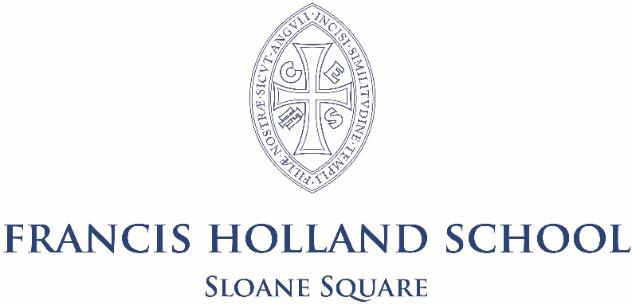

39 Graham Terrace
LONDON
SW1W 8JF
Tel 020 7730 2971

TEACHER OF MATHEMATICS
Full-time, permanent position
Required from September 2023
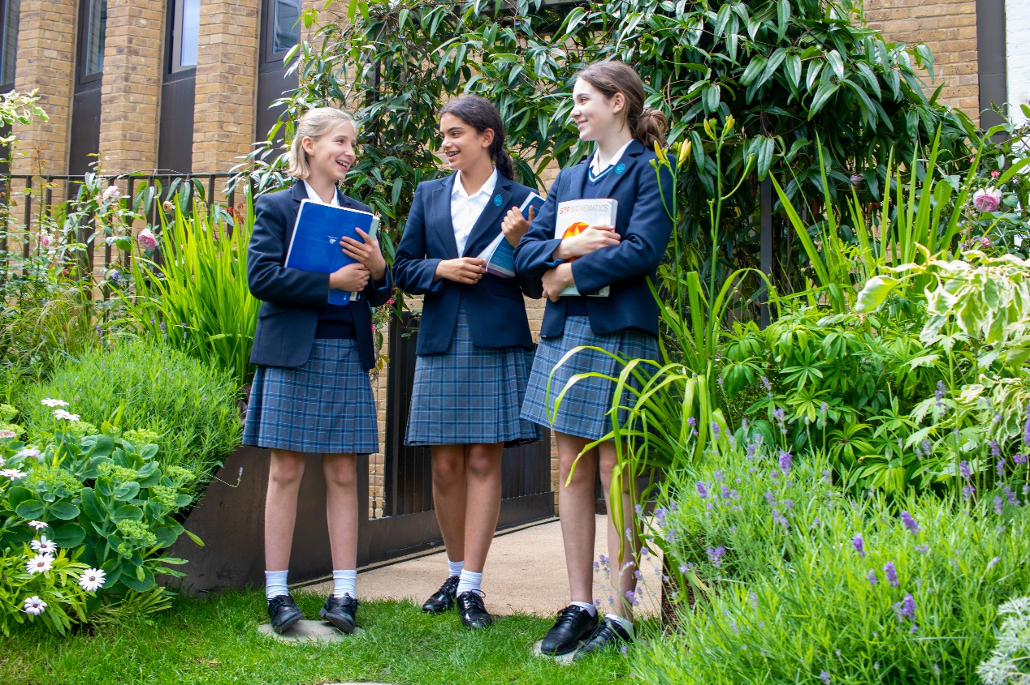

General Information

Francis Holland School Sloane Square is a highly sought-after, independent selective school for over 660 girls aged 4 to 18 (HMC and GSA). There are around 160 Juniors and 500 Seniors, including usually about 100 in a fast-growing Sixth Form, with the school recently having grown from 3 to 5 form entry in Year 7. The School is located on a spacious site in a beautiful residential part of Belgravia, close to the Saatchi Gallery and many cultural institutions such as the Victoria and Albert Museum, the Science and Natural History Museums, the Royal Academy and the Tate Galleries. The proximity to Imperial College offers us unparalleled access to lectures and support.

The School has enjoyed some significant building developments in recent years to accommodate a dramatically increasing roll and our vision for creative learning for the real world. Most recently, the Sixth Form has moved into a spacious and inspirational building called The Old School House, which forms a bridge with the local community and provides an exciting environment for young people to develop their entrepreneurial talents.

Pupils come from all parts of London with many of the Junior School pupils choosing to stay for the Senior School. Ours is a vibrant international community, and families from major cities abroad often seek places for their children here as a priority. Each member of staff is involved in the pastoral life of the School, normally as a Form Tutor, and the care of the children is renowned and exceptional. A team of counsellors provide constant support to the pupils and staff, reflecting our emphasis on supporting wellbeing.

A very wide range of co-curricular opportunities is offered to the pupils, and all staff contribute to this vibrant dimension of the School. Over sixty clubs and societies, outstanding music and drama opportunities and renowned art department are complemented by an exceptional sporting reputation which benefits from the superb facilities of nearby Battersea Park. Overseas trips and annual expeditions for all pupils build resilience and independence. The School has a distinctive emphasis on creativity and innovation, and all pupils learn to use their ‘time, talent and treasure’ in the service of the local and wider community. Volunteering and fundraising are strong, and all girls develop an understanding of social enterprise, with many setting up their own business ventures. The School has several energetic partnerships, including a link school in Tanzania.

Academic standards are consistently high throughout the School, placing it amongst the most successful schools in the UK. On leaving, after A Levels, girls proceed to a wide range of prestigious higher education courses, sometimes after a gap year.

The staffing ratio is generous and the School has its own attractive salary scale. Interest free travel loans are available and assistance with removal expenses is also offered for new appointments.

Mathematics Department information

The Mathematics Department consists of a Head of Department and seven other teachers. The subject is taught in groups divided according to ability up to IGCSE.

The Mathematics Department fosters a ‘Can-do’ attitude among our pupils; we are proud of our students, and keen that they receive the best possible mathematical education and achieve the best results that they can. We are looking for a well-qualified and enthusiastic graduate who would be able to teach from KS3 to A-level, with the ability to teach Further Mathematics being an advantage.

Each teacher is equipped with a Microsoft surface device, which facilitates a range of applications for the teaching of Mathematics and which complements our traditional and structured approach to teaching and learning.

For the past several years our girls have taken part in the Junior, Intermediate and Senior UK Mathematics Challenge. Many have achieved gold, silver, and bronze awards. Relevant year groups also have an opportunity to take part in team Maths challenges, as well as attending lectures run by the RI and FMSP.

We follow the Edexcel Higher IGCSE course. Our most able students in Year 10 and 11 are entered for Further Mathematics (AQA) and we take Edexcel A level for Maths and Further Maths. Mathematics is the most popular subject in the VIth form and the number choosing to take Further Mathematics at A level is also consistently high, with the department invariably producing excellent examination results.

The appointment
We are looking for a well-qualified and enthusiastic graduate who would be able to teach from KS3 to A-level, with the ability to teach Further Mathematics being an advantage.
Completed application forms must be received by 10.00am on Tuesday 9th May 2023, with interviews taking place during wk/c Monday 15th May 2023
Early application is advised and applications will be assessed in order of receipt.
The Trust is committed to safeguarding and promoting the welfare of children and young people and expects all staff to share this commitment. Statutory checks including a satisfactory DBS certificate and references will be a requirement for this role. This role is classed as regulated activity with children as it involves teaching, training or supervising children on a day-to-day basis and is exempt from the Rehabilitation of Offenders Act, 1974.

