Front Page

Table of Contents
- Welcome from Trustees
- School Information
- Mission Statement
- Job Description
- Person Specification
- Application Process

September 2019

Dear Applicant,

Thank you for your interest in the position of Head Teacher at Pond Meadow Academy Trust and I would like to welcome you to our school, on behalf of the Trustees.
Pond Meadow Academy Trust is a school for pupils, aged between 2-19, with Autistic Spectrum Disorder (ASD), Severe Learning Difficulties (SLD) and Complex and Profound Learning Difficulties (including complex medical needs). The focus of the Academy is to provide Equality of Opportunity and promote Respect for each pupil in all settings and to be a true and trusted advocate for their needs, wishes and opinions. Our key aim is to develop each pupil’s independence to support them in becoming an active citizen within our society.
We are proud of the quality of our teaching and learning and of the strong outcomes we achieve for all cohorts across the school. We emphasise encouragement and enjoyment in our teaching so that pupils feel happy to come to school. We recognise the varied needs of our pupils but place high expectations on their learning. We take pride our recent Ofsted reports, which have found the school to be ‘Outstanding’.
While Pond Meadow is a ‘Standalone’ Single Academy Trust, it is also an active and engaged participant in the region’s Special Schools community. We work closely with our local Teaching Schools and have a strong link to GEP, the local confederation of schools. These collaborative relationships support us to learn and develop in a wider community and for the community to benefit from the experience, support and expertise that we share.
At Pond Meadow, whilst taking satisfaction in the outcomes that the school has delivered, we are restless to continue to develop, improve and move forward the provision of Special Education.
You will see from the person specification the key skills, qualities and experience we seek in our Headteacher. If you think that you are the person to lead Pond Meadow Academy Trust, we would love to hear from you.

Caitriona Walsh
Chair of Governors

Pond Meadow School
Overview
Pond Meadow Academy Trust provides education for children with Autistic Spectrum Disorder (ASD), Severe Learning Difficulties (SLD), and Complex and Profound Learning Difficulties (including complex medical needs). The school provides places for children aged 2 – 19, class groups are Year Group based and are manage in four Phases. The 16 class groups are small, with between 6 – 8 students staffed by one teacher, a senior support assistant and three classroom assistants. In September 2018 there will be 138fte pupils on roll, rising to 145fte by September 2019. There are currently 110fte staff across both education and admin.

Ethos and Values
The ethos and values of Pond Meadow School are summarised in the following four words:
"Learning, Independence, Respect, Equality"
The school prides itself on the individual pupil's learning and outcomes and seeks to provide a teaching and learning environment that allows each pupil to achieve to their highest potential.
Independence is of great importance to us and we put in place an holistic curriculum model that supports both independent learning and the development of independence skills. Independence that we hope will support each pupil throughout their life.
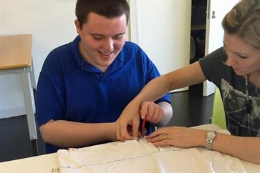
Our approach to teaching, care and support is rooted in absolute respect for the individual, their dignity and their rights as a young person. A key part of our approach is to view behaviour as communication and to respect the pupil's right not to be physically handled but, instead, to be supported through their own communication.
Equality is imbedded in our whole school approach and through every policy area, providing support for equal access to learn through to a right to be free from discrimination.
The focus of the Academy is to provide Equality of Opportunity and promote Respect for each pupil in all settings and to be a true and trusted advocate who represents their needs, wishes and opinions. A key aim here is to develop each pupil’s Independence so that they are able to be supported to become an active citizen within our society.
Our approach to teaching and the intention of the curriculum model is that pupils will learn about and develop these values in a relevant and age appropriate manner. Every member of the Pond Meadow Academy staff are key to the delivery of this ethos and as such the same model of Equality and Respect is inherent in our work with staff, with all staff having the opportunity to develop as self-directed, reflective learners, through working collaboratively to enhance their own expertise, free from discrimination.
The Governors have endorsed an Ethos and Equality Statement
Pond Meadow Academy values ‘Learning, Independence, Respect and Equality’ and seeks to give all pupils, parents/carers and staff members in the Academy an equal opportunity to learn, work and live, free from the action, or fear, of discrimination because of their sex, race, disability, religion or belief, or sexual orientation and whether they are pregnant or undergoing gender reassignment.

Teaching and Learning
The school is proud of the quality of teaching and learning it offers and has been judged as outstanding in our last four Ofsted reports.
At Pond Meadow we recognise the varied needs of our pupils but place high expectations on their learning. All pupils follow a full curriculum to provide them with the breadth of learning opportunities required to develop new skills and generalise old. The curriculum is seen as a vehicle for supporting key areas of individual learning and is fully adapted to allow pupils to take individual steps. Each pupil has an individual Education Plan, agreed with parents, that sets out our approach to their specific needs. At the heart of our x-curricular work is our PSHCE curriculum and this is used to develop independence skills but also to encourage pupils to be as independent learners as possible.
We emphasise encouragement and enjoyment in our teaching so that pupils feel happy to come to school and look forward to the challenges within the school day. The relationship that builds up between our staff and pupils is placed at the heart of our work and creates the trust that is required for our pupils to make progress.
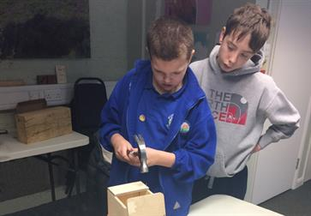
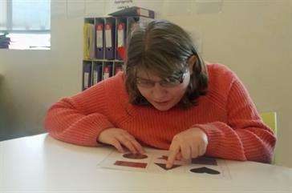
Activities are planned to give pupils an individual sense of achievement and also for class groups to contribute and then share in the achievements.
Teaching staff work closely with families to find new solutions to individual pupil needs to enable each pupil to take positive steps towards independent learning. Our aim is not just to meet needs but to do so in a way that supports learning throughout the child's life.
All teaching sessions have a clear structure that emphasises the role of the Introduction and Plenary of each lesson, so that pupils have support in making links in their learning, opportunities and time to reflect on past learning and a clear purpose for each lesson. To ensure individual needs are met, the key aspects of the Introduction and the pupil’s individual goals are re-emphasised as the pupils move on to paired, small group, or individual teaching sessions. The Plenary includes a planned opportunity for pupils to contribute and use their communication skills when celebrating individual or whole group achievements.
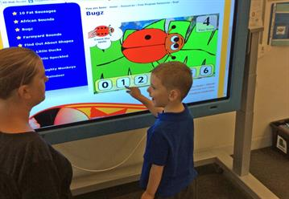
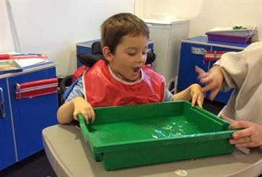
Classes are organised on an ‘approach to learning’ basis and, although this aligns to the three main needs groups it does not define the classes by need. The three approaches are:
- High Structure – a low distraction environment providing a predictable routine, with an emphasis on individual, TEACCH style, areas and a horse-shoe table group area
- Medium Structure – has the same key elements as the high structure class but with a higher emphasis on group work and shared learning opportunities
- Sensory Structure – provides a highly engaging environment with dedicated areas for sensory-based learning, lower class group sizes and more of an emphasis on 1:1 support for engagement for learning
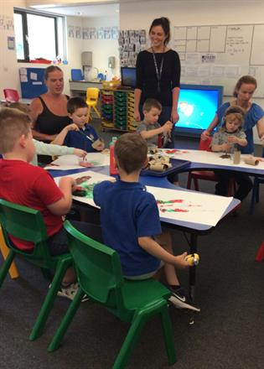
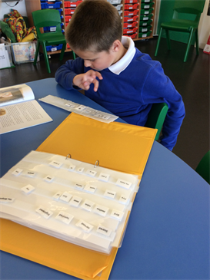

Springboard Assessment Nursery
The school established Springboard Nursery over a decade ago to provide a multi-professional assessment nursery for pupils with Autistic Spectrum Disorders.
The multidisciplinary team comprises a teacher in charge of the nursery, a speech and language therapist, teaching assistants and additional inputs from a wealth of other professionals as required, including support from clinical psychology.
.

The team works towards:
- Giving support and guidance to parents
- Providing links with education, health and social services (including clinical psychology and occupational therapy)
- Using ongoing assessments in order to make recommendations for future educational settings
- Offering advice and support to staff from other placements where children may be attending or moving on to
- Providing parents/carers with support through home visits and access to workshops and information
- Continually extending and updating their knowledge and understanding of Autism

Outcomes and Impact
The school has always achieved very strong outcomes for all cohorts across the whole school and has successfully challenged areas of poor progress seen in national data (see website for greater detail).
The key assessment tool for this work was originally P-Scales and the Durham Project but this has now moved to use of Sheffield STAT progression documents alongside the use of the Engagement Profile first developed by Prof. Carpenter.
All pupils from Year Group 7 follow an Accreditation program in ASDAN, providing a focus for their achievements and a real opportunity to leave school with a qualification level that demonstrates their ability to continue learning for post-19.
As part of the School Development Plan, there will also be an increasing emphasis on broader areas of the curriculum, independent learning development and other PSHCE themes. This will form part of the schools approach to measuring the ‘Impact’ of our curriculum model and assessing how well we prepare each pupil for their next phase of education.

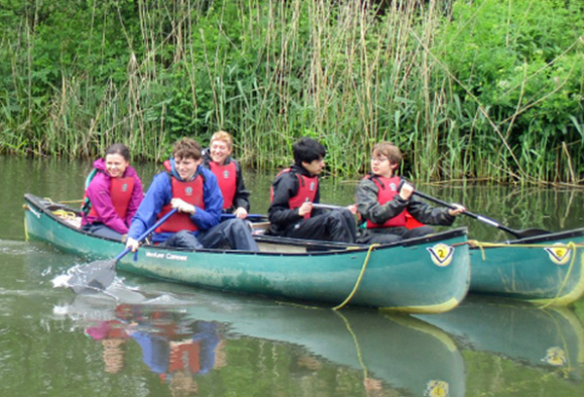

School Buildings and Expansion of Pupil Numbers
In 2008 the school moved into its current, purpose built, school in Guildford. This provides a wonderful learning environment with light and airy spaces, giving the school a sense of calm. The children can easily move around the school with wide corridors and plain walls to limit distraction. There are specialist rooms for Sensory Light and Sound, Soft Play, Hydro Therapy, ITFood Technology, and Art.

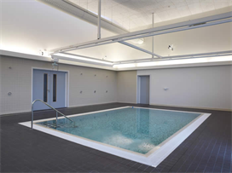
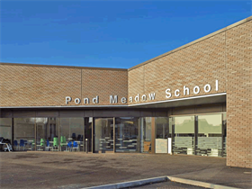

The school is on a single level with no stairs, level door thresholds, wide corridors and large classroom spaces providing easy access for all pupils. The classrooms in each phase are centred around large internal courtyards, linked to open plan learning areas. Classrooms have been designed so that on each move of class, pupils experience a slightly different environment. The two school halls are large areas used for assembly, PE and social events. There is an additional dining hall.
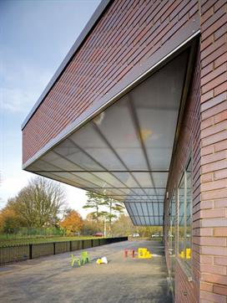
The school currently provides for 16 class bases but with increasing pressure on places and an expansion of the school from 80fte places in September 2008 to 138fte in September 2019, the Academy, in partnership with Surrey LA, is adding two more classrooms in the main grounds to provide for 18 class groups in total. The Trustees are also in discussion with Surrey LA to find a ‘community hub’ in central Guildford for the two 16-19 class groups, to provide both classroom space and the potential of a school-led small retail outlet.
It is likely that the school will expand to around 150fte places over the next few years and the accommodation needs to be developed to continue to provide the same high-quality environment as was originally planned.

Academy Trust Status and Collaborative Working
Pond Meadow became a ‘Standalone’ Single Academy Trust in November 2014 and has considered joining a MAT as part of its future development. However, the school currently sees many benefits in remaining as a SAT and continuing its strong partnerships with different ‘confederations’ of schools.
At Headteacher level the school is a member of both the Surrey Special Schools Phase Council (21 Special Schools) and the Surrey SLD/ASD network, SPAN, (10 schools). These groupings provide a strong forum for Special School development in Surrey and good opportunities for Headteacher development through a range of, Surrey wide, strategic and financial meetings and workstreams.
The SPAN group also runs working groups in a range of areas, providing a collaborative framework for shared development goals and giving good CPD opportunities to Deputies and Middle Managers.
As part of our school-to-school work, the Academy is involved in a pilot scheme linking Special Schools in Surrey, Kent and Hampshire at Leadership level, where the Headteachers and Leadership teams work together to support and challenge whole school development. In this ‘Cross County Challenge’, Pond Meadow is working with The Orchard School, Canterbury, and Oak Lodge School, Southampton.
Pond Meadow also works closely with our local Teaching Schools providing year-long placements to trainee Special School teachers and week-long placements to mainstream trainee teachers and support staff. We have a strong link to the local confederation of schools and, as part of the school’s development, we are seeking to provide greater support and training to the local SENCO network. The Academy has also expressed a keen interest in Surrey LA’s initiative to form an Education Learning Partnership.

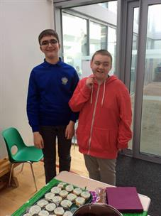
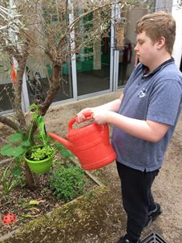

Mission Statement

‘Learning, Independence, Respect, Equality’

Our purpose is to provide an outstanding education that enables every pupil to reach their full potential, whatever their starting point and to achieve the very best outcomes for their next stage in life.

School Aims

- To provide an education that is ambitious for and relevant to our pupils and which equips them with the skills and knowledge to progress to and succeed in next stage of their education and throughout their lives.

- Pond Meadow benefits from a uniquely diverse context. We aim to continue to develop this fantastic culture by expanding the curriculum to include greater creativity and diversity – reflecting how our pupils learn and interact with the wider world.

- We aim for our curriculum to be coherently planned and sequenced to build cumulatively towards the aspired for knowledge and skills. For our specific student body, where each child has an IEP, we aim for the curriculum be designed to be able to be tailored to their specific needs and abilities

- We aim to offer staff a supportive, empowering and rewarding environment in which to work. We will provide great opportunities for growth and development, promoting effective leadership at all levels.

- We aim to be active and positive participants in both the Special School and mainstream school communities. We wish to engage so as to learn, share our learning and support one another.

- We aim to develop ever stronger relationships with the parents, supporting agencies, volunteers and neighbours whose involvement places us at the heart of a vibrant community.

JOB DESCRIPTION
While it is desirable for the Headteacher to have some, reduced, teaching responsibilities, the large proportion of his or her work is the day-to-day management, organisation and administration of the school in order to create a productive learning environment which maximises progress of all pupils. He or she will be accountable to the Governing Body of Pond Meadow Academy Trust and serve as its Chief Executive Officer. Key responsibilities lie in the following areas:
- Formulating overall aims and objectives for the school and policies for their implementation
- Working with governors and senior colleagues to deploy staff effectively and recruit new staff
- Meeting with other education professionals, and representing the school at conferences and other events outside the school in the local community and nationwide
- Motivating, training and disciplining staff
- Ensuring the motivation of the pupils
- Ensuring an infrastructure is in place in which all members of staff and pupils feel they can register their opinions on serious matters, and have a route via which they can communicate problems to senior members of staff
- Ensuring the good financial management of the school
- Ensuring the school is up-to-date with innovations, from teaching practices to new technologies
- Design and implementation of a curriculum in which the impact on pupil outcomes is monitored and maximised
- Reporting on the school’s performance to a range of audiences, including governors, the Local Education Authority, the local community, Ofsted and others
- Managing accommodation (e.g. classrooms) effectively to meet the needs of the curriculum and Health & Safety requirements, and ensuring the physical infrastructure of the buildings and grounds is well maintained
- Assuming responsibility for other legal matters in the day-to-day running of the school
- Assuming responsibility for pastoral care of pupils and safeguarding of all pupils and staff
- Resolving major disciplinary issues with pupils, including working in partnership with the social services and other agencies.
- Establish and maintain links or partnerships with businesses.
The responsibilities above to not form an exhaustive list and the National Standards of Excellence for Headteachers (2014) provides guidance that underpin best practice in these and other areas. The Governing Body intend that these standards are used to shape the way the Headteacher develops his or her own practice in the leadership of Pond Meadow School to continue the outstanding education it provides.

PERSON SPECIFICATION
 | Essential | Highly desirable
Qualifications and experience | Qualified Teacher Status or Qualified Teacher Learning and Skills (QTS or QTLS) (with degree level education or equivalent).  Proven recent senior leadership experience in a relevant sector school.  Proven excellent and inspirational teaching relevant to sector.  Relevant experience of working with children with a wide range of special needs.  Experience and understanding of managing people, budgets, ICT and facilities. | National Professional Qualification for Headship (or working towards this) or evidence of similar professional development.  Recent experience of working with and strong professional knowledge regarding children with Autistic Spectrum Disorder, Severe Learning Difficulties, and Complex and Profound Learning Difficulties (including Complex Medical Needs).
Leadership and management skills | The ability to develop and communicate a clear vision for the future development of the school in consultation with stakeholders.  The ability to keep up with developments in national and local educational agenda particularly in the areas of policy, curriculum and statutory/legal frameworks as well as Ofsted inspection criteria.  The ability to lead, motivate and inspire others and manage people to work as individuals and as part of a team. To provide professional leadership, motivate all staff, set standards and engender initiative and a common purpose.  To retain and recruit high quality staff at all levels and manage their performance constructively – promoting excellence and effectively challenging underperformance – motivating colleagues and facilitating appropriate continuous professional development.  The ability to initiate and manage change to meet the school’s strategic objectives.  The ability to lead the development, planning, monitoring and evaluation process.  The ability to manage and plan strategically the use of financial and other resources to achieve the school’s objectives.  The ability to plan, prioritise and delegate responsibilities according to both the long term and day-to-day needs of the school, monitor their implementation and ensure feedback on their effectiveness.  The ability to identify and evaluate data critical to the assessment of the school’s performance and take appropriate action.  The ability to create a school environment that promotes behaviours that support children’s learning and social development.  The ability to communicate effectively in writing and orally to a range of audiences.  Expertise in best practice and procedures for the safeguarding of children. | To have a comprehensive and up-to-date understanding of national policy, curriculum developments, and statutory and legal frameworks within which schools operate, including the Ofsted Inspection framework.  Experience of effectively dealing with complaints, resolving problems and reconciling conflicts.  Evidence of commitment to recent personal professional development, and the ability to foster an environment in which all staff share best practice and individuals have opportunities to develop their own careers.
Management of teaching and learning | Demonstrate a sound understanding of child development, learning and care in the context of Autistic Spectrum Disorder, Severe Learning Difficulties, and Complex and Profound Learning Difficulties (including Complex Medical Needs).  Understand how to manage challenging behaviours effectively in accordance with the ethos of the school, particularly the non-restraint focus of its understanding behaviour policy.  Demonstrate an understanding of the principles of excellence in teaching, learning, care and assessment, competently using ICT to provide continuous monitoring.  Demonstrate a thorough understanding of the teaching skills required to achieve high standards and experience of raising pupil attainment and ensuring strong pupil progress.  Demonstrate an ability to monitor and evaluate the quality of teaching, learning, care and assessment with a demonstrable impact on improving pupils’ outcomes.  Demonstrate a very good knowledge and understanding of how to provide a broad and balanced education and the widest range of opportunities for all pupils to enable them to achieve their full potential. | Understand how to implement and evaluate personalised learning strategies to support excellent classroom delivery of individuated lesson plans in accordance with pupils’ Education and Health Care Plans.  Ability to clearly evidence and communicate pupil progress and demonstrate outstanding provision in the intent, delivery and impact on both individual pupils and cohorts.
Partnerships, managing the school and Academy Trust | The ability to work in partnership with Governors, the Local Authority, other schools and agencies including Children’s Services, Education Funding Agency and the NHS.  The ability to work productively with local educational groups (including Surrey Special Schools’ Phase Council, Surrey SLD/ASD network, SPAN) and to develop links with appropriate groups and consultants to manage both education, logistics and facilities.  The ability to attract sufficient pupils and to manage pupil placement, admissions and key stage transfers.  The proven ability to work in partnership with all families to involve them in the education of their children. To promote good staff and parent relationships. To involve all pupils in their education and learning.  The ability to be accountable to the Governing Body for decisions taken affecting pupils, staff, premises, facilities, finances and the wider community.  Undertake whole school self-evaluation and performance monitoring using all data available (including local and national standards) to rigorously analyse performance of staff and pupils, and to ensure facilities, finances and buildings are well-maintained.  Commitment to safeguarding children and ensuring all members of the community share that commitment. | Experience of effectively dealing with external contractors and ability to effectively manage their services particularly those relating to transportation, catering and maintenance.  Experience of working within a Trust, Limited Company and/or serving on a Governing Body.

Application procedure
We hope that this information has been useful to you in starting to look at Pond Meadow as a possible Headship for you. The Trustees are seeking a knowledgeable, dynamic and empathetic Leader to build upon the school’s strong foundations and high reputation, and to use this to take the school in a new and exciting direction for the future.
Visits are very much encouraged and we would welcome the chance to engage with you in any pre-interview discussions that would help you to get to know our school community better. Visits should be arranged by emailing emailing HT recruitment email by Friday 20 September.
Applications should consist of a completed application and equalities monitoring forms accompanied by a supporting statement of no more than 500 words addressing candidate’s motivation for applying, experience and suitability for the role, and your vision for special education and leading Pond Meadow.
Attachments
Safeguarding statement.

