**RAYNER STEPHENS HIGH SCHOOL**

**HUMANITIES DEPARTMENT**

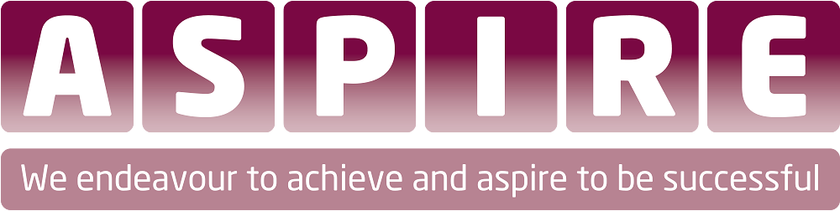

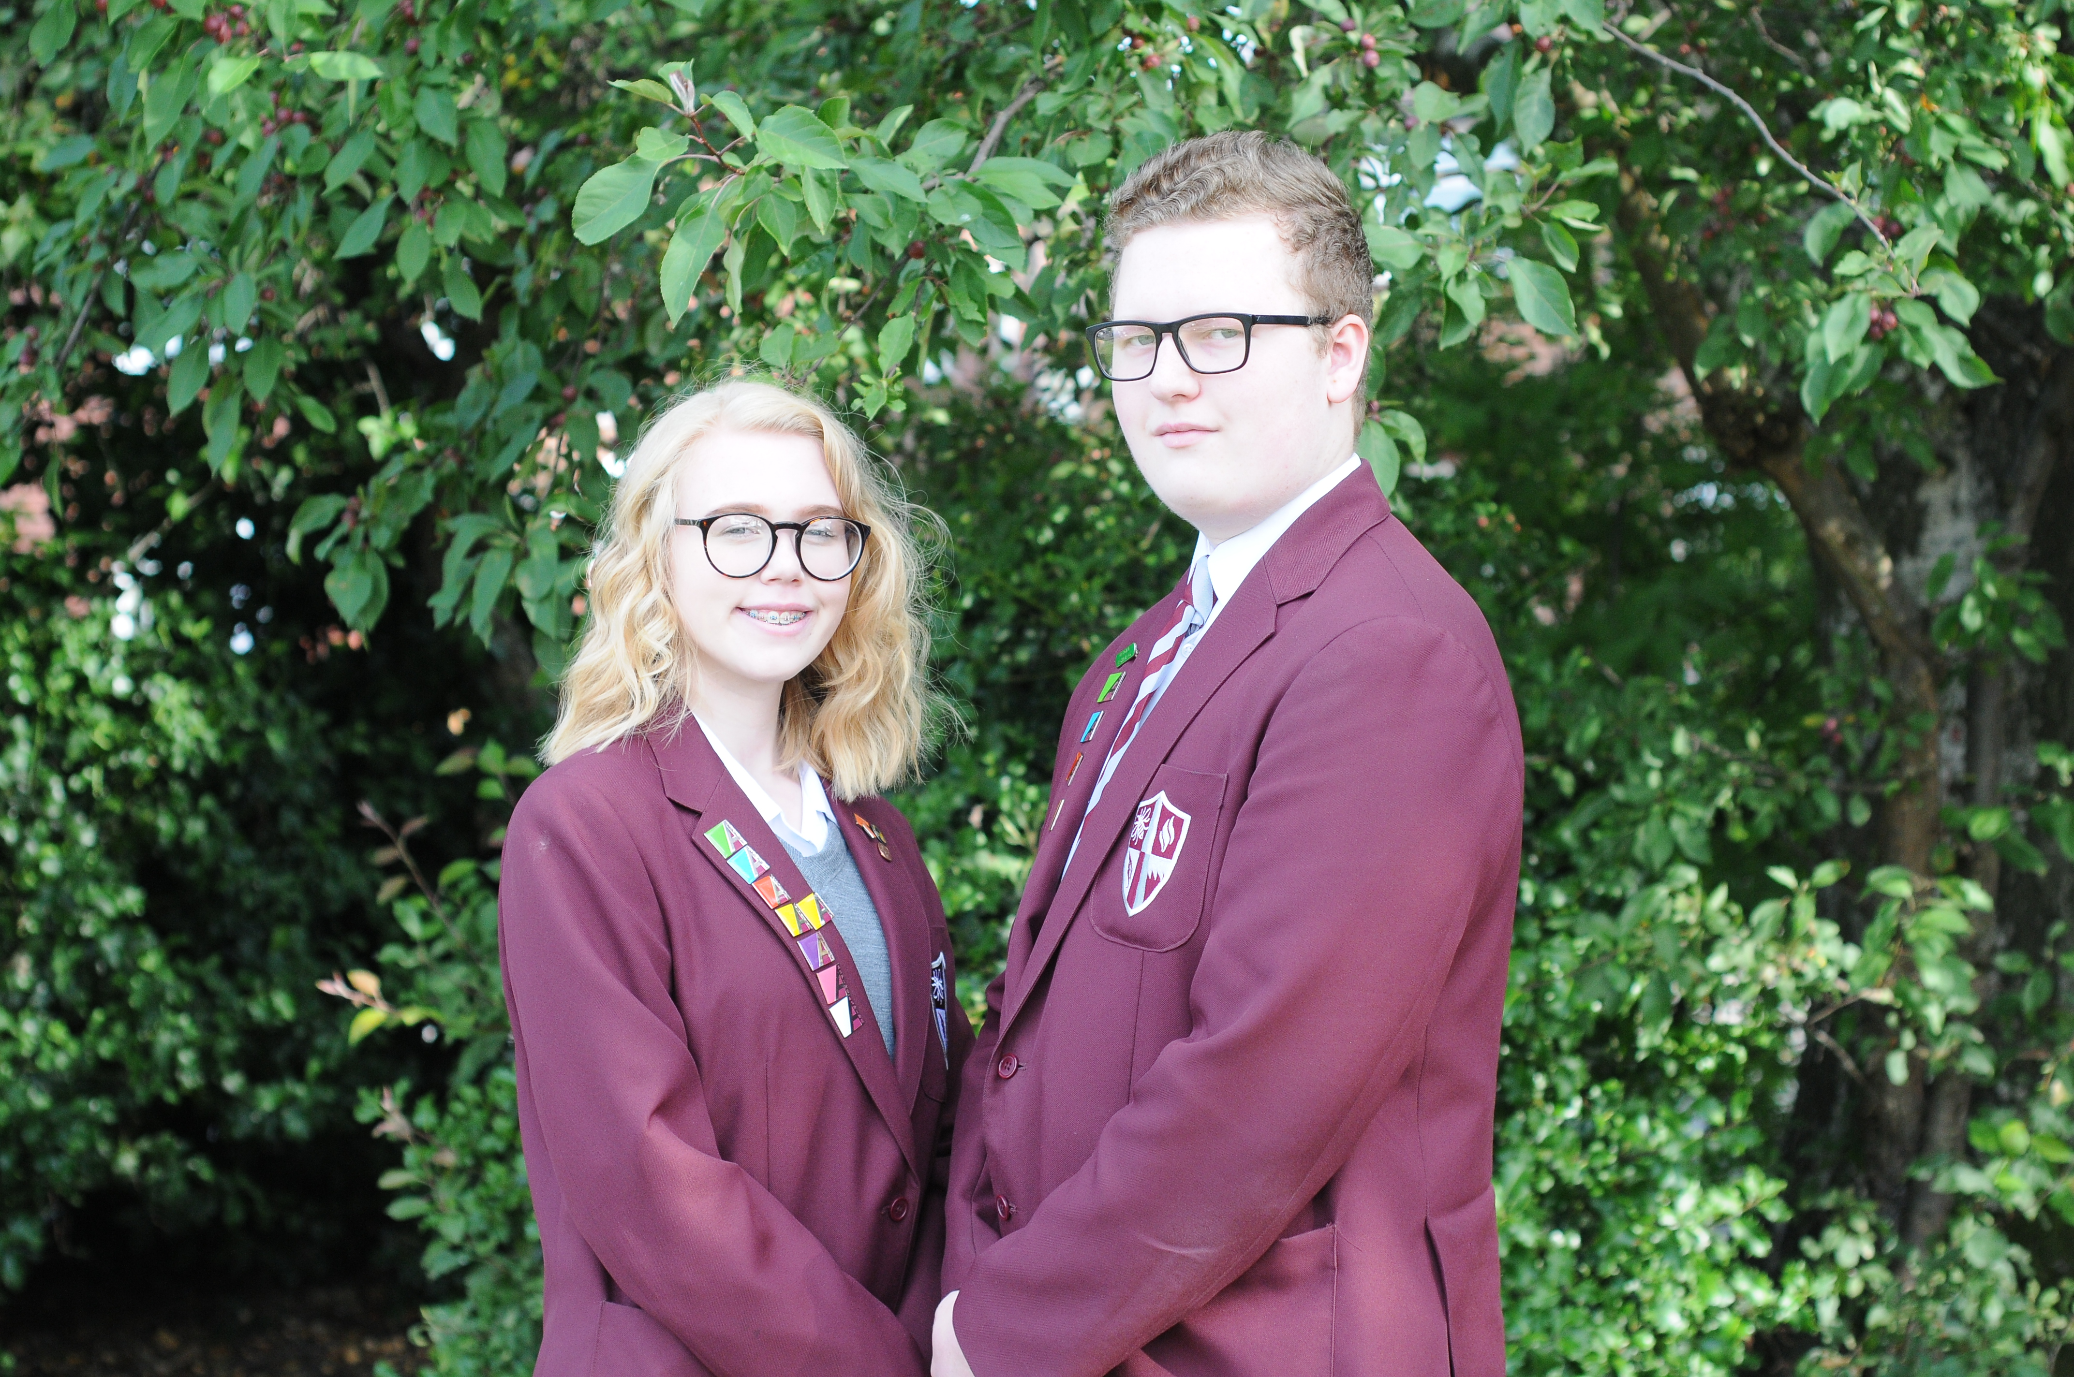

**Science Department**

There are six members of teaching staff in the Science department. Leadership and management of the department will be structured with a Leader of Science on the Leadership Pay Spine and two Lead Teachers who will take responsibility as defined by the Senior Leader for Science. All classrooms are equipped with projector and/or interactive whiteboard. Standards of teaching and learning, assessment and achievement within the department have improved in recent years – but further work is required to continue this trajectory.

**Aims**

Through outstanding teaching and a challenging curriculum, best suited to the needs of our students, we aim to inspire, excite and nurture future generations of well-informed 21st century citizens, scientists and engineers. We aim to give every learner at Rayner Stephens High School memorable experiences and rich opportunities of Science learning at school. We endeavour to develop the full potential of each individual in Science.

We intend to give students access to a wide variety of quality learning opportunities in Science and promote a love of the subject and an appreciation of the transformational impact Science knowledge, understanding and application can have. Our Science team are friendly and approachable and we are committed to working in partnership with parents and carers to ensure that all students fulfil their aspirations.

**Methodology**

The learners will develop their knowledge, skills and understanding of Biology, Chemistry and Physics and investigations are a key aspect of the curriculum. The curriculum is delivered through a range of teaching strategies that includes individual work, investigations, group-work and the use of ICT. Learners in Year 7 begin the year work in classes that are set initially using Key Stage 2 data. However, there is flexibility within this to move students based on regular teacher and formal assessment. Years 7 and 8 are assessed formally three times each year with setting being revisited following each assessment.

The curriculum is based on embedding skills, applications and processes in order to develop students’ higher order thinking skills in science and allow then to apply scientific knowledge to increasingly more complex and unfamiliar problems. To enable this, students will spend specified time on a module. During each module students will experience:

* Engaging lessons with a variety of resources and activities.
* Investigations
* Real life scenarios
* Links to other topic areas
* Consolidation work
* Weekly homework
* A mid-module assessment with targets to improve.
* A revised end of module assessment based on improvements in classwork and/or homework.

There will be some flexibility in the delivery of the curriculum allowing for teachers to adapt their teaching (revisit/extend/intervention) based on the mid-module assessment ensuring that students are not accelerating through content without thorough understanding