

Classroom Entry Level Teaching Assistant - CETA
Candidate Information Pack

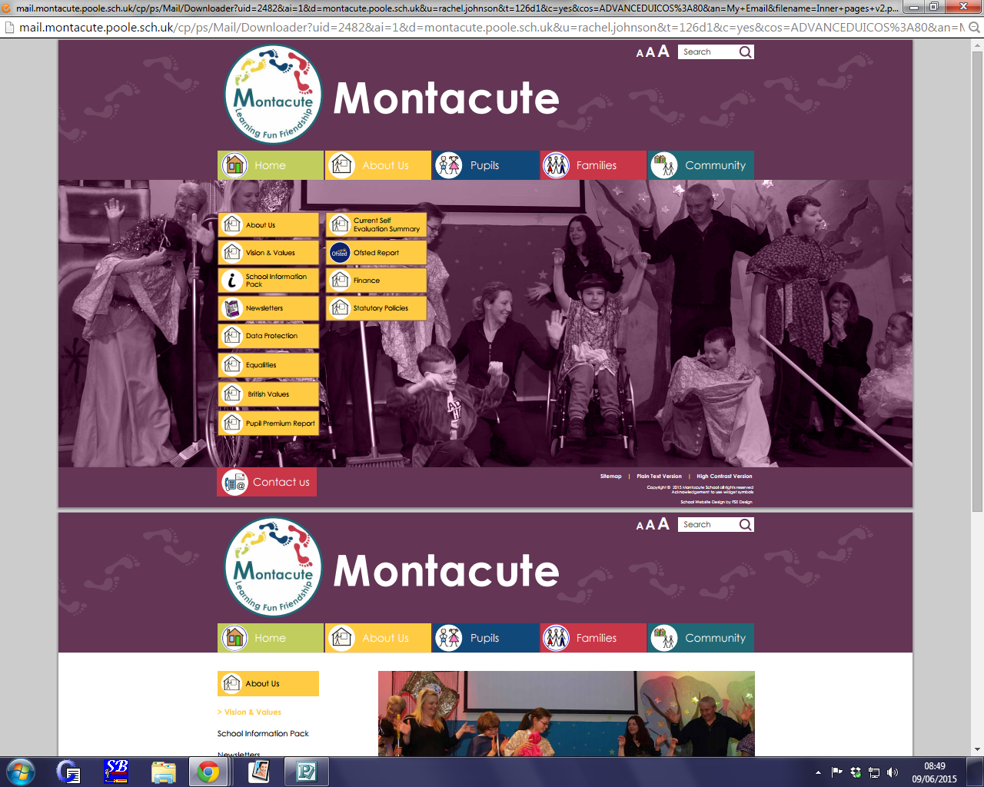

CONTENTS

Welcome to Montacute

Job Advertisement

We are Montacute

Montacute Vision and Values

Job Description

How to Apply

WELCOME TO
MONTACUTE SCHOOL


Dear Candidate,
I would like to extend a very warm welcome to you!
It is a privilege to be the Headteacher of Montacute School. I never tire of the new and amazing things that our children and young people achieve every day and being a part of their journey!
At Montacute we strive to ensure that every one of our young people is provided with their own personalised support and learning pathway delivered by specialists in their field. We believe in providing an eclectic mix of interventions and enrichment experiences to enable our learners to be exposed to as many opportunities that life offers and to ensure that their every need is met.
We are very fortunate to have wonderful buildings and grounds to deliver the care and education that our young people need and deserve and we constantly review our practice and provision to see how we can continually improve.

And just as we support and encourage our young people, we invest in our fantastic staff and help them grow as professionals with a comprehensive and often personalised pathway for career development.
We never stand still, we aspire to greatness and I hope that you will want to be a part of that journey with me and my team.

Below, you will see our Vision. Please take a moment to step into the shoes of one of our pupils and if this comes to life for you, then maybe you’re the Deputy for us!

Step over the threshold at Montacute school to experience the wonder of a world carefully created to empower its very special population.
Every child is unique in their talents and needs. From their smallest whisper to the loudest song every voice is heard.
We are a family, harmonising to create a world full of opportunities, wonder and joy for each of our pupils. We believe in being in tune with the unique characters, voices, learning styles and talent of all our young people and will stand alongside their other supporters to celebrate every achievement they make.
We encourage every one of our treasured pupils and staff members to allow them to shine, sparkle, grow and change ready to take on the world.
At the end of the day when their school song has been sung and heard we are confident that the world will be able to listen and hear them too.
It is our school, it is our time, we are Montacute!

With my kind regards,

Ginny Bellard
Headteacher, Montacute School

ADVERTISEMENT

Classroom (Entry Level) Teaching Assistants – CETA

If you are interested in being part of our Teaching Assistants at this vibrant, all-age Special School for children who have CLDD (Complex Learning Difficulties and Disabilities). You will be working as part of a team to support the learning and care needs of children and young people aged between 3 and 19. We are looking for a conscientious, self-motivated, flexible, team worker with a genuine interest in working with special children. Montacute has a comprehensive induction process, coupled with many opportunities for professional development.

All posts are subject to an enhanced level DBS check.

CETA positions are for up to 30 hours per week, term time only and for 45.6 weeks paid per annum, pro-rata. Hourly rate is from APT & C point 2 £10.60 to point 5 £11.18, depending on experience.

Previous candidates who have applied in the last 6 months need not apply.

We will only consider applications made on our standard form, please complete our application form and return to: heather.row@montacute.poole.sch.uk
Montacute School is committed to safeguarding and promoting the welfare of children, young people and vulnerable adults and expect all staff and volunteers to share this commitment. All appointments are subject to a satisfactory enhanced disclosure check with the Disclosure and Barring Service. We will only consider applications made on our standard form.

WE ARE MONTACUTE

Welcome to our vibrant and happy school for children and young people with severe and complex learning needs. At Montacute School we make the most of every moment to provide exciting and engaging learning opportunities.


Montacute is a specialist school for children and young people who have Complex Learning Difficulties or Disabilities (CLDD).
This means that our pupils usually have more than one part of themselves that affects their ability to learn. These parts interact with each other to create a unique picture in terms of their individual learning needs and abilities. People with CLDD are unlikely to fit into a ready–made learning framework, and need a very personalised learning pathway put together for them.
At Montacute, we have skilled staff with different types of expertise who can collaborate together – as well as with external consultants where needed – to create learning approaches for individual pupils, based on finding out about that particular pupil. If we come across a pupil who needs us to have some knowledge we do not have, we will train ourselves so we can support that pupil.
We specialise in taking pupils who are at the most complex end of the spectrum, ie. children and young people whose ability to learn has been most affected by their difficulties and disabilities.
Here are some examples of diagnoses our pupils may have:
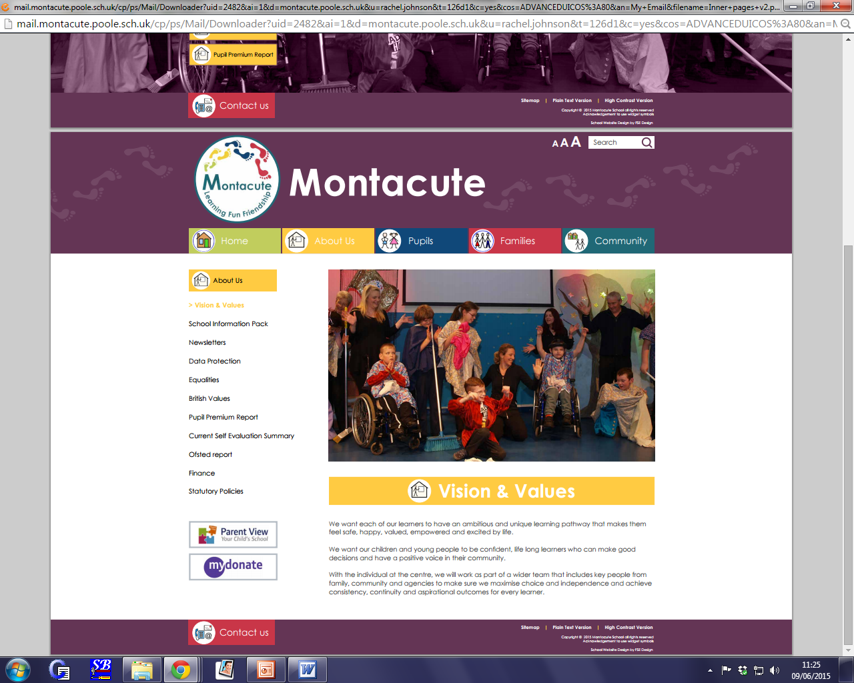
- Autism
- Communication Difficulties
- Complex Developmental Delay
- Complex Medical Needs
- Emotional / Mental Health Needs eg. Anxiety / OCD
- Physical Disabilities
- Sensory Integration Difficulties
- Sensory Disabilities

Montacute can take pupils from the age of 2 to the age of 19, or at any points in between.

MONTACUTE
VISION AND VALUES

We have recently re-visited our vision. We very much wanted this to be representative of our children’s lived experiences whilst reflecting our ambitions and pride for our school.
This new re-working of the vision will help us to continue to return back to our collective values and aspirations not only for our young people, but for our staff. We will revisit this piece of work periodically to enable reflective practice and ambitions planning for our collective futures.

Vision
Step over the threshold at Montacute school to experience the wonder of a world carefully created to empower it’s very special population.
Every child is unique in their talents and needs. From their smallest whisper to the loudest song every voice is heard.
We are a family, harmonising to create a world full of opportunities, wonder and joy for each of our pupils. We believe in being in tune with the unique characters, voices, learning styles and talent of all our young people and will stand alongside their other supporters to celebrate every achievement they make.
We encourage every one of our treasured pupils and staff members to allow them to shine, sparkle, grow and change ready to take on the world
At the end of the day when their school song has been sung and heard we are confident that the world will be able to listen and hear them too.
It is our school, it is our time, we are Montacute!

Values
Empowerment
On the snowy slopes of Montacute mountain you will be supported to climb as high as you would like. If you feel unsure you will be encouraged to conquer your doubts. Your strengths and interests will be explored and developed in an environment of appreciation. You will grow in confidence. You will understand that you are powerful, that you can climb to the top and feel the sense of exhilaration as you overlook a vast and stunning landscape. You will reflect on your journey and know that you are capable of greatness and you in your turn will support others to become empowered for the future.

Authenticity
Dive beneath the crystal-clear waters of the Montacute Ocean. Leave the air behind and breathe deeply from your own truth. There is another world of colour and beauty. It is deep and clean and real. Home to millions of coloured sea creatures, it is a different world, more magical and even more beautiful than our everyday experience. These animals live a fluid and instinctive life trusting their feelings and living with a clarity of purpose and sense of justice. All are included in the world in a meaningful way where even the smallest of them has a role to play.

Learning

At Montacute we promise to recognise and celebrate every step you take on your journey through our school. We will lend you a hand when you need it and help you carry your bag when it becomes too heavy. We will make sure your eyes are always open to the wonder of the world and surprise you at every turn with our creative and engaging methods of teaching.
At Montacute we understand that some mountains take longer to climb but know we will always be by your side as your biggest supporters, cheering your name and climbing alongside you. When you reach the top of your mountain, we will look back with you and see how far you’ve come and all the beautiful landscapes you have seen.

Respect

At Montacute we welcome you stepping into our world that is designed with all in mind. Walk through our corridors reading as you go, enter a classroom and be transported into a secret garden, climb on board a pirate ship or fly in a hot air balloon around the world. Our language rich classrooms are specifically tailored to make all our pupil’s readers and active learners, you will want to stay even if you are only passing through.
At Montacute our radios are tuned into a huge range of frequencies so no matter how you communicate we will hear you and you will always feel valued and listened too. To us Montacute means family; will help guide and support you, raise you up and hold you closer if you need but above all celebrate all your achievements because we know all the little things add up to fulfilling and joyful life.

JOB DESCRIPTION
TEACHING ASSISTANT

Job Description

Classroom (Entry Level) Teaching Assistant (CETA)

Job title: | Classroom (Entry Level) Teaching Assistant - CETA | Job Ref: | XS 10.4
Directorate: | Montacute Academy Trust
School: |  | Grade: | APT&C pay range SCP 8-14  NEW pay range SCP 2-5 as of 01.04.2019
Reports to: | Teacher

Main job purpose
Responsible for working across a varied range of responsibilities.

The post holder will play an important role in supervising the activities of pupils during all learning activities and lunchtimes within the school, including both indoor and outdoor areas and community-based learning, ensuring a safe environment is maintained at all times.

To assist the school’s Leadership to promote pupils’ academic, social, health and emotional development through the development and implementation of programmes of pupil work, therapy and support (individual and group) and in the provision of a stable, caring and supportive learning environment; to enable all pupils to achieve their full learning potential and facilitate their personal, academic, social and moral development, whatever their disabilities and barriers to learning.
Support is both on a one to one basis and in groups, to pupils with a wide range of needs and ages as required by the Leadership of the school.

Main responsibilities and duties
- To support the teaching and learning processes.
- To assist the Teacher in developing, implementing and managing individual/group pupil learning strategies aimed at
  - establishing and maintaining positive relationships with individual pupils and groups to promote self-esteem, wellbeing and to best support pupils in learning activities
  - supporting individual emotional and health needs to facilitate best learning, including positively managing pupil behaviour and pupil health needs
  - maximising motivation for engagement and learning
  - ensuring inclusivity and access for all pupils
- To support the teacher in consistently providing an organised and appropriate learning environment for the whole range of pupil needs
- To maintain school equipment and resources, and the personal belongings of pupils, in good order.
- For the post holder to participate positively in the continuous review and development of their professional practice.

Under the guidance of direction of the teacher:
- Develop, maintain and apply knowledge and understanding of pupils’ general and individual learning needs.
- Ensure that support is given to pupils in ways that promote engagement, independence and pupil voice. This will involve providing the right resources for each pupil.
- When directed, support or lead small group tasks, clarifying and explaining instructions in ways suitable for individual pupils (e.g. using augmented communication).
- Be willing and able to participate in all timetabled activities, including swimming, horse-riding, messy play etc.
- Ensure consistency of approach in the whole team is maintained through good communication.
- Contribute to the assessment of pupils’ learning against their individual learning programme. Assist in the development, monitoring and evaluation of programmes of work as part of a team.
- Seek to ensure the promotion and reinforcement of pupils’ self-esteem, appropriate levels of effort and behaviour, and guide pupils to become independent learners.
- Assist teaching staff with the provision of teaching and learning resources, and in the preparation, organisation and maintenance of a safe, secure and suitable learning environment.
- Support the use of ICT in the classroom – e.g. set up ICT ready for a lesson, and work with pupils to ensure they are able to best access ICT and other specialist equipment to enhance their learning.
- Upkeep data files, catalogue resources, maintain inventories, photocopy, and use I.T. systems for administration and educational purposes as needed.
- Assist in the preparation for educational visits, and accompany/supervise students undertaking off-site activities, preparing for such visits by ensuring familiarity with pupil needs, risk assessments and learning intentions.
- Attend and contribute to school staff meetings and in-service training within contracted hours or outside normal hours by agreement.
- Contribute to the process of school self-review when required.
- Provide diligent care and supervision of pupils within the classroom, within the school and outside of the school, also ensuring appropriate care is taken of their personal belongings.
- Supervise pupils in playgrounds and when entering and leaving using school transport to ensure their safety and wellbeing. This will include any pupil in the school, not just those in one class. It will include having an overview or “whole picture” so that the post holder can predict difficulties and avoid them.
- Develop an understanding of and provide for pupils’ specific personal needs to ensure a safe learning environment. This will probably include providing some direct personal care, support and assistance to the pupil in respect of toileting, eating, mobility and dispensing and administering medication and other medical interventions as needed. It will include following the school’s hygiene guidelines and ensuring the proper care and maintenance of all equipment related to a pupil’s physical and medical needs.
- Assume sole supervision of groups of pupils. This may include whole classes for short periods in the absence of the teacher.
- Work with pupil groups where needed, using a range of strategies to gain acceptance and inclusion of pupils whose needs may feel different and challenging to the rest of the group.
- Under the direction of Health Service professionals, undertake activities in support of occupational, physio and speech therapy. This may involve correctly using postural management systems such as standers or splints or using communication systems such as PECs books or VOCAs, ensuring these items are kept fit for use and well cared for. The post holder must dispense any such duties as they have been instructed and according to the child’s manual handling risk assessment or communication plan.
- Under the direction of the Behaviour Lead, follow the school’s behaviour policy at all times. This will include avoiding restrictive practices and following behaviour plans written for individual pupils. The post holder must support the behaviour of pupils correctly and consistently, in accordance with training, policies, plans and team decisions.
- Liaise with parents and other professional agencies in support of pupil’s needs (where the teacher directly requests this).
- To undertake a key worker role when required. When this role is an appropriate one, it should be clearly defined within a team but will never mean working exclusively with one pupil, or a small group of pupils.
- Take joint responsibility for all of the shared areas in the school, making sure they are kept clean and tidy and that resources and equipment are well looked after. In addition, the post holder may be required to take on one particular area of the school to monitor and maintain.
- Monitor and support pupils/students/volunteers placed within the school on work experience programmes.
- To undertake continuous professional development
- Promoting and safeguarding the welfare of children and young people in accordance with the school’s safeguarding and child protection policy.

Knowledge & skills
Essential:
Experience of working with children in an educational setting is essential.
Qualities required are discretion, loyalty, commitment, patience, flexibility, good personal organisation, firmness, to be numerate and literate, a team worker and to have good oral communication. Background knowledge of Curriculum and Assessment and School’s procedures and policies.
Knowledge of pupils’ individual targets and, where appropriate may require more specialised knowledge in specific curriculum areas.
Significant empathy with pupils of all needs. Where appropriate, to be prepared to undertake special skills training e.g. signing, epilepsy training to meet additional educational and communication needs.
A willingness to attend courses as required to enhance knowledge, understanding and skills to improve the level and quality of support given to pupils and teachers.
Sound interpersonal and supervisory skills supported by recognised training are required to assist in managing the resources available.
Knowledge of legislation and regulations applicable to the support and care of pupils.
The post holder must not have a criminal record which would be incompatible with the post and will be required to hold an enhanced DBS clearance.

Additional:
To cross bar at SCP3 the following are needed: L2 English and Maths, L2TA qualification, Meet TA standards in practice, Successful appraisals
Supervision and management
Typically, there will supervision available from the classroom teacher on a daily basis and regularly within the day. The post holder may be required to support the induction and further training of classroom Teaching Assistants.
Problem solving and creativity
On a daily basis, within prescribed school guidelines and under the direction of the teacher, develop a range of strategies to engage individuals and groups of pupils, often with differing requirements, in the experience of learning and in their personal, social, health and moral education. For example, a reward system appropriate to an individual pupil.
Use a variety of interpersonal techniques to establish supportive relationships with pupils, parents and carers.
There will be occasional interruptions. Deadlines will relate and be appropriate to the timetable being followed.
Additionally, creativity and innovation are needed to meet the special education and care needs of individual pupils, such as those with significant physical disability and emotional difficulties, including regular exhibitions of challenging behaviour and aggression.
A creative approach to supervisory duties, training and in supporting staff is required.
Key contacts and relationships
Contact with all staff in school to pass and receive information, advice, guidance, suggestions and ideas.
Contact with Health Service professionals to provide daily support for the pupils with known medical conditions.
Contact with parents / carers and other agency staff to provide support for pupils, such as giving feedback on pupil’s progress. Such communications can be of a delicate nature depending on a pupil’s particular needs.
There will be regular contact with the Headteacher, relating to on-site supervision of TAs, deployment and cover arrangements.
Decision making
Within the agreed school policies, guidelines and rules, decide on when and how to apply a range of strategies for the benefit of pupils in relation to their education activities behaviour and care. These decisions often need to be made immediately to deal with the situation presented.
Guidance is normally readily available from teaching staff and more complex or controversial decisions will be referred to a teacher.
There will be often a need to make immediate decisions, without initial referral to teachers, in relation to immediate care, control and safety of pupils with special educational needs.
Decisions are made on the day to day deployment of TA staff and resources, under the overall direction of teaching staff.
Resources
IT equipment – laptop, whiteboard, iPad, VOCA, communication aids, AAC
Medical equipment, telephone, pastoral equipment, hoists.
Working Environment
The range of areas, number of classrooms/halls etc will depend on the particular school.
Most of the working day is spent standing, with periods of crouching / bending to engage pupils in activities. There may be periods where staff have to move quickly to avert a pupil putting themselves in danger. Staff may have to physically support pupils to participate in activities.
A high level of vigilance is often required when supporting a group in the classroom or the community, or supervising play.
Sometimes, substantial physical effort may be required in providing assistance to pupils with significant physical disability or those who are very active and unaware of danger. There may be frequent incidents of cleaning up relating to pupils’ intimate care needs.
There can often be physical risks associated with intervention in incidents of challenging behaviour, including aggression, which are encountered with pupils.
A normal school environment, although the job holder may be involved in external school activities, such as swimming and educational visits.
Equipment used will include photocopiers, computers, medical /sport /science /art /technology /home economics equipment / hoists, class chairs, walkers, standers, commodes, wheelchairs, VOCAs, Weighted Jackets etc, and minibuses.
While the level of pupil needs will vary from time to time, the job holder will be predominantly working with pupils who are especially difficult to engage in activities, may present more frequent behavioural problems and where the attention span presents greater challenges and a need for high levels of patience to attain pupils’ individual targets.
Progression in Post (if applicable)
To apply to become an Advanced Skills TA: L3 TA qualification required and 3 yrs. + experience
To apply to become a Higher-Level TA: L4 HLTA qualification required and 3 yrs. + experience at ASTA level. Proven ability to perform at this level
To apply to become a Teaching & Learning Lead (UQT): L4 HLTA qualification required and (ideally) 3 yrs. + experience at HLTA or equivalent Need to show ongoing commitment to training Proven ability to perform at this level. A relevant degree may be taken into account.

Job description reviewed by: | Ginny Bellard
Based on XS 10.4s Dorset Grade 6
Designation: | Headteacher
Date: | April 2018

Disclosure and Barring Service
The nature of the work requires that the post holder has undergone checks by the Disclosure and Barring Service and has enhanced level of Disclosure.

Health and Safety
The post holder must:
- Follow the school’s Health and Safety Policy
- Ensure confidentiality at all times and always seek to behave within professional boundaries
- Ensure work is conducted within the framework of all local guidelines and policy

Equal Opportunities
The post holder has a responsibility to understand and abide by the obligations laid down in the school’s equal opportunities policy.
HEAD TEACHER: ……………………………….
EMPLOYEE: ………………………………………
DATE: ……………………………………………….
Whole School Responsibility
Date
Please7

HOW TO APPLY

Download details and application form from our school website https://www.montacute.poole.sch.uk/vacancies-1/

Please send completed applications to Heather Row at Montacute School, 3 Canford Heath Road, Poole, Dorset, BH17 9NG
or email: heather.row@montacute.poole.sch.uk

Informal visits to the school are warmly encouraged. To arrange a visit please contact Heather Row on tel.no. 01202 693239

We look forward to hearing from you!

