Loughborough College

Job Description

Job Details

Job Title: | Lecturer in Sport – Further Education
Department: | Sport
Reporting To: | Curriculum Manager
Competency Level: | Teaching 2
Hay Grade: | TBC
Date of Job Evaluation: | TBC
Annual Salary (FTE): | £24,512 - £30,632 per annum
Date: | February, 2019

Job Purpose
To deliver inspiring teaching and learning where knowledge being transferred is predominantly know-why or conceptual knowledge.

Dimensions
Not applicable

Organisation chart
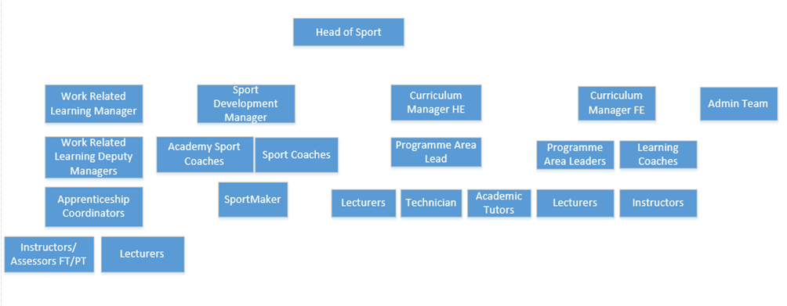

Key Responsibilities

- To deliver high quality and challenging learning experiences.

- To lead and devise appropriate assessments and assessment strategies and feedback to students through a variety of formative and summative assessment methods.

- To lead and collaborate with staff in the development of excellent learning materials and programmes of study utilising a range of media.

- To lead on the development and planning of teaching and learning including schemes of work for units, programmes, modules and qualifications as appropriate.

- To undertake curriculum area responsibility duties as designated by the Curriculum Manager.

- To contribute to curriculum planning and development to work with the curriculum areas to develop and coordinate a dynamic and responsive curriculum.

- To play a key role in quality assurance and quality improvement.

- To comply with and develop best practice administrative and quality assurance systems.

- To undertake and deliver appropriate staff development and training, including the maintenance and updating of specialist skills.

- To attend and actively participate in area and department meetings, planning events, open days and recruitment events.

- To modify duties and responsibilities as required to meet new situations, in consultation with the curriculum area leader/manager and college management.

Core Responsibilities

- To promote the College’s vision, mission and strategic objectives and to promote the values and behaviours which underpin them at all times.
- To act as an ambassador for the college in dealings with all external agencies (other colleges, funding bodies, suppliers, learners, parents and employers) and to maintain the highest standards of professional conduct.
- To promote Loughborough College and its subsidiaries as the first choice destination for students, employers and staff alike.
- To proactively promote equality of opportunity in all aspects of the work role and to assist in the leadership and management of compliance to the agreed Health & Safety policy and practice.
- To promote a positive approach to security and discipline within the College community.

Key Result Areas

Action | Result
Lead on curriculum development | Resourced programmes of study
Lead on the planning, preparation, delivery, and assessment of effective learning programmes | To ensure students achieve
Create and apply effective differentiation and stretch and challenge techniques | To ensure all students achieve to the best of their ability
Monitor progress in lessons and disseminate learner progress with key staff | To ensure students are on track to achieve their target grades
Lead on development of assessments/assessment strategies and give high quality feedback | To ensure students can meet their targets and progress
To participate in moderation and second marking | To ensure Awarding Organisation criteria are met and academic standards maintained
Participate in and deliver staff development opportunities | To ensure teaching and learning is up to date and maintained to the highest standards
To play a key role in quality assurance and quality improvement | To ensure Awarding Organisation requirements and College KPIs are met
Participate in department activities and meetings | Increased recruitment, broader knowledge of department

Key Working Relationships and Communications

Internal:
Head, Deputy Head, Curriculum Manager, Curriculum Area Lead, Programme Area Leader, Curriculum Staff, Administration Staff, Support Services Staff

External:
Awarding Bodies

Scope for Impact
Not applicable

Competency profile

The following profile is a description of the required competencies of the role:

Competency | Descriptor | Competency | Descriptor
Accountable - We have full ownership for our actions, thinking through our decisions and taking responsibility for the outcomes. | Takes ownership for own development, supports that of others and develops beyond own role. Works efficiently; makes best use of the College's resources. Maintains a healthy and safe environment for College people and visitors. Swiftly implements changes to keep up with legislation and best practice. Enable learners to share responsibility for their own learning and assessment, setting goals that stretch and challenge Understand the teaching and professional role and your responsibilities Maintain and update your knowledge of educational research to develop evidence-based practice Maintain and update knowledge of your subject and/or vocational area Evaluate and challenge your practice, values and beliefs | Entrepreneurial - We think outside the box, exploiting technology and providing opportunities using our initiative and creativity. | Looks for opportunities to do own job better; puts forward ideas. Always considers longer term impact of own tasks You try new approaches and are not tied down by the existing ways of doing things. Address the mathematics and English needs of learners and work creatively to overcome individual barriers to learning Be creative and innovative in selecting and adapting strategies to help learners to learn
Agile - We are flexible and responsive in all that we do and demonstrate adaptability towards new challenges and changing environments. | Handles change with responsiveness and adaptability. Uses a structured and collaborative approach to solving problems in own and related work areas. Reaches clear, definite and timely decisions based on thorough understanding of the facts and an eye to their practical implications. Multi-tasks and consistently delivers own and team objectives on time and to standard. Anticipates customer needs; prevents poor service; delivers consistently high quality service. Knows how to handle, store, disseminate and share digital information and data in a responsible and ethical way. 0 Maintain and update your teaching and training expertise and vocational skills through collaboration with employers Evaluate your practice with others and assess its impact on learning Reflect on what works best in your teaching and learning to meet the diverse needs of learners | Inspiring - We are passionate and positive about what we do, creating challenging and motivational environments where everyone grows and succeeds. | Inspires people to reach great heights of performance and success through leadership. Communicates with impact and sophistication; adapts style and uses varied media to meet different audience needs. Promotes and ensures diversity, equality and inclusion in own team; team works within relevant laws. Promote the benefits of technology and support learners in its use Motivate and inspire learners to promote achievement and develop their skills to enable progression Inspire, motivate and raise aspirations of learners through your enthusiasm and knowledge
Engaging - We are focussed on building relationships, using clear communication to ensure everyone participates and feels part of the College. | Supportive team member; forms positive working relationships in team. Effectively coordinates others in achieving a task. Contribute to organisational development and quality improvement through collaboration Plan and deliver effective learning programmes for diverse groups or individuals in a safe and inclusive environment Manage and promote positive learner behaviour Apply theoretical understanding of effective practice in teaching, learning and assessment drawing on research and other evidence Build positive and collaborative relationships with colleagues and learners Value and promote social and cultural diversity, equality of opportunity and inclusion | Integrity - We are open, honest and transparent in our work, behaving professionally and ethically at all times | Credibly represents the College by demonstrating a superior knowledge of subject area - current and related topics. Own work consistently contributes to the strategic aims of the College. Improves diversity, equality and inclusion in own area; challenges inappropriate behaviours. Understands self and others; communicates with sensitivity; handles difficult people and events effectively. Apply appropriate and fair methods of assessment and provide constructive and timely feedback to support progression and achievement

Knowledge, Skills and Experience (Person Specification)

QUALIFICATIONS |  | ESSENTIAL | DESIRABLE | HOW ASSESSED
1 | Possess a degree in a relevant subject area |  |  | Application
2 | Possess assessor and/or verifier qualifications |  |  | Application
3 | Possess a teaching qualification |  |  | Application
4 | Good standard of literacy and numeracy. At least GCSE passes Levels 4 to 9 (Grades A-C) in English Language and Maths or equivalent |  |  | Application
EXPERIENCE
5. | Significant experience of designing and delivering vocational/ academic programmes to students |  |  | Application
6 | Significant experience of teaching within an FE context |  |  | Application
7 | Experience in a relevant vocational industry setting or academic background |  |  | Application
8 | Experience of supporting and managing diverse groups of students |  |  | Interview
9 | Proven experience of motivating students to achieve excellent results |  |  | Interview
10 | Experience contextualising and embedding learning to meet specific learning needs |  |  | Interview
11 | Evidence of effective use of ICT/ILT in all aspects of work |  |  | Interview
12 | Experience of collaborating with teaching colleagues from other subject areas |  |  | Interview
SKILLS & KNOWLEDGE
13 | Excellent teaching and learning skills |  |  | Interview
14 | Experience of active learning and assessment methods |  |  | Interview
15 | Knowledge of a range of teaching methodologies and the ability to utilise these effectively within a variety of contexts |  |  | Interview
16 | Work flexibly and to deadlines |  |  | Interview
17 | Excellent planning, administration and organisational skills |  |  | Interview
18 | Communicate effectively to a diverse range of stakeholders at all levels |  |  | Interview
19 | Work autonomously and as a part of a cross-curricular team |  |  | Interview
20 | Provide clear and formative feedback on academic and pastoral issues |  |  | Interview
BEHAVIOURS
21 | Work effectively with colleagues as part of team |  |  | Interview
22 | Motivate and relate with students from a range of different cultural backgrounds |  |  | Interview
23 | Comply with professional standards at work |  |  | Interview
24 | Show commitment to the improvement and maintenance of standards |  |  | Interview
25 | Promote the College’s equal opportunities policy and practices |  |  | Interview
26 | Ensure the safeguarding of students |  |  | Interview

Notes

- A satisfactory Enhanced Disclosure & Barring Service check is required for this post. Loughborough College is committed to safeguarding and promoting the welfare of children and young people and expects all staff and volunteers to share this commitment.

- Loughborough College retains the right as a condition of your employment to require you to undertake such other duties as may be expected of you in the post mentioned above, or in a similar post within the College.

- This job description and person specification was prepared in May 2018 and may be amended in light of changing circumstances following discussion with the post holder.

Job Description Agreement

Job Holder Signature |  | Date
Manager Signature |  | Date

