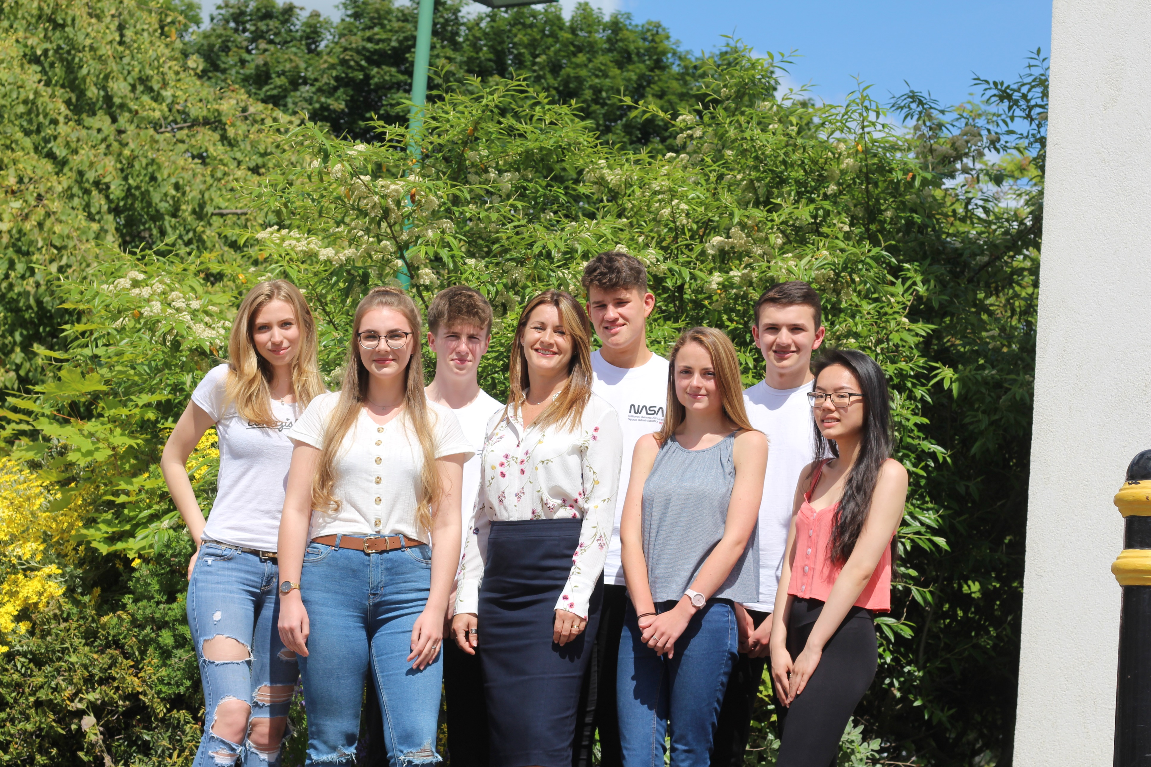

Headteacher’s PA

Part-time/Full-time Teacher(s) of
BTEC SD Performing Arts, A level Music and/or A level Theatre Studies

Advertisement

Job Title: Headteacher’s PA

Scale: Grade 5 SCP 7 – 12 (£19,554 - £21,589)

Start date: 4th November 2019 or as soon as possible thereafter

Hours: 7.30am – 3.30pm (3.00pm on Friday) 37 hours per week

Holiday entitlement: 26 days per year (31 days after 5 years of service) not including public holidays

This is an exciting time to join Durham Sixth Form Centre: we are an oversubscribed post-16 institution; our results are significantly above National Averages; we are expanding our premises; we have gained external recognition and national awards for our work; we are Outstanding as defined by Ofsted, March 2017.

We know that the very best way to continue to provide outstanding education is to ensure our teaching staff and support staff are outstanding. With this in mind we wish to appoint a forward thinking, enthusiastic and ambitious PA to the Headteacher who has the drive, intellect and motivation to work with Headteacher in realising the ambitions for the school.

The successful candidate will have exceptional planning and time management skills; be able to inspire and challenge colleagues; have the ability to communicate effectively with a wide range of stakeholders including staff, students, parents, the media and governors; and be committed to working in an inclusive environment in support of the values, vision, purpose and direction of Durham Sixth Form Centre.

The position has arisen due to the promotion of the current post holder.
The job description, person specification and application form are available from our website www.durhamsixthformcentre.org.uk or alternatively from the Headteacher’s PA – Emma Tallentire. Applicants should complete the standard application form and submit a short letter of application. The closing date for applications is Thursday 17th October 2019.

“This school is committed to safeguarding and promoting the welfare of children and young people and expects all staff and volunteers to share this commitment”

Dear Applicant,
Welcome to Durham Sixth Form Centre and thank you for your interest in the advertised post. I hope the following information gives you an insight into our school.

Durham Sixth Form Centre is the largest post-16 school in the North East of England (and 1 of 4 nationally), with approximately 1,500 students on roll. We are situated in the middle of Durham City Centre, a couple of minutes’ walk from both the bus and railway stations. Students generally enrol at Durham Sixth Form Centre from over 50 different secondary schools from across County Durham, Sunderland and into Northumberland.

We were inspected by Ofsted on 1st and 2nd March 2017 and are delighted with the outcome. We are an Outstanding post-16 school. Our students have an excellent record of success; they work hard to achieve it.

- Our A level results are above the national average and in the top 12% of schools in England.
- Students’ grades and points for A level are above both the County Durham average and national average.
- Students’ points and grades for their best 3 A levels are also above the national average.

- Our Applied General results (broad vocational qualifications) are above the national average and in the top third of schools in England.
- Students’ grades and points for Applied General are well above the County Durham average and national average.

- Our Tech Level (occupational qualifications) grades and points are well above the County Durham average and national average.

Most of our students continue their studies at university, some take up employment or apprenticeships; others stay with us into Year 14 where we run some Level 4 courses. Our award-winning Careers Information Advice and Guidance team support our students into higher education, employment or their chosen future pathways.

In 2013 we celebrated our Centenary year. We are housed in a 1913 former Girls’ Grammar School which was converted to Sixth Form accommodation in 1983. In addition to the original building there is now a Science Block; a 210 seated Theatre; our Hunter Resource Centre; Visual Arts Centre and Freemans Quay Leisure Centre. We are opening our Digital Media Centre in October 2019 and have announced our plans for Durham Mathematics School, a new school credited in Partnership with Durham University.

Through sustained effort, and a clear focus and direction, Durham Sixth Form Centre is a truly embracing and dynamic organisation. We are committed to promoting the principals of equal opportunities and we aspire to an environment where all our students and employees can develop their potential. We have a strong professional development programme and have achieved CPD Mark accreditation, Investors in People Gold and Governor Mark. Our recent Ofsted inspection report said ‘The Headteacher and the highly skilled leadership team have established a culture in
which students flourish and grow. Consequently, there is a healthy appetite for learning and achievement in an environment that demands high expectations for academic, vocational and personal excellence.’ The school operates according to values which we feel help to determine the culture, ethos and atmosphere of Durham Sixth Form Centre. We value:

- high quality, inspirational teaching and learning;
- excellent support, care and guidance;
- personal and professional integrity;
- ambition and progress for our students, our communities and ourselves.

If you are energetic and passionate about post-16 education and have the skills and aptitude required for the role then we would welcome your application and look forward to hearing from you.

Ellen Beveridge
Headteacher
September 2019

We seek the following in our Headteacher’s PA:

Person Specification | Essential | Desirable
- Ability to relate to students and staff in a professional, constructive manner and uphold/model high standards and expectations. | ✓
- Outstanding interpersonal and relationship building skills. | ✓
- Evidence of continued professional development in line with current and/or potential future role(s). Willingness to undertake further professional development. | ✓
- Excellent literacy, numeracy and ICT skills. Ability to proof read documents. Ability to interface and learn new IT programmes. | ✓
- Ability to prepare and write reports/letters and develop uncomplicated systems and processes. | ✓
- Attention to detail, organisation, energy and drive respecting confidentiality at all times. | ✓
- Ability to deal with people and diffuse difficult situations both internal and external to the school. | ✓
- Ability to work under pressure to meet deadlines and manage conflicting demands whilst maintaining quality standards, managing own workload priorities. | ✓
- Ability to gather information, analyse, interpret and solve difficult problems. | ✓
- Reliable, trustworthy and flexible with warmth, resilience and a good sense of humour. | ✓
- Exemplary health and attendance. | ✓
- Committed to working in an inclusive school in support of the values, vision, purpose and direction. | ✓
- Knowledge and understanding of school governance and committee structures. |  | ✓
- First aid training qualification. |  | ✓
- Hold a current driving license. | ✓
- To promote and safeguard the welfare of children and young adults. | ✓

We have identified below where we anticipate gaining the information outlined in the Person Specification.

Person Specification | Application | Interview/  Selection Process | Reference prior to interview | Post offer check
- Ability to relate to students and staff in a professional, constructive manner and uphold/model high standards and expectations. | ✓ | ✓ | ✓
- Outstanding interpersonal and relationship building skills. | ✓ | ✓ | ✓
- Evidence of continued professional development in line with current and/or potential future role(s). Willingness to undertake further professional development. | ✓ | ✓ | ✓
- Good literacy, numeracy and ICT skills. Ability to proof read documents. Ability to interface and learn new IT programmes. | ✓ | ✓ | ✓
- Ability to prepare and write reports/letters and develop uncomplicated systems and processes. | ✓ | ✓ | ✓
- Attention to detail, organisation, energy and drive respecting confidentiality at all times. | ✓ | ✓ | ✓
- Ability to deal with people and diffuse difficult situations both internal and external to the school. | ✓ | ✓ | ✓
- Ability to work under pressure to meet deadlines and manage conflicting demands whilst maintaining quality standards, managing own workload priorities and that of others. | ✓ | ✓ | ✓
- Ability to gather information, analyse, interpret and solve difficult problems. | ✓ | ✓ | ✓
- Reliable, trustworthy and flexible with warmth, resilience and a good sense of humour. | ✓ | ✓ | ✓
- Exemplary health and attendance. |  | ✓ |  | ✓ | ✓ | ✓
- Committed to working in an inclusive school in support of the values, vision, purpose and direction. | ✓ | ✓ | ✓
- Knowledge and understanding of school governance and committee structures. | ✓ | ✓ | ✓
- First aid training qualification. | ✓ |  |  | ✓ | ✓ | ✓
- Hold a current driving license. | ✓
- To promote and safeguard the welfare of children and young adults. | ✓ | ✓ | ✓ | ✓

HEADTEACHER’S PA

Job Evaluation Ref: A6736

Grade: 5 SCP 7 – 12 (£19,554 - £21,589)

Hours: Whole-time, 37 hours per week

Responsible to: Headteacher

Appraisal: Human Resources and Data Manager

Brief: To provide professional, efficient administrative support to the Headteacher and HR Manager as and when appropriate.
Summary of the Key Areas of Responsibility:

- To provide high quality communications from the Headteacher’s office.
- Ensure personnel records and all associated documentation are updated, accurate and compliant with the latest GDPR requirements.
- To ensure the school calendar is fully up-to-date and accurate.

Key Areas of Responsibility | Brief Outline
- To provide high quality communications from the Headteacher’s office. | - To carry out all duties as Personal Assistant to the Headteacher.  Be responsible for confidential secretarial, administration, filing and clerical duties relating to all aspects of Headteacher’s work including management of diary, correspondence, records, databases and personal work.  - Ensure the Headteacher is briefed for all meetings with relevant correspondence, documents/presentations and in the Headteacher’s absence refer matters to the relevant members of the Senior Leadership Team for action.  - Open correspondence addressed to the Chair of Governors, including all highly confidential correspondence and in consultation with the Chair of Governors/Headteacher, take appropriate action.  - Take minutes of meetings for the Headteacher.  - Manage hospitality for meetings, visitors and events/functions throughout the year.  - Receive and appropriately deal with all incoming electronic communication to the school’s secure and general email. Use judgement to redirect them to appropriate people/departments. Keep the ‘in boxes’ clear of read messages.  - Undertake project/research work as required.  - Monitor and communicate DfE publications/websites and any other education/school related information and inform the Headteacher where appropriate.  - Manage and organise the staff birthday and service lists and liaise with the Headteacher as appropriate.  - Organise the Headteacher’s school travel arrangements.  - Respect confidentiality at all times.  - Manage and update the school emergency contact list.
- Ensure personnel records and all associated documentation are updated, accurate and compliant with the latest GDPR requirements. | - Be the first point of contact for staff absence.  - Be responsible for the Headteacher’s administrative filing including confidential staff files (also through the HR Manager).  - In connection with staff appointments and in liaison with the Headteacher (and at times HR Manager) prepare advertisements, advertise vacancies, prepare and send out job details, obtain references and arrange interviews.  - To ensure all pre-employment clearances, e.g. references, work permits, DBS clearances, List 99 checks, ID, qualification and health clearances etc. are completed in a timely manner (with the support of the HR Manager).  - To liaise with supply agencies for cover for absent teachers negotiating best rates and reducing/extending contracts.  - Ensure an accurate record of staff details are kept in SIMS and new staff details are promptly inputted.  - Update the school’s HR calendar and liaise with the Headteacher/HR Manager as appropriate.  - Update MyView for staff absence and SAIL for staff contracts.
- To ensure the school calendar is fully up-to-date and accurate. | - To routinely monitor and update the school calendar including populating future calendars as information becomes available.  - To alert SLT members to any potential issues relating to scheduled events or future events within the school calendar.
In addition | - Be responsible for opening the school office and switchboard each morning and ensure reception is covered until colleagues start work.  - To monitor and evaluate the area of responsibilities in line with agreed school procedures including evaluation against quality standards and performance criteria.  - To ensure effective introduction of new staff in line with school procedures where applicable.  - Participate in support staff appraisal.  - To undertake any additional work requested appropriate to the pay grade by the Headteacher.
Modelling | - To lead and model the values, ethos and vision of the faculty in pursuit of excellence and equality, valuing individual achievement.  - To help build, communicate and implement a shared vision.  - To role model and actively promote high expectations.  - To inspire, challenge, motivate and empower others within the area of responsibility.  - To be aware of the responsibility for personal health, safety and welfare and that of others who may be affected by individual action/inaction.
Training/Qualifications | - Where appropriate (and when trained) act as a school first aider.  - The employee will be expected to undertake ongoing research to develop their knowledge base and will undertake any CPD, inset and qualifications as deemed necessary by the Headteacher.  - Where formal qualifications are identified the employee will be required to sign an agreement to reimburse the school of any training costs incurred if the employee leaves before qualification and/or if they leave before a period to be specified after qualification.

Day | Hours | Total hours in school | Lunch break | Total hours worked
Monday | 7.30am – 3.30pm | 8 hours | 30 mins | 7 hours 30 mins
Tuesday | 7.30am – 3.30pm | 8 hours | 30 mins | 7 hours 30 mins
Wednesday | 7.30am – 3.30pm | 8 hours | 30 mins | 7 hours 30 mins
Thursday | 7.30am – 3.30pm | 8 hours | 30 mins | 7 hours 30 mins
Friday | 7.30am – 3.00pm | 7 hours 30 mins | 30 mins | 7 hours
 |  |  |  | 37 hours

Job Title: Headteacher’s PA

Scale: Grade 5 SCP 7 – 12 (£19,554 - £21,589)

Start date: 4th November 2019 or as soon as possible thereafter

Hours: 7.30am – 3.30pm (3.00pm on Friday) 37 hours per week

Holiday entitlement: 26 days per year (31 days after 5 years of service) not including public holidays

Should you decide to apply for the vacancy then please return a completed application form including the names, addresses and relevant contact details of two referees together with your short letter of application.

The letter of application should be no more than two sides of A4 and should set out the particular strengths that you would bring to the post; how you feel you meet the criteria outlined in the job description and person specification; and a response to the following questions:

- Why are you interested in applying for the role?
- How would your skills meet the needs of the post?

Completed applications must be received by 10.00am on Thursday 17th October 2019 addressed to:

Emma Tallentire
Headteacher’s PA and Office Manager
Durham Sixth Form Centre
Providence Row
The Sands
Durham City
DH1 1SG

Or emailed to:

dsfc@durhamsixthformcentre.org.uk entitled ‘For the Attention of Emma Tallentire - Application for insert job title’.

Interviews are provisionally scheduled to take place on Wednesday 23rd October 2019.

If you have not heard from us within 4 weeks please assume that you have been unsuccessful on this occasion.

Durham Sixth Form Centre:
- is committed to safeguarding and promoting the welfare of children and young people and expects all staff and volunteers to share this commitment.
- ensures all appointments are subject to an enhanced DBS check, satisfactory medical report and satisfactory references.
- is an equal opportunity employer.
- is a Local Authority Maintained school.
- operates a strict no-smoking policy.

