

Headmaster's Message
Bedstone College is a leading independent day & boarding school Set in an area of Outstanding Natural Beauty in the South Shropshire Hills and just 12 miles from the famous, medieval, walled market town of Ludlow, Bedstone College is a quintessentially British Independent School. With the historic towns of Hereford and Shrewsbury within 25 miles, there are excellent transport links to the rest of the UK. Birmingham International airport is just over an hour by car. We are a co-educational, ‘All-Through’ school, serving children from Reception age through to Sixth Form.

You are undoubtedly wondering what it is that sets us apart from the many other schools that you see. The simple answer is: "our young people".

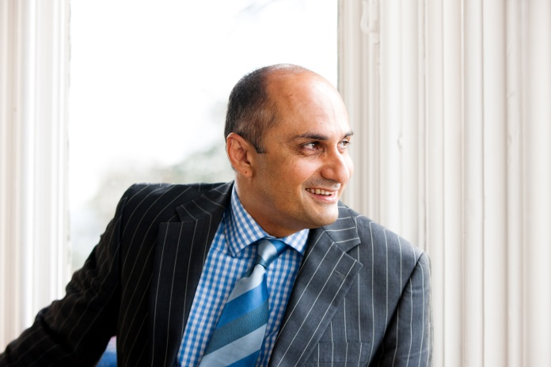
Visitors to Bedstone are immediately struck by the friendly atmosphere of the school; the openness and confidence of our students, the support that they give to each other and the fact that the children are patently enjoying life at school.

Thank you for expressing an interest in working with us. Life at Bedstone is incredibly rewarding and I am sure that you will be excited at the prospect of joining us if you are invited to interview.

If you require further information on the post for which you are applying, please do not hesitate to contact us at your convenience.

I wish you all the very best with your application!

David Gajadharsingh BSc (Hons), PGCE, CPhys, MInstP, NPQH
Headmaster

David Gajadharsingh did his first degree in Aeronautical Engineering and then went on to study for his PGCE at Oxford University. He started his teaching career at Peers School in Blackbird Leys, Oxford. He left teaching for a brief sojourn with Glaxo Pharmaceuticals in their sales and marketing department before returning to the profession with Collingham Tutorial College in London in 1990. He was appointed as a Physics teacher and Head of Year at Aylesbury Grammar school in 1991. In 1997 he secured the post of Head of Physics at Millfield School in Somerset and while in post was also asked to take on the role as Head of Year (Sixth Form), in which he was responsible for the academic and pastoral welfare of some 340 students. David was appointed as Deputy Headmaster of King Edward VI Grammar School in Stratford-upon-Avon in 2003. During his time at KES, Stratford, David was responsible for both the pastoral and academic dimensions of the school. In the school's last OfSTED inspection during David's tenure, Leadership and Management was rated as 'Outstanding'. David has always been involved in playing and teaching sport and has gained county, national and international honours in fencing. At Oxford he was awarded a fencing 'Blue' and he has run clubs in fencing, football, basketball, badminton, table tennis and cricket during his teaching career. David was born in Trinidad & Tobago. At the age of three his family left the Caribbean island. They moved first to Dublin, (his mother is Irish), and then on to London where he attended Burlington Danes Comprehensive School in Shepherd's Bush. David is married to Gabi and they have two daughters.
Bedstone College Shropshire SY7 0BG 01547 530961 admissions@bedstone.org
An Independent Boarding & Day School for Boys & Girls Aged 4 - 18

