Welcome to ICT
at All Hallows

We aim to equip our students with the skills required to operate in the digital world. We teach the valuable ICT basics and also introduce the students to a variety of new computing skills including programming. Our students learn by doing where every lesson is built around practical ICT tasks. Our lessons are always busy and our students enjoy a full and varied curriculum at Key Stage Three. We currently offer the Cambridge National IT course at Key Stage Four and the Level 3 BTec National in the Sixth Form. We plan interesting tasks which teach the students the skills they need, not just for ICT but also to support other curriculum subjects.

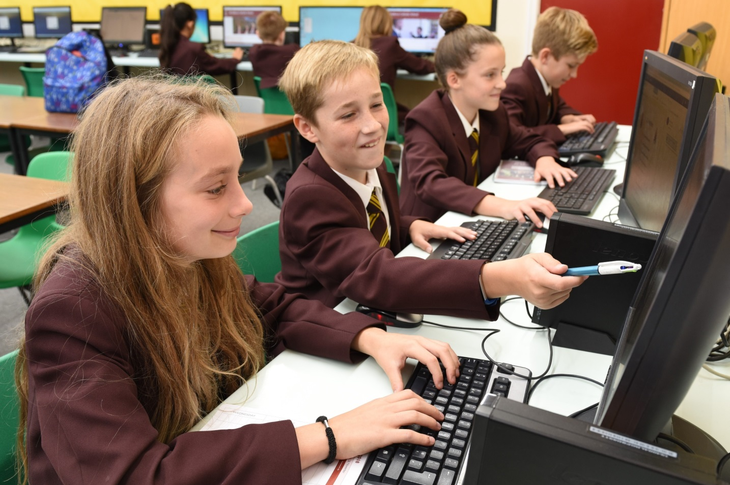

We provide instruction and feedback to the students as they complete challenging tasks and we witness the students develop their skills and interest in ICT as they progress through the school. At All Hallows we ask ourselves a simple question, “In an ideal world, would we want this standard or form of education for our own children?” It helps keep us focused on what matters and provide the best we collectively can.
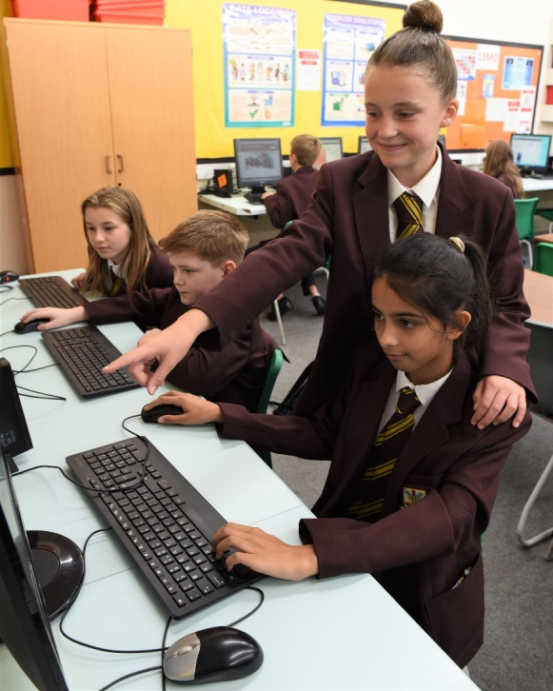
Last year we had one mixed ability class studying GCSE ICT. A third of the class achieved either an A or A* grade. The students worked hard and enjoyed their project work. Students are always keen to come back after school to do more! There is a positive culture within the department and this extends to the whole school, set up by the experienced leadership team. Students are taught to respect staff and respect learning right from the beginning. They are taught that the most valuable thing we can offer as a school is the opportunity to learn. They are taught to say, ‘thank you’ to the teacher at the end of the lesson, to stand behind their chairs and wait to say, ‘good morning’ before sitting down, to keep uniform standards high… i.e. they are taught that the little things matter. At All Hallows all staff are expected to collectively reinforce and upkeep this message. The children expect you to expect a lot of them.

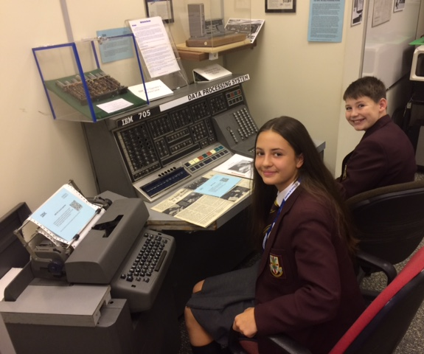
Naturally, this means that they have high standards of us as well as themselves. They expect, and respect, someone who is an expert in their subject, someone skilful at disseminating this to them, someone who can guide them with authority in how to do well in their lessons and exams.

We offer extra-curricular opportunities such as a recent visit to IBM Hursley, where a group of Year 9 students took part in a Day of Innovation. At lunch time we offer a support/ catch up session for the lower school and also after school sessions for those students who study the subject at Key Stage Four or in the Sixth Form.
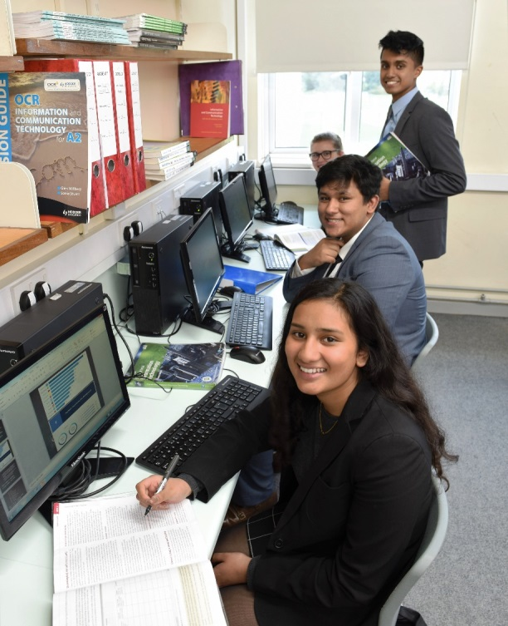
Finally, and most importantly, we are a team. We come from different curriculum areas and this can help to show the students how ICT can be used in so many different aspects of life and learning. We work well with the ICT technicians who serve the whole school not just our department. The small team of ICT teachers share the same vision and we get along well. It would be important to us that the successful candidate could easily become part of this.

Should you have any questions or queries, please do not hesitate to contact me at the school or at c.rees@allhallows.net

Mr Chris Rees, Head of ICT

