January 2020

Dear Prospective Candidate

Head of Art Department

Thank you for showing an interest in this key role at Woodcote High School.

Woodcote is a great place to work and visitors never fail to be impressed with the friendliness of both our students and staff and the mutual support that ensures that it is a pleasure to come and work at Woodcote High School every day.

Art has played a pivotal role in the success of Woodcote High School over the years and we are looking for someone to continue the success of the Art Department.

The best way to find out about a school is to visit personally and we really encourage all our potential applicants to come and have a look around the school before they make their application. In the past, many present colleagues have done this with their application in hand and have been very keen to submit it once they have had a chance to look around the school. Please telephone my PA (option 4 on the telephone) or email l.allen@woodcotehigh.com should you wish to pop in and see us.

We are looking for the best person for the job but at the same time recognise this is a two-way process and we desire to be the sort of school that teachers and leaders want to work in and flourish during their time here.

I look forward to meeting you either on the informal visit or at formal interview and particularly look forward to working with the successful candidate come January.

Please remember the closing date for applications is no later than 12 noon on Monday 24th February 2020.
Interviews will be ongoing from this date

Yours sincerely
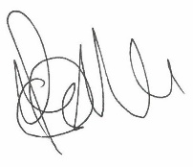
Mr P Mundy-Castle
Headteacher

