THE GRANGE SCHOOL

Specialising in Business & Enterprise



Year Team Leader



THE GRANGE SCHOOL

The Grange School is a well-established, friendly school, specialising in Enterprise.
Enterprise is a driving factor throughout learning as evidenced by our Grange Enterprise and Learning Skills (GELS), which are embedded across the curriculum.

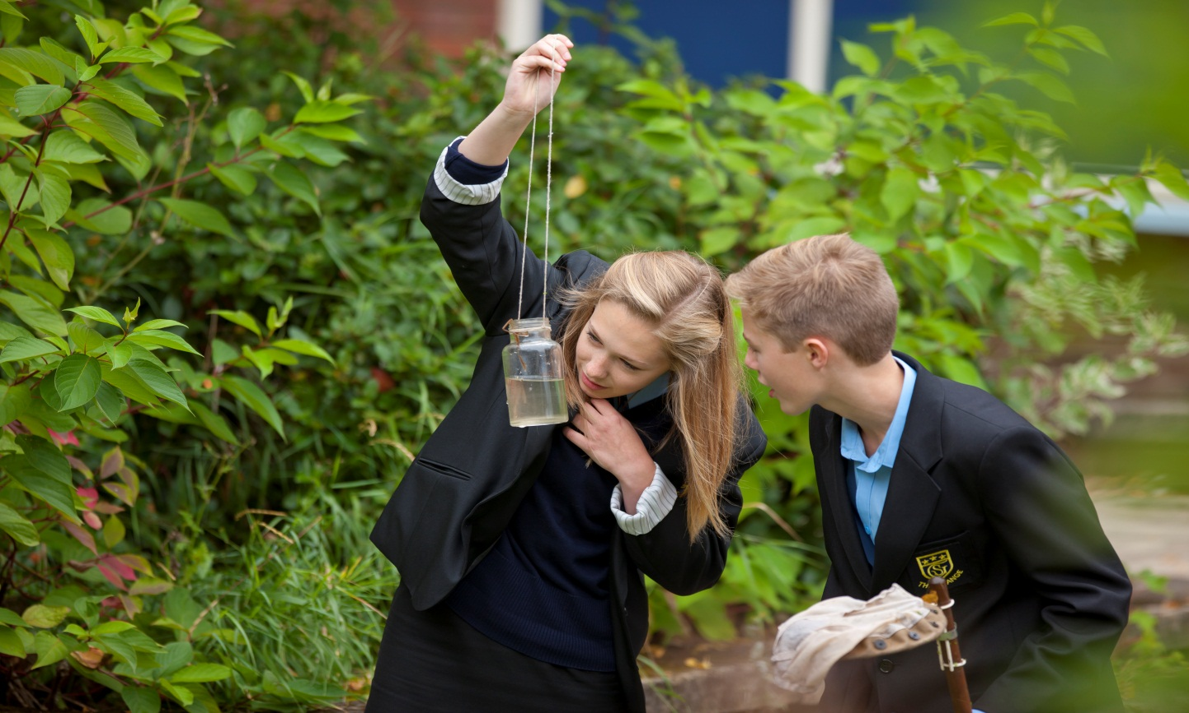

We aim to equip all students with the adaptability and flexibility to meet the demands of a rapidly changing world and to promote a sense of responsibility towards others, the school and the wider community. The support and guidance of students is based on a Year system and aims to develop co-operation, involvement and respect in all students.

A broad and balanced curriculum is provided for Years 7 to 9. In Years 10 and 11 all students will study English, Mathematics, Science, PE, RE and PSHCE (Personal, Social & Health and Citizenship Education). Students can then choose from a range of additional GCSE, BTEC and vocational courses. We offer a range of traditional and vocational courses at Key Stage 5. The curriculum in all Key Stages is further enhanced through wide ranging extra-curricular experiences.

We aim to attract energetic and conscientious staff who have a commitment to the education of our students. The professional development of all staff is an important focus for the school. We strive to create a learning environment, which serves the needs of all the members of our diverse and vibrant community.

THE GRANGE SCHOOL
JOB DESCRIPTION

YEAR TEAM LEADER

The co-ordination and leadership of learning within half a year group is at the centre of the Year Team Leader role.

The Year Team Leader and their teams operate at the centre of the school to support learning and to give students the confidence to be ambitious and to succeed.

The Year Team Leader will have primary role as teacher of a subject within The Grange School with additional responsibilities explained below.

Responsible to: Deputy Headteacher (Pastoral).

JOB PURPOSE
- To ensure the well-being of students and staff.
- To ensure that the focus of the pastoral system is on raising achievement.
- To proactively track students’ progress and learning.
- To be ambitious for every student and to raise individual aspirations.
- To support, hold accountable, develop and lead a team of tutors.

KEY RESPONSIBILITIES
- To nurture a team spirit and year group ethos, setting and maintaining high expectations and standards. Promoting and maintaining a positive climate for learning.
- To forge strong links between home and school to create a dynamic and supportive relationship.
- To support the development of a meaningful and dynamic curriculum which supports learning and empowers students for life beyond school.
- To have a commitment to an extra-curricular programme, which supports both the academic and cultural life of the school.
- To build a strong and supportive team of tutors based on excellent communication and shared good practice.
- To make a major contribution to the main aim and purpose of the school that places learning at the centre.

DUTIES

Student Well Being
- To establish and promote good relationships with every student within the year.
- To promote and develop a close partnership with parents/carers.
- To encourage participation in the Year and School Council, and organise tutor group representatives to contribute to the development and the direction of The Grange School.
- Co-ordinating the work of student learning mentors, school buddies or prefects across the school.
- To liaise with external agencies to support students.
- To work with other Year Team Leaders in developing an effective programme of assemblies and extra-curricular activities.
- Liaising with the Support for Learning Department to co-ordinate and organise the individual learning, counselling, welfare and discipline of identified individual students.
- Organising the induction programme for students new to the school, including placing students into forms and monitoring individual student’s progress during the induction period into the school.
- Contributing to the evaluation and planning of Enrichment activities.
- To jointly produce a termly year team pastoral report.

Student Progress
- To establish systems to monitor individual student progress.
- To respond creatively to identified student needs.
- To co-ordinate all communications with parents, including parents’ evenings.
- To maintain a comprehensive and up-to-date student file on each student, containing records of achievements, sanctions, contacts with parents, etc.
- To support tutors in the use of school’s attainment data to evaluate student progress and respond accordingly.
- Identifying and supporting students who are under achieving across the curriculum.
- Identifying and supporting students who are under achieving in particular subject areas.

Student Behaviour and Attendance
- To ensure the school’s Behaviour Policy is fully supported and implemented across the year group.
- To monitor and analyse student behaviour data, identifying areas of concern and taking appropriate courses of action to support students.
- To ensure the school’s Anti Bullying policy is fully supported and implemented across the year group.
- To actively monitor the system of rewards and sanctions.
- To actively promote and participate in the introduction and development of “Restorative Justice” across the year group.
- Implementing individual support systems including Personal Support Plans (PSPs) and Individual Behaviour Plans (IBPs) for students in the year group.
- Implementing the schools policy and procedures with regard to Internal and External exclusions, including the reintegration of students back into school following exclusion.

Staff Management
- To develop systems of communication which enhance the effectiveness of staff and students
- To establish, with other Year Team Leaders, a pattern of social events designed to place the school at the heart of the community and enrich the experiences of the students
- To ensure that Form Tutor teams fulfil their administrative duties, e.g. registration, attendance, homework, and uniform checks etc. in line with school policy
- To organise calendared events throughout the year that relate to the year group.
- To joint chair the meeting of the Year Team Tutors. This meeting will include at least one member from the Support for Learning Department.
- To support tutors in their tasks when necessary.

Additional Responsibilities
- To be a member of the Key Stage Learning Focus Group meeting chaired by the Key Stage Assistant Headteacher.
- Monitoring of and contributing to the evaluation and evidence for school self evaluation.
- Contributing to the management of the key stage budget allocation, ensuring it is spent in line with learning priorities and staff training needs.
- Attending professional development training as necessary and sharing knowledge and
good practice within the year team.
YEAR TEAM LEADER (TLR 2B)
PERSON SPECIFICATION
 | Essential | Desirable
Qualifications
- Qualified Teacher Status. | ✓
- Evidence of attendance at courses and/or further study with regard to this aspect of school life. |  | ✓
- Evidence of and/or a willingness to attend further professional management development. |  | ✓
Knowledge and Experience
- Experience of works as part of a Pastoral and Curriculum Team. | ✓
- An awareness of the issues regarding outside agencies and the school. | ✓
- A minimum of two years experience of leading a team. |  | ✓
- An understanding of the role of Year Management within a school. | ✓
- An understanding of the use of student progress data and its role in supporting student achievement. | ✓
- Evidence of successfully implementing an initiative with regard to an area of school life. |  | ✓
- The ability to use Information Communication Technology. | ✓
- Evidence of successful interaction with students on an informal level. |  | ✓
- Successful experience of being a committed form tutor. | ✓
Personal Qualities
- The ability to lead a team of hard working committed professionals. | ✓
- An understanding and commitment to being a team member. | ✓
- A high level of interpersonal skills. | ✓
- The ability to communicate well, both orally and in writing. | ✓
- A high level of tolerance. | ✓
- A sense of humour. | ✓
- Flexibility. | ✓
- High levels of personal organisation and appearance. | ✓

