Presdales School

Candidate Information Pack
Teacher of Drama – Part Time (0.5 FTE)
Maternity Cover (March 2020 start)

Presdales School – Teacher of Drama (Maternity Cover)

Information for candidates
Start date: March 2020
Part time (0.5FTE) Maternity cover

Thank you for your interest in joining our team of outstanding staff. Please find enclosed in this pack general information about the school and also specific information about the post.

Presdales is a 11-18 non-selective girls school, with boys welcomed in to the Sixth Form. We have a long tradition of providing an outstanding education for our students. Formerly Ware Grammar School for Girls, which opened in 1906, we became Presdales School in the mid-1960s, and a fully comprehensive school in the early 1970s. The mansion house which fronts the school and our stunning grounds provide a calm and relaxed atmosphere for our school community. Presdales School is one of nine designated Lead Language Hub schools in England. We work with the National Centre for Excellence at York University, and with other Hertfordshire schools to enhance and improve opportunities for students in Modern Foreign Languages.

We are very proud of the high academic standards that our students achieve, regardless of their starting point. Our motto, ‘Achievement for all’, runs through all that we do. We understand that every student is an individual, with different interests, strengths and characteristics, and we celebrate the diversity that each one of them brings to our community. We believe that all students, with the appropriate balance of support and challenge, can be successful.

We aim to develop their creativity and independence inside and outside of classroom lessons. There is an extensive range of extra-curricular clubs and activities, including numerous trips throughout the school year, which provide students with the opportunity to develop their leadership skills, to be part of a team and to develop a ‘can-do’ attitude.

Our vision and values are instilled in our students throughout their time with us, whether this be through our House system, the excellent pastoral care they will receive or the culture of achievement for all that we foster in our community. We want our students to be happy and confident young women who are ready to make a meaningful contribution to our global society.

We are seeking a confident and enthusiastic teacher of Drama who is able to inspire our students and who shares our vision for girls’ education. We offer Drama and Theatre studies at KS3, GCSE and A level. The Drama department has a specialised studio with a new LED lighting rig and traditional spotlights, there is projection and sound system installed for lesson and performance delivery. KS3 students are timetabled to have one 50-minute lesson of Drama a week, increasing to three lessons at GCSE and six at A Level. The Drama department consists of one full and one part-time teacher and we also work in close proximity with Presdales Music department whom we collaborate with on the school musical in the summer term. Pupils show a love of learning and are hugely successful in their results. Presdales Drama department is a fantastic place to teach your specialism, this year we have our largest cohort studying A Level Drama and Theatre, which is a reflection in the interest and success of the subject. We provide opportunities for students to showcase their classwork in Creative Arts evenings and house events. Presdales students participate in lessons fully and show real engagement and enthusiasm for Drama. The department prides itself on offering an excellent array of student experiences and a curriculum that builds on the skills required at exam level.

I do understand and appreciate the time and effort it can take to complete an application for a job such as this; thank you for considering Presdales School.

Matt Warren
Headteacher

Presdales School

Teacher of Drama
Start date: March 2020
Part time (0.5FTE) Maternity cover

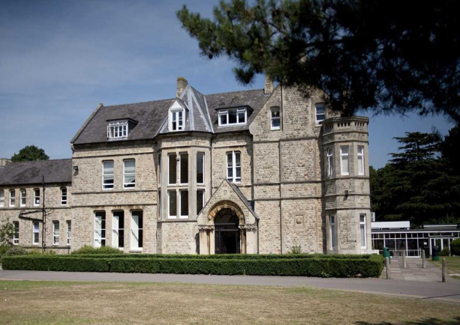
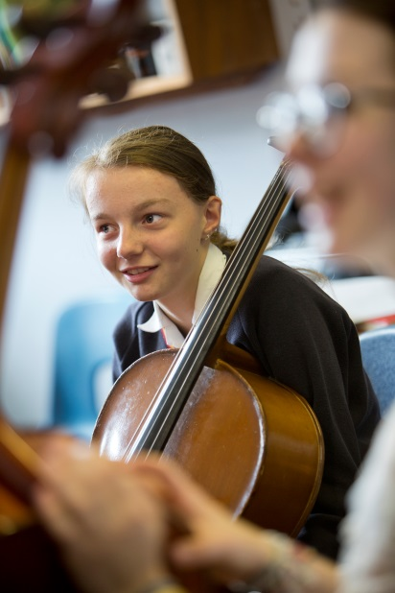
Presdales is a high achieving, all-girl, non-selective 11-18 school (boys are accepted into the sixth form).
We aim to provide an outstanding education that enables all students, regardless of their background and starting point, to achieve and surpass their academic potential.
We are committed to the development of independent minded young people who have active and creative minds.
We expect our students to acquire a sense of understanding and compassion for one another and to have the courage to act on their beliefs. We will equip our students with the skills and attributes to empower them to lead happy and successful lives, enabling them to make a meaningful contribution to our global society.
The school is committed to safeguarding and promoting the welfare of young people and expect staff to share this commitment. Applicants must be willing to undergo an Enhanced DBS disclosure and approved references will be required for the post

Closing date for applications: 9th December 2019, 9.00am
(We reserve the right to close applications before this date, so early applications are advisable)
We expect to interview: w/c 16th December 2019

Please submit:

- A letter of application, no more than one side of A4, outlining how you meet the person specification
- A completed application form (available on the school website)

You can post your application to the school, or send by email to recruitment@presdales.herts.sch.uk
Please note that CVs will not be accepted

Person Specification – Teacher of Drama

We are looking for a candidate who is able to demonstrate the following essential or desirable requirements

Qualifications
- A good honours degree
- Qualified teacher (QTS)
- A commitment to on-going professional development with evidence of further study or professional training
Knowledge and Experience
- Successful teaching of KS3/GCSE/A Level
- Evidence of adding value to current students
- Knowledge of current educational developments in subject and implications
- Good understanding of how students learn and how to raise standards of achievement
- Evidence of active involvement in own professional development
- Experience of using data systems such as SISRA/4Matrix
Skills and Abilities
- Able to communicate well, both in writing and orally
- Excellent organisational skills
- Good ICT skills and be able to use them in own teaching
- Able to manage time effectively and work to deadlines
- An excellent classroom practitioner
Personal Qualities
- Committed to safeguarding and promoting the welfare of young people
- Excellent record of attendance and punctuality
- Ability to work well within a team
- Ability to work under pressure and meet deadlines
- The ability to motivate others
- Positive attitude
- Self-motivated and hardworking
- Creative
- Sense of humour

Job Description –Teacher of Drama

Vision and Purpose

- To teach across the age and ability range, as and when experience allows, and to provide a learning environment that enables all students to make progress regardless of their starting points

- To share the responsibility of all staff to ensure that our students are challenged, encouraged, nurtured and developed as all-round young people

Main Responsibilities

- Teach across the full range of age and abilities, as and when experience allows

- Committed to safeguarding and promoting the welfare of young people

- Monitor and evaluate the progress of students in your classes in line with school policies, and lead on actions within your classes to address underachievement

- Plan and deliver lessons that are in line with the departments curriculum

- To maintain good order and discipline in line with the school’s behaviour policy

- Actively engage in the performance management process

- Communicate effectively both orally and in writing with students, staff, parents and governors

- Have a commitment to your own continued professional development

- Keep up to date with your subject knowledge

- Attend all relevant meetings as required in order to fulfil your role and responsibilities

- Be a form tutor as required

- Ensure that all students have equality of opportunity

- Promote the school’s ethos and culture within the department and wider community

- To comply with the school’s Health and Safety policy

Whilst this job description is current, and every effort has been made to explain the main duties and responsibilities of the post, each individual task may not have been identified. Employees will be expected to comply, following consultation, with any reasonable request from the Headteacher to carry out tasks and duties that are of a similar level, but not specified in the job description.

