

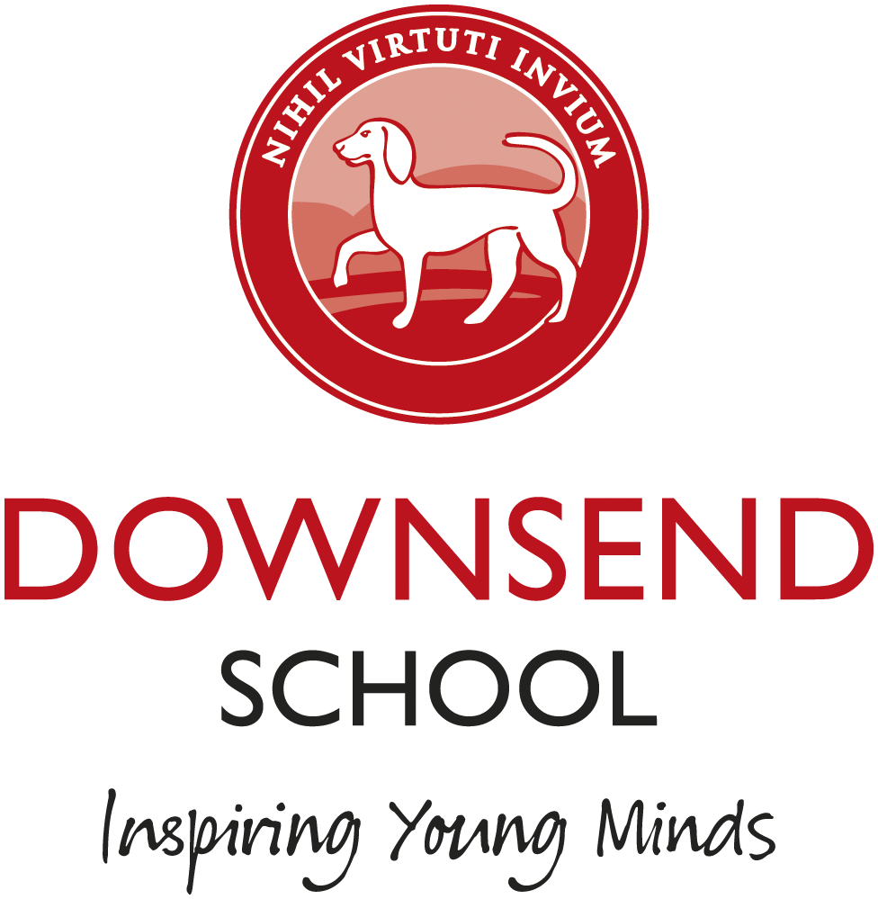

Gap Students x 2

Required September 2024 - July 2025
Term time only

Downsend is an innovative, forward-thinking independent school, for children aged two to sixteen. At Downsend, we prepare children for the future with a creative and problem-solving approach to learning that inspires young minds.

Gap Students play an important role at Downsend in supporting the staff and pupils around the school. This is a great opportunity to get some school experience and increase your confidence before moving on to your next role or university.

Closing date Wednesday 20th March 2024

Interviews will take place week beginning 25th March 2024

If you would like to apply for the above post, further details are available on our website. Any questions please contact:

Michaela Abraham, HR Administrator
Downsend School, 1 Leatherhead Road
Leatherhead, Surrey, KT22 8TJ

Tel: 01372 385419 Email:michaela.abraham@downsend.co.uk www.downsend.co.uk

Cognita Schools are committed to safeguarding and promoting the welfare of children and young people and expects all staff, volunteers and other third parties to share this commitment. Safer recruitment practice and pre-employment background checks will be undertaken before any appointment is confirmed.

