** TEACHER OF MANDARIN**

**Salary: TMS / UPS**

Full time permanent or part time post

Required immediately or January 2020

**INFORMATION FOR APPLICANTS**

**CONTENTS**

1. Letter from Headteacher
2. Job Description
3. Person Specification

July 2019

Dear Applicant

**Teacher of Mandarin**

Thank you for your interest in this post. I hope that you find the enclosed information useful and that you are motivated to join our college at a very exciting time.

Staff and pupils are proud of our college. We have talented and highly motivated pupils and staff. Our staff team work tirelessly to ensure that teaching is the best it can be and everyone has a role to play in this. We support each other and there is an open, friendly and collegiate atmosphere within our staff team. We believe it is crucial that new members of the team are welcomed and well supported.

Well behaved and hard working our pupils have achieved outstanding results year on year at our college.

We are:

* An Investors in People Gold Award School, which means that we invest heavily and value the development of all our staff
* An inclusive Church of England School with the benefits of links with The Diocese of Chichester and the opportunity to promote strong lasting values based on the Christian faith

Understandably this letter and our website [www.stcatherines.college](http://www.stcatherines.college), only gives a flavour of life at our exciting college. We therefore encourage visits for prospective candidates to see us in action. We do understand however that visits are not always possible or practical and you would not be at a disadvantage if you are unable to visit the college.

**The Post**

MFL offers a well-established French and Spanish curriculum and we are one of the only state schools in East Sussex that teaches Mandarin Chinese to GCSE.

We are a Confucius Classroom school which means a strong link is built with Goldsmith’s University London.

The department supports its pupils and staff by investing in smaller class sizes, language assistants, technology and plentiful online learning platform subscriptions. We are proud to actively encourage our team to go for external training and school hub meetings. You will be working in a newly decorated MFL corridor and classrooms where you will be offered opportunities to help shape your department.

We aim at what works for our pupils in regards of their understanding of the bigger world, resistance of challenges and skills for their progress.

We have a vacancy for a Teacher of Mandarin. This is a full time or part time permanent post. This can either be for January 2020 or earlier if a teacher is able to be released from their current school prior to this date or is not currently in post.

We run regular school trips, for example to China; welcome exchange groups from Peru and have MFL activities such as singing competitions and international bake off. We believe an innovative and immersive curriculum will spark our pupil’s passion and truly engage their MFL learning.

Candidates should have previous experience of teaching Mandarin. The successful candidate must be passionate and knowledgeable about their subject and demonstrate a proven track record of very strong teaching and learning leading to positive outcomes as well as a secure understanding of the national curriculum.

As mentioned, we host the Confucius classroom to promote Mandarin language and Chinese culture through The Goldsmiths Confucius Institute. This provides a long term Mandarin learning support to our College as well as a sponsored Chinese teacher and resources. It offers a positive dimension to all curriculum areas and helps raise pupil’s aspirations and attainment, preparing them for working and living in an increasingly competitive global economy.

**We offer you**

**We know it’s a competitive market and are proud of what we can offer:**

* **Excellent career development opportunities**

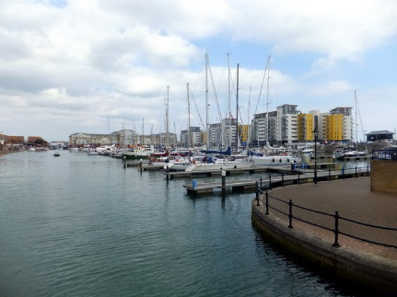

* **A geographical location**, being situated near Sovereign Harbour, Eastbourne’s award winning Marina. It is part of several miles of beautiful coastline, including the South Downs National Park, the white cliffs of Beachy Head and 1066 country
* **A friendly**, supportive and caring staff team
* **CPD,** starts immediately upon employment
* **A fabulous staff room** with complimentary tea and coffee
* **A café** that serves at breakfast, break and lunch using freshly sourced ingredients
* **Teachers’ Pension Scheme**
* **Free Flu Vaccine**
* **Banked** cover system promoting work / life balance
* **Highly visible** supportive senior leaders
* **Same-day** centralised detentions
* **Great Pupils** – you can make a massive difference to them
* Did you know that buying a house in East Sussex can be cheaper than in many other counties in the UK. Average house prices are lower than the national average.

**Your Application**

Completed application forms and letters of application should be sent directly to the college addressed to Mrs S Windsor, Head of Personnel: swindsor@stcatherines.college, and arrive by no later than **noon on Friday 6 September 2019. We reserve the right to call applicants to interview prior to this date if in the best interest of the organisation.**

Please use the standard application form, accompanied by a letter of application, which must be no more than two sides of A4. We are unable to consider CVs in place of application forms unless you are a person with a disability and a CV is the most convenient method of applying. In your letter of application you should clearly address the relevant sections of the Person Specification for this post and may find it helpful to use headings. We are committed to safeguarding and promoting the welfare of children and young people, successful applicants will need to undertake a DBS enhanced clearance.

I am conscious of the time and effort it takes to submit an application and am grateful for your interest. Shortlisted candidates should hear from us shortly after the closing date. St Catherine’s is a thriving college with a bright future and a vibrant and collegiate atmosphere within which to work. I am keen that we appoint quality candidates to join what is, I believe, one of the best staff teams. If I can be of any assistance or provide any further information, please do not hesitate to contact me.

Yours faithfully



Solomon Berhane

Headteacher

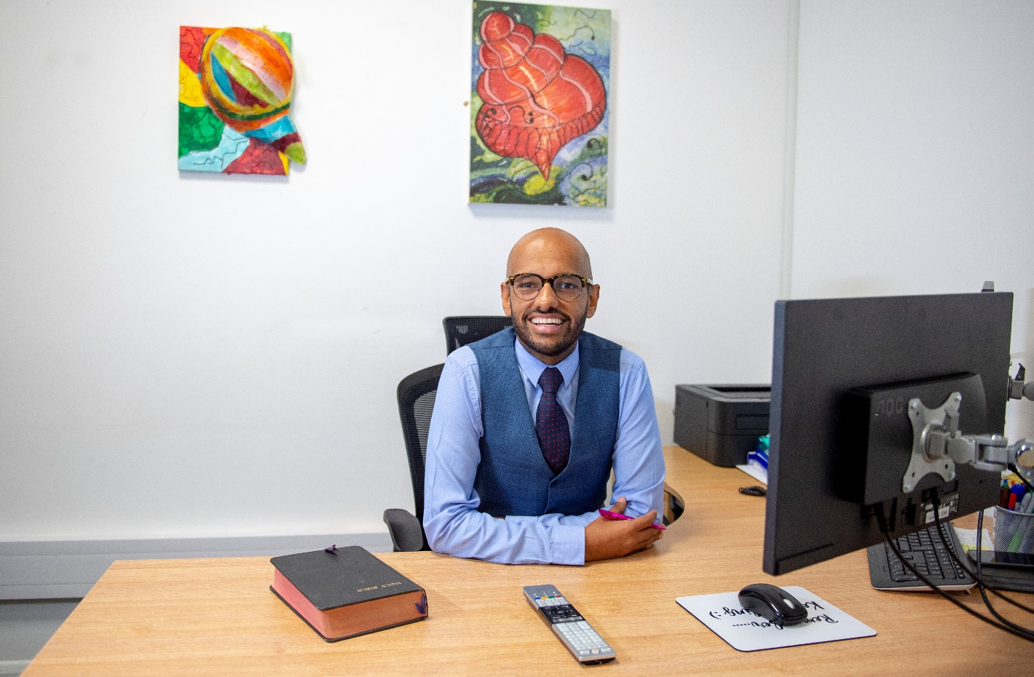

**PERSON SPECIFICATION: TEACHER OF MFL – Mandarin**

|  |  |  |  |
| --- | --- | --- | --- |
| **Attributes** | **Essential** | Desirable | |
| Qualifications and training | * Qualified teacher status recognised by the DfES * Graduate with a degree in languages or a related subject |  | |
| Experience | 🖹 Experience of teaching Mandarin to GCSE |  | |
| Skills and Abilities | * Be a talented classroom practitioner, with potential to develop further * 🗣Able to teach Mandarin to GCSE * Enthuse pupils * Will teach a vibrant and varied culture of MFL * 🗣Possess good ICT skills and be able to use them in their own teaching * 🗣 Able to communicate well, both in writing and orally * Able to manage time effectively and work to deadlines |  | |
| Knowledge and Understanding | * 🗣Understanding of the principles, processes and strategies underpinning outstanding teaching and learning * 🗣 Outstanding knowledge of current educational developments/issues in MFL teaching |  | |
| Values | * 🗣 Be broadly in sympathy with the aims and ethos of the School * A commitment to comprehensive education, equal opportunities and inclusion * A passionate commitment to achieving the highest standards for all learners * A commitment to teaching approaches which make learning interesting, challenging, relevant and effective * An enthusiasm for running and involvement in, extra-curricular activities | * 🗣 A practising Christian |
| Personal Qualities | * Shows warmth, care and a sensitivity to the needs of others * Is self-motivated and hard working * Possesses a sense of humour and the humility to admit mistakes * Shows imagination, vision and proactivity * Possesses an infectious enthusiasm, stamina and considerable energy * Ability to work under pressure to achieve, to have high expectations, lead by example and meet deadlines | 🖹 Has a good health and attendance record |

**Criterion assessed by:** 🖹 = application form; ✍ = letter of application; 🗣 = interview

