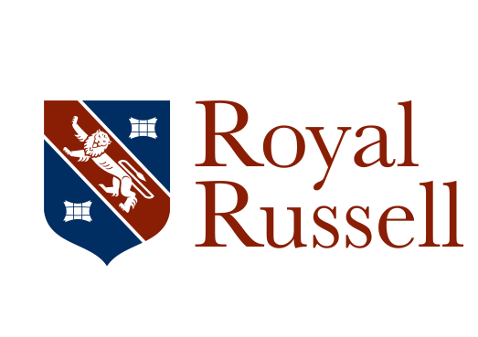

Job description
Job title: Graduate Sports Coach (2 posts) – in Football and Hockey
Reports to: Director of Sports

Responsible for: No posts

Working Time: c 37.5 hours per week during term time and hours as required for School sports tours and trips during School holidays.
Purpose of Job:
To support the provision of high quality Sports to pupils at the School and in particular delivers Netball

Main Responsibilities:
- Deliver high quality, up-to date and challenging sessions across all school age groups.
- Utilise RRS sports technology to analyse individual player’s performance.
- Work technically with individual player’s on a one to one basis to improve their performance.
- Uses performance analysis platform (Hudl) liaising with Head of Sport as required.
- Take and support teams to fixtures (Home and Away) both midweek and on Saturday mornings
- To support with the strength and conditioning room programme.
- To check that areas are suitable for each sports activity in accordance with good health and safety practice as specified in the RR Sports Handbook.
- To set high expectations and standards of behaviour by pupils towards each other that encourages effective team-working.
- To promote a competitive spirit within the specified team with mutual support for each other regardless of individual abilities and outcomes.
- To provide feedback on pupil performance if required, including contributing to reports on athletes to facilitate improvement in their performance and/or contribute to their development.
- To bring any concerns about a pupil to the attention of the Head of Games.
- Assists with school educational trips when required in both Senior/Junior Schools.
- To cover and assist in lessons when required
- Assists with the Royal Russell School October IMUN Conference from Friday to Tuesday of October half-term (paid).
- Responsible for a tutor group

General Responsibilities:
- Ensures the safety and well-being of children and young people at the School by adhering to and complying with the School’s Safeguarding and Child Protection Policy at all times.
- Attends Royal Russell Day and Open Day as required.
- Displays correct staff identification at all times whilst on site.
- Attends training and staff INSET sessions organised by the School to provide a consistent approach across the entire School staff population.
- Adheres at all times to Health & Safety legislation, and all departmental policies and procedures, to ensure the safety of you and colleagues as well as pupils, staff and visitors.
- Carries out any other reasonable duties as requested by the Headmaster

This job description contains an outline of the typical functions of the job and is not an exhaustive or comprehensive list of all possible job responsibilities, tasks, and duties. The job holder’s actual responsibilities, tasks, and duties might differ from those outlined in the job description, and other duties commensurate with this level of responsibility may be either permanently or temporarily assigned as part of the job.

April 2017

