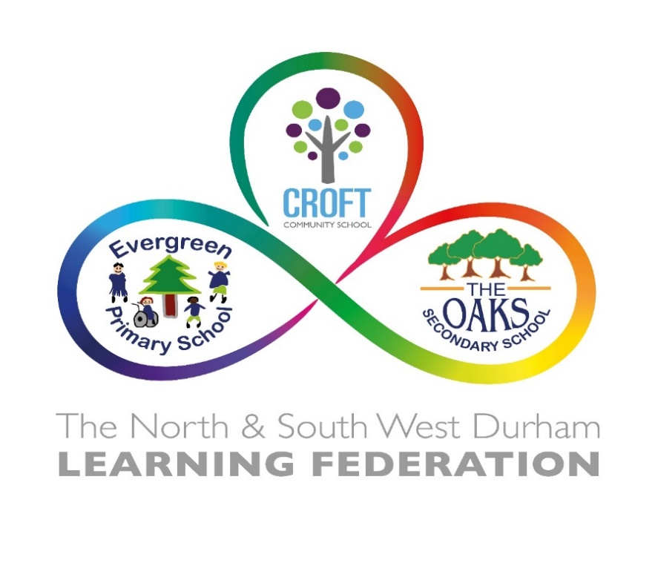

Dear Applicant

Post of Executive Headteacher

Thank you for your interest in the post of Executive Headteacher at The North and South West Durham Learning Federation.

Governors anticipate that a shortlist of candidates will be drawn up on 26 June 2023 in order to enable interviews for the post to take place on Thursday 6 & Friday 7 July 2023.

It is anticipated that the successful candidate will take up duty on 1 January 2024.

Visits to the school are encouraged. Please contact the school office at The Oaks Secondary to make an appointment tel: 01388 827380

Further information about the federation is available on our website.

Applicants are reminded of the importance of completing the application form with a focus on evidencing how you meet each part of the selection criteria. In addition, it is a requirement that you submit a well-structured supporting letter outlining the impact your leadership has had on outcomes for pupils (No more than 1000 words).

Completed application forms should be returned to EDGS.Administration@durham.gov.uk. by no later than Monday 19 June 2023 at 12:00noon

I wish you well should you decide to proceed with your application.

Yours faithfully

C Hubery

Mr C Hubery BEM
Chair of Governors

