Welcome to St Mary’s Catholic School
INFORMATION FOR PROSPECTIVE CANDIDATES
Thank you for showing an interest in working at St Mary’s Catholic School, an Outstanding mixed comprehensive in the pleasant market town of Bishop’s Stortford. As a Catholic school we have developed strong values by which we work, and we welcome your application – whatever your beliefs – to share in these traditional values of a fully rounded education in mind, body and spirit, integrity, honesty and sense of moral purpose. We have a strong partnership with our 7 local Catholic state schools and we are members of the Bishop’s Stortford Education Trust, a local collaboration of secondary and primary schools with a shared interest the very best educational standards for the students in our care. BSET also run a successful teacher training programme (SCITT) of which we are a part. We attract students from across the local area and from further afield in the Diocese of Westminster.
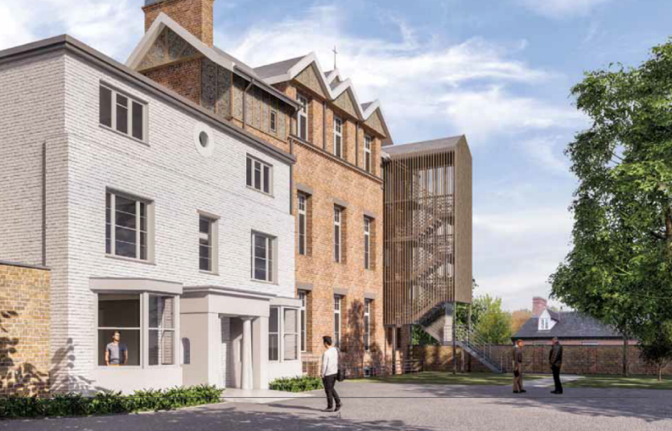
There has never been a better time to join our school community. GCSE results consistently place us within the top 25% of schools nationally and these successes continue in our strong Sixth Form. Many of our students undertake the English Baccalaureate and there is a thriving extra-curricular programme. In addition to the above, our financial position is extremely and almost uniquely strong. We have been fortunate to have recently renovated classrooms, Sixth Form study facilities, Maths, RE and Science laboratories and other areas of the school. Our most recent building programme is the renovation of the historic Victorian and Georgian buildings, which, at a cost of over £4m, will provide another ten renovated classrooms and office space. Indeed, this will once again become the main entrance to the school - proudly facing the Bishop’s Stortford town centre. In total, over £7m has been invested in the last 3 years – a remarkable project.
Our students, staff and parents are our biggest asset; they are polite and well-mannered, well presented and take a pride in their school. Students are a joy to teach and motivated by the strong pastoral and academic life of the school. Our Surveys this year showed that 96% of staff enjoy their work at St Marys, 97% agree that leaders do all they can to ensure a motivated and respected staff, 100% of students enjoy their learning and believe that behaviour around the school is good, and 97% of parents would recommend St. Mary’s to other parents.
Artist impression of the renovated Victorian and Georgian buildings facing Bishop’s Stortford town centre
The advert and our website contain a lot of information about our school and each department. If you would like more information, or to visit, please feel free to contact the school by telephone or by e-mail and we will be more than happy to accommodate your requests.
Finally, if you are passionate about working with young people and really believe you can join our team in making a difference, then I warmly invite you to apply. This will enable you to take a look at us in more detail and really experience at first hand the friendly and professional environment we have established.
“Thank you for taking an interest in teaching at St Mary’s School. We very much look forward to receiving your application. Successful candidates will be joining a happy, harmonious school in which teaching and learning is the number one priority and enjoyable!”
Andrew Celano
Headteacher

