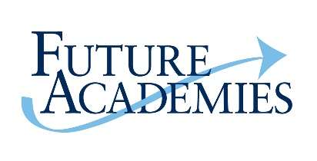
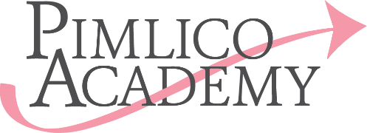

Job Description – Office/HR Administrator

Responsible to: PA to Executive Principal
Responsible for: None
Hours: Up to 40 hours a week (All year round)
Salary: Up to £26,253

Job purpose
The main purpose of this role will be to support the school in the provision of a high quality, efficient day to day Office/HR administration service.
Main Duties and Responsibilities:
- Answering and dealing with day to day enquiries (both internal and external) in a timely and efficient manner
- Dealing with incoming email, post and other paperwork
- Providing efficient administration for the recruitment and selection processes including application management, booking interviews, liaising with recruitment agencies and with direct applicants, preparing shortlisting and interview packs, meeting and greeting candidates, carrying out tours and sending out regret letters
- Providing efficient administration of paperwork for new employees including reference checks and verifications, Disclosure and Barring Service (DBS) checks, preparing offer letters and contracts, and compiling new starters’ employment packs
- Assisting with new employee inductions including arranging induction programmes, and requesting ID badges and computer access from the IT Department
- Managing the School’s single Central Register and maintain records of safeguarding training arranging the necessary refresher training when required.
- Ensuring employee details are entered onto the SIMS (School Information Management System) database accurately and updated when required
- Record and monitor all annual leave and working days for support staff.
- Helping to compile employee statistics including preparation for annual census reports
- Making relevant departments aware of all starters and leavers. Ensuring the contact details and staff photographs are up to date on all relevant places.
- Managing payroll changes and processes, to ensure that all Pimlico Academy staff are
accurately paid on time each month. This input includes setting up new staff, and all changes
including payments claimed by staff for lunch duties, overtime etc.
- Organising, monitoring and updating other paper based and electronic records and reports including working time regulations opt out forms, absence management, maternity & paternity leave, probation and performance management, equal opportunities data and all other similar HR administration
- Maintaining all personnel records in accordance with the GDPR regulations
- Carrying out regular audits of the personnel files
- Producing standard and ad hoc letters and documents
- Taking minutes of meetings where required

General
- Ensuring that established processes are followed in a consistent manner
- Providing excellent (internal and external) customer service and building strong relationships
- Ensuring confidentiality of all written and verbal communication
- Maintaining good housekeeping, strictly adhering to all School policies and procedures
- Maintaining up to date awareness of current employment law and best practice issues
- Assisting and providing cover for other members of the School Administration Team as required
General points
No job description can be entirely comprehensive, and roles develop organically over time. The post holder will be expected to adapt and carry out such duties as may be required from time to time, on the understanding that they will be within the individual’s remit and capability, and consistent with the status and responsibilities of the role within the organization.
Future Academies is committed to safeguarding and promoting the welfare of children and young people and expects all members of staff and volunteers to share this commitment. To this end both an Enhanced Disclosure and Barring Service check and a Barred List check are required for this role.

Person specification
 | Description | Essential (E) / Desirable (D)
Qualifications | CIPD qualified Level 3 or willingness to study for this | E
 | Educated to A-level or equivalent and minimum of 5 GCSE’s including Maths and English | E
Training | Evidence of continuous professional development in the area of HR/Office Administration | E
Experience | Experience of working in a HR role in a school/Education setting for at least 2 years | E
 | Experience in dealing with a range of employee queries/concerns in a professional manner | E
 | Experience of using HR /Payroll systems | D
 | Experience of working in a clerical or administrative role | E
 | Experience of Safer Recruitment | E
 | Experience of working with Trade Unions | D
 | Experience of working within the Education sector, ideally Schools for at least 2 years | E
 | Experience of building positive professional relationships with key stakeholders | E
Skills & Knowledge | Up-to-date knowledge of employment law | D
 | Highly computer literate | E
 | Excellent organisational skills | E
 | Proven ability to work flexibly under pressure, prioritise effectively and meet deadlines | E
 | Excellent written and oral communication skills | E
 | Knowledge of child protection and safeguarding | D
 | Excellent inter-personal skills with the ability to communicate effectively with a broad range of audiences | E
 | Good time management with the ability to work under pressure and prioritise effectively | E
 | Ability to work on own initiative with a proactive approach | E
Other requirements | Committed to Equality, Diversity & Inclusion | E
 | Self-motivated, with a ‘can do’ approach to problem solving | E
 | Ability and willingness to travel across the Trust to support stakeholders, attend meetings etc. | E

August 2019

