

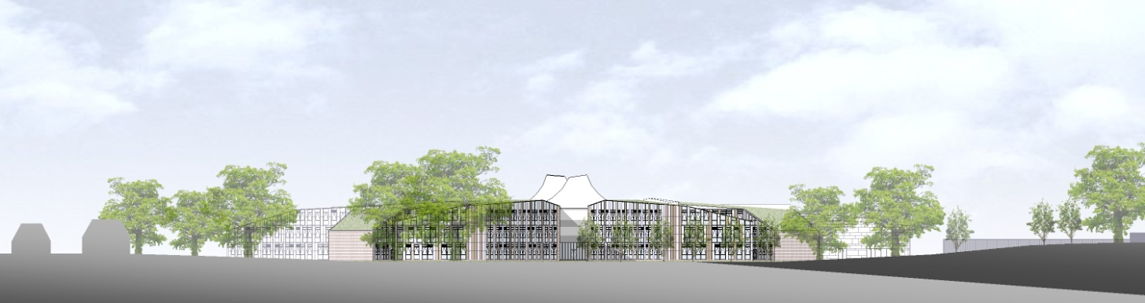

# ST. BARTHOLOMEW'S SCHOOL

# TEACHER OF ART & GRAPHICS

# (MATERNITY COVER)

Part-time, fixed term

# Required from March 2019



**Andover Road**

**Newbury RG14 6JP**

**Tel: 01635 521255**

**Fax: 01635 576320**

**Email:** [**recruitment@stbarts.co.uk**](mailto:recruitment@stbarts.co.uk)

[**www.stbarts.co.uk**](http://www.stbarts.co.uk)

Dear Colleague,

Thank you for your interest in the position of Teacher of Art & Graphics at St Bartholomew’s School. I hope that the details contained in this pack will provide you with a clear picture of this post and give you a flavour of the school and its values. This post really is an exciting opportunity for the successful candidate who will be joining a highly achieving faculty in the school with outstanding facilities.

St Bartholomew’s prides itself on its academic success. For the last 3 years St Bart’s has secured the best GCSE and A level results in West Berkshire state schools. This year 84% of our students achieved both English and Mathematics at level 4 or better and 40% of all grades were 9 – 7 (A*/A). Our Progress 8 score is 0.66 which puts St Bartholomew’s in the top 8% of schools nationally which we are very proud of. A level results were strong with 33% of all grades A*/A and 82% of all grades A* – C.

This is an important appointment for the school at an exciting time when we are working towards becoming outstanding as recognised in our recent short Ofsted Inspection. At St Bartholomew’s we all work together as a team to share good practice, and really develop outstanding teaching and learning to ensure every student makes expected or greater than expected progress. Every member of staff is part of an Action Research Group and you will also contribute to whole school development in this way. The staff at St Bartholomew’s care very much about the community and are ambitious for the school in terms of learning and enrichment opportunities for all the students.

Teaching at St Bartholomew’s School is a rewarding experience. Our students are eager to learn, well behaved and proud of their school, and this was reflected in our last Ofsted inspection which judged students’ behaviour and safety as outstanding. As a school we are committed to ensuring that all the students and staff realise their full potential. Students leave the school as good citizens and this is underpinned by an exceptional house system and a vast range of extra curricular activities.

The professional development of staff is a significant factor in ensuring that we achieve our aim of improving on our previous best and there are rich professional development opportunities at St Bartholomew’s (see CPD offer on our website under Job Opportunities) at all levels. Our induction and NQT programme for new staff is supportive and thorough and coaching is available for all staff across the school upon request.

All staff are issued with their own laptop and the Governors currently kindly offer a subsidised meal at Activity time. All faculties have their own workrooms.

I know that anyone applying for this post will find working at St Bartholomew’s very rewarding, and the Governors and I look forward to hearing from you if you feel you have the qualities and experience we are looking for.

If you would like to have a discussion with me or the Head of Expressive Arts about this post, or require any further information please contact Human Resources on the above number or recruitment@stbarts.co.uk.

Yours faithfully,

Julia Mortimore

Headteacher

**THE FACULTY**

The Expressive Arts Faculty (also known as Bart’s Arts) is a busy and thriving aspect of the school. We have an extensive extra-curricular programme and offer GCSE and A-level courses in all disciplines. The Faculty is composed of Art, Dance, Drama, Graphic Design and Music. Each department has autonomy over its own teaching, and regularly co-operates to co-ordinate similar teaching concepts across the subject areas.

The faculty has an excellent reputation for promoting achievement and success within our subject areas. Numerous arts students have gone on to study at some of Britain’s top institutions including Oxford, Cambridge, Guildhall and other Higher Education establishments, whilst also developing promising careers within the arts fields. As a result, the department has also acquired an extensive student alumni who are always willing to return to the School and offer their support to current students.

In addition to Concerts, School Productions, Dance Shows and Art Exhibitions, the Expressive Arts subjects also host an annual House event for different subject areas, which feeds into the whole school House structure. Students regularly lead such initiatives themselves, with teacher support offered as appropriate.

As recognition for their work and as part of our praise and support outlook, Bart’s Arts also reward students for their contributions to the Arts within the wider school context. The departments award subject colours to KS3 and KS4 students and KS5 students are attributed Bart’s Arts Ambassador status. School visits to see professional artists in action or the arrangement of workshops within school time are regularly pursued within the Faculty and are fully supported by the school Leadership team.

St Bart’s new facilities offer teachers the opportunity to teach in exciting ways, and enable students to learn in state of the art environments. The annual School production has become a showcase for our talented youngsters and staff always take the opportunities to strive for professional outcomes. Class sizes do not exceed 28 and students have hourly lessons in years 7 and 8 (Dance and Drama rotate each half term), whilst opting for their chosen Arts subjects in year 9 and receiving two teaching hours per week. GCSE and A level numbers are thriving and students receive on average two to three hours of teaching at KS4 and four to five hours at KS5.

Bart’s Arts are held in high esteem within the wider community, and as such are frequently approached by local and national organisations to participate in specialist events. We welcome new ideas and initiatives to continue to build upon our students’ success.

**THE POST**

* We are seeking to appoint a suitably qualified inspiring Teacher of Art & Graphics to join the Expressive Arts Faculty with effect from March 2019 on a fixed term basis of up to one year to cover maternity leave.
* The position is part-time (0.60 FTE).
* Applications are welcome from newly qualified and experienced teachers.

###### THE SALARY

* The successful candidate will be appointed to the main or upper pay scale in accordance with her/his experience and qualifications.

**HOW TO APPLY**

Full post details, an application form and instructions on how to upload your completed application are available via the Jobs & Training / Job Opportunities section on the School’s website:

[**www.stbarts.co.uk**](http://www.stbarts.co.uk)

(Please note that curriculum vitae and covering letters cannot be accepted)

Successful candidates will be subject to a DBS enhanced check along with other relevant employment checks.

## Closing date: Sunday 20 January 2019

Thank you for considering St Bartholomew’s School.

Julia Mortimore

Headteacher