Why you should choose Nobel

The Nobel School is located in Stevenage, a town and borough in Hertfordshire, England, situated on the A1 between Letchworth Garden City to the north and Welwyn Garden City to the south. Just 20 minutes from London via train, a 40 minute drive from Cambridge with nearby airports just 20 minutes away (Luton) and 40 minutes away (Stansted), Stevenage has excellent transport links to London and the rest of the country. Stevenage Old Town has a village feel with historic buildings, cafes, coffee shops, restaurants and coaching inns and is lively in the evenings and weekends (for more information, see http://www.stevenage.gov.uk/regeneration/131675/).

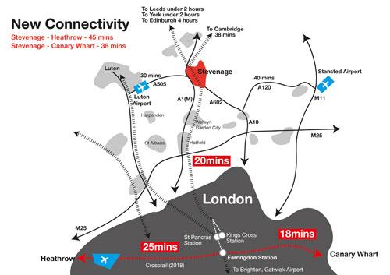
Staff CPD

- We provide a comprehensive induction programme for all colleagues joining our school and all our new teaching staff are paired with a buddy to support them.
- On-going in-house professional development is an expectation for all via our core CPD days; after school Pit Stops; open classroom weeks; our teaching and learning journal; Lead Practitioners; middle leader training; and open door policy practiced by both our Senior Leadership Team and our Directors of Faculty, all of which support the aims of our school improvement plan and encourage colleagues to develop their careers with opportunities provided for staff to advance within school, as well as offering support for those who may wish to find promotion elsewhere.
- We are active members of the Stevenage Educational Trust (http://www.educationtrust.org.uk/) and the North Herts Teaching Alliance (http://www.northhertsteachingalliance.org/) so we have excellent links with other schools in the area, plus robust networking and CPD opportunities.
- All NQTs are given a mentor and 10% release time to enable them to see examples of excellent practice across our school. They are also supported through the Stevenage Educational Trust (http://www.educationtrust.org.uk/) and receive specific training through Herts for Learning (http://www.hertsforlearning.co.uk/team/nqt-induction-service).
- Competitive salaries and pay progression - all our staff are entitled to an annual professional appraisal review, with strong performance evaluation systems and linked pay progression.

Staff well-being

- Our recent rebuilding programme means that we have a ‘state of the art’ £38 million 21st century school with outstanding facilities (http://thenobelschool.org/venues/school-facilities/).
- Our Governing Body comprises professional people from business, finance and education (http://thenobelschool.org/about-the-school/governors/). Our Governors have both general and specialist roles in supporting the school and are very active backers of the leadership, staff and students. Additionally, the school has well-established and very close community links, with strong parental support.
- Occupational Health with Carewell – a free and confidential 24-hour employee assistance programme which provides advice and support, including a counselling service.
- Free, onsite parking for all staff.
- We have superb sports facilities that include a large sports hall, a gymnasium, a dance studio, AstroTurf, a climbing wall, a multi-use games areas and the trim trail. In addition to these facilities, we have a fitness centre available for use by staff for free until 6pm (http://thenobelschool.org/venues/fitness-suite/).
- Staff well-being survey (annual).
- Christmas and summer all-staff parties plus regular faculty-wide socials.
- VDU and eye tests as appropriate.
Financial benefits

- Teaching Pension Scheme with generous employer contributions and the option to make additional contributions.
- Child Care Voucher Salary Sacrifice Scheme, with access to tax free childcare vouchers.
- Reduced rates for facilities hire (http://thenobelschool.org/venues/).
- Lunches are provided free on weekdays during term time for those that undertake school duties. The meals are prepared daily from fresh ingredients by the school’s in-house caterers and hot and cold food choices are available.
- Local and national retail discounts - our school is a member of Herts Rewards, an online 'one-stop' portal (http://www.countyofopportunity.co.uk/about-us/rewards-benefits/).
Our 2018 Ofsted inspection accurately reflects where we are as a school:

- The school’s work to promote pupils’ personal development and welfare is outstanding..
- There is a clear culture of hard work and good behaviour throughout the school.
- New teachers and inexperienced staff are supported well by the school.
- …effective teaching, learning and assessment support pupils to make good progress.
- The headteacher and his team have created a powerful community in the school which reflects the importance of being a ‘Nobelian’.
- Leaders are very aware of the aspects of the school’s work that need to improve.
Our prospectus is available on our website (http://thenobelschool.org/) and you can find out still more about our lovely school at the following links: https://www.facebook.com/nobelschooluk and https://twitter.com/nobelschooluk

Why you should apply for this post

As a school, we have the very highest expectations of our students. Our core principle will always be that we endeavour to improve the teaching and learning in the school. We are therefore committed to recruiting only the very best teachers and have the highest expectations in terms of lesson planning, classroom delivery and student assessment. In return, we provide excellent working conditions, first rate CPD and a real sense of community.

The Nobel School is committed to safeguarding the welfare of all of its students and staff. The successful candidate will have to meet the requirements of the person specification in order to be offered the post and will be subject to satisfactory recruitment checks, including an enhanced DBS check and satisfactory references. We welcome applications from all suitably qualified individuals regardless of age, gender, ethnicity or religion.

