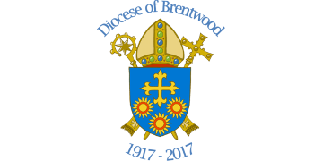



TRINITY CATHOLIC HIGH SCHOOL (Science & Sports College)
Headmaster: Dr P C Doherty OBE, BA (Hons), DPhil (Oxon), FRSA
Website: http://fc.tchs.uk.net

Our Vision at Trinity

[1] At Trinity, we believe that the centre of our Life is the Eucharist through which we love God and also love our neighbour.
[2] At Trinity, we believe that religion lies at the heart of every individual. Accordingly, we must never mock, ridicule or harass anyone because of their religious beliefs or their practice of them.

[3] At Trinity, we believe we are brothers and sisters, sons and daughters of God, equal in dignity to each other and before God. We must never take away, in any fashion, the dignity of another person.

[4] At Trinity, we believe that the teachers and staff are here to serve us. According to Christ, those who serve should be treated with a special dignity and respect, especially people who, when we are at school, act as our parents, our mothers and fathers.

[5] At Trinity, we believe that our community is a happy, pleasant and harmonious one. We must all work hard to maintain this.

[6] At Trinity, we believe that the fabric of the school and all its resources are for our enjoyment. We must take great care of these.

[7] At Trinity, we believe that we are here to grow stronger and better so that we can serve others both in our own community and those communities attached to it, be it our neighbourhood, our country or those communities in the world which require our special support.

[8] At Trinity, we believe that the strong must always protect and go to the help of those who are weaker than us.

[9] At Trinity, we believe we are here to develop our God-given talents.

[10] At Trinity, we believe we are here to make our parents and families proud.

[11] At Trinity, we believe that what we do, what we achieve, is important in this life and in the life to come.

[12] Our vision is summed up in this statement:

“Lord Jesus,
Teach me when to speak and when to listen
When to ponder and when to share
In moments of challenge and decision
Attune my heart to the whispering
Of your wisdom.”

We solemnly promise and reconfirm this on 19th September 2018

