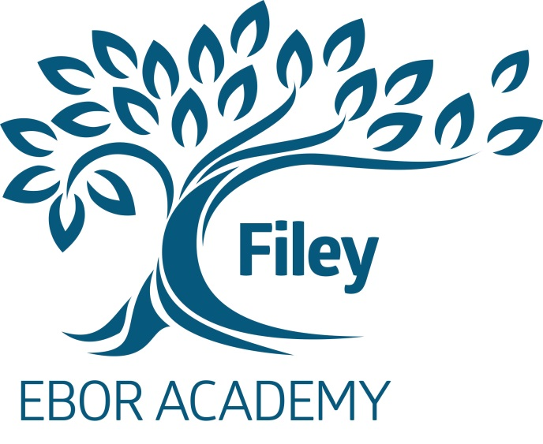

EBOR ACADEMY FILEY
MUSTON ROAD
FILEY
NORTH YORKSHIRE
YO14 0HG
TEL: 01723 512354
FAX: 01723 512165
e-mail: admin@fs.ebor.academy

MIXED COMPREHENSIVE 11-16
NUMBER ON ROLL: 392

HEADTEACHER: Mr A Galbraith

FEMALE PE TEACHER

Maternity cover - fixed term for one year

SALARY RANGE BAND TEACHERS PAY SCALE MPS 1 TO UPS3
which is £22917 to £38633

Required from 16 April 2018

At Ebor Academy Filey we are seeking to appoint a dynamic, enthusiastic and innovative female PE specialist to teach across the full range and ability at KS3 and KS4 and to be able to maximise the potential of all students of all abilities.

.
The successful applicant should have a desire to raise the profile of PE within the school and encourage wider participation across the school for extra-curricular activities. They will be passionate about their subject, have a good knowledge of the National Curriculum and be keen to contribute to the wider aspects of school life particularly surrounding after school PE activities.

Ebor Academy Filey is located on the beautiful North Yorkshire coast with easy access to areas of outstanding natural beauty as well as fantastic culture and arts.

We are looking for a colleague who shares our commitment to high standards of academic achievement for every one of our students and who will go the extra mile to help them achieve excellence. If you are an outstanding practitioner with a commitment to high standards and a passion for enhancing the life chances of young people we would be delighted to hear from you and look forward to receiving an application.

The successful candidate can be assured of our full support in their professional development and career aspirations.

The job description, person specification and application form are available as downloads from the school website address namely filey.ebor.academy.

Please return your application to the Headteacher, Mr A. Galbraith, by post to the school address or log on http://www.eboracademytrust-careers.co.uk/vacancies where you can apply direct.

Ebor Academy Filey is an Enhanced Mainstream School for Autism.

Ebor Academy Filey is committed to the safeguarding and promoting the welfare of children and young people and expects all staff and volunteers to share this commitment.

Applicants should be aware that this post is subject to compliance with a fully Enhanced DBS
Disclosure.

Closing date for applications: Monday 19 February 2018 by 5.00 p.m.

Interviews to be held: Thursday 22 February 2018.

