

Senior Data Manager
Term time only + 10 days – 37 hours per week
Salary: (SCP 40 – 44) £36,153 - £39,961

We are looking to appoint a well organised, flexible and hardworking Senior Data Manager to develop and maintain high quality of data management support in school.

The successful candidate will be responsible for:
- All aspects of school data management and adherence to all appropriate regulations
- Supporting curriculum area leaders in setting up, maintaining and interpreting data reports
- Data systems management, including anticipating any changes and developments which the school will need to make in the field of Management Information Systems
This is an excellent opportunity to join St Aidan’s Church of England Academy which is continually looking to improve. If you are appointed for this post, you will report to the Vice Principal (Standards & Achievement) and will support whole school improvement by presenting accurate and timely analyses of student progress.

We are ideally seeking someone who possesses:
- Extensive experience and knowledge of educational data management and school performance statistics
- Previous experience in a similar role
- The ability to analyse data, and produce comprehensive reports that meet the differing needs of stakeholders (teachers, governors, parents and others)
- Advanced MS Excel knowledge, SIMS, and a sound knowledge of school data management systems
- Excellent organisational, time management and planning skills including the ability to be flexible in order to achieve targets
- The ability to work under pressure, prioritising and managing expectations
- Excellent interpersonal skills

Should you wish to visit the school, please contact Alex Simpson, PA to the Principal, on 01325 373778 to arrange a date/time.

Further details and an application form are available from Alex Simpson, Tel: 01325 373778 or Email: A.Simpson@staidansacademy.org.uk or alternatively downloaded from our website: www.staidansacademy.co.uk.

Applications must be returned to Alex Simpson via email.
Closing Date: Friday 9 November, 12noon
The Academy is committed to safeguarding and promoting the welfare of children and expects all staff to share this commitment. The post is subject to a successful DBS clearance and pre-employment checks will be undertaken before an appointment is confirmed.

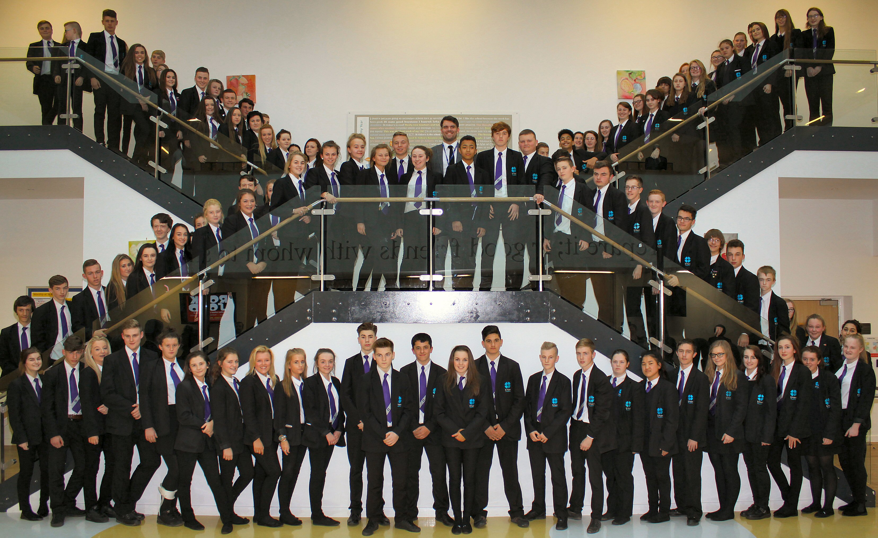 | St Aidan’s Church of England Academy  Hundens Lane, Darlington  DL1 1LL  Phone: (01325) 373770  Principal: Mrs N Gibbon

