
Job Role

CONTENTS
WELCOME 3
ABOUT THE ROLE 4
ABOUT OUR SCHOOL 6
ABOUT INSPIRE EDUCATION TRUST 9
WELLBEING & SUPPORT 13
PERSON SPECIFICATION 14
MAKING AN APPLICATION 16
HOW TO FIND US 17
FAQ’S 18
STAFF TESTIMONIALS 20
PRIVACY NOTICE 22

WELCOME FROM OUR CEO

It is my pleasure to welcome you to Inspire Education Trust.
At Inspire Education Trust we are passionate about making a difference to the lives of our pupils. They are at the heart of everything we do and we strive to inspire all learners, and want all our schools to be the best they can be and for each and every child, to discover the skills, abilities, talents and interests that lie within them.
We believe in working in partnership, enabling us to ensure all children and pupils achieve their full potential. Our schools know the impact that working collaboratively can bring.
Our schools have a desire to question, change and innovate to ensure that what they provide enables our children to become successful learners, confident individuals and responsible citizens.
At the same time, we recognise the importance for each school to retain and promote their individual identity. Every school has its own context and challenges. This is why we encourage our member schools to lead and manage in a way that preserves that individual identity and responds to the specific needs of their children and community.
The combination of autonomy and collaboration across key areas of leadership and management, underpinned by shared values and best practice is what makes our schools special.
Lois Whitehouse – CEO


HEAD OF EDUCATION - PRIMARY
We put the quality of education at the core of our vision. Our school improvement strategies provide an excellent framework to deliver a truly broad, balanced and inclusive curriculum with an emphasis on co-curricular activities such as Arts, Music and Sports from age 2 to 18. We believe that every child is a powerful learner.
We are a progressive Trust with an excellent track record of Primary school improvement across our portfolio of 8 schools, 7 of which are Primary schools.

We have strong models of Primary school improvement alongside high-quality implementation and delivery. We have proven able to deliver high standards of education, systematically, through excellent improvement practice that incorporates knowledge building, evidence-informed professional development, and the creation of communities of improvement.
As a successful Trust we deploy the expertise of specialist primary teachers and leaders across our schools to ensure maximum impact.
The goal is for every member of staff, in every classroom to be as good as they can be in what they teach (the curriculum) and how they teach (pedagogy), e.g., paired planning time with subject/ teaching expert to develop teacher confidence and pedagogy.
Coaching conversations with teachers/ leaders so that developments come directly from them to motivate and signpost independent improvements through self-study documents such as WALKTHRUS and external courses. This will allow capacity to be enhanced so that teachers can then improve each other and hone/ innovate practice. Once practice is embedded and impactful, we would look to develop leaders of these areas externally to innovate and lead future practice in their school and more widely across the Trust.
We are constantly refining the way we support, challenge, and improve our schools. At the heart of our approach is first-class teaching.
Rob Darling – Head of Education, Primary

ABOUT THE ROLE

Post Title | Cleaner
Salary Range | G1 Support Staff pay scale. pro rata £22,366
Reporting to | Site Supervisor
Status | Permanent. Term Time +
Flexibility | Term Time + 1 week

Main Duties and Responsibilities:
- Cleaning of premises (including toilets, classrooms, offices, etc.), furnishings and equipment to include vacuuming, deep cleaning, sweeping, washing, polishing, dusting and emptying of litter bins together with the operation of powered equipment where necessary to ensure that recognised standards are maintained.
- Provide cleaning of all accessible floors, internal windows, walls, partitions, ceilings, fixtures and fittings as directed by the Site Manager or SSO team.
- The collection of rubbish and debris from the buildings and replenishing materials in toilet and amenity blocks required to maintain the necessary standard of hygiene.
- Use cleaning materials economically and accept responsibility for cleaning equipment and ensuring its safe usage and storage, and for washing pads, dusters, mops, floorcloths etc. issued to them.
- Reporting to the Site Manager or SSO team, anything which they consider should be brought to their notice (H&S issues, maintenance issues etc.).
- Complete and sign timesheets and attendance registers and other records as required.
- To attend training courses as considered necessary by the management team.
- To understand and comply with the general requirements of the Health and Safety at Work Act, 1974.
- Any other appropriate work as required by the Site Manager or SSO Team.

Safeguarding and Child Protection:
- Knows what to do if they have concerns about a child
- Takes on the responsibility for providing a safe environment and promoting children’s welfare
- Undertakes regular safeguarding and child protection training
- Familiarises themselves with Keeping Children Safe in Education part 1 (KCSIE) and local policies and procedures as directed by the trust/academy

Other Responsibilities:
- Carries out any other duties as directed by the estates manager that are within the scope, purpose and spirit of the role
- Attends regular continuing professional development (CPD) as required by the school, and other optional relevant CPD to develop good practice
- Proactively takes steps to ensure their mental health and wellbeing is protected, seeking further support if appropriate

ABOUT STOCKINGFORD ACADEMY


FACTS AT A GLANCE
2-FORM ENTRY
NUMBER OF PUPILS: 495
NUMBER OF STAFF: 86
BASED IN: NUNEATON, WARWICKSHIRE

WELCOME FROM HEADTEACHER

Welcome to Stockingford Academy. Stockingford Academy is a vibrant, happy school with a real family feel. We are proud that many former pupils now choose to send their own children to Stockingford and indeed some, even choose us as their place of work!
Our mission statement, ‘Nurturing hearts, inspiring minds, shaping futures’ captures the fact that we pride ourselves on getting to know the passions and talents of each child, celebrating and respecting their differences and recognising their individual and team successes. Stockingford pupils will develop a lifelong love of learning, a deep curiosity about the world around them and a knowledge that they can aspire to be whatever they choose to be.
To ensure that all children achieve their very best at Stockingford, we believe it is essential for children to feel safe, secure, and happy. Our nurturing environment supports children to reflect on their own needs, become independent, develop resilience, and think creatively. Our focus is on children becoming confident, well-rounded citizens of the world, and developing emotional, social and academic intelligence.


Stockingford Academy is part of the Inspire Education Trust family of schools. We work closely together with Walsgrave CE Academy, Clifford Bridge Academy, Whittle Academy, Hearsall Community Academy, Frederick Bird Academy, Arley Primary Academy and Blue Coat Church of England School. We are able to offer support to one another, collaborate as teachers and leaders and ensure that we are at the forefront of changes in education. We fully embrace the vision of the MAT: “Together we achieve, individually we grow.” We believe whole-heartedly in our partnership with you as parents and members of the community. Our aim is that you feel valued and will work with us to support your child’s learning at home.
Children, staff, parents, friends, and governors contribute to Stockingford Academy being the very special place that it is. We are keen to share what makes our school such a great place to grow and so, if you would like to find out more about our school, please do call in – our door is always open.
Gill Bowser – Headteacher

OUR SCHOOL VALUES

Excellence
We strive to be the best we can be and to do the best we can do.

Resilience
When times are difficult, we have the ability to withstand adversity and bounce back.

Nurturing
We encourage and support the development of each other in a gentle and caring way.

Fairness
We treat each other fairly and equally in a way which is right and reasonable. We make sure that everyone’s needs are met.

Partnership
We work in partnership to achieve our goals


MISSION AND ETHOS

We are busy bees. Our school is our hive. Every bee is unique and valued. Where everyone works together, the hive thrives. We are bold. We are brave. Learning is a constant buzz of excitement. Like a family of bees, we empower each other. We all fly high.

Motto
Nurturing Hearts Inspiring Minds Shaping Futures

STOCKINGFORD ONLINE
Please see below the ways to connect with Stockingford Academy online. We have so much great content on our website and our social media, which is where you can see what life at Stockingford is really like.
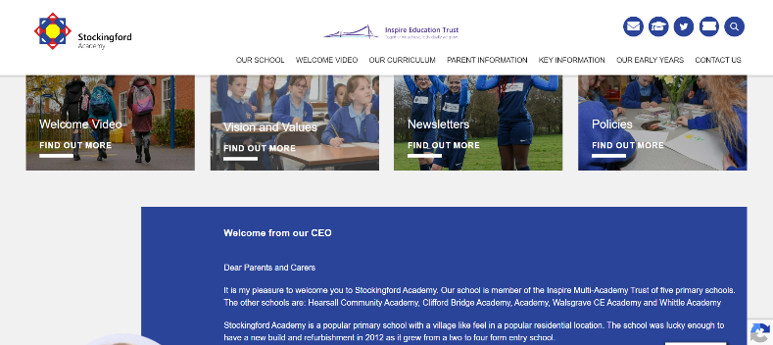
www.stockingfordacademy.org
Facebook
Facebook.com/stockingfordprimary
Instagram
instagram.com/stockingfordacademy
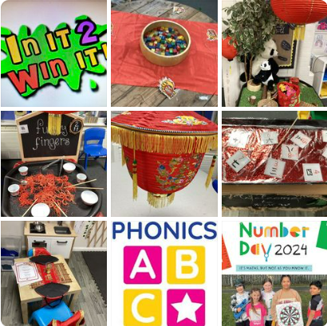
X/ Twitter
twitter.com/stockprim
YouTube
youtube.com/@stockingfordacademy

ABOUT INSPIRE EDUCATION TRUST

Inspire Education Trust is an Multi Academy Trust that grew from a shared belief that children deserve a first-class education, so that each child and student understands what they are capable of, and what talents they have, and strives for excellence in themselves to succeed in the next stage of their education and the world of work.

We understand that every member of our staff is here for the best interest of our children. With them, we want to ensure that every child is valued and that the unique identity of each of our schools is protected, celebrated, and recognised for the contribution it makes to ensuring our pupils have the best education and experiences.

Inspire Education Trust is made up of 8 schools.
Arley Primary School, New Arley, Warwickshire (2024)
Blue Coat Church of England School & Music College, Stoke, Coventry (2020)
Clifford Bridge Academy, Binley, Coventry (2015)
Frederick Bird Primary School, Hillfields, Coventry (2024)
Hearsall Community Academy, Earlsdon, Coventry (2017)
Stockingford Academy, Nuneaton, Warwickshire (2019)
Walsgrave Church of England Academy, Walsgrave, Coventry (2015)
Whittle Academy, Walsgrave, Coventry (2015)

Our Trust Motto encapsulates the beliefs and ideals of our family of schools.

“Together we achieve, individually we grow”

KEY FACTS AT A GLANCE
7 PRIMARIES & 1 SECONDARY
MIXED MAT – 2 CHURCH OF ENGLAND SCHOOLS
3,800 PUPILS AS OF JAN 2024
709 STAFF
OPERATING OVER 2 LOCAL AUTHORITIES

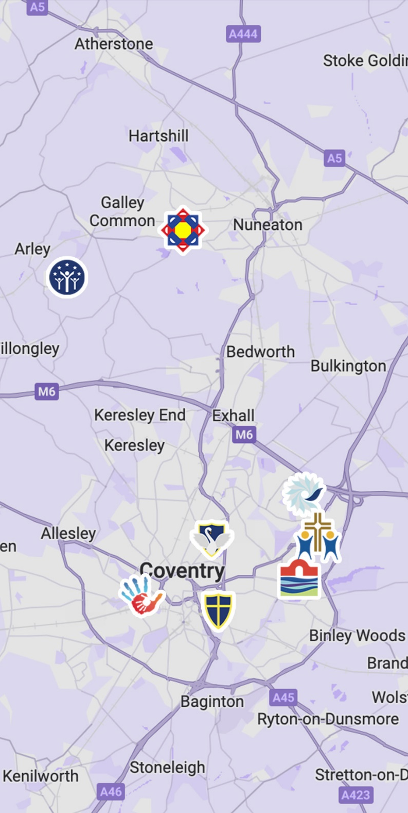
The mission statement for our Trust is “Together we achieve, individually we grow’. We aim to ensure that our academies will provide an environment which is welcoming, caring and purposeful, where we will encourage our pupils to be the best they can be, whilst supporting them pastorally and helping them develop socially. We want our children to enjoy school, have fun and develop a love of learning.
We have a Board of Directors and Members who hold the schools to account and work closely with the Local Governing Bodies of each school who support and challenge the outcomes and quality of teaching and learning. We have strong links with the Coventry Diocesan Board of Education reflecting the church status of our faith schools, Blue Coat School and Music College and Walsgrave Church of England Academy.
As schools, we are committed to sharing the good practice that exists in all the schools and we have numerous opportunities for joint training days and shared professional development for support and teaching staff across the Trust. Staff have welcomed this collaboration and we have retained quality staff and promoted from within.
We strive to maintain academies which will retain their own independent culture and ethos whilst operating within a strategic partnership to improve quality, share best practices and operate effectively and efficiently. We firmly believe that “Expectations Shape Outcomes” and we expect the very best for all members of our school’s communities.
OUR VISION
To be the educator and employer of choice, with a first-class education that empowers pupils to flourish, grow and achieve. Where pupils matter to us as much as their academic success and with staff who are valued, supported, and developed. Together, we will live life in all its fullness.

This Vision sets the aspiration for everything we do.

For Our Pupils and Students
- where all Pupils are valued, respected and experience success
- where who they are matters as much as their academic achievement
- where children are encouraged to reach their potential, both academically and socially
- where we provide a wide range of opportunities / something for everyone
- where learning is fun
- where they experience care with high expectations

For Our Staff
an organisation:
- which prides itself in high quality CPD
- where staff receive every support to be the best they can be
- where we endeavour to promote from within, with cross MAT appointments
- where we try to support staff in achieving a work life balance
- where all staff are valued, respected and can experience success
- where people feel supported and want to work
- where they experience care with high expectations

For Our Parents and Communities
schools where:
- they are made to feel welcome
- their ideas are valued
- we work in partnership
- they are involved in their children’s education
- where they receive care with high expectations

All our academies have their distinctive vision celebrating the communities they serve.
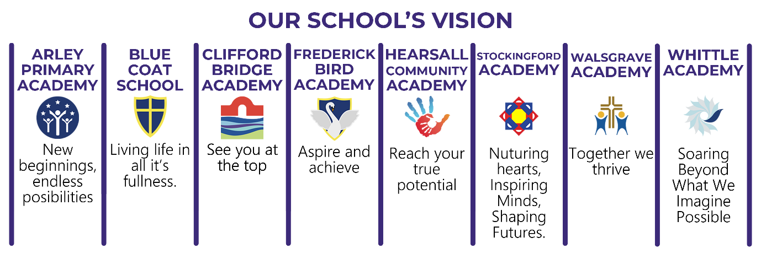
OUR VALUES
Our values drive our behaviours, decision making and ambitions:

Inclusive: We celebrate diversity and difference. All are valued as members of our community knowing they belong.

Nurture: We promote positive wellbeing, so all feel safe, cared for and enabled to thrive.

Servanthood: We considerately put the needs of others before our own, recognising that in serving each other we serve all.

Partnership: We work collaboratively, recognising we achieve more together than on our own.

Integrity: We are open, honest and have strong moral principles which we use to guide us.

Respect: We show care, consideration, and courtesy for ourselves and all around us.

Excellence: We always strive to be better in order to become first class in all we do

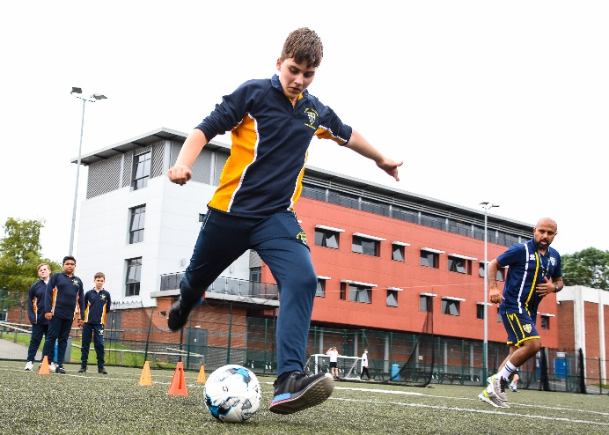



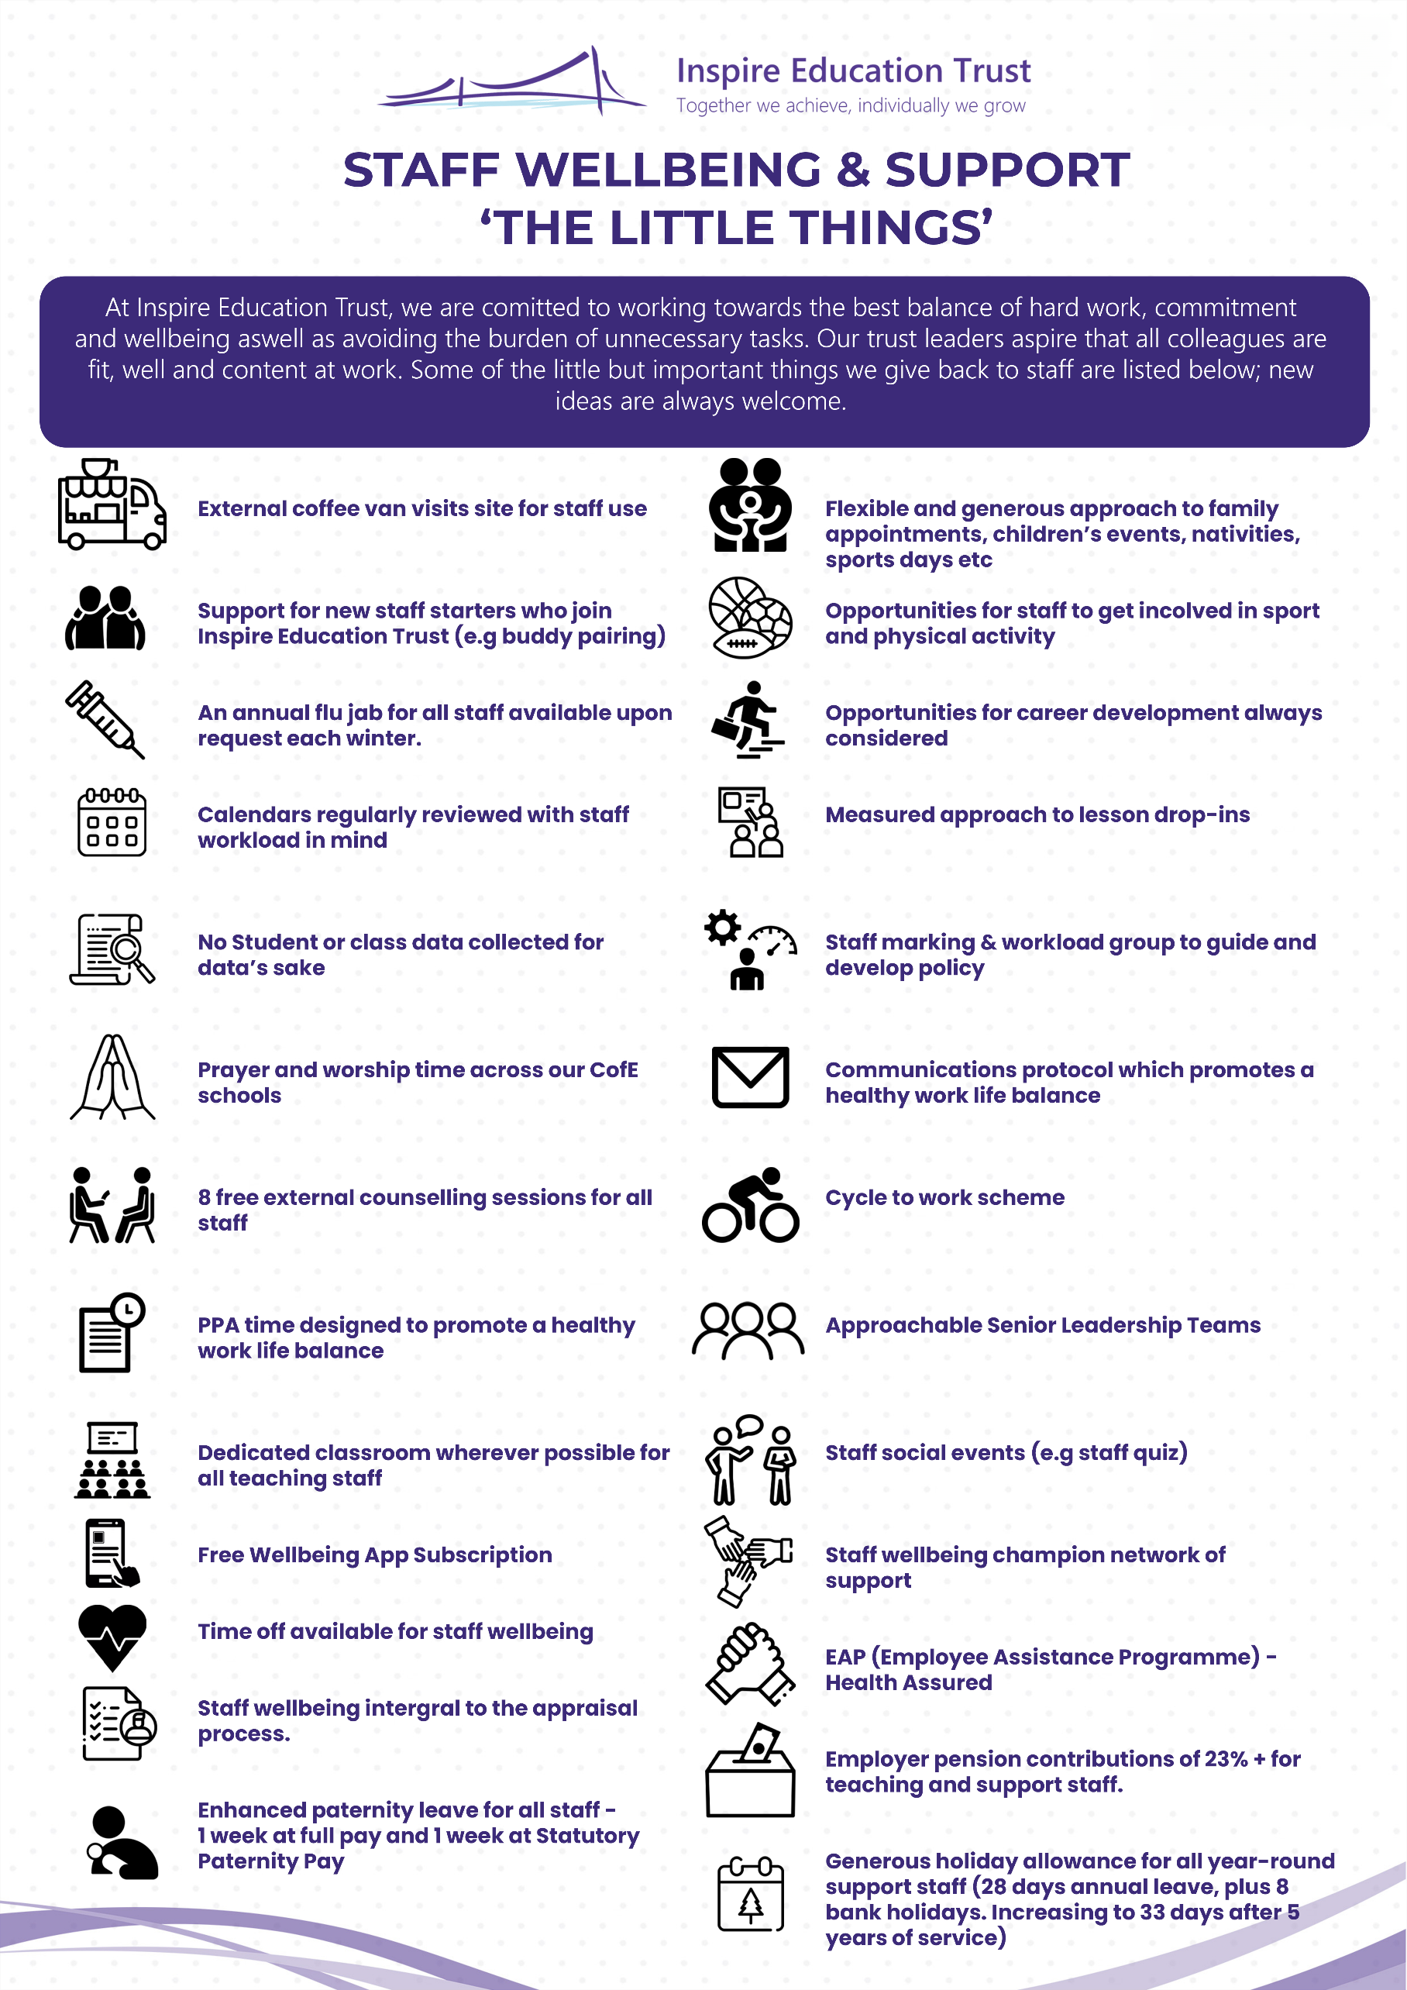
PERSON SPECIFICATION – Cleaner  Stockingford Academy |  | Essential | Desirable
Education and Qualifications | Basic reading and writing skills to maintain records | 
Education and Qualifications | A willingness to attend meetings and training | 
Experience | Previous cleaning experience | 
Experience | Previous cleaning experience of a commercial background including the use of machinery, buffers etc. |  | 
Skills and Knowledge | Knowledge of basic Health & Safety in the work place | 
Skills and Knowledge | General knowledge of COSHH regulations, Working at Height regulations, Electricity at work regulations, Manual Handling regulations |  | 
Skills and Knowledge | Able to carry out manual duties | 
Skills and Knowledge | Team player | 
Skills and Knowledge | Good timekeeping | 
Personal Qualities | Dedicated to our vision that all children are entitled to a first-class education | 
Personal Qualities | Possesses a genuine belief that all children are equal and celebrates the diversity in our school communities | 
Personal Qualities | Self-motivated and able to work on own initiative without supervision | 
Personal Qualities | Works with honesty and integrity | 
Personal Qualities | Emotional resilience in working with challenging behaviour | 
Personal Qualities | Recognises the importance of protecting their own personal wellbeing | 
Personal Qualities | Committed to making children feel happy, safe and secure | 
Safeguarding and Child Protection | Understands their role in safeguarding and protecting children or a keen willingness to learn this | 
Safeguarding and Child Protection | Develops appropriate professional boundaries with children. Knows not to build friendships | 
Safeguarding and Child Protection | Awareness of the key safeguarding processes in schools or willingness to understand these | 
Safeguarding and Child Protection | In-depth understanding of the requirements of Keeping Children Safe in Education |  | 
Safeguarding and Child Protection | A realistic appreciation of the challenges involved in working with children |  | 
Safeguarding and Child Protection | Committed to improving safeguarding processes and practices. Sees it as part of their job |  | 
Professional Development | Willing to participate in further appropriate professional development | 
Professional Development | Positive approach to own continuous personal professional development and training |  | 
MAKING AN APPLICATION
Applications for this post will only be accepted using the electronic application form on the Tes website.
The closing date for applications is midday on 11th June.
Applicants are advised to contact Admin2121@stockingfordacademy.org if they wish to organise a visit to the school.

HOW TO FIND US
If you arrange a visit or are successfully shortlisted for an interview, then you will need to visit our school. Please see the below for guidance and directions on how to find Stockingford Academy.

ADDRESS
Stockingford Academy
Cross Street
Nuneaton
CV10 8JH

A 7-minute drive from George Eliot Hospital, and a 10-minute drive from Nuneaton Rail Station.

PARKING
As you arrive at the back gate, you can ring an intercom to request access to the car park, but you will also need to ask them to send someone to collect you from here. There is also a lot of road parking around the school normally which would be easier for you to access the main office. Please see below for guidance. Car park circled.


Main reception
Back gate

FREQUENTLY ASKED QUESTIONS

How do I apply for a vacancy at Inspire?

All applications must be received electronically via our TES page. CVs may be accepted but will not replace the application form.

Top tips for writing my application for Inspire?

Complete the application form as thoroughly as possible, providing comprehensive information about your past employment, training, and any gaps in employment, from leaving school, until the present day. Emphasize your alignment with the Person Specification criteria in your supporting statement, elaborating on why you believe you are the best candidate for the job.

How does shortlisting work?

‘Blind’ shortlisting is carried out by a panel of staff who will judge the applications based on how closely they match the criteria from the person specification. By ‘blind’ we do not divulge to the shortlisting panel, certain sensitive information about candidates protected characteristics.

When will my referees be contacted?

Following KCSIE guidance, we will seek to obtain references for all shortlisted candidates, before the interview. This allows any concerns raised to be explored further with the referee and taken up with the candidate at the interview. With effect of 1st September 2022, following further guidance from KCSIE, there will also be an online search as an additional pre employment check at this stage. Referees will not be contacted if candidates have not given permission.

How will I be contacted if I am successful?

Successful candidates will be contacted by email after the closing date to invite them to interview with the date, time, and location of the interview. At this stage, you will also be asked to complete a self-declaration of your criminal record or information that would make you unsuitable to work with children.
Whilst we endeavour to inform all candidates of their application outcome, If you have not heard from us within 2 weeks of the closing date, please assume you have not been successful on this occasion.

What is involved in the interview process?

All of our interviews consist of formal, competency-based questions. Additionally, for teaching roles, there will be a lesson observation, and for other key roles, there may be an assessment task (e.g. a presentation, administrative task, data analysis task etc). You will receive information on your invite to interview email which will detail the specifics of the task and what we would like you to prepare in advance.

You will also be asked to bring in proof of identity documents to satisfy a DBS check and qualification certificates, relevant to the role.

Candidates who have a disability or any other needs will be given the opportunity to highlight this prior to any selection activities in order that reasonable adjustments may be made to the selection process.

Is there an onboarding process?

We have an extensive onboarding and induction program which will take you through exactly what to expect before you start your new role, by the end of your first day, by the end of your first week, and by the end of your first month. You will also find important information to online safeguarding training sessions you will be required to complete during your induction.

Is there a probation period?

Yes, there is a probation period of 6 months for support staff. This provides an opportunity for us to put in place a structured plan of CPD and support for new colleagues.

STAFF TESTIMONIALS
Taken from our 2023 staff wellbeing survey

“I work with a wonderful team of colleagues who are supportive and will make themselves available when needed to debrief etc. I feel very blessed that my line manager in particular is very supportive and understanding and takes into consideration any presenting factors which could potentially impact on my wellbeing and workload.”

“I find that generally my wellbeing and work-life balance is good. I find that SLT are very supportive of my department and I can talk to other people I work with about ant issues. I appreciate that any time there are parents evenings, there is not CPD on a Monday evening. I also like that we have been given other training days as days off, such as September 1st.”

“I feel well supported in my role. In particular with regard to flexible working and ad-hoc childcare needs which used to be a big cause of anxiety for me.”

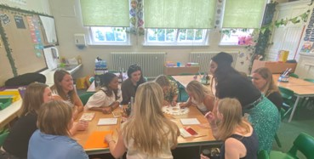
“Employee support program is good and helpful to manage life inside and outside school.”

“I think the school and Trust does a lot to support wellbeing and workload.”


“Wellbeing champions and their supportive work of the staff has been excellent and would continue to help the continual wellbeing of staff. The coffee van is also an excellent little pick-me-up when it's on site.”

“The work of the wellbeing champions. It is much appreciated!”

“Deputy head actively shows support, always makes sure we feel seen and heard and checks in regularly to make sure everything is going OK. “

“My Head has been incredibly supportive of my wellbeing and is always willing to stop and listen when I am in need of someone to talk to if things become overwhelming. They have supported with helping to make my workload manageable so I can have a better work life balance. I am really grateful for that. It makes a huge difference.”
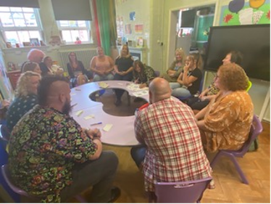
“I feel our SLT are really approachable and understanding. I think they do a great job at just listening and supporting where needed.”

“I feel always cared for by school. It is a really lovely nurturing caring place to work.”
“I am very happy at work, I look forward to coming in and the things put in place by the trust after the last survey such as the coffee van visits have made a massive improvement to the enjoyment we collectively have at work.”

“I am very happy in my place of work. I feel issues are listened to and management support them as best they can. Thank you.”

“I love working at my school! Although it’s crazy busy we always work together as a team to support each other. I am always thanked by my direct leadership at the end is each day.”




