RECRUITMENT PACK

Cover
Supervisor

September 2024


The Archbishop Lanfranc Academy
Mitcham Road, Croydon, CR9 3AS
020 8689 1255
office@lanfranc.org.uk
www.lanfranc.org.uk


Contents

Welcome 1
Our Values 2
Job Title Here 3
Job Description 4
Person Specification 8
How To Apply 9
How To Find Us 10


Welcome

Thank you so much for your interest in The Archbishop Lanfranc Academy, and for considering becoming part of ‘Team TALA’. There’s been a school on this site for nearly 100 years, and, despite being a new academy with a new building, we’re proud of our history and our place in the community.
The Archbishop Lanfranc Academy is a modern, vibrant community and yet one with a long and historic tradition of educating students from the three London boroughs on whose crossroads we sit – Croydon, Merton and Sutton. The Academy is proud of its history, and through its various incarnations, has educated children from its local community since 1931.
We are an 11–16 mixed, comprehensive secondary of about 850 students, situated on the north Croydon/Mitcham border. We benefit from a lovely site with brand new buildings; some great sports facilities (including a fully equipped gym available for staff); plenty of on-site parking; good public transport links and well resourced, purpose built, classrooms and learning spaces, rebuilt in September 2017. The Academy also benefits from an on-site nursery open to both staff and the general public which has a grading of “Good” from Ofsted.
We are committed to high-quality, collaborative and relevant CPD for all members of staff to enable and support them to make the best possible progress in their role and in their future career development. As a growing school there are many opportunities for ‘in-house’ progression.
But more than that, we are a school with a vision for outstanding education and care for all of our students, and are made up of passionate, hardworking staff, and energetic determined students. We invest in our staff, whatever stage of their career, and support and challenge all colleagues to deliver the very best possible experience for our students.
For more information about the school, see:
- Our student prospectus
- Performance tables
- Our Ofsted report
Or, better still, contact us for a discussion or to arrange a visit to come and see us: office@lanfranc.org.uk
Many thanks,
Simon Trehearn
Principal

Our Values

TALA Mission Statement
The Archbishop Lanfranc Academy exists to serve and empower its diverse community by providing an inclusive, safe and nurturing environment that values and celebrates cultural diﬀerences. TALA Vison and Values are promoted to all students so they can achieve their goals in a rapidly changing world.

TALA Vision
Students at The Archbishop Lanfranc Academy are successful learners who strive for excellence academically, creatively and socially. By focusing on personal growth, they become aspirational, resilient, conﬁdent and principled adults.

TALA Values

Teamwork – We all contribute to the betterment of the ‘teams’ we are in
Accountability – We are responsible for our own development and behaviour
Leadership – We have the power to exert inﬂuence and bring about change
Aspiration – We place no limits on what we can achieve

Cover Supervisor

We are seeking to appoint a committed colleague to join our team in the role of Cover Supervisor to cover for teaching colleagues when absent from school. We currently have a team of two Cover Supervisors, and this appointment is to add capacity to our team, and allow greater flexibility for deployment of this cover.
Students and staff value the model of the school having our own directly employed in-house cover; and this model has led to improved consistency and commitment from all involved.
Following a supportive induction process, on-going training and development would be in place to support this colleague – recently two of our Cover Supervisors have begun/completed training to be a teacher, and have joined the teaching team at TALA.



Job Description

Job Title: Cover Supervisor
Accountable To: Principal & Governing Body
Responsible To: Vice Principal
Salary Range: S1 to S6 (£21,246 - £25,616)

Accountable For:
Ensuring that the areas of Academy life for which I am responsible contribute to outcomes above expectations for the Academy students, especially in the standards they attain and the progress and achievement they make.
Understanding, operating and developing the ethos of the Academy so that it becomes a centre of excellence where mutual respect, tolerance, care and support are evidenced in all of the Academy’s activities and that this in turn ensures that everybody takes pride in all aspects of the Academy’s work.

RESPONSIBILITIES

Overall Responsibility
- To supervise cover lessons when Teachers are absent.
- To assist with administration, on-call, supervision and inclusion room, exam invigilation and display and classroom tasks when not covering lessons.
- To assist with teacher photocopying as necessary.

- To contribute to the safeguarding and promotion of the welfare and personal care of children and young people with regard to the Every Child Matters agenda and Area Child Protection Procedures.

DUTIES

Cover
In the context of this job description the term ‘cover’ refers to those occasions when the normal classroom Teacher is absent leaving a teaching group without a Teacher. Absence can be planned, i.e. where a Teacher’s absence is known in advance, or unplanned, i.e. where the Teacher’s absence is for unexpected medical or personal reasons.

- Cover for short term planned or unplanned absence of a Teacher by taking registration and supervising lessons. In all cases work will have been set, either by the ‘absent’ member of staff or the appropriate Team Leader.
- Manage the students’ behaviour in line with Academy policies, thus ensuring learning continues to take place.
- Report, as appropriate and in line with Academy policies and procedures, any problems such as incidents of disruptive or unacceptable behaviour during the lesson.
- Report any problems with the set work to the Team Leader – especially if it is inappropriate or below an agreed standard.
- Help students during a lesson to complete tasks set either through supporting self-directed study, or assisting students by responding to their questions.
- Collect all work done during the lesson retaining it until it can be passed on to the class Teacher, via the agreed route, upon their return.
- Work with Teachers and Team Leaders to plan cover work for an absence known in advance, and prepare a bank of materials available for unexpected absence.
- Work with Teachers in the development of educational initiatives by supporting those initiatives in the classroom.

Other Duties
- Assist in the supervision of examinations, both public and internal.
- Provide administration support for Teachers, assist with classroom displays and other management tasks as directed.
- During periods when cover is not needed, work as a Teaching Assistant under the direction of the SENCO.
- Set a good example in terms of personal presentation, attendance and punctuality.

Health and Safety
- Undergo Basic First Aid training and update courses.
- Be aware of the responsibility for personal Health, Safety and Welfare and that of others who may be affected by your actions or inactions.
- Co-operate with the employer on all issues to do with Health, Safety and Welfare.
- Manage the students Health and Safety, taking appropriate action related to any problems or emergencies that occur during the lesson.

Continuing Professional Development
- Participate in an induction programme that includes lesson observations by experienced Teachers and application and use of Academy policies and procedures.
- In conjunction with the line manager, take responsibility for personal professional development, keeping up-to-date with research and developments related to Academy efficiency, which may lead to improvements in the day-to-day running of the Academy.
- Undertake any necessary professional development as identified in the Academy Improvement Plan taking full advantage of any relevant training and development available.
- Undergo appropriate training to support the delivery of ‘specified work’ in order to develop skills for the post.
- Maintain a professional portfolio of evidence to support the Performance Management process – evaluating and improving own practice.

Other Requirements
- To carry out any other duties as may be reasonably required by the Principal.
- To be aware of and adhere to all Academy policies and procedures.
- To maintain confidentiality at all times.
- To promote and safeguard the welfare of children and young people at the Academy.
- To work in support of the Academy Improvement Plan.
- To take time to read notices, keep to deadlines and carry out duties to the best of your ability.



Person Specification

Experience
- Experience working with young people in a school setting
- Evidence of making an effective contribution to a team
Skills and Attributes
- Capacity to work alongside colleagues, contributing effectively to overarching aims and priorities
- Ability to quickly establish and maintain positive relationships with students, staff and parents
- Ability to demonstrate and promote good practice in line with the ethos of the Archbishop Lanfranc Academy
- Understanding of safeguarding issues and promoting the welfare of children and young people
- Well-developed communication skills, including high level of written and oral literacy and competent ICT use
- Suitability to work with children
- Potential for professional progression

The Archbishop Lanfranc Academy is committed to safeguarding and promoting the welfare of children and expects all staff and volunteers to share this commitment.
Applicants must be willing to undergo child protection screening appropriate to the post, including checks with past employers and the Disclosure and Barring Service.
Candidates should be aware that a check of social media accounts may take place during screening.
Appointment will be dependent upon further health, medical and attendance checks.

How To Apply

To apply for this position, please complete the Academy's application form available both on the TES and on the academy website, under the vacancies section, at www.lanfranc.org.uk.
Completed application forms can be returned by mail/ email to:
The Principal
The Archbishop Lanfranc Academy
Mitcham Road
Croydon
CR9 3AS
Email: recruitment@lanfranc.org.uk

How To Find Us

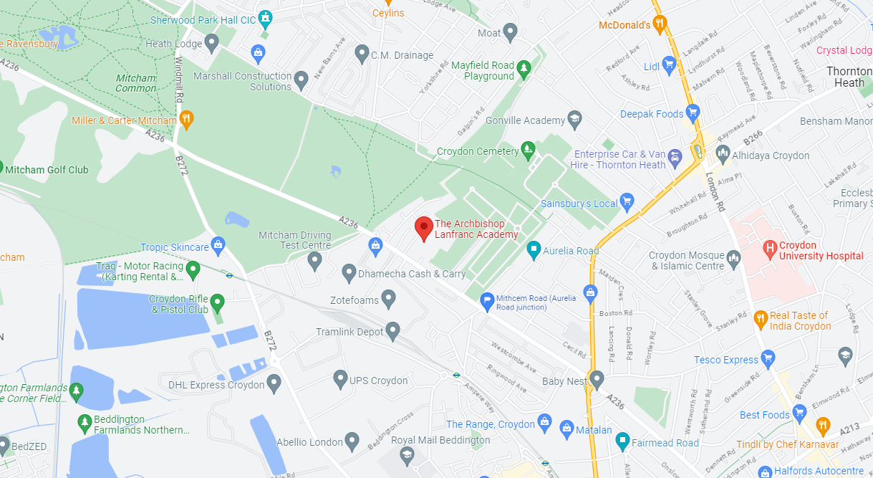

Bus Routes:
152, 255, 264, 455 and 463

Tramlink:
Therapia Lane and West Croydon
The Archbishop Lanfranc Academy
Mitcham Road, Croydon, CR9 3AS
020 8689 1255
office@lanfranc.org.uk
www.lanfranc.org.uk

